CS 405 Module Four Unit Testing
Name: Jeremiah Longwa
Course: CS 405 Secure Coding
Assignment: 4-2 Milestone: Unit Testing
Screenshot:
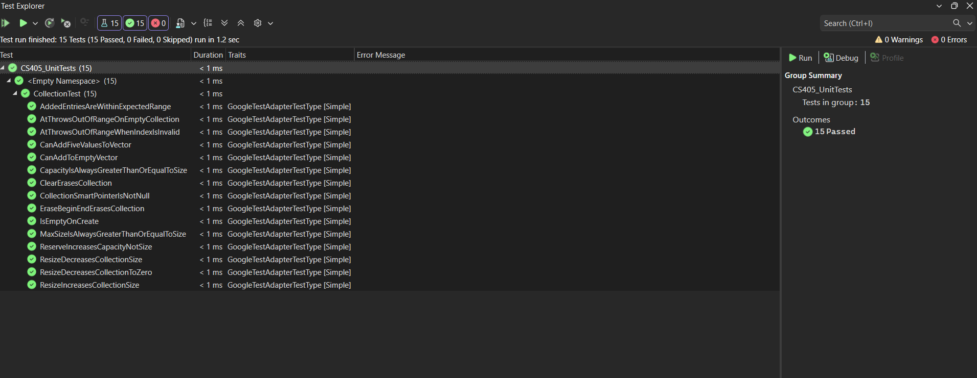
Figure 1: Google Test Explorer results showing all unit tests passing successfully.
Process Summary
In this activity, I completed and extended a Google Test fixture to validate the behavior of a std::vector<int> collection. I reviewed the provided test.cpp file and analyzed the existing test fixture, setup, and teardown logic to understand how shared test data was managed using a smart pointer. I then systematically implemented the remaining required unit tests, ensuring that each test name clearly reflected the specific behavior being verified.
Positive unit tests were created to confirm correct functionality under valid conditions, such as adding elements to the collection, verifying size and capacity relationships, resizing the vector, reserving capacity, clearing the collection, and erasing elements. These tests explicitly proved expected behavior using appropriate ASSERT and EXPECT macros, following best practices for test termination and continued execution.
Negative unit tests were implemented to validate error handling and boundary conditions. Specifically, tests confirmed that std::out_of_range exceptions are thrown when calling the at() method with an invalid index or when accessing an empty collection. All unit tests were executed using the Visual Studio Test Explorer, and the final test run confirmed that all tests passed successfully without errors or warnings. This demonstrates robust unit testing, adherence to C++ best practices, and effective use of the Google Test framework.

