CS 405 - Module Two Buffer Overflow Activity
Name: Jeremiah Longwa
Course: CS 405 Secure Coding
Assignment: 2-3 Activity: Buffer Overflow Coding
Buffer Overflow Prevention Summary
A buffer overflow occurs when a program attempts to write more data into a memory buffer than it was allocated to hold. This can result in memory corruption, undefined program behavior, and serious security vulnerabilities. In this activity, a buffer overflow vulnerability was demonstrated in a C++ program where user input could overwrite a sensitive account number stored in adjacent memory. Although the account number was declared as a constant, unsafe input handling allowed it to be modified under certain conditions.
The vulnerability existed because the program used an unbounded input operation to read user data into a fixed-size character array. When the user entered more characters than the buffer could store, the excess input overflowed into adjacent memory and overwrote the account number. This scenario realistically demonstrates how buffer overflows can lead to data corruption in real-world applications, particularly those handling sensitive financial information.
To address this issue, the input handling logic was modified to safely limit the number of characters read from user input. The updated implementation uses bounded input based on the size of the buffer, ensuring that no memory beyond the allocated buffer is overwritten. In addition, the program checks whether the input operation failed due to excessive input length.
When input exceeding the buffer size is detected, the program clears the input error state, discards any remaining characters from the input stream, and displays a clear warning message informing the user that a buffer overflow attempt was prevented. This approach ensures the program fails safely while providing transparency about what went wrong. Valid input continues to be processed normally, and the account number remains unchanged.
This solution follows secure coding best practices by validating user input, enforcing strict memory boundaries, and applying defensive programming techniques. By preventing unrestricted memory writes and providing clear user feedback, the application protects sensitive data from unintended modification. The included console output screenshots demonstrate both normal program execution and the successful detection and prevention of a buffer overflow attempt.
Screenshot:
Normal input (no overflow):
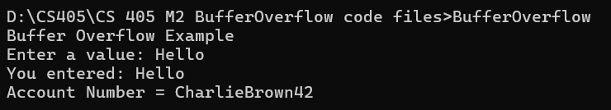
Overflow attempt (blocked):
