EMPLOYER / REVIEWER PACKET
Japanese Kanji Anki Builder
Program identity: Governed data pipeline / release-controlled content generation system
Distribution artifact: JLPT kanji and vocabulary study content for Anki
Evidence mode: Read-only document generation from live commands and tracked docs
Generated: 2026-06-11 America/Chicago
Repo commit: a824d0bc data(words): expand n3 silver batches 35-41
Scope: Whole program: kanji and word decks, proof/governance, release-trust boundaries
Bottom line: This repository is not merely a deck. It is a governed content data system that keeps generated surfaces, review lanes, proof ledgers, media identity, source evidence, NLP support, and release claims separate.

1. Sixty-Second Read
A reviewer should understand the project as backend/data/product engineering: a controlled system that turns tracked contracts and curated local inputs into deterministic study artifacts, then protects trust claims through explicit gates and proof ledgers.
Signal | Verified state | Why it matters
System type | Governed data pipeline and release-controlled content generation system. | Evaluates as software/data architecture, not a static flashcard file.
Whole-program scale | 2212 generated kanji rows and 1470 generated word rows across JLPT N5-N1. | The system covers multiple product surfaces and keeps denominators visible.
Locked scope | v0.2.0 freezes N5-N2 core kanji and N5-N4 words as scoped Obsidian-certified release content. | Release claims are bounded instead of implied across unfinished work.
Proof storage | Canonical JSONL ledger validates with 1969 events across 6 files. | Certification evidence is tracked, queryable, and replayable.
Support boundary | NLP governance passes, but it cannot certify cards or write tracked templates. | Automation supports review without becoming unchecked authority.

2. Architecture
The pipeline separates input authority, generated surfaces, review certification, proof storage, and release packaging. The diagrams below are derived from tracked architecture docs and live command posture.
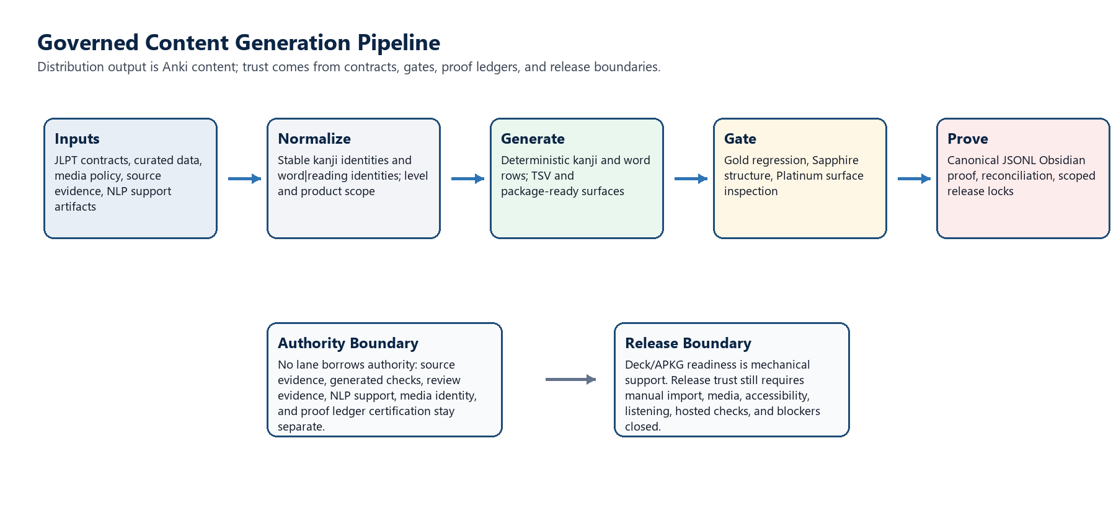
Figure 1. Governed content generation pipeline. Source: docs/system-architecture.md plus live closeout/proof commands.
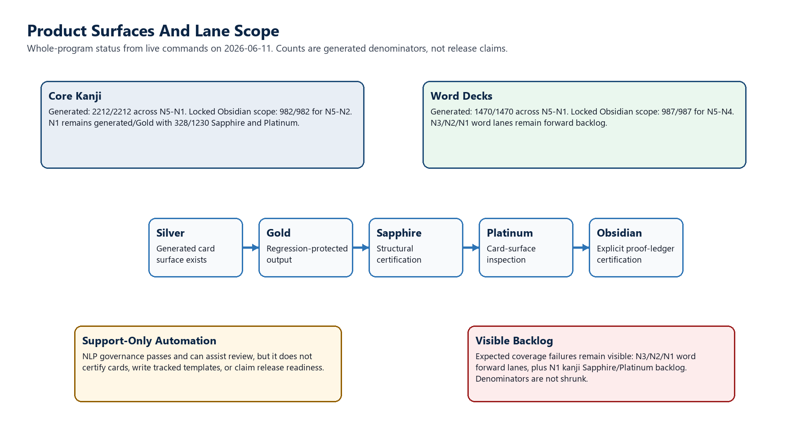
Figure 2. Product surfaces and lane scope. Counts use live commands from this run; stale tracked docs still need count refresh where noted.

3. Current Product State
Surface | Generated | Gold | Sapphire | Platinum | Obsidian / proof boundary
Kanji N5 | 80/80 | 80/80 | 80/80 | 80/80 | Locked scope; Obsidian certified.
Kanji N4 | 212/212 | 212/212 | 212/212 | 212/212 | Locked scope; Obsidian certified.
Kanji N3 | 341/341 | 341/341 | 341/341 | 341/341 | Locked scope; Obsidian certified.
Kanji N2 | 349/349 | 349/349 | 349/349 | 349/349 | Locked scope; Obsidian certified.
Kanji N1 | 1230/1230 | 1230/1230 | 328/1230 | 328/1230 | No trusted Obsidian proof counted; 902 rows need current Sapphire and Platinum first.
Word N5 | 287/287 | 287/287 | 287/287 | 287/287 | Locked scope; Obsidian certified.
Word N4 | 700/700 | 700/700 | 700/700 | 700/700 | Locked scope; Obsidian certified.
Word N3 | 429/429 | 8/429 | 8/429 | 8/429 | Forward backlog; Obsidian proof not recorded.
Word N2 | 28/28 | 0/28 | 0/28 | 0/28 | Forward backlog; Obsidian not started.
Word N1 | 26/26 | 0/26 | 0/26 | 0/26 | Forward backlog; Obsidian not started.

4. Proof And Governance State
Check | Result | Evidence
Proof ledger validation | PASS | 1969 proof events across 6 JSONL files.
Kanji proof reconciliation N5-N2 | PASS | 982 ledger proofs bound; 0 mismatches.
Word proof reconciliation N5-N4 | PASS | 987 ledger proofs bound; 0 mismatches.
Kanji Obsidian certification N5-N2 | PASS | 982/982 Obsidian certified; 0 needs Obsidian; 0 blocked/failing.
Word Obsidian certification N5-N4 | PASS | 987/987 Obsidian certified; 0 needs Obsidian; 0 blocked/failing.
NLP governance gate | PASS | 8 checks pass; certifies cards: no; writes tracked templates: no.
Performance/memory matrix | PASS | 7 lanes pass as governance map; not a release-readiness claim.
Release trust | FAIL-CLOSED | Open release blockers: SEC-P0-004, PROD-REL-001, SEC-REQ-007.

Important limitation: The proof ledger and Obsidian status commands certify scoped content proof only. They do not prove APKG import, mobile behavior, accessibility, listening quality, hosted CI status, source-evidence depth completion, or broader release readiness.

5. Word Reading And Expansion Posture
Level | Inventory | Built | Readiness | Reading coverage | Notes
N5 | 287 | 287/287 | ready; deferred variants | 67.7% (233/344) | Active triage cleared; exact command label preserved in appendix.
N4 | 700 | 700/700 | ready; deferred variants | 76.7% (579/755) | Active triage cleared; exact command label preserved in appendix.
N3 | 429 | 429/429 | incomplete | 34.9% (413/1184) | Silver expansion exists; forward review lanes are 8/429.
N2 | 28 | 28/28 | incomplete | 5.4% (56/1045) | Forward review lanes not started.
N1 | 26 | 26/26 | incomplete | 1.3% (41/3274) | Forward review lanes not started.

6. Explicit Limitations
Limitation | Verified handling
Tracked-doc count drift | docs/employer-overview.md and docs/system-architecture.md still say 1400 word rows. Live commands now show 1470. Update tracked docs before sending them as the sole external evidence.
Generated artifact dirtiness | git status is not clean because generated outputs/ artifacts exist. Tracked source excluding outputs remains clean.
Release readiness | security:release-trust fails closed on two high/critical release-blocker risks and one unimplemented release-blocker requirement.
Manual QA | APKG import, mobile, accessibility, listening, and managed-media review are not proven by these commands.
NLP | NLP artifacts are support-only. Passing NLP governance does not certify a card or mutate tracked templates.
Unfinished lanes | Expected coverage failures remain visible for N1 kanji Sapphire/Platinum and N3/N2/N1 word Gold/Sapphire/Platinum.

7. Reviewer Route
Use this packet as an orientation layer, then verify with the commands in the appendix. The strongest tracked human-facing docs are README.md, docs/employer-overview.md, docs/system-architecture.md, docs/releases/v0.2.0-scoped-obsidian-lock.md, docs/product-exit-criteria.md, docs/verification.md, and docs/release-process.md.
For a hiring reviewer, the most important engineering signal is not the existence of cards. It is the system's refusal to collapse generated output, structural checks, learner-surface inspection, proof-ledger certification, and release readiness into one vague claim.

Appendix A. Live Command Evidence
Command | Classification | Packet use
git status --short --branch | PASS | main tracking origin/main; generated outputs/ present.
git status --short --branch -- . :(exclude)outputs | PASS | Tracked source clean when generated outputs are excluded.
git log -1 --oneline --decorate | PASS | a824d0bc data(words): expand n3 silver batches 35-41.
git ls-remote --heads origin | PASS | Remote heads show main at a824d0bc5ee8f405cf3aacf2e00ac111251b0cf7.
npm run deck:closeout -- --levels=5,4,3,2,1 | PASS / expected gaps | Reports whole-program lane counts; expected coverage failures remain visible.
npm run data:obsidian:proof:validate | PASS | 1969 proof events, 6 files.
npm run data:obsidian:proof:reconcile -- --levels=5,4,3,2 | PASS | 982 kanji proofs bound, 0 mismatches.
npm run data:obsidian:proof:reconcile -- --deck-kind=word --levels=5,4 | PASS | 987 word proofs bound, 0 mismatches.
npm run deck:kanji:obsidian:certify-status -- --levels=5,4,3,2 | PASS | 982/982 certified for locked kanji scope.
npm run deck:words:obsidian:certify-status -- --levels=5,4 | PASS | 987/987 certified for locked word scope.
npm run nlp:governance-gate | PASS | 8 checks pass; support-only boundaries explicit.
npm run perf:memory:matrix | PASS | 7 governance lanes pass; benchmark authority remains separate.
npm run security:release-trust | EXPECTED FAIL-CLOSED | SEC-P0-004, PROD-REL-001, and SEC-REQ-007 remain blockers.
npm run deck:words:completion:n5 | PASS | N5 ready_with_deferred_variants; reading coverage 67.7%.
npm run deck:words:completion:n4 | PASS | N4 ready_with_deferred_variants; reading coverage 76.7%.
npm run deck:words:completion:n3 | PASS / incomplete | N3 generated 429/429; reading coverage 34.9%; forward lanes 8/429.
npm run deck:words:completion:n2 | PASS / incomplete | N2 generated 28/28; reading coverage 5.4%; forward lanes not started.
npm run deck:words:completion:n1 | PASS / incomplete | N1 generated 26/26; reading coverage 1.3%; forward lanes not started.

Appendix B. Tracked Document Sources Read
Source | How used
README.md | Project identity, authority boundary, review tiers, current baseline, source-of-truth map.
docs/employer-overview.md | Employer-facing framing; count drift noted against live commands.
docs/system-architecture.md | Architecture maps and lane authority model; count drift noted against live commands.
docs/releases/v0.2.0-scoped-obsidian-lock.md | Frozen release scope and release-ready caveats.
package.json | Command inventory and program description.
outputs/spreadsheets-whole-program-governance | Prior workbook/export contract and visual dashboard previews.

Boundary statement: This packet is an evidence-backed orientation artifact. It does not certify new cards, append proof, change lane counts, update tracked docs, approve release readiness, or replace rerunning the commands above at decision time.

