Jeremiah Richard
Professor Jeff Lei
CSE-4317-001
7/6/2023

Project
MAIN
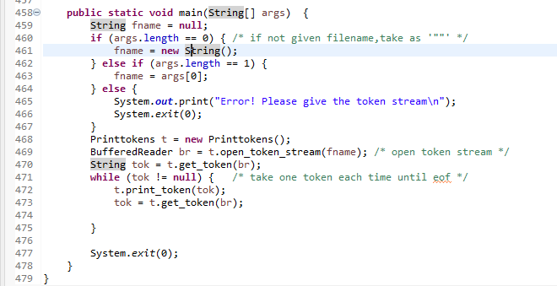
Block Number | Lines | Entry | Exit | Function Calls
1 | 459, 460 | 459 | 460
2 | 461 | 461 | 461
3 | 462 | 462 | 462
4 | 463 | 463 | 463
5 | 465, 466 | 465 | 466
6 | 468 | 468 | 468
7 | 469 | 469 | 469 | open_token_stream
8 | 470 | 470 | 470 | get_token
9 | 471 | 471 | 471
10 | 472 | 472 | 472 | print_token
11 | 473 | 473 | 473 | get_token
12 | 477 | 477 | 477

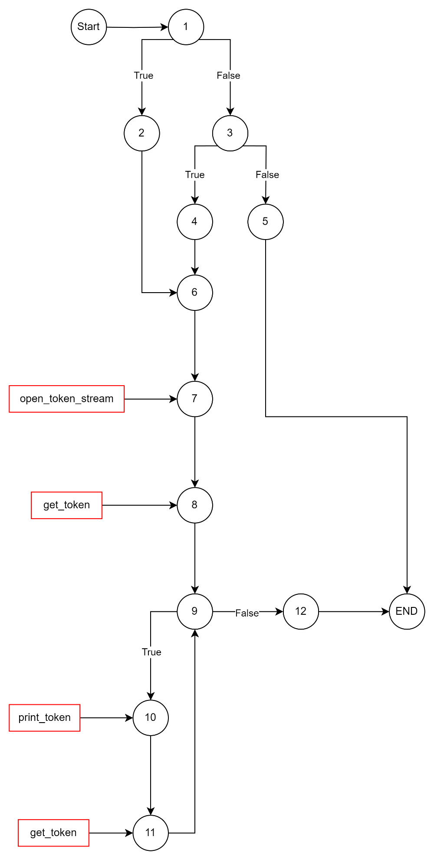
EDGE-COVERAGE
TEST PATHS:
[ (1, 2, 6, 7, 8, 9, 10, 12, END),
(1, 3, 4, 6, 7, 8, 9, 12, END),
(1, 5, END)
OPEN_TOKEN_STREAM
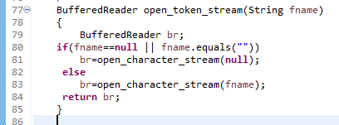
Block Number | Lines | Entry | Exit | Function Calls
1 | 79, 80 | 79 | 80
2 | 81 | 81 | 81 | open_character_stream
3 | 83 | 83 | 83 | open_character_stream
4 | 84 | 84 | 84
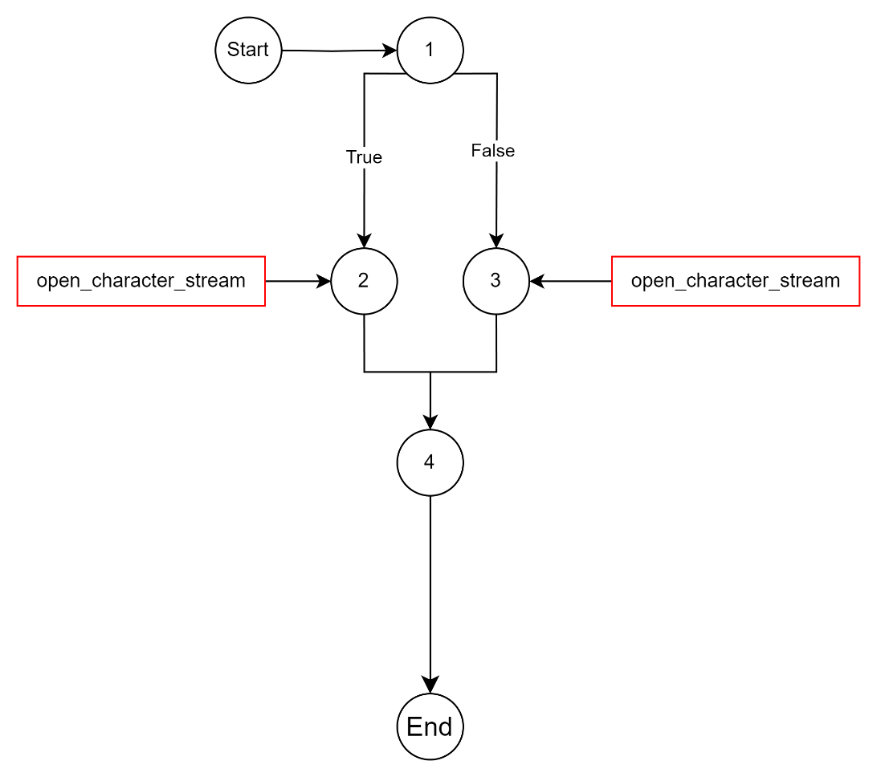

EDGE-COVERAGE
TEST PATHS:
[
t1: (1, 2, 4),
t2: (1, 2, 3)
]
Unit Test
T1
- Input: String fname = “testfile.txt”
- Output: “RANDOM STUFF // ##\n"
T2
- Input: String fname = “”
- Output: NULL
OPEN_CHARACTER_STREAM
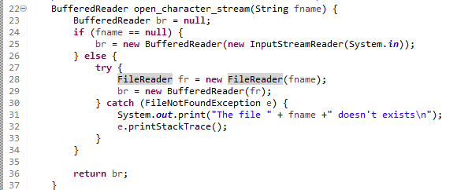
Block Number | Lines | Entry | Exit | Function Calls
1 | 23, 24 | 23 | 24
2 | 25 | 25 | 25
3 | 28, 29, 36 | 28 | 36
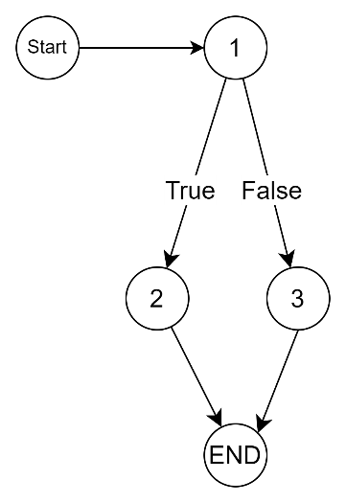
EDGE-COVERAGE
TEST PATHS:
[
t1: (1, 2)
t2: (1, 3)
]
Unit Test
T1
- Input: String fname = “testfile.txt”
- Output: String “RANDOM STUFF // ##\n”
T2
- Input: String fname = “”
- Output: NULL

GET_TOKEN
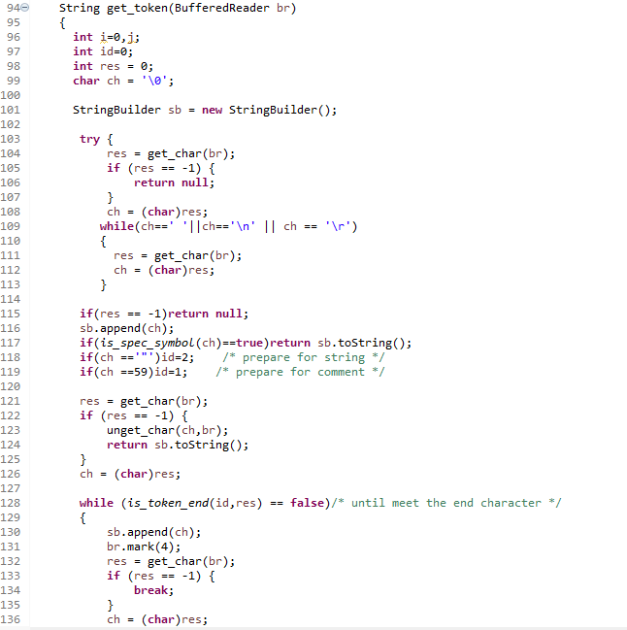
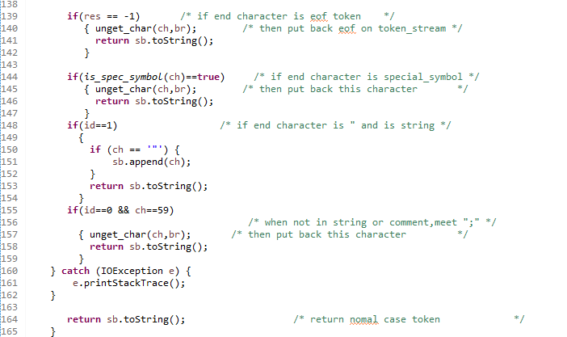
Block Number | Lines | Entry | Exit | Function Calls
1 | 96, 97, 98, 99, 101 | 96 | 101
2 | 104 | 104 | 104 | Get_char
3 | 105 | 105 | 105
4 | 106 | 106 | 106
5 | 108 | 108 | 108
6 | 109 | 109 | 109
7 | 111 | 111 | 111 | Get_char
8 | 112 | 112 | 112
9 | 115a | 115a | 115a
10 | 115b | 115b | 115b
11 | 116 | 116 | 116
12 | 117a | 117a | 117a
13 | 117b | 117b | 117b | is_spec_symbol
14 | 117c | 117c | 117c
15 | 118a | 118a | 118a
16 | 118b | 118b | 118b
17 | 119a | 119a | 119a
18 | 119b | 119b | 119b
19 | 121 | 121 | 121 | Get_char
20 | 122 | 122 | 122
21 | 123 | 123 | 123 | Unget_char
22 | 124 | 124 | 124
23 | 126 | 126 | 126
24 | 128 | 128 | 128
25 | 130, 131 | 130 | 131
26 | 132 | 132 | 132 | Get_char
27 | 133 | 133 | 133
28 | 134 | 134 | 134
29 | 136 | 136 | 136
30 | 139 | 139 | 139
31 | 140 | 140 | 140 | Unget_char
32 | 141 | 141 | 141
33 | 144a | 144a | 144a
34 | 144b | 144b | 144b | Is_spec_symbol
35 | 145 | 145 | 145 | Unget_char
36 | 146 | 146 | 146
37 | 148 | 148 | 148
38 | 150 | 150 | 150
39 | 151 | 151 | 151
40 | 153 | 153 | 153
41 | 155 | 155 | 155
42 | 157 | 157 | 157 | Unget_char
43 | 158 | 158 | 158
44 | 164 | 164 | 164

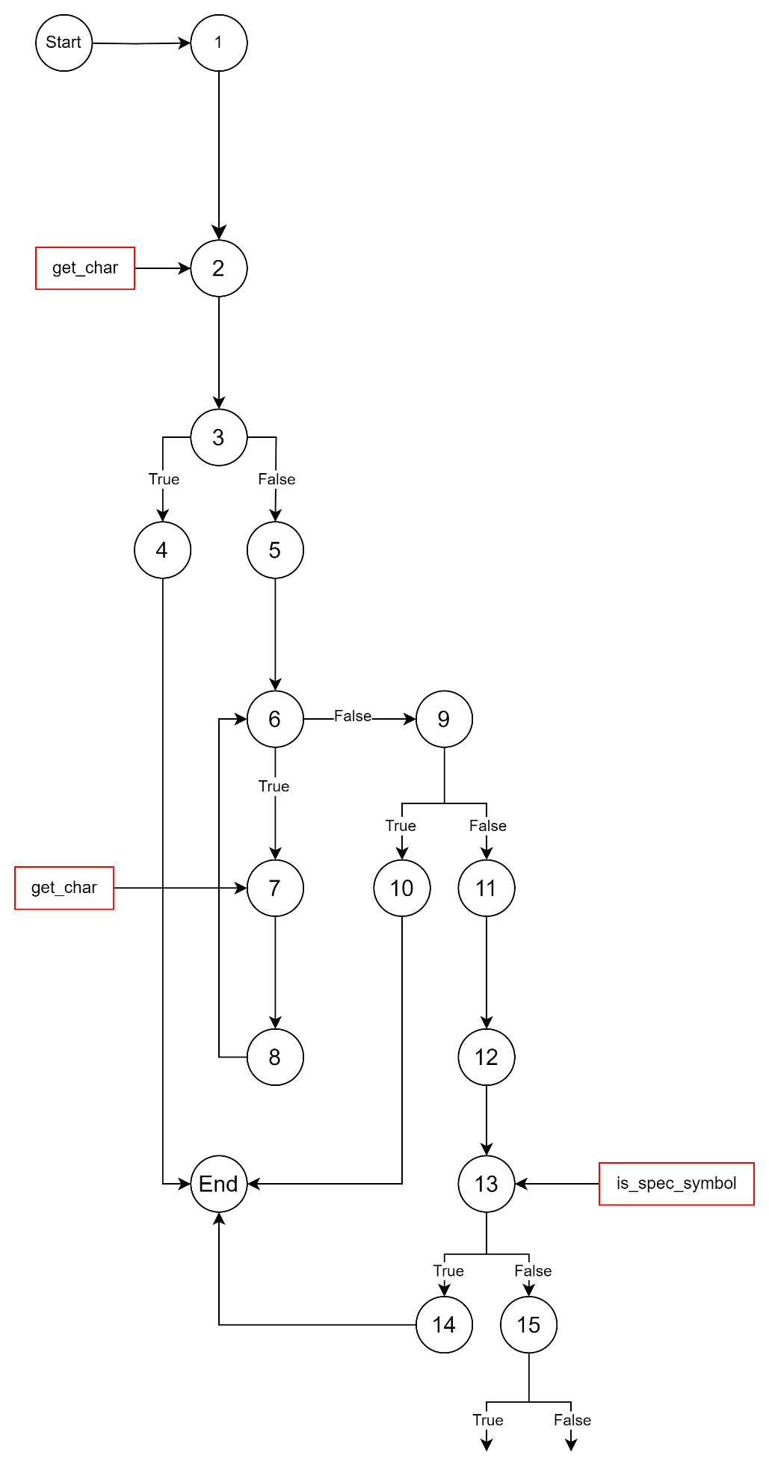
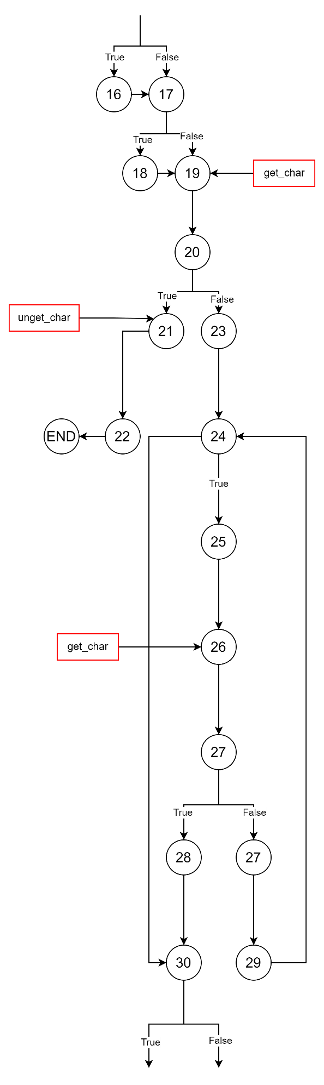
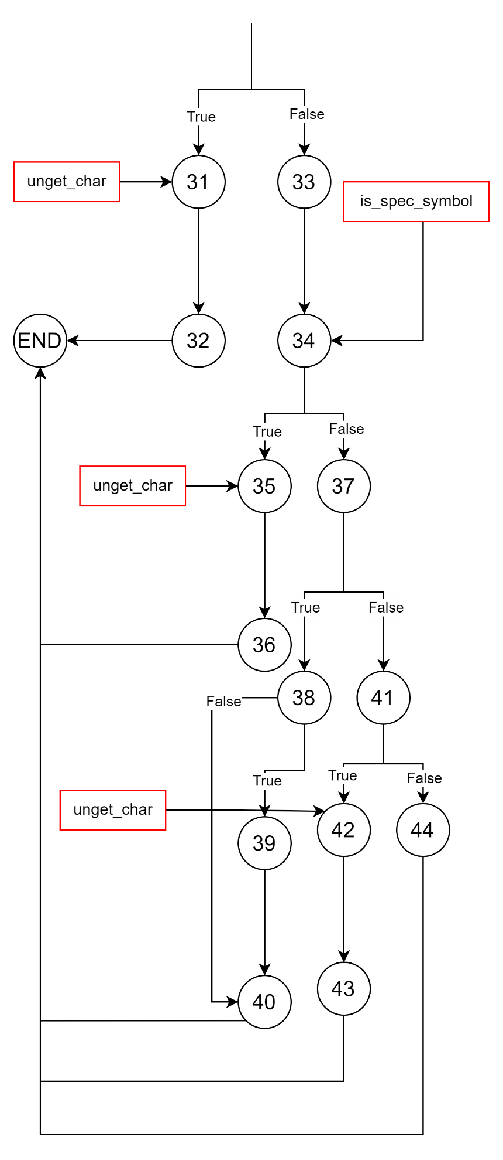
EDGE-COVERAGE
TEST PATHS:
[
(1, 2, 3, 4)
(1, 2, 3, 6, 7, 8, 6, 9, 10)
(1, 2, 3, 6, 9, 11, 12, 13, 14)
(1, 2, 3, 6, 9, 11, 12, 13, 15, 16, 17, 18, 19, 20, 21, 22)
(1, 2, 3, 6, 9, 11, 12, 13, 15, 16, 17, 18, 19, 20, 23, 24, 25, 26, 27, 29, 23, 24, 25, 26, 27, 28, 30, 31, 32)
(1, 2, 3, 6, 9, 11, 12, 13, 15, 16, 17, 18, 19, 20, 23, 30, 33, 34, 35, 36)
(1, 2, 3, 6, 9, 11, 12, 13, 15, 16, 17, 18, 19, 20, 23, 30, 33, 34, 37, 38, 40)
(1, 2, 3, 6, 9, 11, 12, 13, 15, 16, 17, 18, 19, 20, 23, 30, 33, 34, 37, 38, 39, 40)
(1, 2, 3, 6, 9, 11, 12, 13, 15, 16, 17, 18, 19, 20, 23, 30, 33, 34, 37, 41, 42, 43)
(1, 2, 3, 6, 9, 11, 12, 13, 15, 16, 17, 18, 19, 20, 23, 30, 33, 34, 37, 41, 44)
]

PRINT_TOKEN
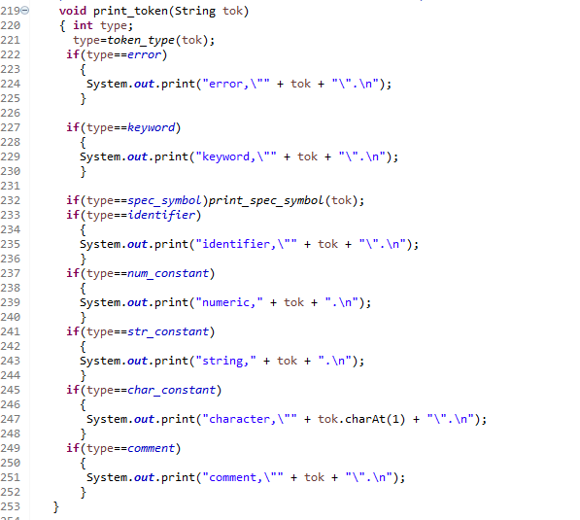
Block Number | Lines | Entry | Exit | Function Calls
1 | 220 | 220 | 220
2 | 221 | 221 | 221 | token_type
3 | 222 | 222 | 222
4 | 224 | 224 | 224
5 | 227 | 227 | 227
6 | 229 | 229 | 229
7 | 232a | 232a | 232a
8 | 232b | 232b | 232b | print_spec_symbol
9 | 233 | 233 | 233
10 | 235 | 235 | 235
11 | 237 | 237 | 237
12 | 239 | 239 | 239
13 | 241 | 241 | 241
14 | 243 | 243 | 243
15 | 245 | 245 | 245
16 | 246 | 246 | 246
17 | 249 | 249 | 249
18 | 251 | 251 | 251
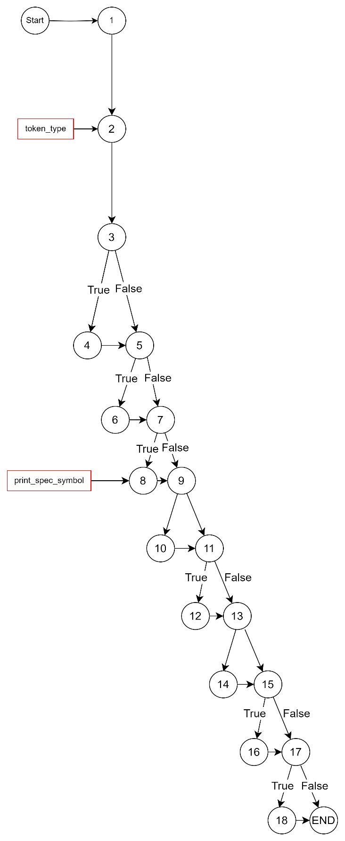

EDGE-COVERAGE
TEST PATHS:
[
t1: (1, 2, 3, 4, 5, 6, 7, 8, 9, 10, 11, 12, 13, 14, 15, 16, 17, 18)
t2: (1, 2, 3, 5, 7, 9, 11, 13, 15, 17)
]
Unit Test
T1, T2
- Not semantically possible

GET_CHAR
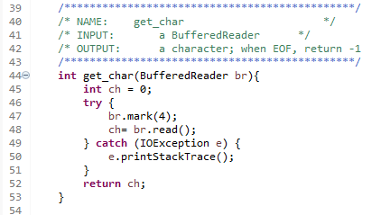
Block Number | Lines | Entry | Exit | Function Calls
1 | 45, 47, 48, 52 | 45 | 52
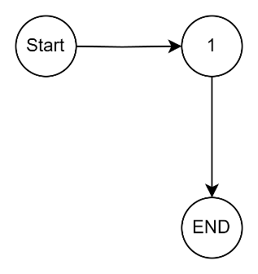
EDGE-COVERAGE
TEST PATHS:
[
(1)
]
Unit Test
T1
- Input: Bufferreader br = testfile.txt
- Output: int ch = 82

UNGET_CHAR
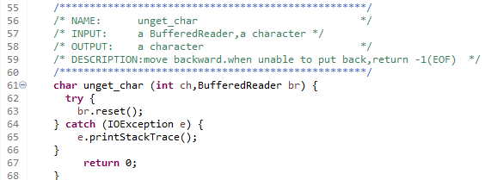
Block Number | Lines | Entry | Exit | Function Calls
1 | 63, 67 | 63 | 67
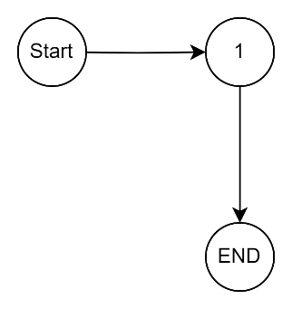
EDGE-COVERAGE
TEST PATHS:
[
(1)
]
Unit Test
No available testing from JAR oracle file.

IS_SPEC_SYMBOL
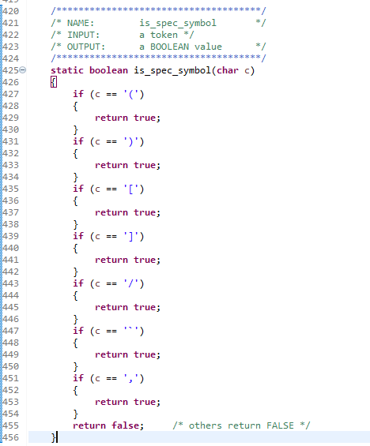
Block Number | Lines | Entry | Exit | Function Calls
1 | 427 | 427 | 427
2 | 429 | 429 | 429
3 | 431 | 431 | 431
4 | 433 | 433 | 433
5 | 435 | 435 | 435
6 | 437 | 437 | 437
7 | 439 | 439 | 439
8 | 441 | 441 | 441
9 | 443 | 443 | 443
10 | 445 | 445 | 445
11 | 447 | 447 | 447
12 | 449 | 449 | 449
13 | 451 | 451 | 451
14 | 453 | 453 | 453
15 | 455 | 455 | 455
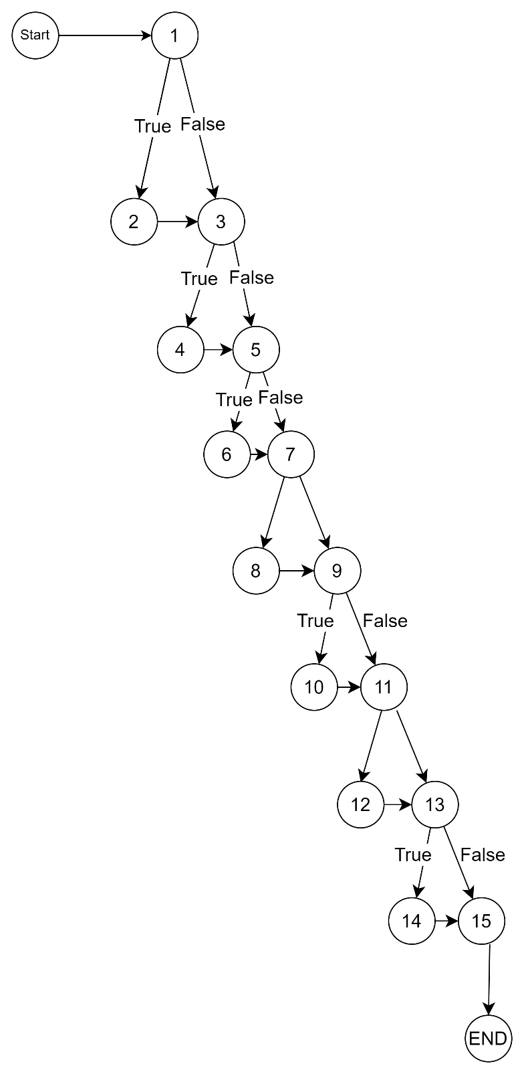

EDGE-COVERAGE
TEST PATHS:
[
(1, 3, 5, 6, 7, 8, 9, 10, 11, 12, 13, 14, 15
(1, 2, 3, 5, 7, 9, 11, 13, 15
]

TOKEN_TYPE
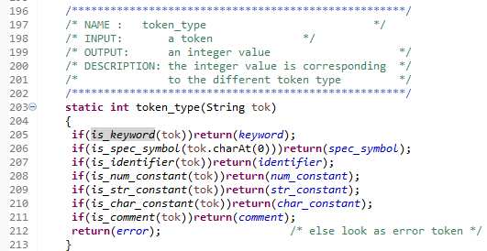
Block Number | Lines | Entry | Exit | Function Calls
1 | 205a | 205a | 205a | Is_keyword
2 | 205b | 205b | 205b
3 | 206a | 206a | 206a | Is_spec_symbol
4 | 206b | 206b | 206b
5 | 207a | 207a | 207a | Is_identifier
6 | 207b | 207b | 207b
7 | 208a | 208a | 208a | Is_num_constant
8 | 208b | 208b | 208b
9 | 209a | 209a | 209a | Is_str_constant
10 | 209b | 209b | 209b
11 | 210a | 210a | 210a | Is_char_constant
12 | 210b | 210b | 210b
13 | 211a | 211a | 211a | Is_comment
14 | 211b | 211b | 211b
15 | 212 | 212 | 212
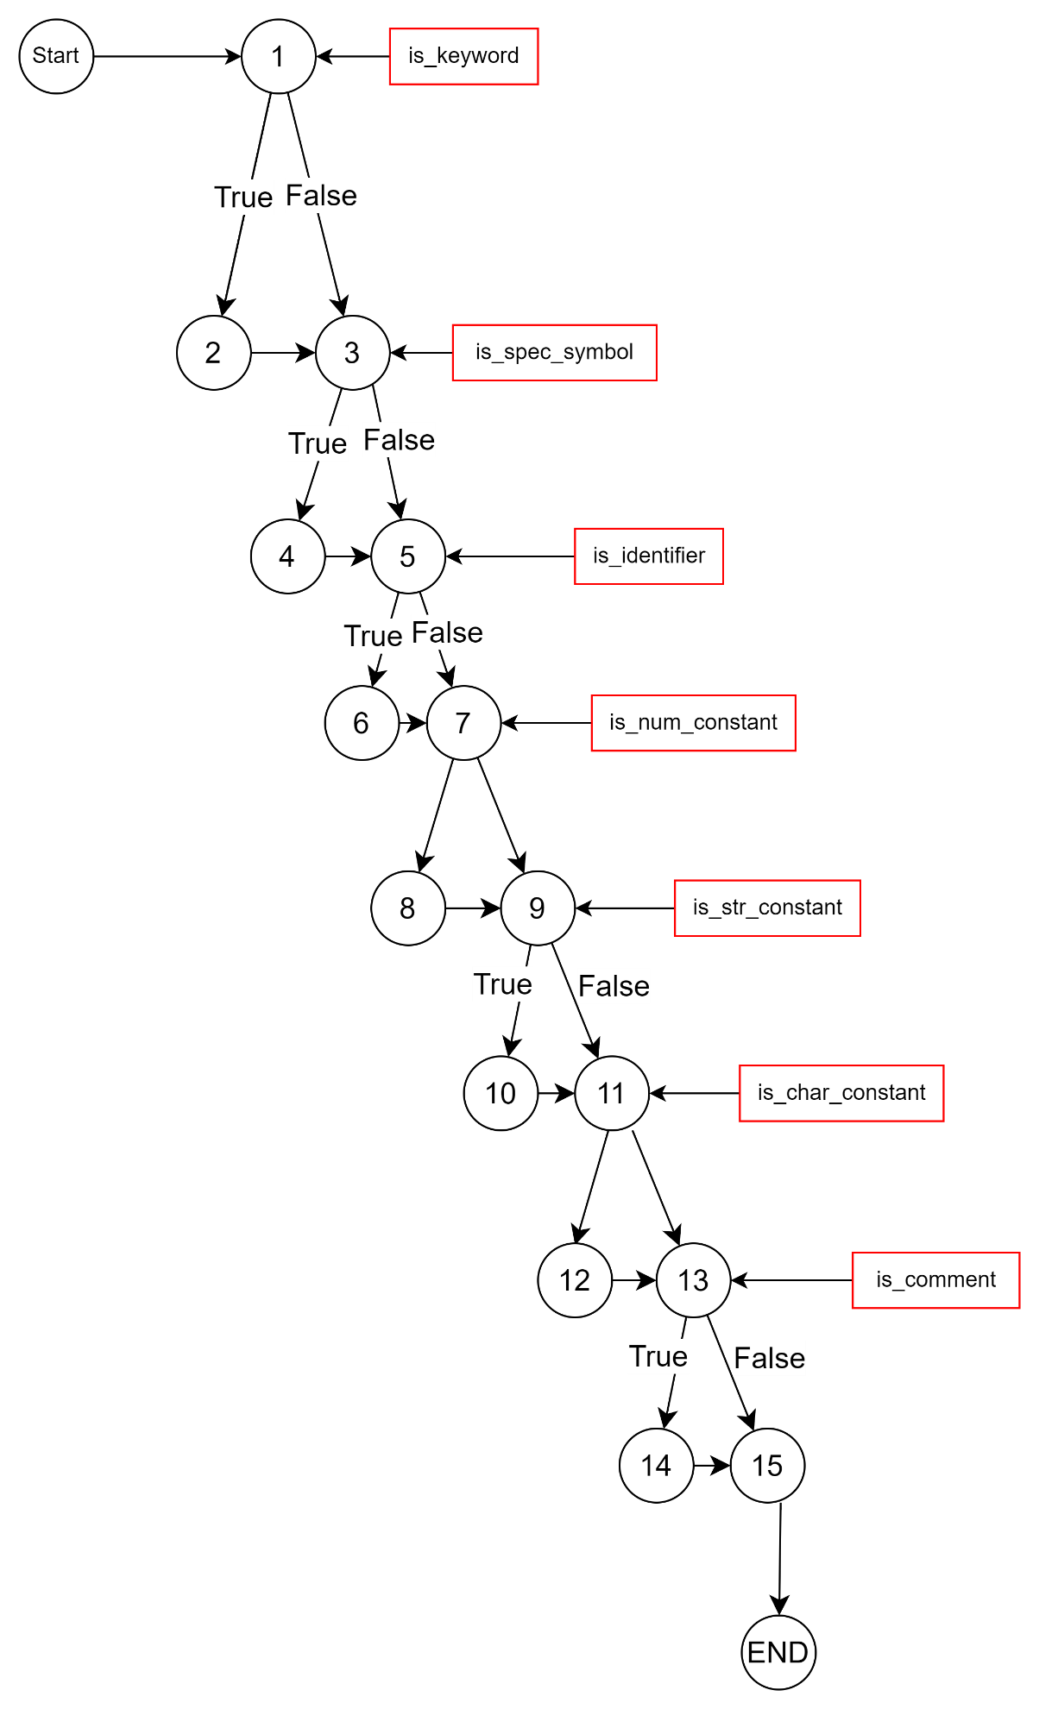
EDGE-COVERAGE
TEST PATHS:
[
(1, 3, 5, 6, 7, 8, 9, 10, 11, 12, 13, 14, 15)
(1, 2, 3, 5, 7, 9, 11, 13, 15)
]
PRINT_SPEC_SYMBOL
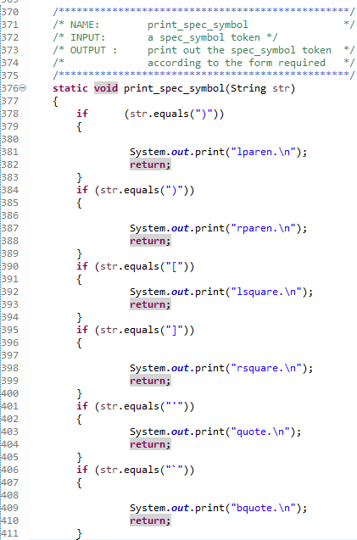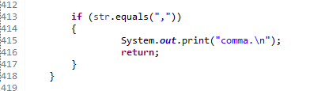
Block Number | Lines | Entry | Exit | Function Calls
1 | 378 | 378 | 378
2 | 381, 382 | 381 | 382
3 | 384 | 384 | 384
4 | 387,388 | 387 | 388
5 | 390 | 390 | 390
6 | 392, 393 | 392 | 393
7 | 395 | 395 | 395
8 | 398, 399 | 398 | 399
9 | 401 | 401 | 401
10 | 403, 404 | 403 | 404
11 | 406 | 406 | 406
12 | 409, 410 | 409 | 410
13 | 413 | 413 | 413
14 | 415, 416 | 415 | 416
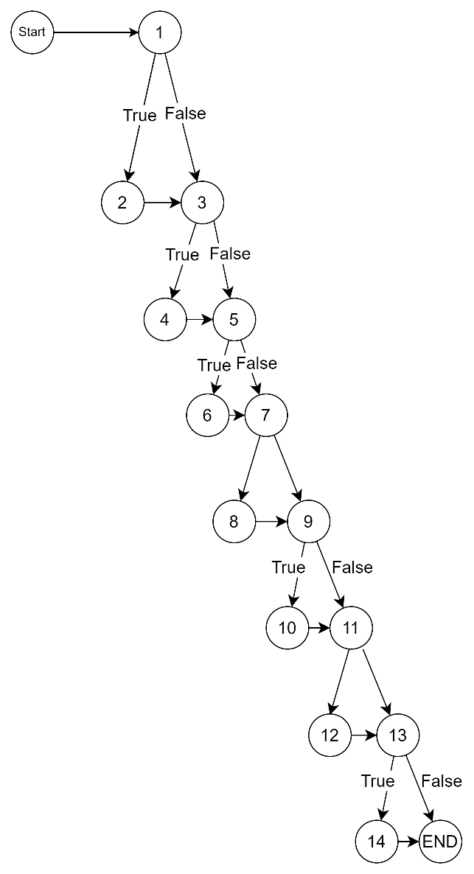
EDGE-COVERAGE
TEST PATHS:
[
(1, 3, 5, 6, 7, 8, 9, 10, 11, 12, 13, 14)
(1, 2, 3, 5, 7, 9, 11, 13)
]

IS_KEYWORD
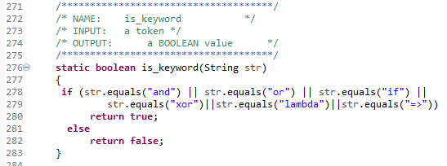

Block Number | Lines | Entry | Exit | Function Calls
1 | 278 | 278 | 278
2 | 280 | 280 | 280
3 | 282 | 282 | 282

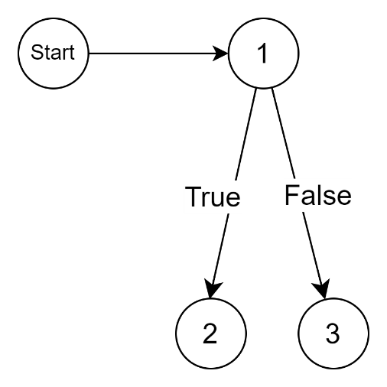

EDGE-COVERAGE
TEST PATHS:
[
(1, 2)
(1, 3)
]
IS_IDENTIFIER
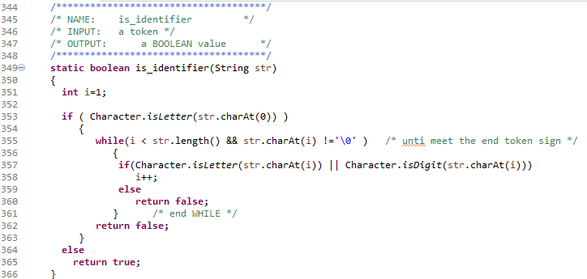
Block Number | Lines | Entry | Exit | Function Calls
1 | 351, 353 | 351 | 353
2 | 355 | 355 | 355
3 | 357 | 357 | 357
4 | 358 | 358 | 358
5 | 360 | 360 | 360
6 | 362 | 362 | 362
7 | 365 | 365 | 365
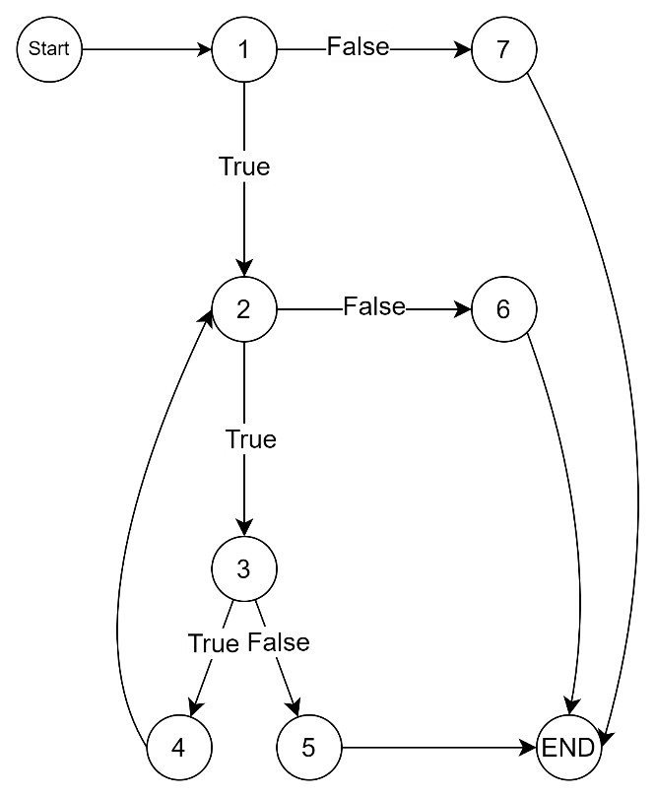
EDGE COVERAGE
TEST PATHS:
[
(1, 2, 3, 2, 6)
(1, 2, 3, 5)
(1, 7)
]

IS_STR_CONSTANT
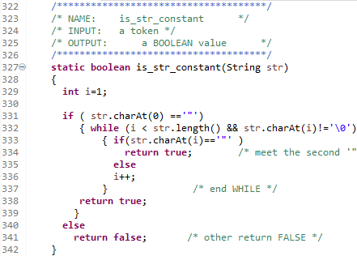
Block Number | Lines | Entry | Exit | Function Calls
1 | 329, 331 | 329 | 331
2 | 332 | 332 | 332
3 | 333 | 333 | 333
4 | 334 | 334 | 334
5 | 336 | 336 | 336
6 | 338 | 338 | 338
7 | 341 | 341 | 341
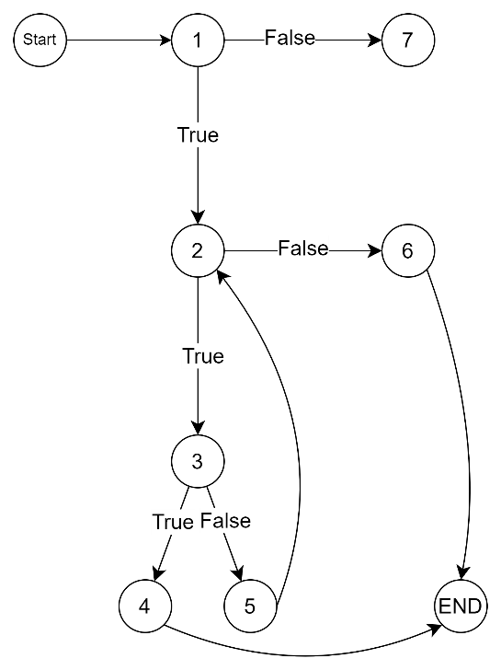
EDGE COVERAGE
TEST PATHS:
[
(1, 2, 3, 5, 2, 6)
(1, 2, 3, 4)
(1, 7)
]

IS_NUM_CONSTANT
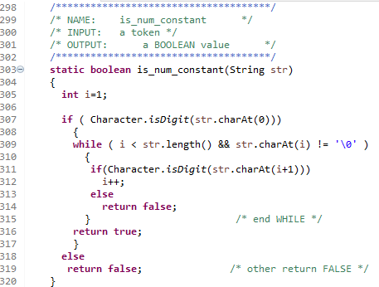
Block Number | Lines | Entry | Exit | Function Calls
1 | 305, 307 | 305 | 307
2 | 309 | 309 | 309
3 | 311 | 311 | 311
4 | 312 | 312 | 312
5 | 314 | 314 | 314
6 | 316 | 316 | 316
7 | 319 | 319 | 319
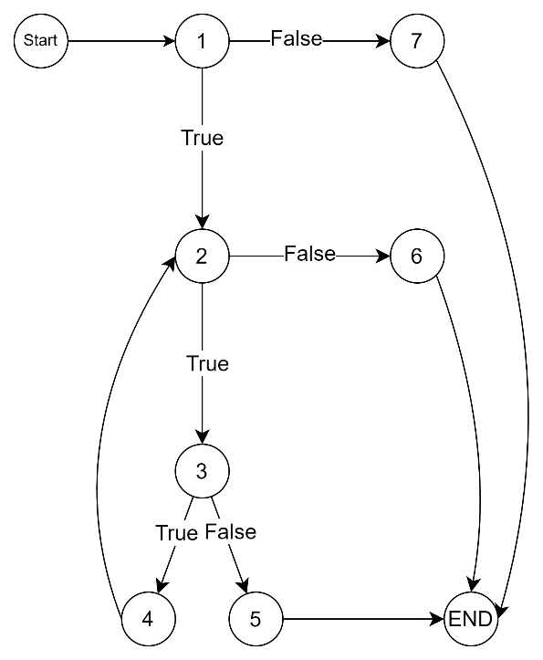
EDGE COVERAGE
TEST PATHS:
[
(1, 2, 3, 4, 2, 6)
(1, 2, 3, 5)
(1, 7)
]

IS_CHAR_CONSTANT
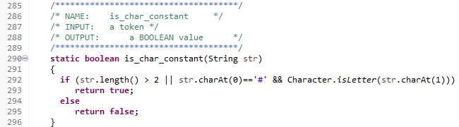
Block Number | Lines | Entry | Exit | Function Calls
1 | 292 | 292 | 292
2 | 293 | 293 | 293
3 | 295 | 295 | 295
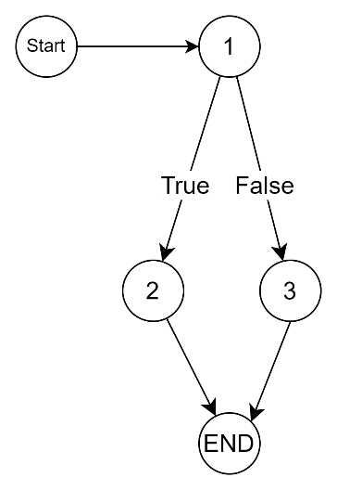
EDGE COVERAGE
TEST PATHS:
[
(1, 3)
(1, 2)
]

IS_COMMENT
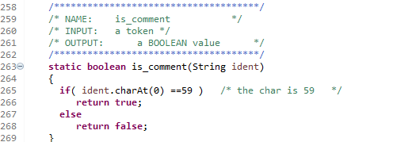
Block Number | Lines | Entry | Exit | Function Calls
1 | 265 | 265 | 265
2 | 266 | 266 | 266
3 | 268 | 268 | 268

EDGE COVERAGE
TEST PATHS:
[
(1, 3)
(1, 2)
]

