1. download SPEC2006 benchmark。Compile following the guidance

<https://www.spec.org/cpu2006/Docs/install-guide-unix.html> step 1-10

* 1. source SPEC2006/shrc 可以注册命令runspec
  2. SPEC2006/config$ cp ./Example-linux64-amd64-gcc43.cfg myconfig.cfg产生linux64 gcc43的配置文件，以备后用。
  3. Build benchmark
     1. runspec --config=myconfig.cfg --action=build --tune=base bzip2
  4. pre-run benchmark with reference workload:
     1. runspec --config=myconfig.cfg --size=ref --noreportable --tune=base –iterations=1 bzip2 在CPU2006/401.bzip2下产生run/run-base-ref-amd64-m64-gcc43-nn.0000文件夹，其中包含可执行程序，所需要的所有输入文件。

1. download pinplay-3.5
   1. 为benchmark编写config file，详见README.pinpoint。注意work directory应为482.sphinx3/run/run-base-ref-amd64-m64-gcc43-nn.0000文件夹.否则找不到相应文件。

[Parameters]

program_name: sphinx3

input_name: ref

command: "./sphinx_livepretend_base.amd64-m64-gcc43-nn ./ctlfile ./ ./args.an4"

debug: False

cutoff: 1.0

epilog_length: 0

maxk: 5

mode: st

num_proc: 1

prolog_length: 0

slice_size: 30000000

verbose: False

warmup_length: 100000

*benchmark使用方法(command)详见官网。

(1)./bzip2 ./input.source

(2)./sphinx ./ctlfile ./ ./args.an4

(3)./cactusADM ./benchADM.par

(4)./mcf ./inp.in

(5)./hmmer ./nph3.hmm ./swiss41

* 1. 使用pinplay提供的pinpoint工具生成simpoints
     1. 在makefile中实现如下
     2. python pinplay-3.5/extras/pinplay/PinPoints/scripts/brpred_pinpoints.py --delete --cfg bzip2.cfg --pinplayhome=$(pin_dir) -lrbsp –TWc

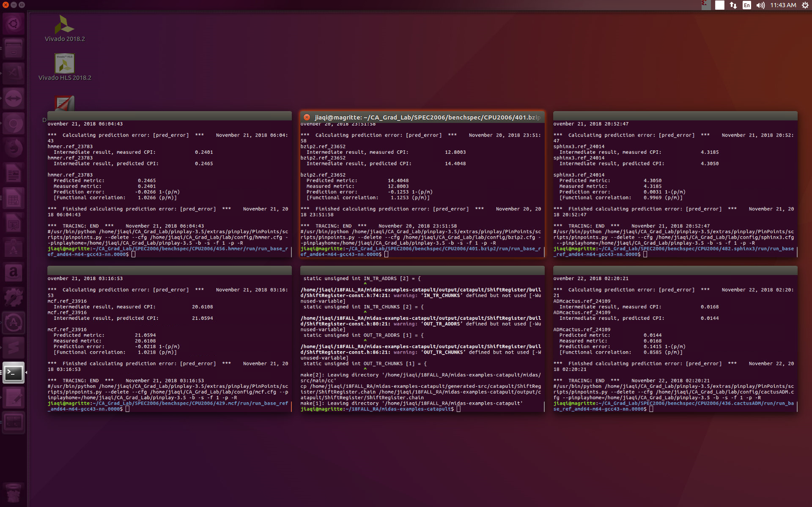

1. clone repo of ChampSim. Build simulator with CPU configuration

./build_champsim.sh ${BRANCH} ${L1D_PREFETCHER} ${L2C_PREFETCHER} ${LLC_REPLACEMENT} ${NUM_CORE}

* 1. branch prediction: bimodal
  2. L1 Data Cache : no, next_line
  3. L2 Coherent Cache: no; ip_stride
  4. LLC replacement policy : lru; drrip;srrip
  5. Core: 1
  6. /inc/cache.h中
     1. LLC set = 2048 , 8192
     2. LLC way=8, 16

1. Generate binary files in /bin

原始命令：./build_champsim.sh bimodal no no lru 1

Python： compile_champsim.py对应修改其中num_way, num_set



1. Generate tracer using Pin
   1. /tracer $ ./make_tracer.sh
      1. obj_dir = obj-intel64
      2. export PIN_ROOT = PIN_ROOT=/home/jiaqi/CA_Grad_Lab/pinplay-3.5
   2. after make tracer, the champsim_tracer.o and champsim_tracer.so is under /tracer/obj-intel64
2. Generate Traces by using pinpoints
   1. 摘取simpoint csv文件中每一个cluster的start，end。
   2. 调用自己编写的trace_gen.py，来生成traces，位于/lab/traces下
   3. 使用compress_trace.py来压缩traces –> *.gz

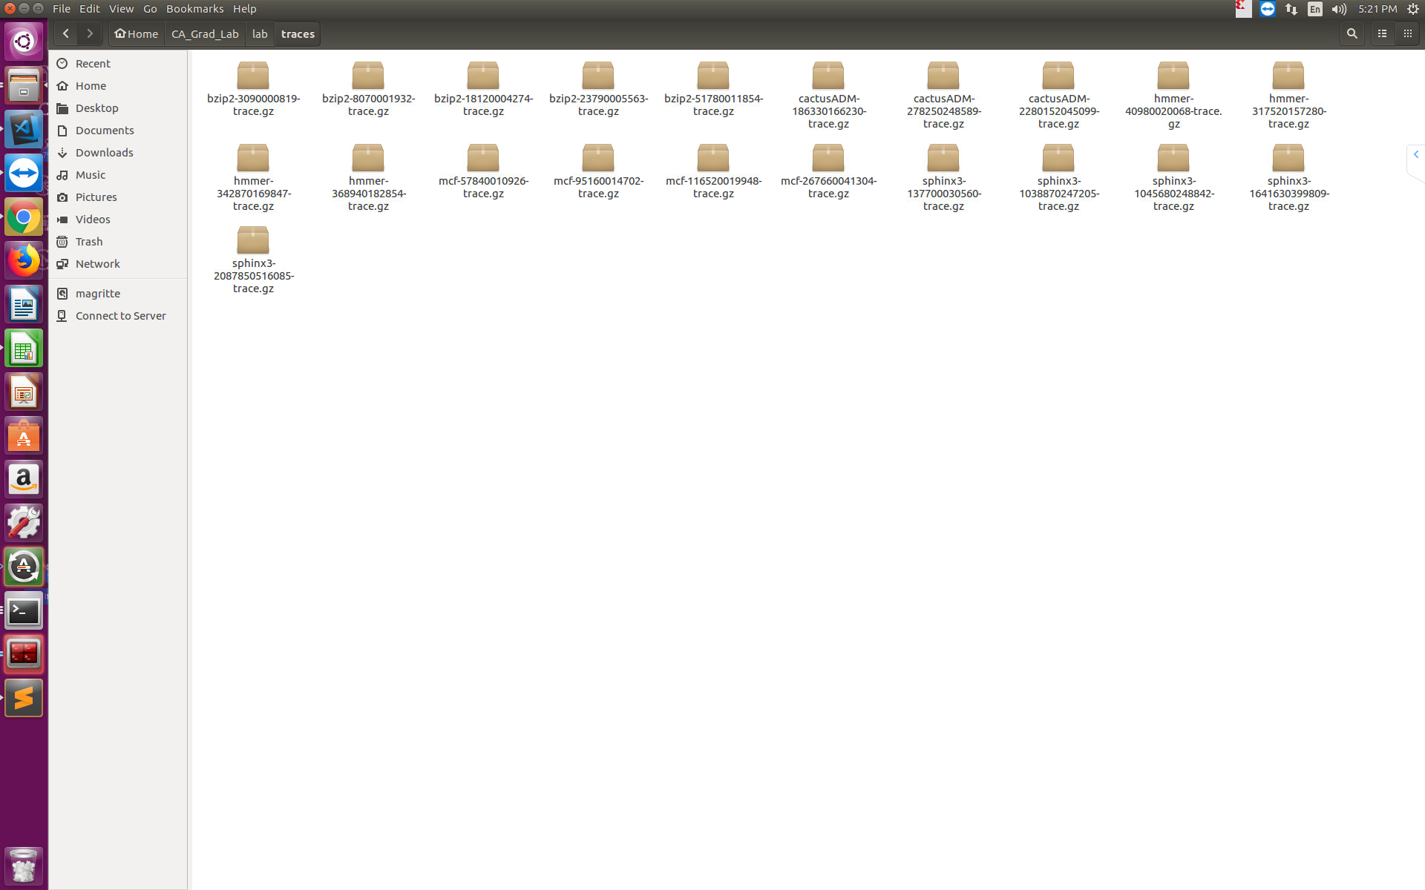

1. 使用trace和champsim进行仿真
   1. 调用run_champsim_bzip2.py来针对不同的系统配置，不同的trace进行仿真。得到result_29M/bzip2/下各种txt结果文件

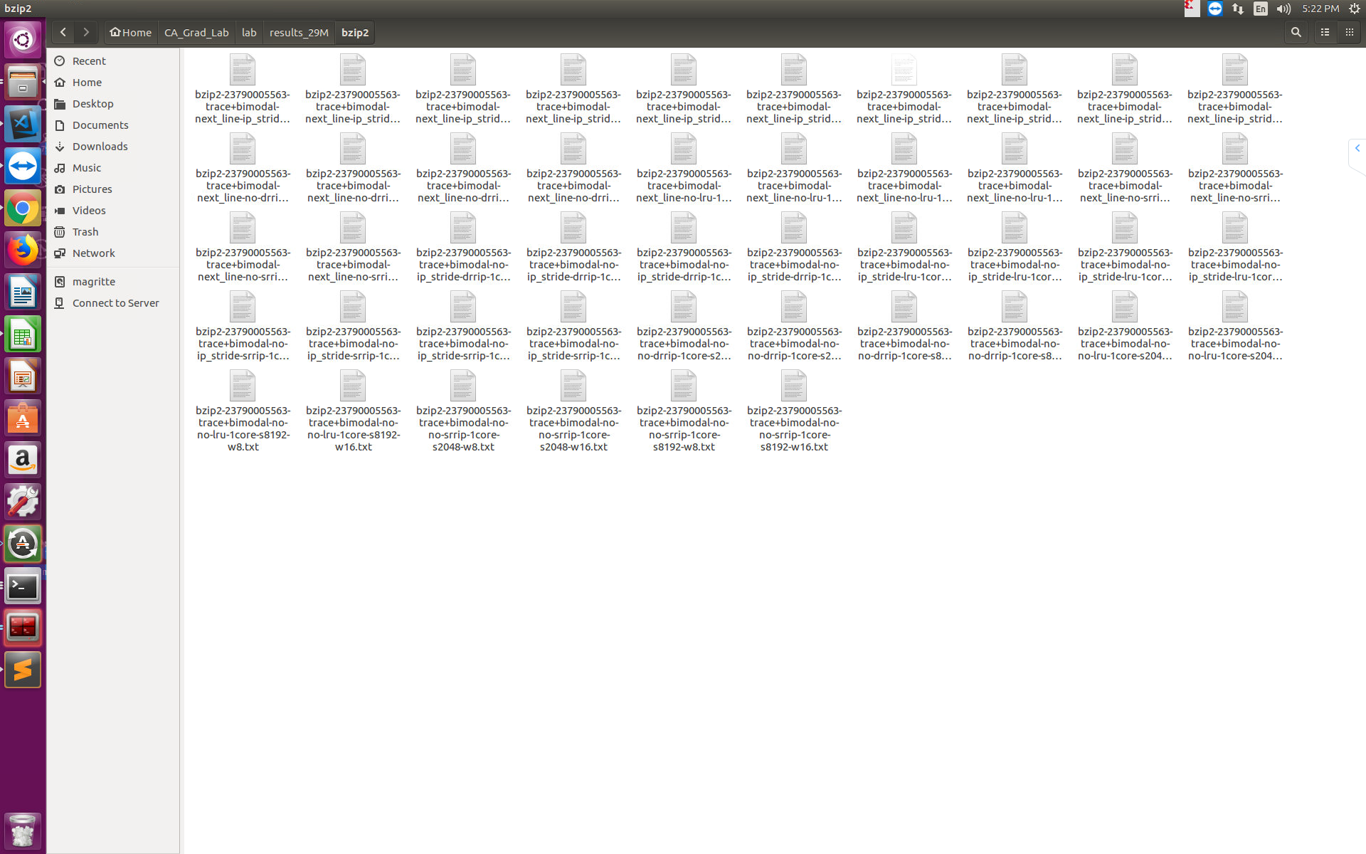

1. 收集数据进行分析
   1. Txt文件中有不同配置、不同benchmark、不同trace对应的IPC, miss rate