Exercise 6.8 — Autocatalytic Chemical Reaction (S + E → 2E)
Textbook: Sayama, Introduction to the Modeling and Analysis of Complex Systems, Section 6.5

Problem Statement
Two chemical species $S$ (substrate) and $E$ (enzyme) interact in a test tube. $E$ catalyzes its own production by consuming $S$:
$$S+E\overset{k}{→}2E$$
Build a continuous-time model for $[S](t)$ and $[E](t)$ and simulate its behavior.

Mathematical Model

Mass Action Kinetics
By the law of mass action, the rate of a reaction is proportional to the product of the reactant concentrations. For $S+E→2E$ with rate constant $k$:
$$\text{rate}=k⋅[S]⋅[E]$$
Each reaction event consumes one $S$ and produces one net $E$ (2 produced, 1 consumed). So:
$$\frac{d[S]}{dt}=−k[S][E]$$
$$\frac{d[E]}{dt}=+k[S][E]$$

Conservation Law
Adding the two equations:
$$\frac{d[S]}{dt}+\frac{d[E]}{dt}=0 ⇒ [S](t)+[E](t)=N \text{(constant)}$$
where $N=[S]_{0}+[E]_{0}$ is the total initial concentration. Total molecules are conserved — every $S$ lost becomes an $E$.

Reduction to a Single Equation
Since $[S]=N−[E]$, substitute into the $[E]$ equation:
$$\frac{d[E]}{dt}=k (N−[E]) [E]$$
This is the logistic equation with carrying capacity $N$ and growth rate $kN$. $[E]$ will grow in an S-curve from $[E]_{0}$ up to $N$ (where all substrate has been consumed), and $[S]$ mirrors it in reverse.

Equilibria and Stability
Setting both derivatives to zero: $k[S][E]=0$, which means $[S]=0$ or $[E]=0$.
Combined with the constraint $[S]+[E]=N$, there are two equilibria:
Equilibrium | $[S]^{*}$ | $[E]^{*}$ | Stability
All substrate | $N$ | $0$ | Unstable (any $E>0$ triggers growth)
All enzyme | $0$ | $N$ | Stable (reaction stops when $S$ runs out)
As long as $[E]_{0}>0$, the system always ends up at $([S]^{*},[E]^{*})=(0,N)$.
import numpy as np
import matplotlib.pyplot as plt
from scipy.integrate import solve_ivp
def model(t, state, k):
"""S + E -> 2E (mass action kinetics)"""
S, E = state
rate = k * S * E
dS = -rate
dE = +rate
return [dS, dE]
# Parameters
k = 0.5 # rate constant
S0 = 9.0 # initial substrate
E0 = 1.0 # initial enzyme
N = S0 + E0 # total concentration (conserved)
t_span = (0, 20)
t_eval = np.linspace(*t_span, 1000)
sol = solve_ivp(model, t_span, [S0, E0], args=(k,), t_eval=t_eval, rtol=1e-9)
# --- Plot 1: Time series ---
fig, ax = plt.subplots(figsize=(8, 5))
ax.plot(sol.t, sol.y[0], label='$[S](t)$ — substrate', color='steelblue', linewidth=2)
ax.plot(sol.t, sol.y[1], label='$[E](t)$ — enzyme', color='darkorange', linewidth=2)
ax.axhline(N, color='gray', linestyle=':', linewidth=1, label=f'$N = [S]_0+[E]_0 = {N}$ (conserved)')
ax.set_xlabel('Time $t$', fontsize=12)
ax.set_ylabel('Concentration', fontsize=12)
ax.set_title('Exercise 6.8 — Autocatalytic Reaction $S + E \\to 2E$\n'
f'$k={k},\\; [S]_0={S0},\\; [E]_0={E0}$', fontsize=12)
ax.legend(fontsize=11)
ax.grid(alpha=0.3)
plt.tight_layout()
plt.show()
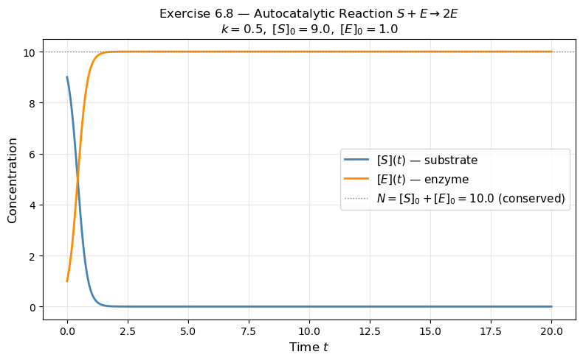
# --- Plot 2: Multiple initial conditions (varying E0) ---
fig, ax = plt.subplots(figsize=(8, 5))
E0_values = [0.1, 0.5, 1.0, 2.0, 5.0, 9.0]
colors = plt.cm.viridis(np.linspace(0.1, 0.9, len(E0_values)))
for E0_i, color in zip(E0_values, colors):
S0_i = 10.0 - E0_i # keep N = 10 fixed
sol_i = solve_ivp(model, t_span, [S0_i, E0_i], args=(k,), t_eval=t_eval, rtol=1e-9)
ax.plot(sol_i.t, sol_i.y[1], color=color, linewidth=1.8,
label=f'$[E]_0 = {E0_i}$')
ax.axhline(10, color='gray', linestyle=':', linewidth=1, label='$N = 10$ (carrying capacity)')
ax.set_xlabel('Time $t$', fontsize=12)
ax.set_ylabel('$[E](t)$', fontsize=12)
ax.set_title('$[E](t)$ for various initial conditions ($N=10$, $k=0.5$)', fontsize=12)
ax.legend(fontsize=9, ncol=2)
ax.grid(alpha=0.3)
plt.tight_layout()
plt.show()
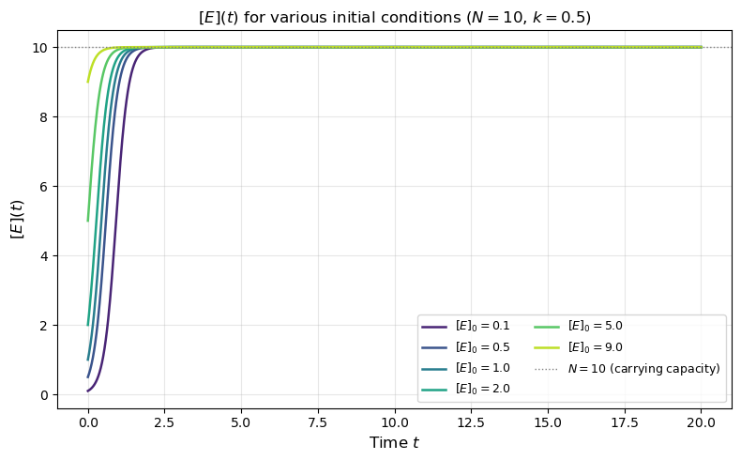
# --- Plot 3: Phase portrait on the conserved line S + E = N ---
fig, ax = plt.subplots(figsize=(7, 5))
# The entire dynamics live on the line S = N - E
E_range = np.linspace(0, N, 300)
S_range = N - E_range
dE_range = k * S_range * E_range # = k*(N-E)*E (logistic)
ax.plot(E_range, dE_range, color='steelblue', linewidth=2, label=r'$d[E]/dt = k(N-[E])[E]$')
ax.axhline(0, color='black', linewidth=0.8)
ax.axvline(0, color='gray', linewidth=0.8, linestyle='--', label='Unstable eq. $[E]^*=0$')
ax.axvline(N, color='darkorange', linewidth=0.8, linestyle='--', label=f'Stable eq. $[E]^*=N={N}$')
ax.set_xlabel('$[E]$', fontsize=12)
ax.set_ylabel('$d[E]/dt$', fontsize=12)
ax.set_title('1-D Phase Portrait (logistic reduced system)', fontsize=12)
ax.legend(fontsize=10)
ax.grid(alpha=0.3)
plt.tight_layout()
plt.show()
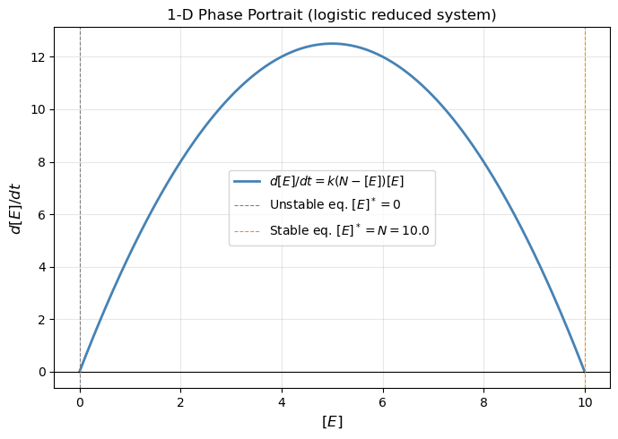

Summary
Reaction | $S+E\overset{k}{→}2E$
ODEs | $d[S]/dt=−k[S][E]$, $d[E]/dt=+k[S][E]$
Conservation law | $[S](t)+[E](t)=N=\text{const}$
Reduced form | $d[E]/dt=k(N−[E])[E]$ — logistic growth
Stable equilibrium | $([S]^{*},[E]^{*})=(0,N)$ — all substrate consumed
Unstable equilibrium | $([S]^{*},[E]^{*})=(N,0)$ — no enzyme to start the reaction
The autocatalytic reaction is self-reinforcing: more $E$ means faster conversion of $S$ into even more $E$. This positive feedback gives the characteristic logistic S-curve, identical in form to population growth with a resource limit.

