Exercise 7.16 — Commensalism Model: Equilibria and Stability
Textbook: Sayama, Introduction to the Modeling and Analysis of Complex Systems, Section 7.5

Model
$$\frac{dx}{dt} = -x + rxy - x^2 \tag{7.71}$$
$$\frac{dy}{dt} = y(1 - y) \tag{7.72}$$
$$x \geq 0, \quad y \geq 0, \quad r > 1 \tag{7.73}$$
Species $y$ follows independent logistic growth. Species $x$ benefits from $y$ (the $rxy$ term) but can't survive without it (the $−x$ term acts as decay), and self-limits via $−x^{2}$.

Part 1 — Equilibrium Points
Set both derivatives to zero.
From $dy/dt=0$:
$$y(1−y)=0 ⇒ y=0 \text{or} y=1$$
From $dx/dt=0$:
$$x(−1+ry−x)=0 ⇒ x=0 \text{or} x=ry−1$$
Combine the two cases:
$y$ | $x$ | Equilibrium | Valid?
$0$ | $0$ | $(0,0)$ | Yes
$0$ | $r(0)−1=−1$ | $(−1,0)$ | No ($x≥0$)
$1$ | $0$ | $(0,1)$ | Yes
$1$ | $r(1)−1=r−1$ | $(r−1, 1)$ | Yes (since $r>1⇒r−1>0$)
Three equilibria:
$$\boxed{(x^{*},y^{*})=(0, 0), (0, 1), (r−1, 1)}$$
The equilibrium with $x>0$ and $y>0$ is $(r−1, 1)$.

Part 2 — Jacobian at $(r−1, 1)$
The general Jacobian of the system is:
$$J(x,y)=\left[\begin{matrix}∂f/∂x & ∂f/∂y \\ ∂g/∂x & ∂g/∂y\end{matrix}\right]=\left[\begin{matrix}−1+ry−2x & rx \\ 0 & 1−2y\end{matrix}\right]$$
Evaluate at $(x^{*},y^{*})=(r−1, 1)$:
$$\frac{∂f}{∂x}|_{(r−1, 1)}=−1+r(1)−2(r−1)=−1+r−2r+2=1−r$$
$$\frac{∂f}{∂y}|_{(r−1, 1)}=r(r−1)$$
$$\frac{∂g}{∂x}|_{(r−1, 1)}=0$$
$$\frac{∂g}{∂y}|_{(r−1, 1)}=1−2(1)=−1$$
$$\boxed{J(r−1, 1)=\left[\begin{matrix}1−r & r(r−1) \\ 0 & −1\end{matrix}\right]}$$

Part 3 — Eigenvalues
$J$ is upper triangular, so the eigenvalues are just the diagonal entries:
$$\boxed{λ_{1}=1−r, λ_{2}=−1}$$
Since $r>1$: $λ_{1}=1−r<0$ and $λ_{2}=−1<0$.
Both eigenvalues are real and negative.

Part 4 — Classification
Property | Value
$λ_{1}$ | $1−r<0$
$λ_{2}$ | $−1<0$
Both real? | Yes
Both negative? | Yes
Two real, negative eigenvalues → trajectories converge to the equilibrium without oscillating.
$$\boxed{\text{Stable node (stable point)}}$$
The closer $r$ is to 1, the slower the convergence along the $λ_{1}$ direction (since $λ_{1}→0$). As $r$ increases, $λ_{1}$ becomes more negative and convergence is faster.
import numpy as np
import matplotlib.pyplot as plt
from scipy.integrate import solve_ivp
r = 2.5 # r > 1
eq_interior = (r - 1, 1.0)
lam1 = 1 - r
lam2 = -1.0
print(f"r = {r}")
print(f"Interior equilibrium: (r-1, 1) = ({r-1:.2f}, 1.00)")
print(f"Jacobian eigenvalues: λ₁ = 1-r = {lam1:.3f}, λ₂ = -1")
print(f"Both negative → Stable node")
def system(t, state):
x, y = state
dx = -x + r*x*y - x**2
dy = y * (1 - y)
return [dx, dy]
r = 2.5
Interior equilibrium: (r-1, 1) = (1.50, 1.00)
Jacobian eigenvalues: λ₁ = 1-r = -1.500, λ₂ = -1
Both negative → Stable node
# --- Phase portrait ---
fig, ax = plt.subplots(figsize=(8, 7))
x_max, y_max = r + 0.5, 1.5
# Vector field
Xg, Yg = np.meshgrid(np.linspace(0.01, x_max, 22), np.linspace(0.01, y_max, 22))
dX = -Xg + r*Xg*Yg - Xg**2
dY = Yg * (1 - Yg)
norm = np.sqrt(dX**2 + dY**2)
norm[norm == 0] = 1
ax.quiver(Xg, Yg, dX/norm, dY/norm, norm, cmap='coolwarm', alpha=0.45, scale=30)
# Nullclines
xx = np.linspace(0, x_max, 300)
yy = np.linspace(0, y_max, 300)
# dx/dt = 0: x=0 OR y = (1+x)/r
ax.axvline(0, color='steelblue', linewidth=1.5, linestyle='--', label='$dx/dt=0$: $x=0$')
ax.plot(xx, (1 + xx) / r, color='steelblue', linewidth=1.5, linestyle='--',
label=r'$dx/dt=0$: $y=(1+x)/r$')
# dy/dt = 0: y=0 OR y=1
ax.axhline(0, color='darkorange', linewidth=1.5, linestyle='--', label='$dy/dt=0$: $y=0$')
ax.axhline(1, color='darkorange', linewidth=1.5, linestyle='-', label='$dy/dt=0$: $y=1$')
# Trajectories
t_span = (0, 15)
t_eval = np.linspace(0, 15, 3000)
ics = [(0.5, 0.1), (2.0, 0.1), (0.1, 1.3), (r+0.3, 1.3),
(r+0.3, 0.5), (0.5, 1.3), (2.5, 0.8), (0.2, 0.5)]
traj_colors = plt.cm.tab10(np.linspace(0, 0.8, len(ics)))
for ic, color in zip(ics, traj_colors):
sol = solve_ivp(system, t_span, list(ic), t_eval=t_eval, rtol=1e-9)
xs = np.clip(sol.y[0], 0, x_max)
ys = np.clip(sol.y[1], 0, y_max)
ax.plot(xs, ys, color=color, linewidth=1.6, alpha=0.85)
ax.plot(ic[0], ic[1], 'o', color=color, markersize=6)
# Equilibria
for eq, label, marker in [((0,0),'$(0,0)$','s'), ((0,1),'$(0,1)$','s'),
(eq_interior, f'$({r-1:.1f}, 1)$', '*')]:
ax.plot(*eq, marker, color='black', markersize=12 if marker=='*' else 8, zorder=5)
ax.annotate(label, xy=eq, xytext=(eq[0]+0.08, eq[1]+0.07), fontsize=10)
ax.set_xlim(0, x_max)
ax.set_ylim(0, y_max)
ax.set_xlabel('$x$', fontsize=13)
ax.set_ylabel('$y$', fontsize=13)
ax.set_title(f'Exercise 7.16 — Commensalism Phase Portrait ($r={r}$)\n'
f'Interior eq. $({r-1:.1f}, 1)$: stable node '
f'($\\lambda_1={lam1:.2f}$, $\\lambda_2={lam2:.2f}$)', fontsize=11)
ax.legend(fontsize=9, loc='upper right')
ax.grid(alpha=0.25)
plt.tight_layout()
plt.show()
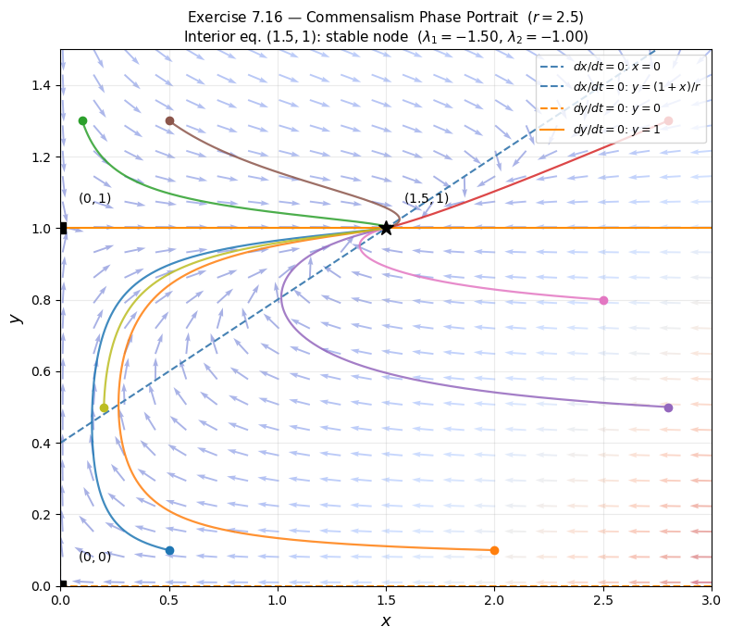
# --- Eigenvalue dependence on r ---
r_vals = np.linspace(1.01, 5, 200)
lam1_vals = 1 - r_vals
lam2_vals = np.full_like(r_vals, -1.0)
fig, ax = plt.subplots(figsize=(7, 4))
ax.plot(r_vals, lam1_vals, label=r'$\lambda_1 = 1 - r$', color='steelblue', linewidth=2)
ax.plot(r_vals, lam2_vals, label=r'$\lambda_2 = -1$', color='darkorange', linewidth=2, linestyle='--')
ax.axhline(0, color='black', linewidth=0.8)
ax.axvline(r, color='gray', linewidth=1, linestyle=':', label=f'$r={r}$ (used above)')
ax.fill_between(r_vals, lam1_vals, 0, where=(lam1_vals < 0), alpha=0.1, color='steelblue')
ax.set_xlabel('$r$', fontsize=12)
ax.set_ylabel('Eigenvalue', fontsize=12)
ax.set_title('Eigenvalues at $(r-1, 1)$ as a function of $r$\n(Both always negative for $r > 1$ → always stable node)', fontsize=11)
ax.legend(fontsize=10)
ax.grid(alpha=0.3)
plt.tight_layout()
plt.show()
