Exercise 7.5 — Phase Space of the SI Model (SIR without R)
Textbook: Sayama, Introduction to the Modeling and Analysis of Complex Systems, Section 7.2

Model
$$\frac{dS}{dt} = -aSI \tag{7.22}$$
$$\frac{dI}{dt} = aSI - bI \tag{7.23}$$
$$S \geq 0, \quad I \geq 0, \quad a > 0, \quad b > 0 \tag{7.24}$$
$S$ = susceptible population, $I$ = infected population, $a$ = infection rate, $b$ = recovery rate.

Step 1 — Nullclines
$S$-nullclines ($dS/dt=0$):
$$−aSI=0 ⇒ S=0 \text{or} I=0$$
$I$-nullclines ($dI/dt=0$):
$$aSI−bI=I(aS−b)=0 ⇒ I=0 \text{or} S=\frac{b}{a}$$
So there are three nullcline curves in the $(S,I)$ plane:
Curve | Type | Meaning
$I=0$ | Both $S$- and $I$-nullcline | The $S$-axis — no infected individuals
$S=0$ | $S$-nullcline | The $I$-axis — no susceptibles left
$S=b/a$ | $I$-nullcline | Epidemic threshold — infections neither grow nor shrink
The vertical line $S=b/a$ is the key threshold: it is often written as $S=1/R_{0}$ where $R_{0}=aS_{0}/b$ is the basic reproduction number.

Step 2 — Direction of Flow in Each Region
The nullclines $I=0$ and $S=b/a$ divide the first quadrant into two regions:
Region 1: $S>b/a$, $I>0$
- $dS/dt=−aSI<0$ → $S$ is decreasing
- $dI/dt=I(aS−b)>0$ → $I$ is increasing (since $aS>b$)
- Flow direction: left and up (epidemic growing)
Region 2: $0<S<b/a$, $I>0$
- $dS/dt=−aSI<0$ → $S$ is decreasing
- $dI/dt=I(aS−b)<0$ → $I$ is decreasing (since $aS<b$)
- Flow direction: left and down (epidemic dying out)
Key insight: Whether $I$ ever rises or only falls depends entirely on whether the initial susceptible population $S_{0}$ is above or below the threshold $b/a$.

Step 3 — Equilibria
Setting both derivatives to zero simultaneously: the only solutions are points where $I=0$ (and $S$ is anything $≥0$). So every point on the $S$-axis is an equilibrium. There are no interior equilibria — the infection either burns through the population or dies out, always landing back on the $S$-axis with $I=0$ and some remaining susceptibles $S^{*}∈(0,S_{0})$.
import numpy as np
import matplotlib.pyplot as plt
from scipy.integrate import solve_ivp
# Parameters
a = 0.3 # infection rate
b = 0.1 # recovery rate
threshold = b / a # S = b/a (epidemic threshold)
def model(t, state):
S, I = state
dS = -a * S * I
dI = a * S * I - b * I
return [dS, dI]
print(f"Epidemic threshold S = b/a = {threshold:.3f}")
print(f"Epidemics grow when S₀ > {threshold:.3f}, decline immediately when S₀ < {threshold:.3f}")
Epidemic threshold S = b/a = 0.333
Epidemics grow when S₀ > 0.333, decline immediately when S₀ < 0.333
# --- Phase portrait with nullclines, vector field, and trajectories ---
fig, ax = plt.subplots(figsize=(8, 7))
S_max, I_max = 1.2, 0.6
# --- Vector field ---
Sg, Ig = np.meshgrid(np.linspace(0.01, S_max, 20), np.linspace(0.001, I_max, 20))
dS = -a * Sg * Ig
dI = a * Sg * Ig - b * Ig
norm = np.sqrt(dS**2 + dI**2)
norm[norm == 0] = 1
ax.quiver(Sg, Ig, dS / norm, dI / norm, norm, cmap='coolwarm', alpha=0.45, scale=30)
# --- Nullclines ---
# I = 0 is the S-axis (both nullclines)
ax.axhline(0, color='black', linewidth=1.5, linestyle='-', label='$I = 0$ (both nullclines)')
# S = 0 is the I-axis (S-nullcline)
ax.axvline(0, color='steelblue', linewidth=1.5, linestyle='--', label='$S = 0$ ($dS/dt=0$ nullcline)')
# S = b/a (I-nullcline)
ax.axvline(threshold, color='darkorange', linewidth=2, linestyle='--',
label=f'$S = b/a = {threshold:.2f}$ ($dI/dt=0$ nullcline)')
# --- Region labels ---
ax.text(0.75, 0.35, 'Region 1\n$S > b/a$\n$\\uparrow I$, $\\leftarrow S$',
fontsize=10, ha='center', color='firebrick',
bbox=dict(boxstyle='round,pad=0.3', facecolor='mistyrose', alpha=0.7))
ax.text(0.2, 0.35, 'Region 2\n$S < b/a$\n$\\downarrow I$, $\\leftarrow S$',
fontsize=10, ha='center', color='navy',
bbox=dict(boxstyle='round,pad=0.3', facecolor='aliceblue', alpha=0.7))
# --- Trajectories ---
t_span = (0, 80)
t_eval = np.linspace(0, 80, 5000)
initial_conditions = [
(1.0, 0.01), # S0 >> threshold → big epidemic
(0.7, 0.01), # S0 > threshold → moderate epidemic
(0.5, 0.01), # S0 > threshold → small epidemic
(0.25, 0.05), # S0 < threshold → immediate decline
(0.1, 0.2), # well below threshold
]
traj_colors = ['firebrick', 'tomato', 'darkorange', 'steelblue', 'navy']
for (S0, I0), color in zip(initial_conditions, traj_colors):
sol = solve_ivp(model, t_span, [S0, I0], t_eval=t_eval, rtol=1e-9, atol=1e-11)
ax.plot(sol.y[0], sol.y[1], color=color, linewidth=1.8, alpha=0.85)
ax.plot(S0, I0, 'o', color=color, markersize=7)
# arrow at ~25% along
idx = len(sol.t) // 4
ax.annotate('', xy=(sol.y[0][idx+5], sol.y[1][idx+5]),
xytext=(sol.y[0][idx], sol.y[1][idx]),
arrowprops=dict(arrowstyle='->', color=color, lw=1.5))
ax.set_xlim(0, S_max)
ax.set_ylim(0, I_max)
ax.set_xlabel('$S$ (susceptible)', fontsize=13)
ax.set_ylabel('$I$ (infected)', fontsize=13)
ax.set_title('Exercise 7.5 — SI Phase Portrait\n'
f'$a={a}$, $b={b}$, threshold $S=b/a={threshold:.2f}$', fontsize=12)
ax.legend(fontsize=10, loc='upper right')
ax.grid(alpha=0.25)
plt.tight_layout()
plt.show()
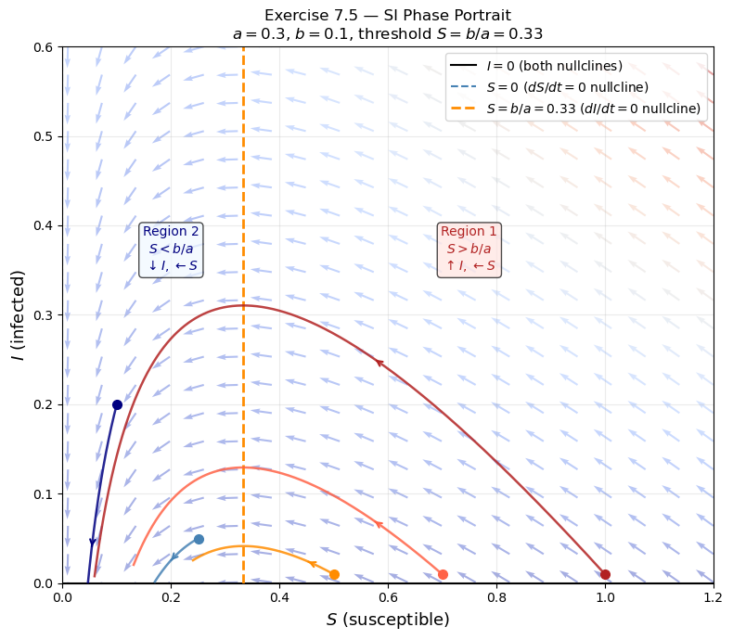
# --- Time series for two contrasting cases ---
fig, axes = plt.subplots(1, 2, figsize=(11, 4), sharey=False)
cases = [(1.0, 0.01, 'Epidemic: $S_0 = 1.0 > b/a$'), (0.2, 0.05, 'No epidemic: $S_0 = 0.2 < b/a$')]
for ax, (S0, I0, title) in zip(axes, cases):
sol = solve_ivp(model, t_span, [S0, I0], t_eval=t_eval, rtol=1e-9)
ax.plot(sol.t, sol.y[0], label='$S(t)$', color='steelblue', linewidth=2)
ax.plot(sol.t, sol.y[1], label='$I(t)$', color='firebrick', linewidth=2)
ax.axhline(threshold, color='darkorange', linestyle='--', linewidth=1,
label=f'$b/a = {threshold:.2f}$')
ax.set_title(title, fontsize=11)
ax.set_xlabel('Time $t$', fontsize=11)
ax.legend(fontsize=10)
ax.grid(alpha=0.3)
fig.suptitle('Time Series — SI Model', fontsize=13)
plt.tight_layout()
plt.show()
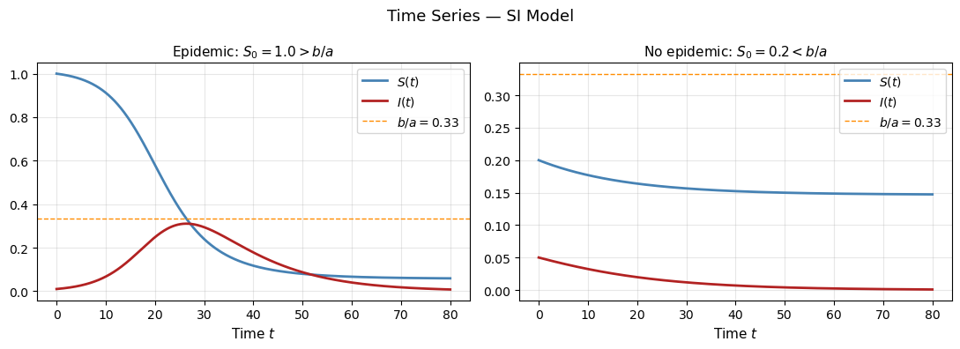

Summary
$S$-nullclines | $S=0$ and $I=0$
$I$-nullclines | $I=0$ and $S=b/a$
Equilibria | Every point $(S^{*},0)$, $S^{*}≥0$ — the entire $S$-axis
Region $S>b/a$, $I>0$ | $I$ rises, $S$ falls → epidemic grows then turns over
Region $S<b/a$, $I>0$ | Both $I$ and $S$ fall → epidemic immediately dies out
Epidemic threshold | $S_{0}>b/a$ is required for an outbreak; equivalently $R_{0}=aS_{0}/b>1$
All trajectories curve leftward (S always decreasing whenever I > 0) and eventually land on the S-axis with some susceptibles still remaining — the epidemic runs out of steam before infecting everyone.

