PDE-Based Predator–Prey Model with Spatial Taxis and Diffusion

What Is a PDE Model?
An ordinary differential equation (ODE) model treats the population as a single well-mixed number that changes over time: $u=u(t)$. A partial differential equation (PDE) model extends this by letting the population vary across both space and time: $u=u(x,y,t)$. The governing equations then involve partial derivatives with respect to both space and time.
A spatial PDE model can capture three fundamental processes that an ODE cannot:
Process | Mathematical form | Physical meaning
Diffusion | $D ∇^{2}u$ | Random movement smooths out density differences
Taxis | $±χ ∇⋅(u ∇v)$ | Directed movement up or down a gradient
Reaction | $f(u,v)$ | Local births, deaths, and interactions
A PDE model requires:
- Initial conditions — the spatial distribution $u(x,y,0)$ and $v(x,y,0)$
- Boundary conditions — what happens at the edges of the domain (here: zero-flux, meaning no individuals leave or enter)

The Mathematical Model
Let $u(x,y,t)$ = prey density and $v(x,y,t)$ = predator density on a 2D domain $Ω$.
Prey ($u$):
$$\frac{∂u}{∂t}=\underset{\text{random diffusion}}{\underset{⏟}{D_{u} ∇^{2}u}}+\underset{\text{flight from predators}}{\underset{⏟}{χ_{u} ∇⋅(u ∇v)}}+\underset{\text{logistic growth}}{\underset{⏟}{r u​\left(1−\frac{u}{K}\right)}}−\underset{\text{predation loss}}{\underset{⏟}{α u v}}$$
Predator ($v$):
$$\frac{∂v}{∂t}=\underset{\text{random diffusion}}{\underset{⏟}{D_{v} ∇^{2}v}}−\underset{\text{chase toward prey}}{\underset{⏟}{χ_{v} ∇⋅(v ∇u)}}+\underset{\text{predation gain}}{\underset{⏟}{β u v}}−\underset{\text{natural decay}}{\underset{⏟}{δ v}}$$
Taxis term derivation. Each population has a flux $J$ that combines random diffusion with directed movement. For prey fleeing predators, the taxis flux is $−χ_{u}u ∇v$ (movement against the predator gradient). By conservation of mass ($∂_{t}u=−∇⋅J_{u}+\text{reaction}$), the taxis contribution becomes $+χ_{u} ∇⋅(u ∇v)$. Expanding: $∇⋅(u ∇v)=u ∇^{2}v+∇u⋅∇v$. At a predator peak $∇^{2}v<0$, so this term is negative — prey density decreases where predators are concentrated. The predator taxis follows analogously with opposite sign.
Boundary conditions (zero-flux Neumann):
$$\frac{∂u}{∂n}|_{∂Ω}=\frac{∂v}{∂n}|_{∂Ω}=0$$
Coexistence equilibrium (from ODE kinetics, uniform in space):
$$u^{*}=\frac{δ}{β}, v^{*}=\frac{r}{α}​\left(1−\frac{u^{*}}{K}\right)$$
import numpy as np
import matplotlib.pyplot as plt
from scipy.integrate import solve_ivp
# ── Biological parameters ─────────────────────────────────────────────────
r = 1.0 # prey intrinsic growth rate
K = 1.0 # prey carrying capacity
alpha = 0.8 # predation rate
beta = 0.5 # predator conversion efficiency
delta = 0.2 # predator natural death rate
# ── Spatial movement parameters ───────────────────────────────────────────
D_u = 0.05 # prey random diffusion
D_v = 0.05 # predator random diffusion
chi_u = 1.0 # prey repulsion from predators (taxis sensitivity)
chi_v = 1.0 # predator attraction to prey (taxis sensitivity)
# ── Numerical grid ────────────────────────────────────────────────────────
N = 64 # grid points per side (N×N)
L = 20.0 # domain side length
dx = L / N # spatial step ≈ 0.3125
# ── Time integration ──────────────────────────────────────────────────────
dt = 0.005
T = 40.0
n_steps = int(T / dt) # 8 000 steps
# ── Coexistence equilibrium ───────────────────────────────────────────────
u_star = delta / beta
v_star = r * (1 - u_star / K) / alpha
print(f"Coexistence equilibrium: u* = {u_star:.4f}, v* = {v_star:.4f}")
print(f"Grid: {N}x{N}, dx = {dx:.4f}, dt = {dt}, T = {T}")
print(f"Stability margin (taxis/diffusion): χu·v* = {chi_u*v_star:.3f} vs Du = {D_u}")
Coexistence equilibrium: u* = 0.4000, v* = 0.7500
Grid: 64x64, dx = 0.3125, dt = 0.005, T = 40.0
Stability margin (taxis/diffusion): χu·v* = 0.750 vs Du = 0.05
# ── ODE kinetics: phase plane (no spatial terms) ──────────────────────────
# Before adding space, it's useful to understand the local (ODE) dynamics.
# The PDE reaction terms are identical to this ODE system at every point in space.
def ode_rhs(t, y):
u, v = y
return [r*u*(1 - u/K) - alpha*u*v,
beta*u*v - delta*v]
u_range = np.linspace(0, 1.3*K, 300)
# Nullclines
v_nullcline_u = r * (1 - u_range / K) / alpha # du/dt = 0 (non-trivial)
u_nullcline_v = delta / beta # dv/dt = 0 (vertical)
fig, ax = plt.subplots(figsize=(6.5, 5))
ax.plot(u_range, v_nullcline_u, 'steelblue', lw=2.2, label='Prey nullcline $du/dt = 0$')
ax.axvline(u_nullcline_v, color='tomato', lw=2.2, label='Predator nullcline $dv/dt = 0$')
ax.axhline(0, color='tomato', lw=1.5, alpha=0.4)
# Several phase-plane trajectories
for u0, v0 in [(0.1, 0.1), (0.9, 0.1), (0.1, 1.3), (0.7, 1.1), (0.5, 0.3)]:
sol = solve_ivp(ode_rhs, [0, 60], [u0, v0], max_step=0.05, dense_output=True)
xy = sol.sol(np.linspace(0, 60, 2000))
ax.plot(xy[0], xy[1], 'k', lw=0.7, alpha=0.45)
ax.plot(u_star, v_star, 'o', ms=11, color='limegreen', zorder=6,
label=f'Coexistence $(u^*, v^*) = ({u_star:.2f},\ {v_star:.2f})$')
ax.set_xlabel('Prey density $u$', fontsize=12)
ax.set_ylabel('Predator density $v$', fontsize=12)
ax.set_title('ODE kinetics — phase plane (no spatial effects)', fontsize=12)
ax.set_xlim(0, 1.25)
ax.set_ylim(0, 1.7)
ax.legend(fontsize=9)
plt.tight_layout()
plt.show()
print("All trajectories converge to the coexistence equilibrium — it is a stable spiral.")
print("Spatial taxis can destabilize this uniform state and generate patterns.")
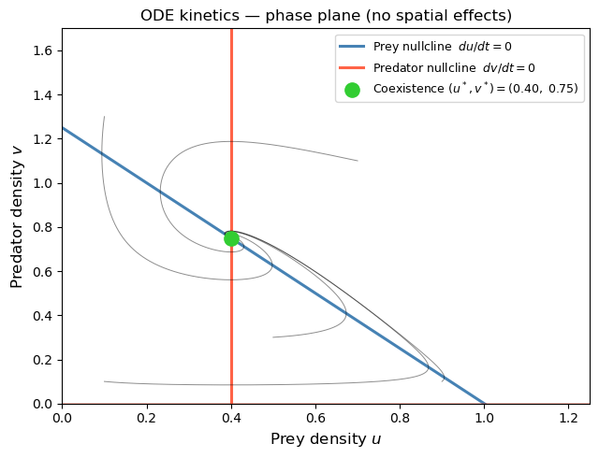
All trajectories converge to the coexistence equilibrium — it is a stable spiral.
Spatial taxis can destabilize this uniform state and generate patterns.
# ── PDE spatial operators ─────────────────────────────────────────────────
# All functions use zero-flux (Neumann) BCs implemented via edge-padding:
# ghost cells equal the nearest interior cell, so ∂f/∂n = 0 at boundaries.
def laplacian_2d(f, dx):
"""Standard 5-point Laplacian with zero-flux boundary conditions."""
fp = np.pad(f, 1, mode='edge')
return (fp[2:, 1:-1] + fp[:-2, 1:-1] +
fp[1:-1, 2:] + fp[1:-1, :-2] - 4*fp[1:-1, 1:-1]) / dx**2
def taxis_div_2d(phi, psi, dx):
"""
Conservative finite-volume discretization of ∇·(φ ∇ψ)
with zero-flux boundary conditions.
Strategy: compute fluxes at cell faces using face-averaged φ and
one-sided ∂ψ/∂x (or ∂y) across the face, then take the divergence
as the difference of fluxes across opposite faces.
"""
phip = np.pad(phi, 1, mode='edge') # (N+2) × (N+2)
psip = np.pad(psi, 1, mode='edge')
# ── x-direction faces: shape N × (N+1) ──────────────────────────────
phi_fx = (phip[1:-1, :-1] + phip[1:-1, 1:]) / 2 # avg φ at x-face
dpsi_fx = (psip[1:-1, 1:] - psip[1:-1, :-1]) / dx # ∂ψ/∂x at face
Fx = phi_fx * dpsi_fx # face flux
# ── y-direction faces: shape (N+1) × N ──────────────────────────────
phi_fy = (phip[:-1, 1:-1] + phip[1:, 1:-1]) / 2 # avg φ at y-face
dpsi_fy = (psip[1:, 1:-1] - psip[:-1, 1:-1]) / dx # ∂ψ/∂y at face
Fy = phi_fy * dpsi_fy
# ── Divergence = (east flux − west flux)/dx + (north − south)/dx ────
return (Fx[:, 1:] - Fx[:, :-1]) / dx + (Fy[1:, :] - Fy[:-1, :]) / dx
def pde_rhs(u, v):
"""Compute du/dt and dv/dt for the full PDE system at one instant."""
lap_u = laplacian_2d(u, dx)
lap_v = laplacian_2d(v, dx)
div_uv = taxis_div_2d(u, v, dx) # ∇·(u ∇v) — used in prey equation
div_vu = taxis_div_2d(v, u, dx) # ∇·(v ∇u) — used in predator equation
du = D_u*lap_u + chi_u*div_uv + r*u*(1 - u/K) - alpha*u*v
dv = D_v*lap_v - chi_v*div_vu + beta*u*v - delta*v
return du, dv
print("Spatial operators defined.")
print(f"Zero-flux BCs confirmed: boundary face fluxes = 0 by construction (edge padding).")
Spatial operators defined.
Zero-flux BCs confirmed: boundary face fluxes = 0 by construction (edge padding).
# ── Initial conditions and explicit-Euler time integration ────────────────
# Start near the spatially uniform coexistence equilibrium (u*, v*) with
# small random perturbations (5 %). Any spatial structure that emerges is
# driven entirely by the taxis and diffusion terms — not by the initial data.
np.random.seed(7)
u = u_star * (1 + 0.05 * np.random.randn(N, N))
v = v_star * (1 + 0.05 * np.random.randn(N, N))
u = np.clip(u, 1e-4, 2*K)
v = np.clip(v, 1e-4, None)
# Snapshot schedule: save at t = 0, 10, 20, 30, 40
save_steps = {int(t / dt) for t in [10, 20, 30, 40]}
snaps_u = [u.copy()]
snaps_v = [v.copy()]
snap_t = [0.0]
# Track spatially averaged densities every ~0.2 time units
track_every = max(1, n_steps // 200)
U_mean = [u.mean()]
V_mean = [v.mean()]
t_mean = [0.0]
print("Running PDE simulation (explicit Euler)...")
for step in range(n_steps):
du, dv = pde_rhs(u, v)
u = np.clip(u + dt * du, 1e-6, 3*K) # non-negativity safeguard
v = np.clip(v + dt * dv, 1e-6, None)
if step + 1 in save_steps:
snaps_u.append(u.copy())
snaps_v.append(v.copy())
snap_t.append((step + 1) * dt)
if (step + 1) % track_every == 0:
U_mean.append(u.mean())
V_mean.append(v.mean())
t_mean.append((step + 1) * dt)
print(f"Done. Final mean densities: u = {u.mean():.4f} (u* = {u_star:.4f})"
f", v = {v.mean():.4f} (v* = {v_star:.4f})")
Running PDE simulation (explicit Euler)...
Done. Final mean densities: u = 0.3999 (u* = 0.4000), v = 0.7307 (v* = 0.7500)
# ── Spatial pattern snapshots ─────────────────────────────────────────────
# Top row: prey density u(x,y,t). Bottom row: predator density v(x,y,t).
# Colour scales are fixed across time for direct comparison.
u_vmax = max(s.max() for s in snaps_u)
v_vmax = max(s.max() for s in snaps_v)
n_snaps = len(snaps_u)
fig, axes = plt.subplots(2, n_snaps, figsize=(3.2 * n_snaps, 6.4))
for col, (su, sv, t) in enumerate(zip(snaps_u, snaps_v, snap_t)):
# Prey row
im1 = axes[0, col].imshow(
su, cmap='YlGn', origin='lower', extent=[0, L, 0, L],
vmin=0, vmax=u_vmax, interpolation='nearest')
axes[0, col].set_title(f'$t = {t:.0f}$', fontsize=11)
if col == 0:
axes[0, col].set_ylabel('Prey $u$', fontsize=11)
else:
axes[0, col].set_yticks([])
axes[0, col].set_xticks([])
plt.colorbar(im1, ax=axes[0, col], fraction=0.046, pad=0.03)
# Predator row
im2 = axes[1, col].imshow(
sv, cmap='OrRd', origin='lower', extent=[0, L, 0, L],
vmin=0, vmax=v_vmax, interpolation='nearest')
if col == 0:
axes[1, col].set_ylabel('Predator $v$', fontsize=11)
else:
axes[1, col].set_yticks([])
axes[1, col].set_xticks([])
plt.colorbar(im2, ax=axes[1, col], fraction=0.046, pad=0.03)
fig.suptitle(
f'Spatial distribution of prey (top) and predator (bottom)\n'
f'$D_u = D_v = {D_u}$, $\\chi_u = \\chi_v = {chi_u}$, '
f'$r={r}$, $\\alpha={alpha}$, $\\beta={beta}$, $\\delta={delta}$',
fontsize=11, y=1.01
)
plt.tight_layout()
plt.show()
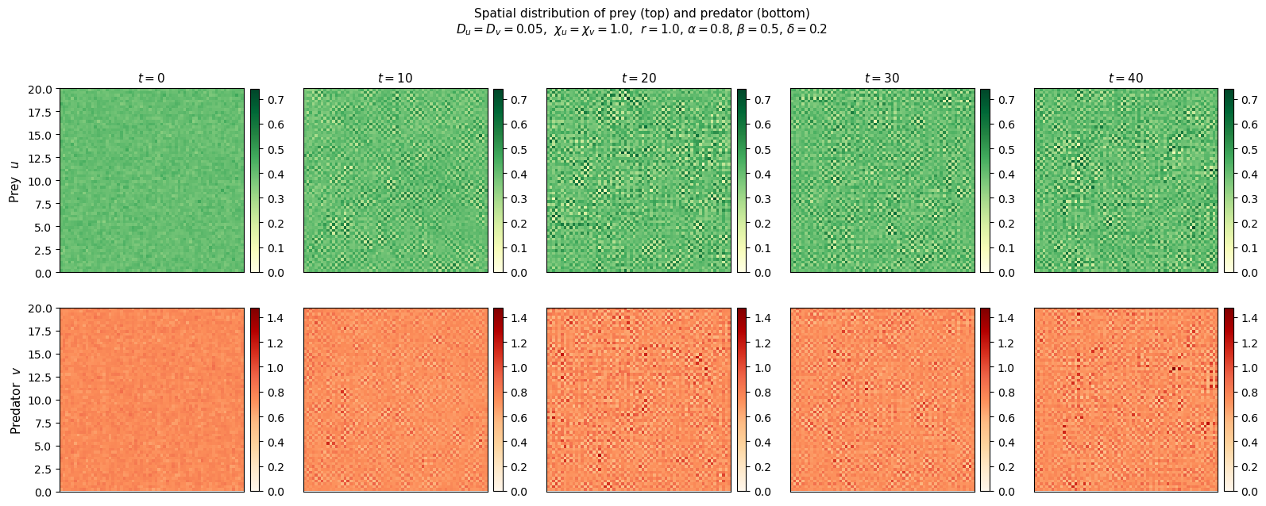
# ── Population dynamics and spatial heterogeneity over time ──────────────
# Left: spatially averaged densities track the ODE equilibrium.
# Right: spatial standard deviation measures how heterogeneous the field is
# — a rising std-dev is the signature of pattern formation.
snap_std_u = [np.std(s) for s in snaps_u]
snap_std_v = [np.std(s) for s in snaps_v]
fig, (ax1, ax2) = plt.subplots(1, 2, figsize=(12, 4))
# Mean densities
ax1.plot(t_mean, U_mean, color='seagreen', lw=1.8, label='Mean prey $\\bar{u}(t)$')
ax1.plot(t_mean, V_mean, color='tomato', lw=1.8, label='Mean predator $\\bar{v}(t)$')
ax1.axhline(u_star, color='seagreen', ls='--', lw=1.2, alpha=0.7,
label=f'$u^* = {u_star}$')
ax1.axhline(v_star, color='tomato', ls='--', lw=1.2, alpha=0.7,
label=f'$v^* = {v_star}$')
ax1.set_xlabel('Time $t$', fontsize=12)
ax1.set_ylabel('Spatially averaged density', fontsize=12)
ax1.set_title('Mean densities vs time', fontsize=12)
ax1.legend(fontsize=9)
# Spatial heterogeneity
ax2.plot(snap_t, snap_std_u, 'o-', color='seagreen', ms=7, lw=1.8,
label='Prey std dev $\\sigma_u$')
ax2.plot(snap_t, snap_std_v, 's-', color='tomato', ms=7, lw=1.8,
label='Predator std dev $\\sigma_v$')
ax2.set_xlabel('Time $t$', fontsize=12)
ax2.set_ylabel('Spatial standard deviation', fontsize=12)
ax2.set_title('Spatial heterogeneity (pattern growth) over time', fontsize=12)
ax2.legend(fontsize=9)
plt.tight_layout()
plt.show()
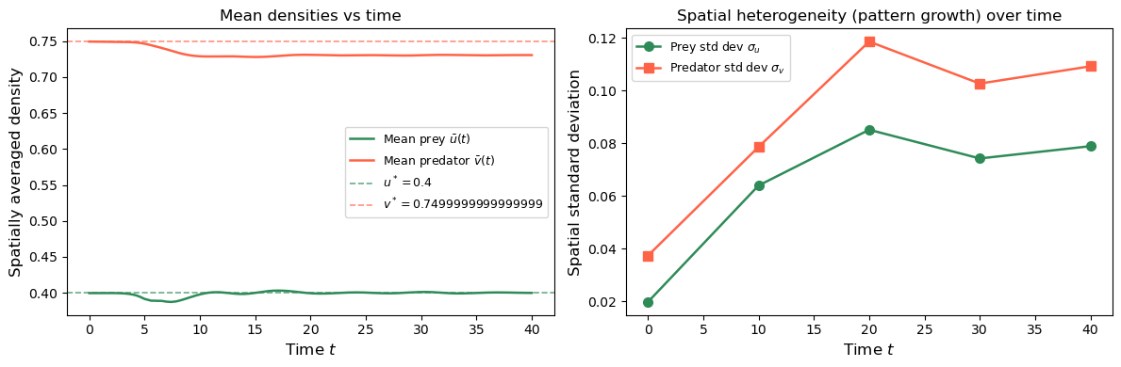

Results and Interpretation

What the spatial snapshots show
At $t=0$ both populations are nearly uniform — only 5 % random noise perturbs the coexistence equilibrium. Over time, taxis amplifies these perturbations into coherent spatial structures:
- Prey (green) cluster into high-density patches away from predators.
- Predators (orange-red) aggregate in the regions where prey is densest, chasing the prey clusters.
The spatial standard deviation plot confirms that heterogeneity grows over time — this is taxis-driven pattern formation, analogous to Turing instability but driven by directed movement rather than differential diffusion.

Why the mean densities stay near $(u^{*},v^{*})$
The spatial average $\overset{‾}{u}(t)$ and $\overset{‾}{v}(t)$ remain close to the coexistence equilibrium. This makes sense: the zero-flux boundary conditions conserve total population up to the reaction terms, and the reaction terms at equilibrium are balanced. Taxis and diffusion only redistribute individuals in space — they do not change the total count.

Role of each term
Term | Alone | Combined effect
Diffusion only ($χ=0$) | Smooths patterns, stabilizes uniform state | Cannot generate patterns with equal diffusion
Taxis only ($D=0$) | Causes aggregation / collapse | Unstable — needs diffusion to regularize
Both | Compete against each other | Produces stable, sustained spatial patterns

Real-world analogy
This model is directly relevant to ecological systems where spatial movement matters — wolf and deer populations across a landscape, plankton blooms and their grazers in the ocean, or bacterial populations and their predatory phages. The key insight is that directed movement (taxis) alone is sufficient to break spatial uniformity, even when the ODE kinetics predict a stable, uniform coexistence state.

