Exercise 8.2 — Market Share Competition and Bifurcation Analysis

Problem Setup
Two companies A and B compete for local market share. Let $x$ = market share of A, $y$ = market share of B. Since there are no third-party competitors:
$$x+y=1⟹y=1−x$$
So the relative competitive edge $x−y$ simplifies to:
$$x−y=x−(1−x)=2x−1$$
The model for A's market share is:
$$\frac{dx}{dt}=ax(1−x)(x−y)=ax(1−x)(2x−1) (8.18)$$

Part 1: Equilibria and Stability of Equation (8.18)

Finding Equilibria
Set $\frac{dx}{dt}=0$:
$$ax(1−x)(2x−1)=0$$
Each factor gives one equilibrium:
$$x^{*}=0, x^{*}=\frac{1}{2}, x^{*}=1$$

Stability Analysis
Compute $f′(x)$ where $f(x)=ax(1−x)(2x−1)$. Using the product rule:
$$f′(x)=a\left[(1−x)(2x−1)+x(−1)(2x−1)+x(1−x)(2)\right]$$
$$=a\left[(2x−1)(1−x−x)+2x(1−x)\right]=a\left[−(2x−1)^{2}+2x(1−x)\right]$$
Evaluating at each equilibrium (assuming $a>0$):
Equilibrium | $f′(x^{*})$ | Stability
$x^{*}=0$ | $a[−(−1)^{2}+0]=−a<0$ | Stable
$x^{*}=\frac{1}{2}$ | $a[0+2(\frac{1}{2})(\frac{1}{2})]=\frac{a}{2}>0$ | Unstable
$x^{*}=1$ | $a[−(1)^{2}+0]=−a<0$ | Stable

Interpretation
For $a>0$ this is a classic winner-take-all dynamic:
- $x^{*}=0$: Company B captures 100% of the market (stable)
- $x^{*}=1$: Company A captures 100% of the market (stable)
- $x^{*}=\frac{1}{2}$: Equal split — an unstable tipping point (repeller)
Whichever company holds more than 50% market share tends toward complete dominance. The boundary $x=\frac{1}{2}$ is the separatrix between the two basins of attraction.
import numpy as np
import matplotlib.pyplot as plt
from scipy.integrate import solve_ivp
# --- Phase portrait for Eq 8.18 ---
a = 1.0
def f_818(x, a=1.0):
return a * x * (1 - x) * (2*x - 1)
x_vals = np.linspace(-0.1, 1.1, 400)
dxdt = f_818(x_vals, a)
fig, axes = plt.subplots(1, 2, figsize=(12, 4))
# Left: dx/dt vs x (1D phase line)
ax = axes[0]
ax.axhline(0, color='k', lw=0.8)
ax.axvline(0, color='gray', lw=0.5, ls='--')
ax.plot(x_vals, dxdt, 'b', lw=2)
ax.fill_between(x_vals, 0, dxdt, where=dxdt > 0, alpha=0.15, color='green', label='dx/dt > 0 (A grows)')
ax.fill_between(x_vals, 0, dxdt, where=dxdt < 0, alpha=0.15, color='red', label='dx/dt < 0 (A shrinks)')
# Mark equilibria
for xeq, stab, col in [(0, 'Stable', 'green'), (0.5, 'Unstable', 'red'), (1, 'Stable', 'green')]:
ax.plot(xeq, 0, 'o', ms=10, color=col, zorder=5)
ax.annotate(f'$x^*={xeq}$\n({stab})', xy=(xeq, 0), xytext=(xeq, 0.06),
ha='center', fontsize=9)
ax.set_xlim(-0.05, 1.05)
ax.set_xlabel('Market share $x$')
ax.set_ylabel('$dx/dt$')
ax.set_title('Phase line — Eq (8.18), $a=1$')
ax.legend(fontsize=8)
# Right: time series from various initial conditions
ax2 = axes[1]
t_span = (0, 20)
t_eval = np.linspace(0, 20, 500)
for x0 in [0.05, 0.2, 0.45, 0.55, 0.8, 0.95]:
sol = solve_ivp(lambda t, y: [f_818(y[0], a)], t_span, [x0], t_eval=t_eval, dense_output=True)
lbl = f'$x_0={x0}$'
ax2.plot(sol.t, sol.y[0], label=lbl)
ax2.axhline(0.5, color='r', ls='--', lw=1, label='$x^*=0.5$ (unstable)')
ax2.set_xlabel('Time $t$')
ax2.set_ylabel('Market share $x$')
ax2.set_title('Time series — Eq (8.18), $a=1$')
ax2.legend(fontsize=7, ncol=2)
ax2.set_ylim(-0.05, 1.05)
plt.tight_layout()
plt.show()
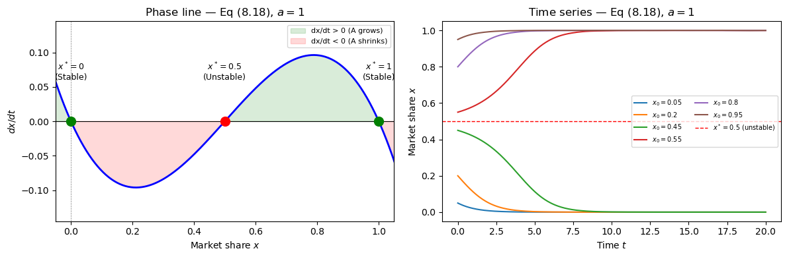

Part 2: Global Market Influence — Bifurcation Analysis of Equation (8.19)
Now add the global market term:
$$\frac{dx}{dt}=ax(1−x)(2x−1)+r(p−x) (8.19)$$
where $r>0$ is the global influence strength and $p$ is A's global market share (held constant).

Finding the Critical Condition (Bifurcation Point)
Step 1 — Check $x^{*}=p=\frac{1}{2}$ for all $r$.
With $p=\frac{1}{2}$, substituting $x=\frac{1}{2}$ into (8.19):
$$a⋅\frac{1}{2}⋅\frac{1}{2}⋅0+r\left(\frac{1}{2}−\frac{1}{2}\right)=0✓$$
So $x^{*}=\frac{1}{2}$ is an equilibrium for all values of $r$.
Step 2 — Stability of $x^{*}=\frac{1}{2}$.
Let $g(x)=ax(1−x)(2x−1)+r(p−x)$. Then:
$$g′(x)=a\left[−(2x−1)^{2}+2x(1−x)\right]−r$$
At $x^{*}=\frac{1}{2}$:
$$g′​\left(1/2\right)=a\left[0+2⋅1/2⋅1/2\right]−r=\frac{a}{2}−r$$
This changes sign at:
$$\boxed{r_{c}=\frac{a}{2}}$$
Condition | Stability of $x^{*}=\frac{1}{2}$
$r<r_{c}$ | Unstable (tipping point survives)
$r=r_{c}$ | Bifurcation point
$r>r_{c}$ | Stable (global market takes over)
Step 3 — Local normal form (confirms pitchfork structure).
Let $u=x−\frac{1}{2}$ (shift equilibrium to origin). Expanding $g(u+\frac{1}{2})$ to third order:
$$g≈\left(\frac{a}{2}−r\right)u−2au^{3}$$
This is the standard supercritical pitchfork normal form $\dot{u}=μu−cu^{3}$ with $μ=\frac{a}{2}−r$ and $c=2a>0$.
- For $r>r_{c}$: $μ<0$ — only $u=0$ ($x=\frac{1}{2}$) is stable.
- For $r<r_{c}$: $μ>0$ — $x=\frac{1}{2}$ becomes unstable, and two stable branches emerge at $x^{*}=\frac{1}{2}±\sqrt{\frac{μ}{2a}}$.

With $a=1$, $p=0.5$: Critical threshold is $r_{c}=0.5$.
# --- Bifurcation diagram for Eq 8.19 with a=1, p=0.5 ---
from scipy.optimize import fsolve
a_val = 1.0
p_val = 0.5
def g_819(x, r, a=1.0, p=0.5):
return a * x * (1 - x) * (2*x - 1) + r * (p - x)
def g_prime(x, r, a=1.0):
return a * (-(2*x - 1)**2 + 2*x*(1 - x)) - r
r_vals = np.linspace(0, 1.2, 600)
r_c = a_val / 2 # = 0.5
# Collect equilibria numerically for each r
eq_stable = []
eq_unstable = []
x_test = np.linspace(0.01, 0.99, 80)
for r in r_vals:
found = set()
for x0 in x_test:
try:
sol = fsolve(g_819, x0, args=(r,), full_output=True)
xeq = sol[0][0]
if 0 <= xeq <= 1:
xeq_rounded = round(xeq, 6)
if xeq_rounded not in found:
found.add(xeq_rounded)
if g_prime(xeq, r) < 0:
eq_stable.append((r, xeq))
else:
eq_unstable.append((r, xeq))
except:
pass
r_s, x_s = zip(*eq_stable) if eq_stable else ([], [])
r_u, x_u = zip(*eq_unstable) if eq_unstable else ([], [])
fig, ax = plt.subplots(figsize=(8, 5))
ax.scatter(r_s, x_s, s=3, color='steelblue', label='Stable equilibrium')
ax.scatter(r_u, x_u, s=3, color='tomato', label='Unstable equilibrium')
ax.axvline(r_c, color='k', ls='--', lw=1.2, label=f'$r_c = {r_c}$ (bifurcation)')
ax.axhline(0.5, color='gray', ls=':', lw=0.8)
ax.set_xlabel('Global influence strength $r$', fontsize=12)
ax.set_ylabel("Equilibrium market share $x^*$", fontsize=12)
ax.set_title("Bifurcation diagram — Eq (8.19), $a=1$, $p=0.5$", fontsize=13)
ax.legend(fontsize=10)
ax.set_ylim(-0.05, 1.05)
ax.set_xlim(0, 1.2)
ax.annotate('Winner-take-all\n(bistable)', xy=(0.2, 0.75), fontsize=9, color='steelblue')
ax.annotate('Global market\ndominates\n$(x^*=0.5)$', xy=(0.65, 0.55), fontsize=9, color='gray')
plt.tight_layout()
plt.show()
print(f"Critical threshold: r_c = a/2 = {r_c}")
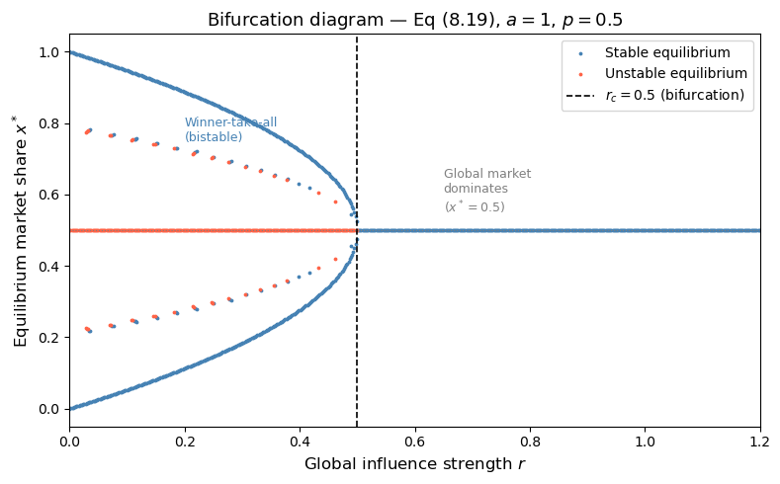
Critical threshold: r_c = a/2 = 0.5
# --- Time series showing the regime shift on either side of r_c ---
fig, axes = plt.subplots(1, 2, figsize=(12, 4))
t_span = (0, 30)
t_eval = np.linspace(0, 30, 600)
x0_vals = [0.1, 0.3, 0.45, 0.55, 0.7, 0.9]
for r_plot, ax, title in [(0.2, axes[0], '$r=0.2 < r_c$ — Bistable (winner-take-all)'),
(0.8, axes[1], '$r=0.8 > r_c$ — Global market drives $x \\to 0.5$')]:
for x0 in x0_vals:
sol = solve_ivp(lambda t, y: [g_819(y[0], r_plot)], t_span, [x0], t_eval=t_eval)
ax.plot(sol.t, sol.y[0], label=f'$x_0={x0}$')
ax.axhline(0.5, color='r', ls='--', lw=1)
ax.set_ylim(-0.05, 1.05)
ax.set_xlabel('Time $t$')
ax.set_ylabel('Market share $x$')
ax.set_title(title, fontsize=10)
ax.legend(fontsize=7, ncol=2)
plt.tight_layout()
plt.show()
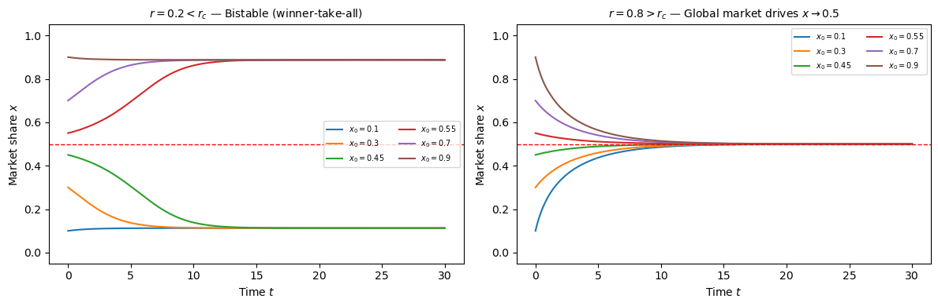

Summary: Bifurcation Type
This is a supercritical pitchfork bifurcation at $r_{c}=\frac{a}{2}$.
- For $r>r_{c}$: the global market erases the winner-take-all dynamic. The single stable equilibrium $x^{*}=\frac{1}{2}$ means market share is pinned to the global value $p$.
- For $r<r_{c}$: the global influence is too weak to overcome local competitive dynamics. $x^{*}=\frac{1}{2}$ becomes an unstable tipping point, and two stable equilibria emerge — one near 0 (B wins locally) and one near 1 (A wins locally).
- The bifurcation represents a transition between market regimes: from a globally-coupled equilibrium market to a bistable winner-take-all market.

Part 3: Marketing Strategy — How to "Flip" the Market

Setup
Suppose company A is currently being overwhelmed — its local market share $x$ is small and stuck near $x^{*}=0$ (B dominates). The bifurcation analysis tells us exactly what levers are available.

Strategy 1: Cross the Tipping Point (Brute-Force Push)
When $r<r_{c}$, the unstable equilibrium $x^{*}=\frac{1}{2}$ acts as a threshold. If A can push its local market share above 50% through any means — heavy advertising, promotions, temporary discounts, strategic partnerships — the dynamics take over. Once $x>\frac{1}{2}$, the term $x−y=2x−1>0$ becomes positive and self-reinforcing, driving A toward full market dominance $x→1$.
This is high-risk but potentially decisive. Think of it as the "blitz" strategy.

Strategy 2: Win Globally First, Then Let It Trickle Down ($r>r_{c}$)
This is the smarter play. Rather than fighting the local winner-take-all dynamic directly, company A should:
- Establish a strong position in the broader national or global market, pushing $p>\frac{1}{2}$.
- Strengthen the coupling $r$ between global and local markets (e.g., through brand recognition, media presence, supply-chain integration).
Once $r>r_{c}=a/2$, the bifurcation disappears — the local winner-take-all dynamic is suppressed. The local market then converges to $p$ regardless of initial conditions. If $p>\frac{1}{2}$, the local market naturally follows. There's no longer a need to "fight" locally.
This is the strategy large multinational brands use: build global dominance, and local markets self-correct.

Strategy 3: Reduce the Competitive Intensity ($a↓$, raising $r_{c}$)
Lowering $a$ raises the threshold $r_{c}=a/2$, meaning the same global influence $r$ now exceeds $r_{c}$ more easily. A could:
- Differentiate its product to avoid direct head-to-head comparison.
- Target a different customer segment entirely (reducing the effective competition parameter $a$).
- Form a strategic alliance to reduce competitive intensity.

Key Takeaway
The model reveals that the local market has a bifurcation point that separates two fundamentally different behaviors. A losing company cannot gradually "improve" its way to dominance if $r<r_{c}$ — it needs either a sudden push past $x=\frac{1}{2}$ or a regime change via global influence. Incremental improvement while stuck below the tipping point will always revert back to near zero. The math recommends going big globally, or going home.

