Exercise 8.4 — Period-Doubling Bifurcation in a Discrete-Time System

Problem
Consider the discrete-time dynamical system:
$$x_{t}=(1−a)x_{t−1}+ax_{t−1}^{3} (8.41)$$
The point $x^{*}=0$ is an equilibrium. Find the value of $a$ at which $x^{*}=0$ undergoes its first period-doubling bifurcation.

Derivation

Step 1 — Confirm the equilibrium
Define the map $f(x)=(1−a)x+ax^{3}$. Substituting $x^{*}=0$:
$$f(0)=(1−a)(0)+a(0)^{3}=0✓$$

Step 2 — Stability of $x^{*}=0$
For a discrete map, the stability of a fixed point is determined by the magnitude of the derivative of $f$ at that point. Compute:
$$f′(x)=(1−a)+3ax^{2}$$
At $x^{*}=0$:
$$f′(0)=1−a$$
The fixed point is stable when $|f′(0)|<1$, i.e., $|1−a|<1$, which gives $0<a<2$.

Step 3 — Period-Doubling Bifurcation Condition
A period-doubling bifurcation occurs at a fixed point when the multiplier (derivative of the map) passes through $−1$:
$$f′(0)=−1$$
$$1−a=−1$$
$$\boxed{a=2}$$

Step 4 — Verify a Period-2 Cycle Emerges for $a>2$
Since $f$ is an odd function ($f(−x)=−f(x)$), any period-2 orbit must satisfy $x_{2}=−x_{1}$, meaning we need $f(x_{1})=−x_{1}$:
$$(1−a)x_{1}+ax_{1}^{3}=−x_{1}$$
$$ax_{1}^{3}+(2−a)x_{1}=0⟹x_{1}\left[ax_{1}^{2}+(2−a)\right]=0$$
The non-trivial ($x_{1}≠0$) solution:
$$x_{1}^{2}=\frac{a−2}{a}$$
This has real solutions only when $a>2$, confirming that the period-2 cycle bifurcates from $x^{*}=0$ at $a=2$.
Regime | Behavior of $x^{*}=0$
$0<a<2$ | Stable fixed point
$a=2$ | Period-doubling bifurcation
$a>2$ | Unstable fixed point; stable period-2 orbit at $x_{1}=±\sqrt{(a−2)/a}$
import numpy as np
import matplotlib.pyplot as plt
# --- Bifurcation diagram: iterate the map and plot long-run behavior vs a ---
def f_map(x, a):
return (1 - a) * x + a * x**3
a_vals = np.linspace(0.5, 3.0, 1000)
n_transient = 500
n_plot = 150
bif_a = []
bif_x = []
for a in a_vals:
x = 0.1 # small nonzero initial condition to avoid the trivial orbit
for _ in range(n_transient):
x = f_map(x, a)
for _ in range(n_plot):
x = f_map(x, a)
bif_a.append(a)
bif_x.append(x)
# Analytical period-2 branches
a_p2 = np.linspace(2.0, 3.0, 300)
x_p2_pos = np.sqrt((a_p2 - 2) / a_p2)
x_p2_neg = -x_p2_pos
fig, ax = plt.subplots(figsize=(9, 5))
ax.scatter(bif_a, bif_x, s=0.4, color='steelblue', alpha=0.5)
ax.plot(a_p2, x_p2_pos, 'r--', lw=1.5, label='$x^* = \\pm\\sqrt{(a-2)/a}$ (period-2, analytical)')
ax.plot(a_p2, x_p2_neg, 'r--', lw=1.5)
ax.axhline(0, color='k', lw=0.8)
ax.axvline(2.0, color='orange', lw=1.5, ls='--', label='$a_c = 2$ (bifurcation)')
ax.set_xlabel('Parameter $a$', fontsize=12)
ax.set_ylabel('Long-run $x$', fontsize=12)
ax.set_title('Bifurcation diagram — Eq (8.41)', fontsize=13)
ax.legend(fontsize=9)
ax.set_ylim(-1.5, 1.5)
ax.annotate('Stable\n$x^*=0$', xy=(1.2, 0.05), fontsize=9)
ax.annotate('Period-2\norbits', xy=(2.3, 0.55), fontsize=9, color='red')
plt.tight_layout()
plt.show()
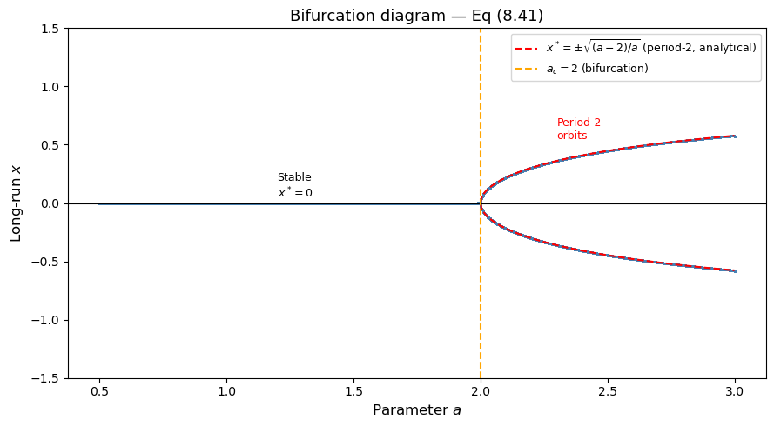
# --- Cobweb diagrams: before, at, and after the bifurcation ---
def cobweb(ax, a, x0, n_steps, title):
x_range = np.linspace(-1.2, 1.2, 400)
y_range = [f_map(x, a) for x in x_range]
ax.plot(x_range, y_range, 'b', lw=2, label='$f(x)$')
ax.plot(x_range, x_range, 'k--', lw=1, label='$y=x$')
x = x0
for _ in range(n_steps):
x_new = f_map(x, a)
ax.plot([x, x], [x, x_new], 'r', lw=0.8, alpha=0.7)
ax.plot([x, x_new], [x_new, x_new], 'r', lw=0.8, alpha=0.7)
x = x_new
ax.axhline(0, color='gray', lw=0.5)
ax.axvline(0, color='gray', lw=0.5)
ax.set_xlim(-1.2, 1.2)
ax.set_ylim(-1.2, 1.2)
ax.set_title(title, fontsize=10)
ax.set_xlabel('$x_{t-1}$')
ax.set_ylabel('$x_t$')
fig, axes = plt.subplots(1, 3, figsize=(13, 4))
cobweb(axes[0], a=1.5, x0=0.8, n_steps=40, title='$a = 1.5 < 2$ — $x^*=0$ stable')
cobweb(axes[1], a=2.0, x0=0.8, n_steps=60, title='$a = 2.0$ — bifurcation point')
cobweb(axes[2], a=2.5, x0=0.1, n_steps=60, title='$a = 2.5 > 2$ — period-2 orbit')
plt.tight_layout()
plt.show()
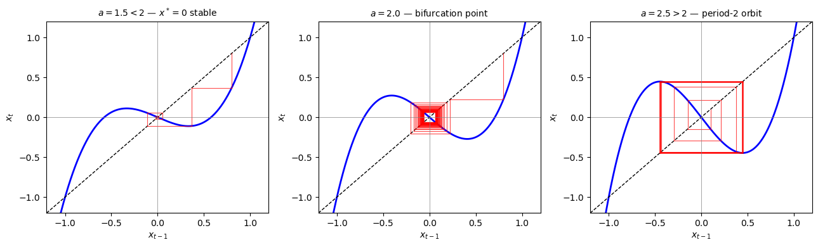

Summary
The equilibrium $x^{*}=0$ of the map $f(x)=(1−a)x+ax^{3}$ undergoes a period-doubling bifurcation at $a=2$.
- The condition $f′(0)=1−a=−1$ gives the critical value $a_{c}=2$.
- For $0<a<2$: $x^{*}=0$ is a stable fixed point.
- At $a=2$: the multiplier hits $−1$ and the fixed point loses stability.
- For $a>2$: $x^{*}=0$ is unstable and a stable period-2 orbit emerges at $x=±\sqrt{(a−2)/a}$, which is confirmed analytically and visible in both the bifurcation diagram and cobweb plots.

