Exercise 9.4 — Bifurcation Diagram and Lyapunov Exponent of a Cosine-Squared Map

Problem
Plot the bifurcation diagram and the Lyapunov exponent of the following discrete-time dynamical system for $r>0$:
$$x_{t}={\text{cos}}^{2}(rx_{t−1}) (9.8)$$
Then explain how its dynamics change over $r$.

Setup
Define the map $f(x)={\text{cos}}^{2}(rx)$. Since ${\text{cos}}^{2}(⋅)∈[0,1]$ for any input, the state space $[0,1]$ is invariant — after the first iteration, $x_{t}$ stays in $[0,1]$ for all time.
Derivative (needed for the Lyapunov exponent):
$$f′(x)=2\text{cos}(rx)⋅(−\text{sin}(rx))⋅r=−r\text{sin}(2rx)$$
Lyapunov exponent:
$$λ=\underset{n→∞}{\text{lim}}\frac{1}{n}\sum_{i=0}^{n−1}{\text{ln}}|f′(x_{i})|=\underset{n→∞}{\text{lim}}\frac{1}{n}\sum_{i=0}^{n−1}{\text{ln}}(r|\text{sin}(2rx_{i})|)$$
- $λ<0$: nearby orbits converge — ordered behavior (fixed point or periodic orbit)
- $λ=0$: marginal stability — bifurcation boundary
- $λ>0$: nearby orbits diverge — chaotic behavior
import numpy as np
import matplotlib.pyplot as plt
# Map and its derivative
def f_map(x, r):
return np.cos(r * x)**2
def f_deriv(x, r):
return -r * np.sin(2 * r * x)
r_vals = np.linspace(0.01, 5.0, 2000)
n_trans = 1000 # transient iterates (discarded)
n_plot = 300 # iterates collected for bifurcation diagram
n_lyap = 8000 # iterates for Lyapunov average
# ── Bifurcation diagram ──────────────────────────────────────────────────────
x = np.full_like(r_vals, 0.5)
for _ in range(n_trans):
x = f_map(x, r_vals)
bif_r, bif_x = [], []
for _ in range(n_plot):
x = f_map(x, r_vals)
bif_r.append(r_vals.copy())
bif_x.append(x.copy())
bif_r = np.concatenate(bif_r)
bif_x = np.concatenate(bif_x)
# ── Lyapunov exponent ────────────────────────────────────────────────────────
x = np.full_like(r_vals, 0.5)
for _ in range(n_trans):
x = f_map(x, r_vals)
lyap = np.zeros_like(r_vals)
for _ in range(n_lyap):
d = np.abs(f_deriv(x, r_vals))
lyap += np.log(np.maximum(d, 1e-14)) # floor avoids log(0)
x = f_map(x, r_vals)
lyap /= n_lyap
# ── Combined figure ──────────────────────────────────────────────────────────
fig, (ax1, ax2) = plt.subplots(
2, 1, figsize=(11, 7), sharex=True,
gridspec_kw={'height_ratios': [2, 1]}
)
ax1.scatter(bif_r, bif_x, s=0.2, color='steelblue', alpha=0.35, rasterized=True)
ax1.set_ylabel('Long-run $x^*$', fontsize=12)
ax1.set_title(
r'Bifurcation Diagram and Lyapunov Exponent — Eq (9.8): $x_t = \cos^2(rx_{t-1})$',
fontsize=13
)
ax1.set_ylim(-0.05, 1.05)
ax2.plot(r_vals, lyap, 'k', lw=0.8)
ax2.axhline(0, color='r', ls='--', lw=1.3, label='$\\lambda = 0$')
ax2.fill_between(r_vals, lyap, 0,
where=(lyap > 0), color='tomato', alpha=0.45, label='Chaotic ($\\lambda > 0$)')
ax2.fill_between(r_vals, lyap, 0,
where=(lyap <= 0), color='steelblue', alpha=0.25, label='Ordered ($\\lambda \\leq 0$)')
ax2.set_ylabel('Lyapunov exponent $\\lambda$', fontsize=12)
ax2.set_xlabel('$r$', fontsize=13)
ax2.set_ylim(-6, 2.5)
ax2.legend(fontsize=9, loc='upper left')
plt.tight_layout()
plt.show()
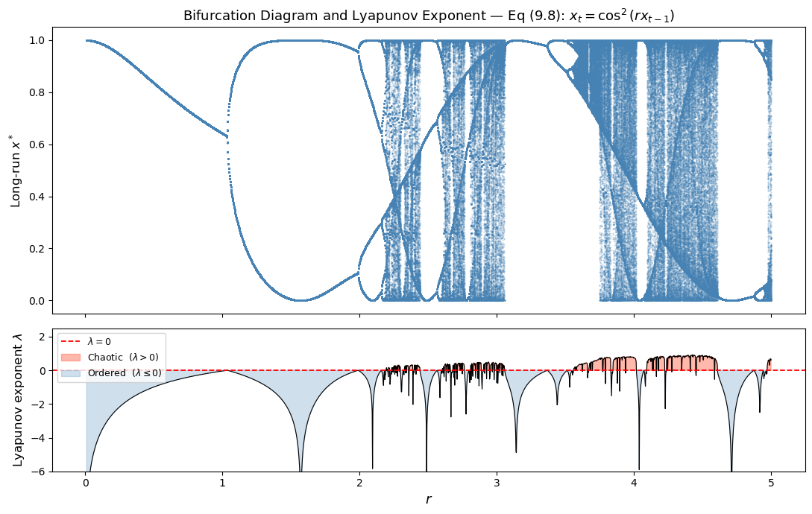
# ── Zoomed view: onset of the first period-doubling cascade ─────────────────
mask = (r_vals >= 0.01) & (r_vals <= 2.5)
r_zoom = r_vals[mask]
lyap_zoom = lyap[mask]
mask_bif = (bif_r <= 2.5)
fig, (ax1, ax2) = plt.subplots(
2, 1, figsize=(10, 6), sharex=True,
gridspec_kw={'height_ratios': [2, 1]}
)
ax1.scatter(bif_r[mask_bif], bif_x[mask_bif],
s=0.4, color='steelblue', alpha=0.4, rasterized=True)
ax1.set_ylabel('Long-run $x^*$', fontsize=12)
ax1.set_title('Zoomed view: $r \\in [0, 2.5]$ — period-doubling cascade onset', fontsize=12)
ax1.set_ylim(-0.05, 1.05)
ax2.plot(r_zoom, lyap_zoom, 'k', lw=0.9)
ax2.axhline(0, color='r', ls='--', lw=1.3)
ax2.fill_between(r_zoom, lyap_zoom, 0,
where=(lyap_zoom > 0), color='tomato', alpha=0.45)
ax2.fill_between(r_zoom, lyap_zoom, 0,
where=(lyap_zoom <= 0), color='steelblue', alpha=0.25)
ax2.set_ylabel('Lyapunov exponent $\\lambda$', fontsize=12)
ax2.set_xlabel('$r$', fontsize=13)
ax2.set_ylim(-6, 1.5)
plt.tight_layout()
plt.show()
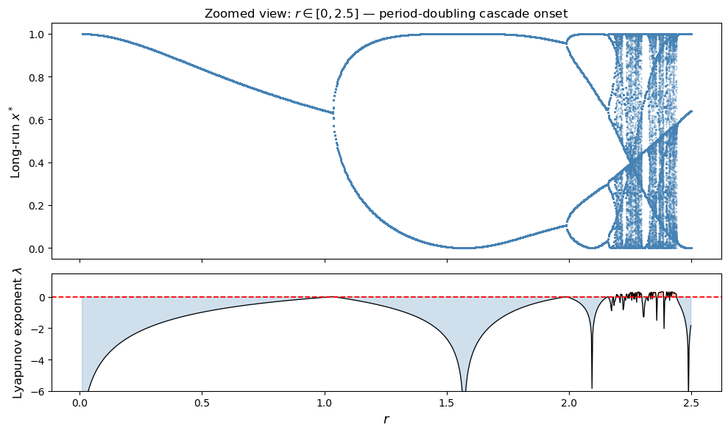

Explanation: How the Dynamics Change over $r$

Small $r$ — Stable fixed point
For small $r$, the map $f(x)={\text{cos}}^{2}(rx)$ is nearly flat, and every orbit converges rapidly to a single stable fixed point. The derivative $|f′(x^{*})|=r|\text{sin}(2rx^{*})|≪1$, so the Lyapunov exponent is strongly negative. The system just locks in to one value and stays there.

Period-doubling cascade
As $r$ increases, the map steepens. When $|f′(x^{*})|=1$, the fixed point loses stability and a period-2 orbit is born — the classic period-doubling bifurcation. Increasing $r$ further triggers another doubling to period-4, then period-8, and so on. This cascade follows the Feigenbaum route to chaos. In the Lyapunov plot, each bifurcation appears as a spike toward zero (the multiplier briefly passes through $±1$), and the exponent stays negative throughout the cascade.

Onset of chaos
After the period-doubling cascade accumulates, $λ$ crosses zero and becomes positive. This marks the onset of chaotic dynamics — trajectories starting at nearby initial conditions diverge exponentially. The bifurcation diagram fans out into a continuous band of visited $x$ values.

Periodic windows within chaos
Inside the chaotic regime, narrow windows of periodicity are visible in the bifurcation diagram — short bands where the orbit collapses back to a finite cycle. These correspond to dips in $λ$ back below zero. This is exactly the same structure seen in the logistic map, and is a universal feature of one-dimensional unimodal maps.

Second chaos-order-chaos cycle (larger $r$)
Because ${\text{cos}}^{2}(rx)$ is periodic in $r$, the entire period-doubling cascade and chaos scenario repeats as $r$ increases further. After a chaotic band, the system can restabilize into ordered behavior, then period-double into chaos again. This gives the bifurcation diagram its layered, self-similar appearance at larger $r$ — a behavior that distinguishes the cosine-squared map from simpler maps like the logistic one.

Summary table
$r$ regime | Bifurcation diagram | $λ$
Small $r$ | Single point (fixed) | $λ≪0$
Period-doubling cascade | Successive doublings | $λ<0$, spikes to $0$ at each bifurcation
First chaotic band | Dense band | $λ>0$
Periodic windows | Narrow bands within chaos | $λ<0$ (dips)
Larger $r$ | Repeated cascades + chaos | Alternating sign

