Exercise 9.6 — Bifurcation Analysis of the Lorenz Equations

Problem
Obtain the equilibrium points of the Lorenz equations as a function of $r$ (with $σ=10$, $b=3$). Conduct a bifurcation analysis on each equilibrium to find the critical thresholds of $r$. Compare with the numerical phase portrait results from Exercise 9.5.
Lorenz equations:
$$\dot{x}=σ(y−x), \dot{y}=rx−y−xz, \dot{z}=xy−bz$$
Fixed parameters: $σ=10$, $b=3$.

Part 1 — Equilibrium Points
Set all derivatives to zero. From $\dot{x}=0$: $y=x$. Substituting into $\dot{z}=0$:
$$x^{2}−bz=0⟹z=\frac{x^{2}}{b}$$
Substituting both into $\dot{y}=0$:
$$rx−x−x⋅\frac{x^{2}}{b}=0⟹x\left(r−1−\frac{x^{2}}{b}\right)=0$$
Case 1: $x=0⇒y=0, z=0$
$$\boxed{O=(0, 0, 0)} \text{exists for all }r$$
Case 2: $x^{2}=b(r−1)$, requiring $r>1$:
$$\boxed{C^{±}=(±\sqrt{b(r−1)}, ±\sqrt{b(r−1)}, r−1)} \text{exists for }r>1$$
With $b=3$: $C^{±}=(±\sqrt{3(r−1)}, ±\sqrt{3(r−1)}, r−1)$.

Part 2a — Bifurcation Analysis of the Origin $O$
The Jacobian of the Lorenz system is:
$$J=\left(\begin{matrix}−σ & σ & 0 \\ r−z & −1 & −x \\ y & x & −b\end{matrix}\right)$$
At $O=(0,0,0)$:
$$J_{O}=\left(\begin{matrix}−10 & 10 & 0 \\ r & −1 & 0 \\ 0 & 0 & −3\end{matrix}\right)$$
The $z$-direction decouples: $λ_{3}=−b=−3$ (always stable).
The remaining $2×2$ block gives:
$$λ^{2}+(σ+1)λ+σ(1−r)=0⟹λ=\frac{−11±\sqrt{81+40r}}{2}$$
Condition | $λ_{1}$ | Stability of $O$
$r<1$ | $<0$ | Stable
$r=1$ | $=0$ | Pitchfork bifurcation
$r>1$ | $>0$ | Unstable (saddle)
At $r=1$: eigenspectrum is $\{0, −11, −3\}$ — one zero eigenvalue confirms a pitchfork bifurcation at
$$\boxed{r_{1}=1}$$
and $C^{±}$ are born simultaneously.

Part 2b — Bifurcation Analysis of $C^{±}$
At $C^{+}=(c, c, r−1)$ with $c=\sqrt{3(r−1)}$, the Jacobian evaluates to:
$$J_{C^{+}}=\left(\begin{matrix}−10 & 10 & 0 \\ 1 & −1 & −c \\ c & c & −3\end{matrix}\right)$$
(By symmetry $J_{C^{−}}$ has identical eigenvalues.)

Characteristic Polynomial
Expanding $\text{det}(J_{C^{+}}−λI)=0$ along the first row:
$$(−10−λ)[(λ+1)(λ+3)+c^{2}]−10[(−3−λ)+c^{2}]=0$$
Collecting powers of $λ$ and substituting $c^{2}=3(r−1)$:
$$λ^{3}+14λ^{2}+(30+3r)λ+60(r−1)=0$$

Routh–Hurwitz Stability Conditions
For a monic cubic $λ^{3}+pλ^{2}+qλ+s$ all roots have negative real part iff:
$$p>0, s>0, q>0, pq>s$$
With $p=14$, $q=30+3r$, $s=60(r−1)$:
- $p=14>0$ ✓
- $s=60(r−1)>0⇔r>1$ ✓ (C± only exist for $r>1$)
- $q=30+3r>0$ ✓
- Critical condition: $14(30+3r)>60(r−1)$
$$420+42r>60r−60⟹480>18r⟹r<\frac{480}{18}=\frac{80}{3}$$

Hopf Bifurcation
At $r=r_{H}$ the Routh condition becomes an equality, and two eigenvalues are purely imaginary $λ=±iω$. Setting $ω^{2}=30+3r_{H}$ (from the imaginary-part condition) equal to $60(r_{H}−1)/14$ (from the real-part condition) yields the same threshold:
$$\boxed{r_{H}=\frac{80}{3}≈26.67}$$
At $r_{H}$: the purely imaginary eigenvalues are $±i\sqrt{110}$ and the real eigenvalue is $−14$.
Condition | Stability of $C^{±}$
$1<r<80/3$ | Stable (spiraling approach)
$r=80/3$ | Hopf bifurcation
$r>80/3$ | Unstable — strange attractor forms

Bifurcation Summary
Critical value | Equilibrium affected | Bifurcation type | Event
$r_{1}=1$ | $O$ | Pitchfork | $O$ loses stability; $C^{±}$ are born
$r_{H}=80/3≈26.67$ | $C^{±}$ | Hopf | $C^{±}$ lose stability; strange attractor emerges
import numpy as np
import matplotlib.pyplot as plt
from scipy.integrate import solve_ivp
from numpy.linalg import eigvals
from mpl_toolkits.mplot3d import Axes3D # noqa: F401
sigma = 10.0
b = 3.0
r_H = sigma * (sigma + b + 3) / (sigma - b - 1) # = 80/3
def lorenz_rhs(t, s, r):
x, y, z = s
return [sigma*(y - x), r*x - y - x*z, x*y - b*z]
def J_origin(r):
return np.array([[-sigma, sigma, 0.],
[r, -1., 0.],
[0., 0., -b]])
def J_cpm(r):
c = np.sqrt(b * (r - 1))
return np.array([[-sigma, sigma, 0.],
[1., -1., -c],
[c, c, -b]])
def c_pm(r):
c = np.sqrt(b * (r - 1))
return np.array([c, c, r-1]), np.array([-c, -c, r-1])
def run(r, ic, t_end, n=8000):
sol = solve_ivp(lorenz_rhs, [0, t_end], ic, args=(r,),
max_step=0.005, rtol=1e-9, atol=1e-12, dense_output=True)
t = np.linspace(0, t_end, n)
return t, sol.sol(t)
print(f"σ = {sigma}, b = {b}")
print(f"Pitchfork bifurcation: r₁ = 1")
print(f"Hopf bifurcation: r_H = 80/3 = {r_H:.6f}")
σ = 10.0, b = 3.0
Pitchfork bifurcation: r₁ = 1
Hopf bifurcation: r_H = 80/3 = 26.666667
# ── Eigenvalue real parts vs r — numerical confirmation of bifurcations ─────
r_for_O = np.linspace(0.05, 3.0, 400)
r_for_C = np.linspace(1.02, 40.0, 600)
# Real parts of eigenvalues at O (always 3 real eigenvalues for this block structure)
eigs_O = np.array([np.sort(np.real(eigvals(J_origin(r)))) for r in r_for_O])
# Real parts at C± (may become complex conjugate pairs)
eigs_C = np.array([np.sort(np.real(eigvals(J_cpm(r)))) for r in r_for_C])
fig, axes = plt.subplots(1, 2, figsize=(13, 5))
# Left: eigenvalues of J_O
ax = axes[0]
labels_O = ['$\\lambda_3 = -b = -3$', '$\\lambda_2$', '$\\lambda_1$']
colors_O = ['gray', 'steelblue', 'tomato']
for i, (lbl, col) in enumerate(zip(labels_O, colors_O)):
ax.plot(r_for_O, eigs_O[:, i], color=col, lw=1.8, label=lbl)
ax.axhline(0, color='k', lw=0.8, ls='--')
ax.axvline(1, color='purple', lw=1.5, ls='--', label='$r_1 = 1$ (pitchfork)')
ax.set_xlabel('$r$', fontsize=12)
ax.set_ylabel('Re($\\lambda$)', fontsize=12)
ax.set_title('Eigenvalues of $J_O$ vs $r$', fontsize=12)
ax.legend(fontsize=9)
ax.set_xlim(0, 3)
# Right: eigenvalues of J_{C±}
ax2 = axes[1]
labels_C = ['$\\mathrm{Re}(\\lambda_3)$', '$\\mathrm{Re}(\\lambda_2)$', '$\\mathrm{Re}(\\lambda_1)$']
colors_C = ['gray', 'steelblue', 'tomato']
for i, (lbl, col) in enumerate(zip(labels_C, colors_C)):
ax2.plot(r_for_C, eigs_C[:, i], color=col, lw=1.8, label=lbl)
ax2.axhline(0, color='k', lw=0.8, ls='--')
ax2.axvline(r_H, color='purple', lw=1.5, ls='--',
label=f'$r_H = 80/3 \\approx {r_H:.2f}$ (Hopf)')
ax2.set_xlabel('$r$', fontsize=12)
ax2.set_ylabel('Re($\\lambda$)', fontsize=12)
ax2.set_title('Eigenvalues of $J_{C^{\\pm}}$ vs $r$', fontsize=12)
ax2.legend(fontsize=9)
ax2.set_xlim(1, 40)
ax2.set_ylim(-20, 5)
fig.suptitle(
'Eigenvalue real parts vs $r$ — confirming bifurcation thresholds ($\\sigma=10$, $b=3$)',
fontsize=13
)
plt.tight_layout()
plt.show()
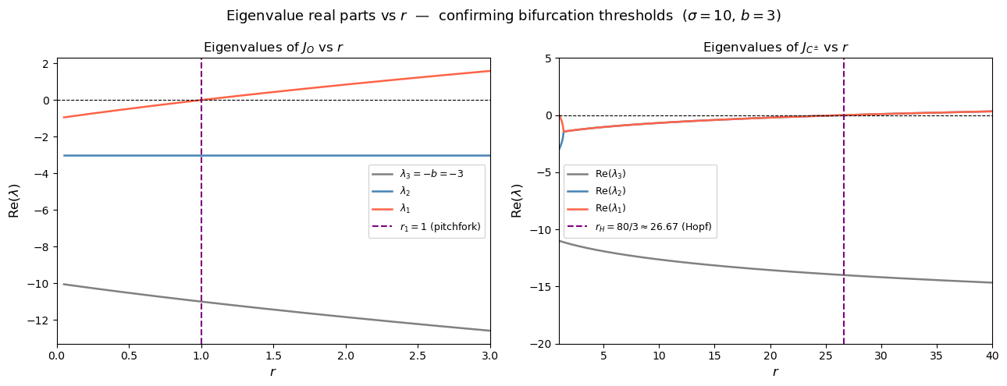
# ── Phase portraits with b = 3: four key regimes ────────────────────────────
# r = 0.5 → below r₁=1 (O stable)
# r = 10 → 1 < r < r_H (C± stable)
# r = 26 → just below r_H (C± stable, slow spiraling convergence)
# r = 28 → just above r_H (Lorenz butterfly)
cases = [
(0.5, 20, [[1,1,1],[4,4,4],[-3,3,5]], '$r=0.5 < r_1=1$\nstable origin $O$'),
(10.0, 30, [[5,5,2],[-5,-5,2]], '$r=10$, $r_1 < r < r_H$\nstable $C^{\\pm}$'),
(26.0, 120,[[1,1,1],[-1,-1,1]], '$r=26 \\approx r_H$\nslow spiral to $C^{\\pm}$'),
(28.0, 60, [[0,1,0]], '$r=28 > r_H=80/3$\nLorenz attractor (chaos)'),
]
palette = ['steelblue', 'tomato', 'seagreen']
fig = plt.figure(figsize=(14, 10))
for panel, (r, t_end, ics, title) in enumerate(cases):
ax = fig.add_subplot(2, 2, panel + 1, projection='3d')
if len(ics) == 1:
t_eval, xyz = run(r, ics[0], t_end, n=12000)
idx = np.arange(0, 12000, 2)
ax.scatter(xyz[0,idx], xyz[1,idx], xyz[2,idx],
c=t_eval[idx], cmap='plasma', s=0.4, alpha=0.6)
else:
for k, ic in enumerate(ics):
t_eval, xyz = run(r, ic, t_end)
ax.plot(xyz[0], xyz[1], xyz[2], lw=0.8, color=palette[k], alpha=0.9)
ax.scatter(*xyz[:, -1], color=palette[k], s=30, zorder=5)
# Fixed-point markers
ax.scatter(0, 0, 0, color='lime', s=55, marker='*', zorder=8)
if r > 1:
cp, cm = c_pm(r)
is_stable = (r < r_H)
mkr = 'o' if is_stable else '^'
ax.scatter(*cp, color='red', s=30, marker=mkr, zorder=7)
ax.scatter(*cm, color='blue', s=30, marker=mkr, zorder=7)
ax.set_title(title, fontsize=10)
ax.set_xlabel('$x$', fontsize=8, labelpad=1)
ax.set_ylabel('$y$', fontsize=8, labelpad=1)
ax.set_zlabel('$z$', fontsize=8, labelpad=1)
ax.tick_params(labelsize=7)
ax.view_init(elev=22, azim=-55)
fig.suptitle(
f'Phase Portraits — $\\sigma=10$, $b=3$, $r_1=1$, $r_H=80/3\\approx{r_H:.2f}$',
fontsize=13, y=1.0
)
plt.tight_layout()
plt.show()
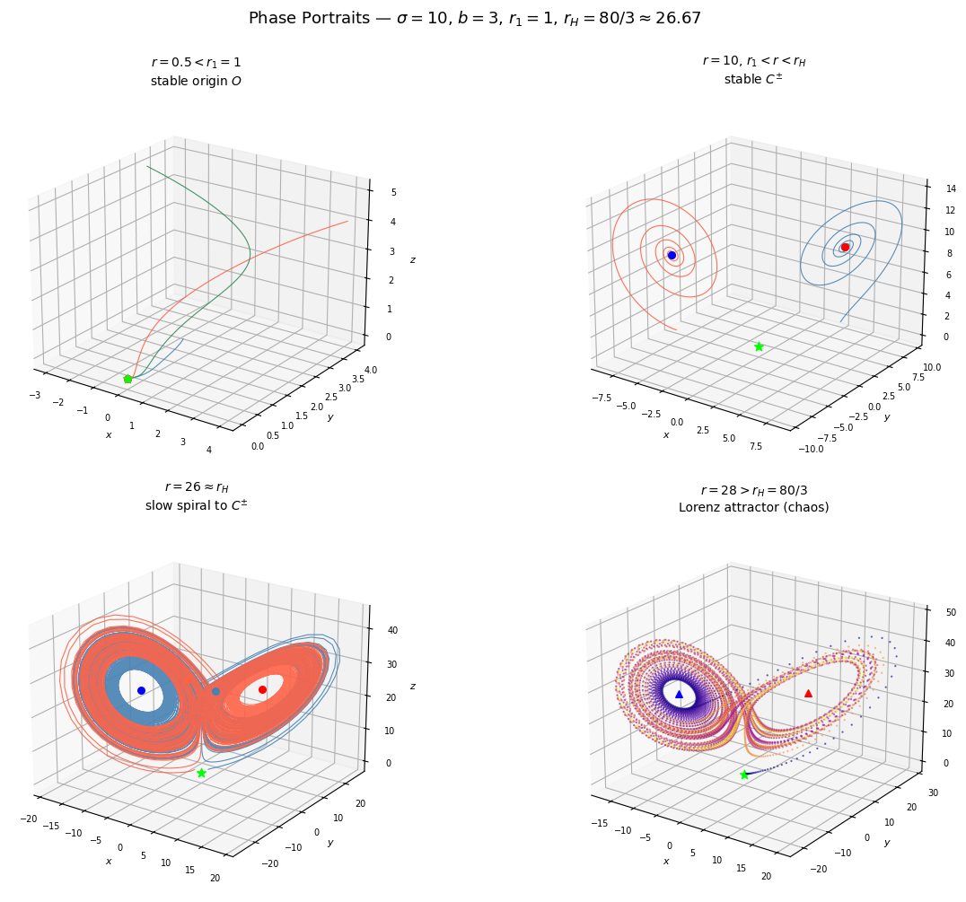

Comparison with Exercise 9.5
Exercise 9.5 used the classic parameter $b=8/3$; this exercise uses $b=3$. The bifurcation structure is qualitatively identical — pitchfork at $r=1$ followed by a Hopf bifurcation at $r_{H}$ — but the Hopf threshold shifts:
$$r_{H}=\frac{σ(σ+b+3)}{σ−b−1}$$
$b$ | $r_{H}$ | Source
$8/3$ | $470/19≈24.74$ | Classic Lorenz (Ex 9.5)
$3$ | $80/3≈26.67$ | This exercise

Consistency with Ex 9.5 Phase Portraits
The numerical phase portraits in Ex 9.5 (using $b=8/3$) showed:
- $r=5$, $r=20$: convergence to $C^{±}$ — consistent with being below $r_{H}$ in both parameterizations.
- $r=28$: Lorenz butterfly — consistent with being above $r_{H}$ in both parameterizations (28 > 26.67 > 24.74).
- $r=100$, $r=200$: extended chaos — confirmed by the analytical result that $C^{±}$ remain unstable for all $r>r_{H}$.
The $r=26$ portrait in this notebook is the most revealing new case: with $b=3$ we can show a trajectory that is just below $r_{H}=26.67$, so $C^{±}$ are still stable but the eigenvalues are nearly purely imaginary — producing long, winding transients that look almost chaotic before eventually settling. This is precisely the behavior predicted by the Routh–Hurwitz condition approaching equality at $r_{H}$.

Summary of Analytical Results
$r$ range | Active equilibria | All stable? | Observed dynamics
$r<1$ | $O$ only | $O$ stable | Decay to origin
$1<r<80/3$ | $O$, $C^{±}$ | $C^{±}$ stable, $O$ saddle | Convergence to $C^{+}$ or $C^{−}$
$r=80/3$ | $O$, $C^{±}$ | All unstable | Hopf bifurcation
$r>80/3$ | $O$, $C^{±}$ | All unstable | Lorenz strange attractor

