Exercise: Discrete-Time Model of Political Opinion Dynamics

Setup
Three ideologies share 100% of public opinion:
- $p_{r}$ = Republican popularity ($0≤p_{r}≤1$)
- $p_{d}$ = Democrat popularity ($0≤p_{d}≤1$)
- $p_{i}=1−p_{r}−p_{d}$ = Independent popularity

Building the Equations
At each poll, people switch from option X to option Y at a rate proportional to $\text{max}(p_{Y}−p_{X}, 0)$ — you only switch toward something more popular than where you are. The fraction of X-people who actually switch = (fraction in X) $×$ (rate), giving six flows:
Flow | Formula
$R→D$ | $p_{r}⋅\text{max}(p_{d}−p_{r}, 0)$
$R→I$ | $p_{r}⋅\text{max}(p_{i}−p_{r}, 0)$
$D→R$ | $p_{d}⋅\text{max}(p_{r}−p_{d}, 0)$
$D→I$ | $p_{d}⋅\text{max}(p_{i}−p_{d}, 0)$
$I→R$ | $p_{i}⋅\text{max}(p_{r}−p_{i}, 0)$
$I→D$ | $p_{i}⋅\text{max}(p_{d}−p_{i}, 0)$
Collecting gains and losses for each variable (following the same simultaneous-update structure as Code 4.13):
$$p_{r}^{(t+1)}=p_{r}^{(t)}+\underset{\text{gain}}{\underset{⏟}{(D→R)+(I→R)}}−\underset{\text{loss}}{\underset{⏟}{(R→D)−(R→I)}}$$
$$p_{d}^{(t+1)}=p_{d}^{(t)}+(R→D)+(I→D)−(D→R)−(D→I)$$
$$p_{i}=1−p_{r}−p_{d} \text{(derived, not modeled separately)}$$
Conservation $p_{r}+p_{d}+p_{i}=1$ is preserved automatically since the six flows cancel in pairs.
import numpy as np
import matplotlib.pyplot as plt
import matplotlib.patches as mpatches
from matplotlib.lines import Line2D
# ── The discrete-time model (revised from Code 4.13 structure) ────────────────
# Key idea: compute ALL next-step values before updating any variable.
def step(pr, pd):
"""One discrete time step. Returns (next_pr, next_pd)."""
pi = 1 - pr - pd
# Six switching flows
flow_rd = pr * max(pd - pr, 0) # R → D
flow_ri = pr * max(pi - pr, 0) # R → I
flow_dr = pd * max(pr - pd, 0) # D → R
flow_di = pd * max(pi - pd, 0) # D → I
flow_ir = pi * max(pr - pi, 0) # I → R
flow_id = pi * max(pd - pi, 0) # I → D
# Simultaneous update — like Code 4.13, we store next values first
next_pr = pr + (-flow_rd - flow_ri + flow_dr + flow_ir)
next_pd = pd + (-flow_dr - flow_di + flow_rd + flow_id)
return next_pr, next_pd
def simulate(pr0, pd0, T=150):
"""Run T steps from initial (pr0, pd0). Returns history arrays."""
pr, pd = pr0, pd0
history = [(pr, pd, 1 - pr - pd)]
for _ in range(T):
pr, pd = step(pr, pd)
history.append((pr, pd, 1 - pr - pd))
return np.array(history) # shape (T+1, 3) → columns: pr, pd, pi
# ── Single simulation: R slightly ahead ──────────────────────────────────────
hist = simulate(0.40, 0.30) # pr=0.40, pd=0.30, pi=0.30
fig, ax = plt.subplots(figsize=(8, 4))
ax.plot(hist[:, 0], color='red', lw=2, label='Republican $p_r$')
ax.plot(hist[:, 1], color='blue', lw=2, label='Democrat $p_d$')
ax.plot(hist[:, 2], color='gray', lw=2, label='Independent $p_i$')
ax.set_xlabel('Poll step $t$', fontsize=12)
ax.set_ylabel('Popularity', fontsize=12)
ax.set_title('Starting: $p_r=0.40$, $p_d=0.30$, $p_i=0.30$', fontsize=12)
ax.legend(fontsize=10)
ax.set_ylim(-0.02, 1.05)
plt.tight_layout()
plt.show()
print(f"Final state: pr={hist[-1,0]:.4f}, pd={hist[-1,1]:.4f}, pi={hist[-1,2]:.4f}")
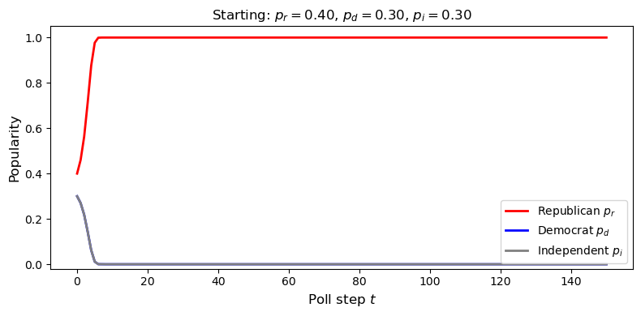
Final state: pr=1.0000, pd=0.0000, pi=0.0000
# ── Multiple initial conditions: ternary phase portrait ───────────────────────
# A ternary plot shows all three variables at once. The equilateral triangle
# has vertices: R=1 (bottom-left), D=1 (bottom-right), I=1 (top).
# Each point inside the triangle is one possible state of the system.
def to_xy(pr, pd):
"""Convert (pr, pd) → 2D ternary coordinates."""
pi = 1 - pr - pd
x = pd + pi / 2 # (1 - pr + pd) / 2 -- same thing
y = pi * np.sqrt(3) / 2
return x, y
# Draw the triangle
fig, ax = plt.subplots(figsize=(7, 6.5))
verts = np.array([[0, 0], [1, 0], [0.5, np.sqrt(3)/2], [0, 0]])
ax.plot(verts[:, 0], verts[:, 1], 'k-', lw=1.5)
# Vertex labels
ax.text(-0.07, -0.04, 'R = 1\n(Republican)', ha='center', fontsize=10, color='red')
ax.text( 1.07, -0.04, 'D = 1\n(Democrat)', ha='center', fontsize=10, color='blue')
ax.text( 0.50, 0.91, 'I = 1\n(Independent)', ha='center', fontsize=10, color='dimgray')
# Mark the equal-split center
cx, cy = to_xy(1/3, 1/3)
ax.plot(cx, cy, 'k+', ms=10, mew=2, zorder=6)
ax.text(cx + 0.03, cy + 0.02, '$p_r=p_d=p_i=\\frac{1}{3}$', fontsize=8)
# Simulate from a grid of initial conditions and plot trajectories
np.random.seed(0)
n_traj = 40
ics = []
while len(ics) < n_traj:
pr0 = np.random.uniform(0.02, 0.96)
pd0 = np.random.uniform(0.02, 0.96 - pr0)
ics.append((pr0, pd0))
for pr0, pd0 in ics:
hist = simulate(pr0, pd0, T=200)
xs, ys = to_xy(hist[:, 0], hist[:, 1])
# Color by winner
final = hist[-1]
winner = np.argmax(final)
col = ['tomato', 'steelblue', 'darkgray'][winner]
ax.plot(xs, ys, color=col, lw=0.9, alpha=0.6)
ax.plot(xs[-1], ys[-1], 'o', color=col, ms=5, zorder=5)
legend_elems = [
Line2D([0],[0], color='tomato', lw=2, label='R wins'),
Line2D([0],[0], color='steelblue', lw=2, label='D wins'),
Line2D([0],[0], color='darkgray', lw=2, label='I wins'),
]
ax.legend(handles=legend_elems, fontsize=10, loc='upper right')
ax.set_aspect('equal')
ax.axis('off')
ax.set_title('Ternary phase portrait — trajectories from 40 random starting points',
fontsize=11)
plt.tight_layout()
plt.show()
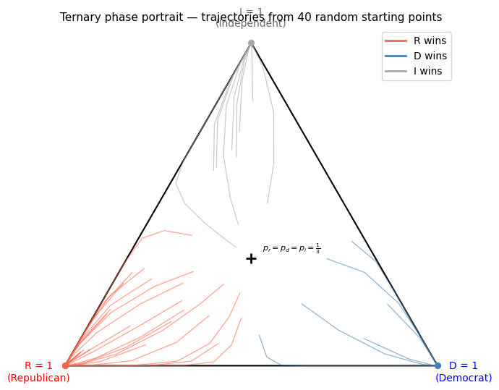
# ── Basin-of-attraction map ───────────────────────────────────────────────────
# For every possible starting state, run 300 steps and record who wins.
# This shows the three basins of attraction clearly.
# Vectorised step for efficiency
def step_vec(pr, pd):
pi = 1 - pr - pd
rd = pr * np.maximum(pd - pr, 0)
ri = pr * np.maximum(pi - pr, 0)
dr = pd * np.maximum(pr - pd, 0)
di = pd * np.maximum(pi - pd, 0)
ir = pi * np.maximum(pr - pi, 0)
id_ = pi * np.maximum(pd - pi, 0)
return pr + (-rd - ri + dr + ir), pd + (-dr - di + rd + id_)
from matplotlib.colors import ListedColormap, BoundaryNorm
res = 200
pr_vals = np.linspace(0.01, 0.98, res)
pd_vals = np.linspace(0.01, 0.98, res)
PR, PD = np.meshgrid(pr_vals, pd_vals)
# Only simulate inside the valid simplex (pr + pd <= 1)
valid = PR + PD <= 1.0
pr_run = np.where(valid, PR, 0.0)
pd_run = np.where(valid, PD, 0.0)
for _ in range(300):
pr_new, pd_new = step_vec(pr_run, pd_run)
pr_run = np.where(valid, pr_new, 0.0)
pd_run = np.where(valid, pd_new, 0.0)
pi_run = 1 - pr_run - pd_run
# Winner: 0=R, 1=D, 2=I
winner_map = np.argmax(np.stack([pr_run, pd_run, pi_run], axis=-1), axis=-1).astype(float)
winner_map[~valid] = np.nan
cmap3 = ListedColormap(['tomato', 'steelblue', 'lightgray'])
norm3 = BoundaryNorm([-0.5, 0.5, 1.5, 2.5], cmap3.N)
fig, ax = plt.subplots(figsize=(6, 5.5))
im = ax.pcolormesh(PR, PD, winner_map, cmap=cmap3, norm=norm3, shading='auto')
# Draw the valid simplex boundary
ax.plot([0, 1], [1, 0], 'k-', lw=1.5)
patches = [
mpatches.Patch(color='tomato', label='Republican wins'),
mpatches.Patch(color='steelblue', label='Democrat wins'),
mpatches.Patch(color='lightgray', label='Independent wins'),
]
ax.legend(handles=patches, fontsize=9, loc='upper right')
ax.set_xlabel('$p_r$ (Republican)', fontsize=12)
ax.set_ylabel('$p_d$ (Democrat)', fontsize=12)
ax.set_title('Basin of attraction map\n(who wins after 300 steps?)', fontsize=11)
ax.set_xlim(0, 1); ax.set_ylim(0, 1)
ax.set_aspect('equal')
plt.tight_layout()
plt.show()
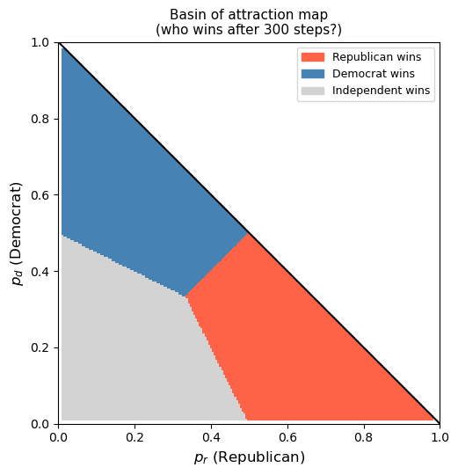

What the Simulations Show

Possible final outcomes
After a long enough time the system always ends up in one of three absorbing (winner-take-all) states:
Outcome | State
Republican dominates | $(p_{r},p_{d},p_{i})=(1,0,0)$
Democrat dominates | $(p_{r},p_{d},p_{i})=(0,1,0)$
Independent dominates | $(p_{r},p_{d},p_{i})=(0,0,1)$

Why winner-takes-all?
The switching rule rewards the most popular option — once a party gets a lead over both others, it draws from both of them simultaneously, growing its advantage until it has everything. The feedback is self-reinforcing.

The equal-split point is unstable
The point $p_{r}=p_{d}=p_{i}=1/3$ is a mathematical equilibrium (all flows are zero), but any small perturbation pushes the system away from it — whichever party has even a tiny edge will keep growing. This is an unstable fixed point (saddle).

Which party wins depends entirely on initial popularity
The basin-of-attraction map shows a clean three-way split of the starting simplex: whichever ideology starts with the largest popularity wins. Since the model treats R and D symmetrically, their basins are mirror images of each other. Independent's basin is the strip where $p_{i}>p_{r}$ and $p_{i}>p_{d}$ (top of the triangle), while R and D each occupy one of the two lower sectors.

