Jeremy Benik
Adam Kochanski
AA3 Project Scope
September 29, 2022
Project Scope
For this project, my task is to compare the Rothermel fire rate of spread model to the Balbi rate of spread model in both a conceptual and numerical way. To evaluate these models, I will be digging further into the papers about how the models were developed and compare the underlying assumptions the developers made about each process and subprocess. This analysis will include an explanation of how all the parameters were formulated, and the assumptions used to create those parameters. Then I will test these processes to see how sensitive they are to changes in fuels and weather conditions, and their overall accuracy. I already have a code for both models written in MATLAB and I can write them in python if needed as well. To test them, I will create arrays containing hundreds of values to test each parameter to see how sensitive it is with small changes. This can be done by modifying the code and taking in certain parameters as inputs to change them manually. As for comparing the models to a realistic dataset, I have the Kolgerberg dataset from the Van Wilgen experiment. This dataset includes a new type of fuel (South African Fynbos) and everything I need to know to implement this fuel type and run the model under the same conditions as the experiment. I can then see how much each parameter within the fuel models influence the overall ROS and how sensitive those parameters are to changes since I will have a baseline to go off from the dataset.
With these tests, I plan to make multiple surface plots in MATLAB to show how much the rate of spread and each component used to calculate the rate of spread varies with changes to the fuels (such as changing the fuel load and fuel height) and weather (changing the fuel moisture, wind speed, and terrain). To compare the data, I will make multiple excel spreadsheets with the rate of spread (and other parameters) values and compute the differences between the models. With these differences I can then determine which parameter may be causing the increase/decrease in these processes to better understand these models.
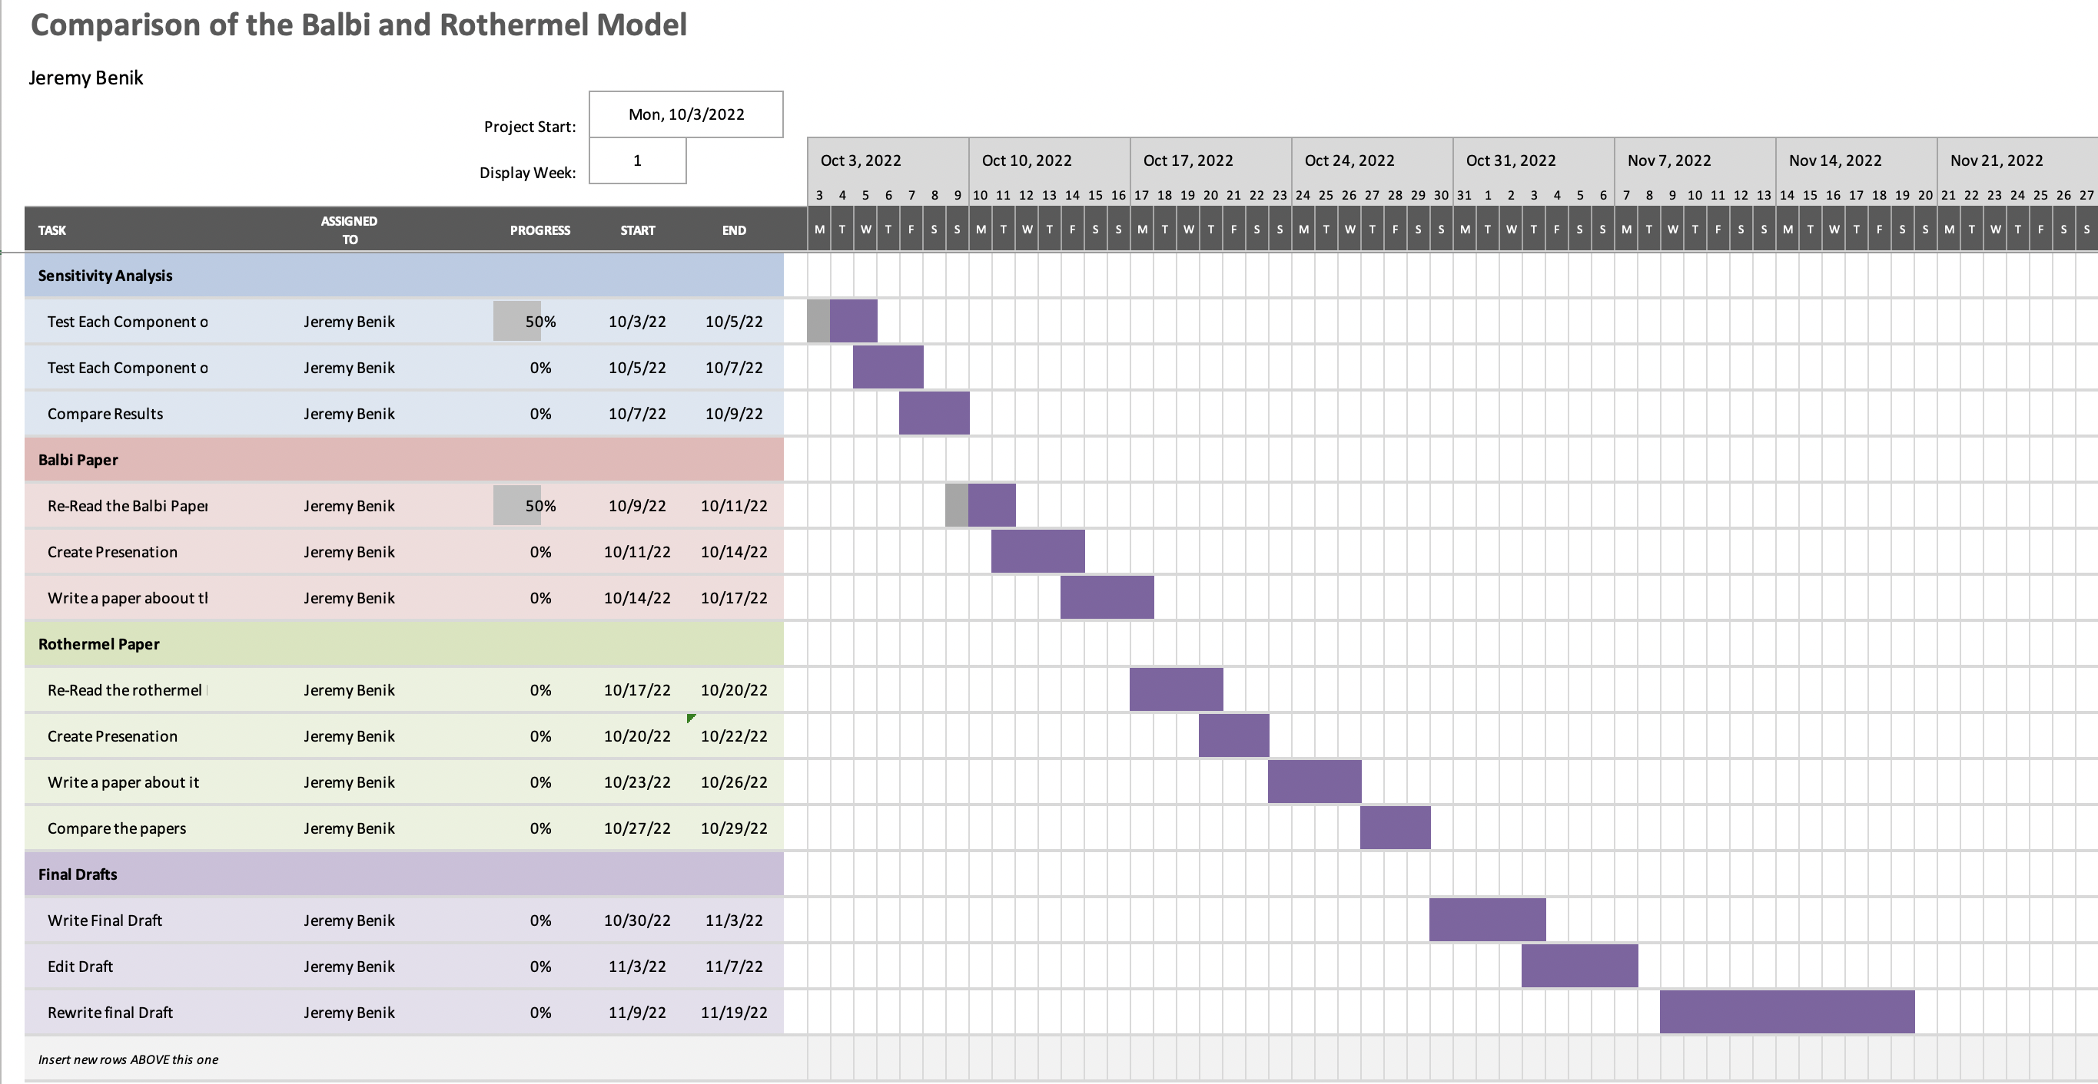
Some results I currently have are sensitivity analyses for the Balbi model and presentations on the new Balbi model. These presentations consist of the equations used in creating the model along with lists of the constants used in the codes. In the Balbi MATLAB code, I tested components of the fuels to see how sensitive small changes would affect the ROS. These changes include changing the fuel height and fuel loads. With these graphs I was curious to see which component contributes the most to the ROS, so I plotted those as well. With most of the plots, I found that the convective component is the most sensitive to changes, and it is the factor that contributes the most to the ROS. The components are as follows: Rf is the flame radiation, Rb is the base radiation, and Rc is the rate of spread due to convection. I have some other plots of the total fuel load and the dead fuel load, but the results are similar in that the convective component is the main contributing factor to the ROS. These tests were performed on a slope so further testing without a slope is needed to see how much other parameters contribute to the ROS without slope. As for the in-depth analysis of the two models, using the papers, old presentations, and the codes, I am comparing them to see how their underlying assumptions change the ROS. Currently there is more completed on the Balbi code since I have been working on that model for a few months now, but the Rothermel is soon to come.

Here are the links to those presentations: (so far, I just have the new Balbi model and the Rothermel model is still a work in progress)
https://github.com/Jeremy-Benik/Meeting_Notes/blob/main/Presentations/Balbi_2022_presentation.pptx
https://github.com/Jeremy-Benik/Meeting_Notes/blob/main/Presentations/Rothermel_presentation.pptx

Figure 1 Rate of Spread with varying fuel height and wind speed for the Balbi model.

