Using RMarkdown for reproducible and neat documents

Table of Contents

Date: 2019-10-28  
R version: 3.5.0  
*Corresponding author: Your email here

# Overview

This document showcases how to create and use RMarkdown documents.

# You can easily create headings. This is a first order heading.

## Then move down in heading order size

### Like this subheading

#### And this fourth order heading

You can write in **bold** and *italicised* text (in **two** different *ways*).

You can write in-line code if you want to differentiate between when you are typing normally or highlighting model parameters, for example.

Equations like this $t'=γ(t-vx/c^{2})$, to appear within text lines.

Create links to your [website](https://github.com/darwinanddavis).

Make footnotes[1].

Insert line breaks between text like this, which works best in large slabs of text

Insert a horizontal line break using five asterisks (‘*****’)

The raw Rmd file also has the code for inserting user comments.

(There is also a page break here. Best seen in PDF. Check the raw Rmd file to see the code)

## Define equations

Accordingly, we write the eigenfunction of a spinless particle as the superposition of plane wave states of momentum ($π$) and energy ($Ej$) having amplitudes $a(π,Ej)$ (from [[1]](https://arxiv.org/vc/quant-ph/papers/0607/0607001v1.pdf)).

$$ϕn(r,t)=\sum_{i,j}{a}(p_{i},E_{j})e^{\frac{i}{h}(p_{i}⋅r-E_{j}t)}$$

## Embed images/gifs:

.

## Create, alter, and embed plots

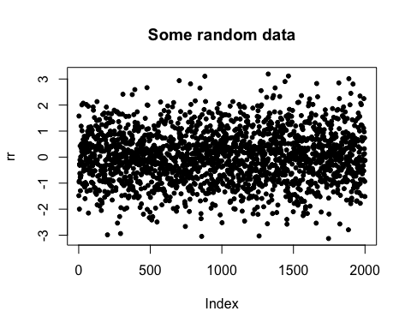

Figure 1. Example of a stock plot embedded into a PDF from RMarkdown.

## Show plots with associated code

suppressWarnings(require(viridis))  
bm <- 0  
par(las=1,bty="n"); xlim <- c(-5,5);ylim <- c(0,0.5)  
set.seed(12)  
N <- 2000  
rr <- rnorm(N); rr2 <- rnorm(N^2); rr3 <- rnorm(N+0.3)  
rrd <- density(rr);rrd2 <- density(rr2);rrd3 <- density(rr3)  
main <- paste0(N," points but plot better");xlab <- "Points in space"  
if(bm==1){  
 layout(matrix(c(rep(1,3),2:4), 2, 3, byrow = TRUE));sc <- 1  
 plot(rr,las=1,bty="n",col=adjustcolor(viridis(N),0.5),pch=20,cex=runif(10,1,5),  
 main=main,xlab=xlab)  
for(r in list(rrd,rrd2,rrd3)){  
 plot(r,xlim=xlim,ylim=ylim,main="")  
 polygon(r,col=adjustcolor(viridis(250)[sc],0.5),border=viridis(250)[sc]);sc <- sc+100}  
}else{par(mfrow=c(1,1))  
 plot(rr,las=1,bty="n",col=adjustcolor(viridis(N),0.5),pch=20,cex=runif(10,1,5),  
 main=main,xlab=xlab)}

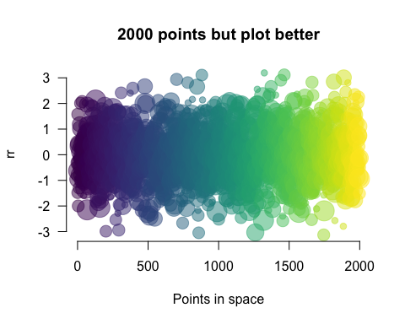

Figure 2. Example of a plot with improved graphics and its associated code embedded into the output document from RMarkdown.

## And tables

Table 1. Definitions of model parameters for individual hosts and **parasites**. Dimensions and units: -, dimensionless; cm, centimetres; J, Joules; L, length.

|  |  |  |
| --- | --- | --- |
| Parameter | Definition | Dimension(unit) |
| *L* | structural length | cm |
| *ee* | scaled reserve density | J (cm3) |
| *D* | host development | — |
| *RH* | energy in reproduction buffer | J |

## Use buttons or tabs for sub-chapters

### Chapter 1

. . . . .

*Then you can add whatever you want here* like you would normally write in the Rmd file.

. . . . .

### Chapter 2 (with new code)

Here’s an Easter egg for you …

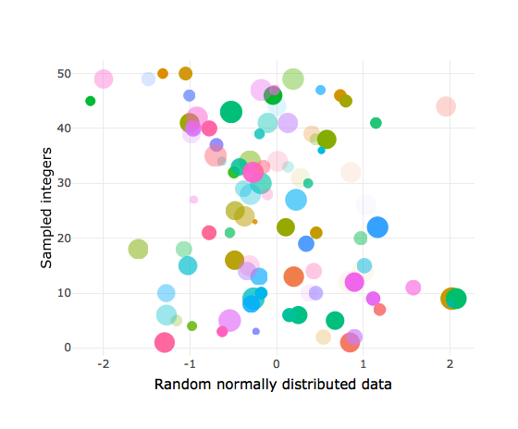

### More tables

Here’s a new way of creating tables using the DT package

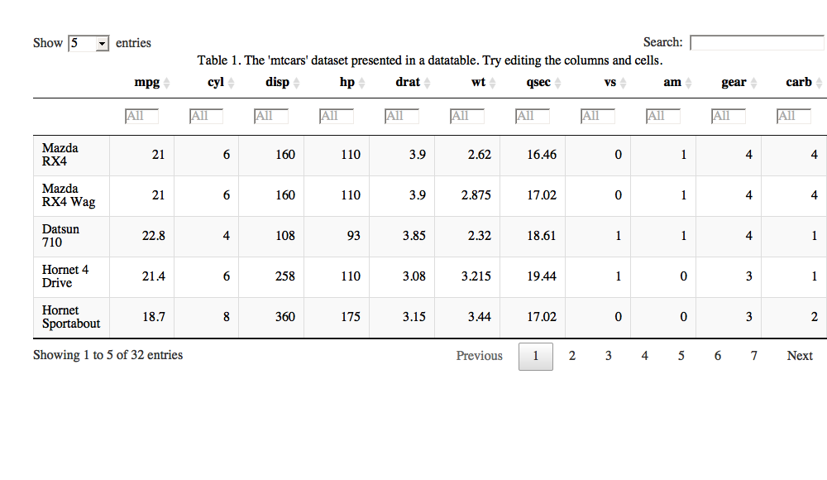

## Embed code from different languages

### This is R code

if(pck==1){  
 p<-c("rJava", "RNetLogo"); remove.packages(p)  
 # then install rJava and RNetLogo from source  
 install.packages("rJava", repos = "https://cran.r-project.org/")  
 install.packages("RNetLogo", repos = "https://cran.r-project.org/")  
}

### shell/bash

echo "Hello Bash!"  
pwd # check working dir  
git init # initialise git

### Octave (and MATLAB from the RMatlab package).

[RMatlab documentation](https://cran.r-project.org/web/packages/R.matlab/index.html).

b = [4; 9; 2] # Column vector  
A = [ 3 4 5;  
 1 3 1;  
 3 5 9 ]  
x = A \ b # Solve the system Ax = b

### HTML

<!-- links-->  
 <div class="footer">  
 <a href="dd_feed.html"  
 class="transition fade_in">  
 Latest post  
 </a>  
 &nbsp; &nbsp; &nbsp;  
 <a href="dd_contact.html"  
 class="transition fade_in">  
 Contact  
 </a>  
 &nbsp; &nbsp; &nbsp;  
 <a href="dd_subscribe.html"  
 class="transition fade_in">  
 Subscribe  
 </a>  
 </div>

### CSS

# custom code for the tabs in this file  
.btn {  
 border-width: 0 0px 0px 0px;  
 font-weight: normal;  
 text-transform: ;  
}  
.btn-default {  
 color: #f08080;  
 background-color: #ffffff;  
 border-color: #ffffff;  
}

### Javascript to access html and css

$('.title').css('color', 'red')

### Python

x = 'hello, python world!'  
print(x.split(' '))

### Here’s a complete list of available languages

names(knitr::knit_engines$get())

## [1] "awk" "bash" "coffee" "gawk" "groovy"   
## [6] "haskell" "lein" "mysql" "node" "octave"   
## [11] "perl" "psql" "Rscript" "ruby" "sas"   
## [16] "scala" "sed" "sh" "stata" "zsh"   
## [21] "highlight" "Rcpp" "tikz" "dot" "c"   
## [26] "fortran" "fortran95" "asy" "cat" "asis"   
## [31] "stan" "block" "block2" "js" "css"   
## [36] "sql" "go" "python" "julia" "sass"   
## [41] "scss"

# References

[1] Efthimiades, S., Physical meaning and derivation of Schrodinger and Dirac equations, Department of Natural Sciences, Fordham University, [doi: d34464566](https://arxiv.org/vc/quant-ph/papers/0607/0607001v1.pdf).

1. Here is the footnote you created earlier, automatically formatted