Using RMarkdown for reproducible and neat documents

Table of Contents

Date: 2019-10-22  
R version: 3.5.0  
*Corresponding author: your email here

# Overview

This document showcases how to create and use RMarkdown documents.

You can write in **bold** and *italicised* text (in *two* different **ways**).

You can write in-line code if you want to differentiate between when you are typing normally or highlighting model parameters, for example.

Equations like this $t′=γ(t−vx/c^{2})$, to appear within text lines.

Create links to your [website](https://github.com/darwinanddavis).

Make footnotes[1].

# You can easily create headings. This is the same font size as the ‘Overview’ above

## Then move down in font size

### Like this subheading

#### And this fourth order heading

Insert line breaks between text like this

Insert a horizontal line break using five asterisks (‘*****’)

(There is also a page break here. Best seen in PDF. Check the raw Rmd file to see the code)

The raw Rmd file also has the code for inserting user comments,

## Define equations

Accordingly, we write the eigenfunction of a spinless particle as the superposition of plane wave states of momentum ($π$) and energy ($Ej$) having amplitudes (from[2])

## Embed images/gifs:

.

## Create, alter, and embed plots

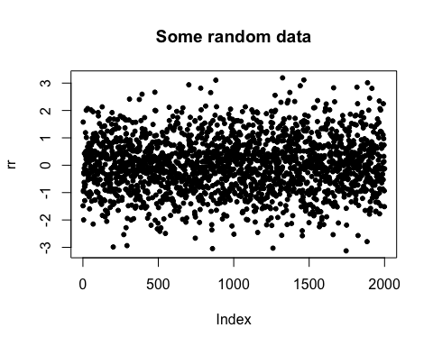

Figure 1. Example of a stock plot embedded into a PDF from RMarkdown.

## Show plots with associated code

require(viridis)  
bm <- 0  
par(las = 1, bty = "n")  
xlim <- c(-5, 5)  
ylim <- c(0, 0.5)  
set.seed(12)  
N <- 2000  
rr <- rnorm(N)  
rr2 <- rnorm(N^2)  
rr3 <- rnorm(N + 0.3)  
rrd <- density(rr)  
rrd2 <- density(rr2)  
rrd3 <- density(rr3)  
main <- paste0(N, " points but plot better")  
xlab <- "Points in space"  
if (bm == 1) {  
 layout(matrix(c(rep(1, 3), 2:4), 2, 3, byrow = TRUE))  
 sc <- 1  
 plot(rr, las = 1, bty = "n", col = adjustcolor(viridis(N), 0.5), pch = 20, cex = runif(10, 1, 5),   
 main = main, xlab = xlab)  
 for (r in list(rrd, rrd2, rrd3)) {  
 plot(r, xlim = xlim, ylim = ylim, main = "")  
 polygon(r, col = adjustcolor(viridis(250)[sc], 0.5), border = viridis(250)[sc])  
 sc <- sc + 100  
 }  
} else {  
 par(mfrow = c(1, 1))  
 plot(rr, las = 1, bty = "n", col = adjustcolor(viridis(N), 0.5), pch = 20, cex = runif(10, 1, 5),   
 main = main, xlab = xlab)  
}

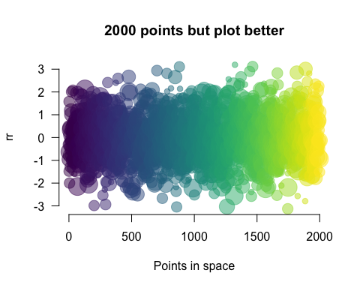

Figure 2. Example of a plot with improved graphics and its associated code embedded into a PDF from RMarkdown.

## And tables

Table 1. Definitions of model parameters for individual hosts and **parasites**. Dimensions and units: -, dimensionless; cm, centimetres; J, Joules; L, length.

|  |  |  |
| --- | --- | --- |
| Parameter | Definition | Dimension(unit) |
| *L* | structural length | cm |
| *ee* | scaled reserve density | J (cm3) |
| *D* | host development | — |
| *RH* | energy in reproduction buffer | J |

## Use buttons or tabs for sub-chapters

### Chapter 1

*Then you can add whatever you want here* like you would normally write in the Rmd file.

### Chapter 2 (with new code)

Here’s an Easter egg for you …

## [[1]]  
## [1] TRUE  
##   
## [[2]]  
## [1] TRUE

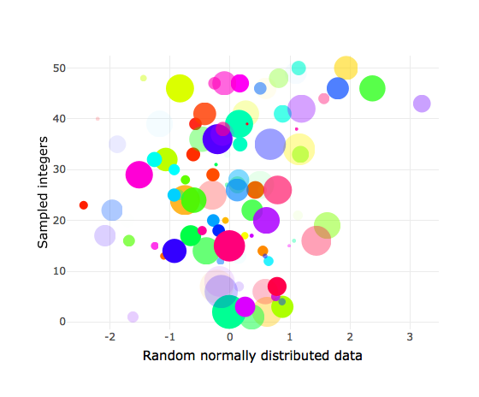

### More tables

Here’s a new way of creating tables using the DT package

## [[1]]  
## [1] TRUE  
##   
## [[2]]  
## [1] TRUE

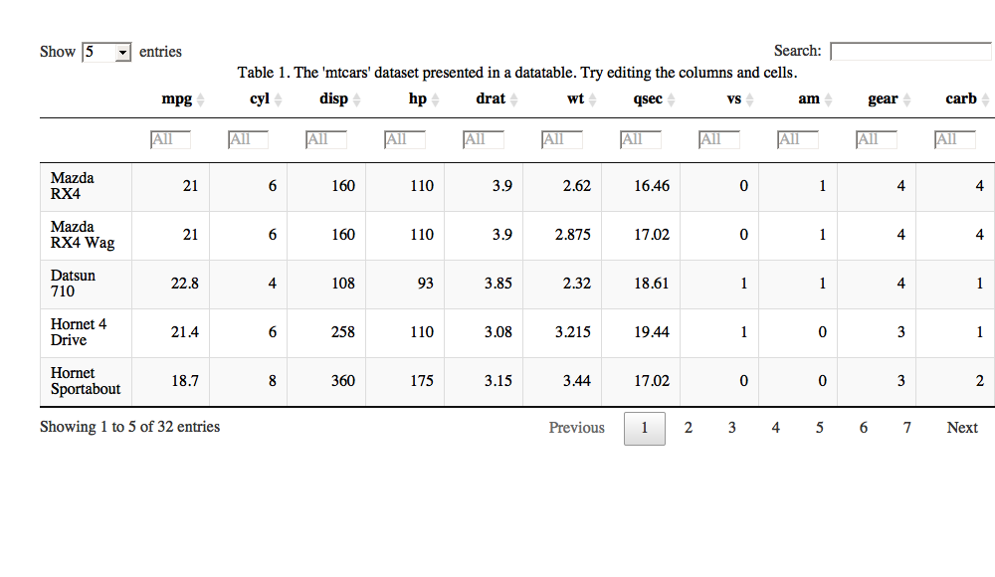

## Embed code from different languages

### This is R code

if (pck == 1) {  
 p <- c("rJava", "RNetLogo")  
 remove.packages(p)  
 # then install rJava and RNetLogo from source  
 install.packages("rJava", repos = "https://cran.r-project.org/")  
 install.packages("RNetLogo", repos = "https://cran.r-project.org/")  
}

### shell/bash

echo "Hello Bash!"   
pwd # check working dir  
git init # initialise git

### Octave (and MATLAB from the RMatlab package).

[RMatlab documentation](https://cran.r-project.org/web/packages/R.matlab/index.html).

b = [4; 9; 2] # Column vector  
A = [ 3 4 5;  
 1 3 1;  
 3 5 9 ]  
x = A \ b # Solve the system Ax = b

### HTML

<!-- links-->  
 <div class="footer">  
 <a href="dd_feed.html"   
 class="transition fade_in">  
 Latest post  
 </a>  
 &nbsp; &nbsp; &nbsp;  
 <a href="dd_contact.html"   
 class="transition fade_in">  
 Contact  
 </a>  
 &nbsp; &nbsp; &nbsp;  
 <a href="dd_subscribe.html"  
 class="transition fade_in">  
 Subscribe  
 </a>  
 </div>

### CSS

# custom code for the tabs in this file  
.btn {  
 border-width: 0 0px 0px 0px;  
 font-weight: normal;  
 text-transform: ;  
}  
.btn-default {  
 color: #f08080;  
 background-color: #ffffff;  
 border-color: #ffffff;  
}

### Javascript to access html and css

$('.title').css('color', 'red')

### Python

x = 'hello, python world!'  
print(x.split(' '))

### Here’s a complete list of available languages

names(knitr::knit_engines$get())

## [1] "awk" "bash" "coffee" "gawk" "groovy" "haskell" "lein" "mysql"   
## [9] "node" "octave" "perl" "psql" "Rscript" "ruby" "sas" "scala"   
## [17] "sed" "sh" "stata" "zsh" "highlight" "Rcpp" "tikz" "dot"   
## [25] "c" "fortran" "fortran95" "asy" "cat" "asis" "stan" "block"   
## [33] "block2" "js" "css" "sql" "go" "python" "julia" "sass"   
## [41] "scss"

1. Here is the footnote you created earlier, automatically formatted
2. Efthimiades, S., Physical meaning and derivation of Schrodinger and Dirac equations, Department of Natural Sciences, Fordham University. [doi: d34464566](https://arxiv.org/vc/quant-ph/papers/0607/0607001v1.pdf).