# Arduino’s skeleton

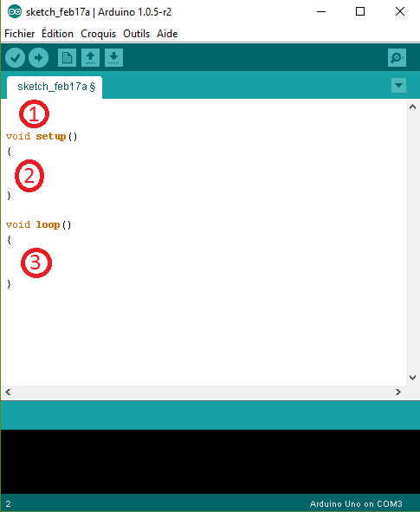

## 1 : Declaration area

This area serves to declare variables, includes, defines and others.

## 2 : Initialisation area

The setup fonction serves to init Arduino’s pins and communications.

Ex : communication between the arduino board and the computer.

## 3 : Execution area

The loop fonction contains the program’s instructions.

This fonction loop endlessly.