Name: Jeremy Lates

Date: 01/26/2024

Assignment #: 3.2

1. NodeSecurity Business Rules
   1. ORD

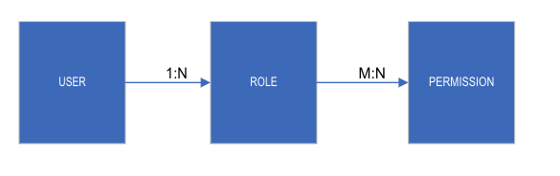

* 1. NoSQL Data Structure
     1. User/Role Data Structure

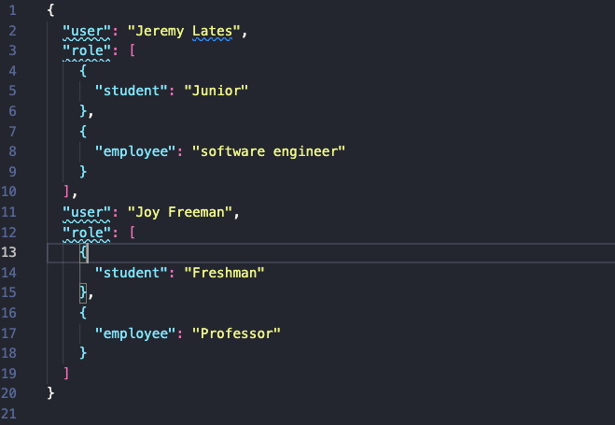

* + 1. For role to permission, which I feel is a many-to-many relationship, I was not sure how to create a many-to-many data structure. This is one to many.

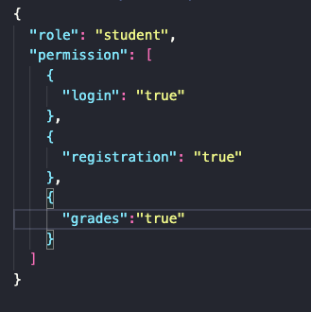

1. Convert NodeBookCO’s data fields into 2NF ORD & NoSQL Data Structure
   1. ORD

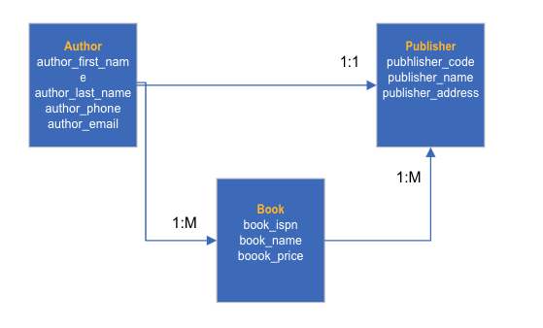

* 1. Data Structure
     1. Author/Book/Publisher data structure

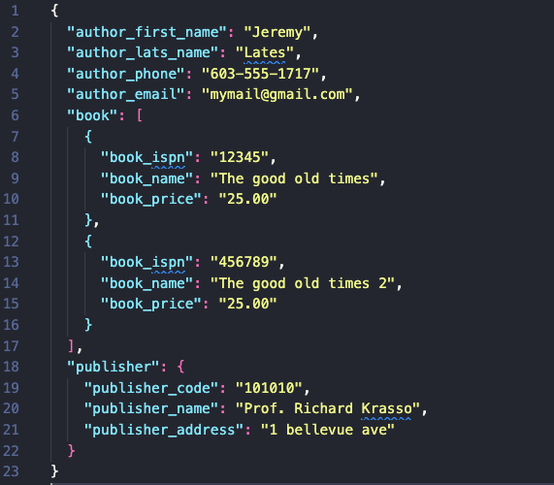

* + 1. Author/publisher