PROYECTO-RESPALDO.R

User

2020-07-26

data=read.csv(url("http://archive.ics.uci.edu/ml/machine-learning-databases/wine/wine.data"), header = FALSE)  
  
names(data)=c('Class','Alcohol','Malic acid','Ash','Alcalinity of ash','Magnesium','Total phenols','Flavanoids','Nonflavanoid phenols','Proanthocyanins','Color intensity','Hue','OD280/OD315','Proline')  
  
#LIBERIAS NECESARIAS   
library(dplyr)

## Warning: package 'dplyr' was built under R version 4.0.2

##   
## Attaching package: 'dplyr'

## The following objects are masked from 'package:stats':  
##   
## filter, lag

## The following objects are masked from 'package:base':  
##   
## intersect, setdiff, setequal, union

library(datasets)  
library(fdth)

##   
## Attaching package: 'fdth'

## The following objects are masked from 'package:stats':  
##   
## sd, var

#FILTRADA DE COLUMNA POR CLASE  
fc1=data %>% filter(data$Class==1)  
fc2=data %>% filter(data$Class==2)  
fc3=data %>% filter(data$Class==3)  
  
#PARTE 1........................................................................  
#HISTOGRAMA DE VARIABLES CUANTITATIVAS  
  
#HISTOGRAMAS DE FILTRADO DE CLASE1  
hist(fc1$Alcohol)

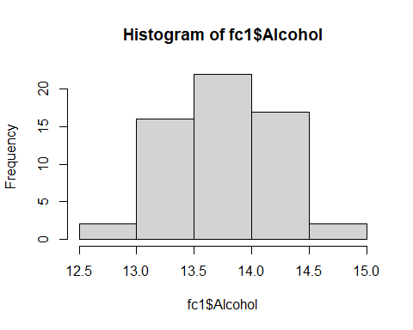

hist(fc1$`Malic acid`)

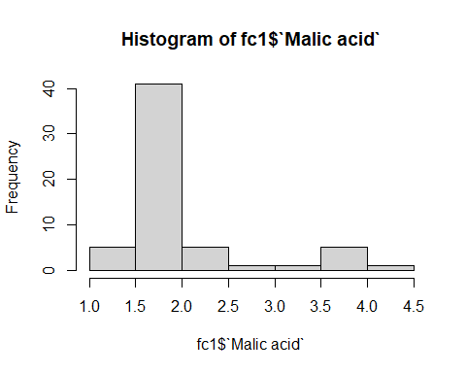

hist(fc1$Ash)

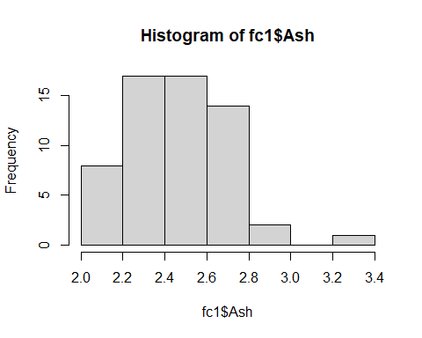

hist(fc1$`Alcalinity of ash`)

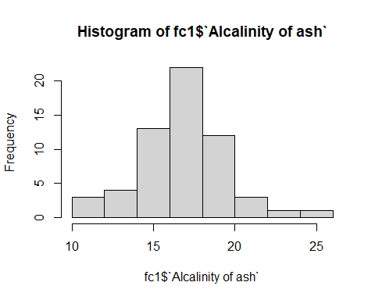

hist(fc1$Magnesium)

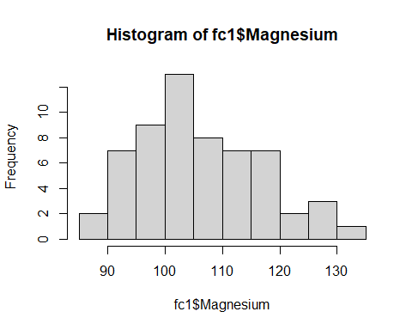

hist(fc1$`Total phenols`)

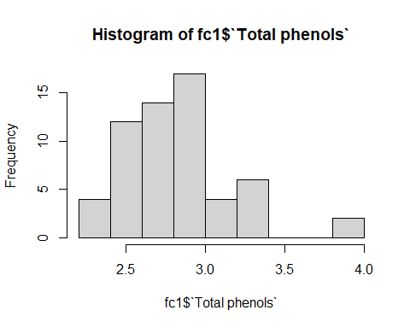

hist(fc1$Flavanoids)

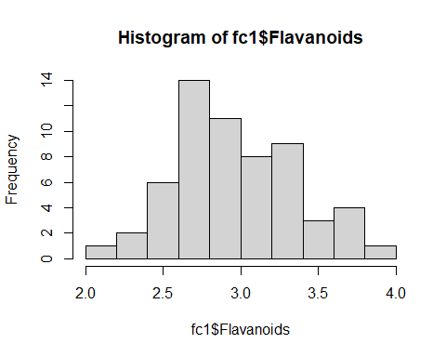

hist(fc1$`Nonflavanoid phenols`)

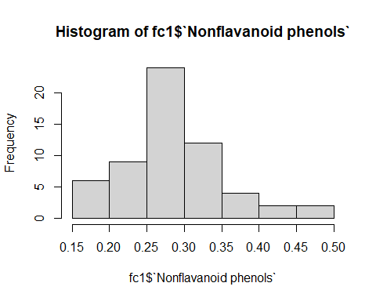

hist(fc1$Proanthocyanins)

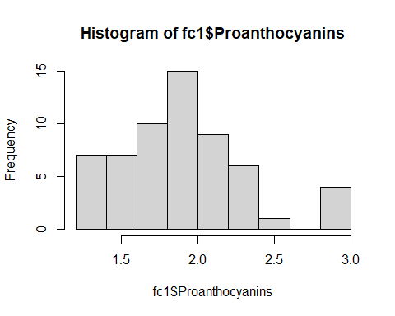

hist(fc1$`Color intensity`)

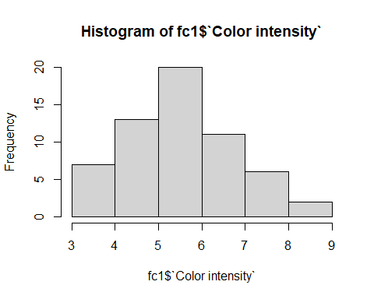

hist(fc1$Hue)

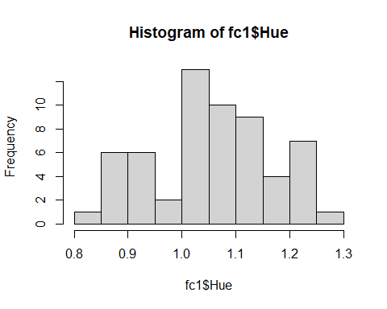

hist(fc1$`OD280/OD315`)

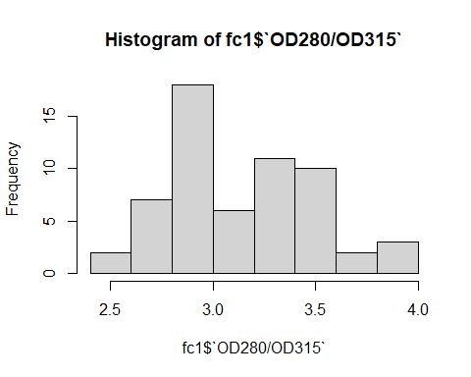

hist(fc1$Proline)

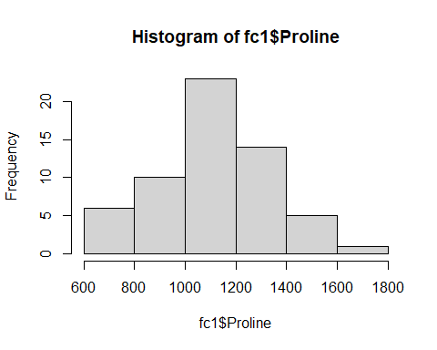

#HISTOGRAMA DE FILTRADO DE CLASE 2  
hist(fc2$Alcohol)

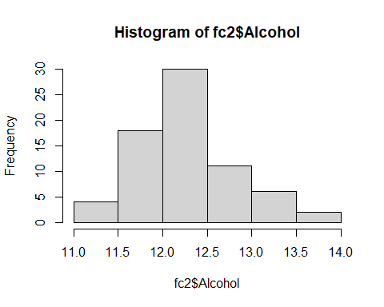

hist(fc2$`Malic acid`)

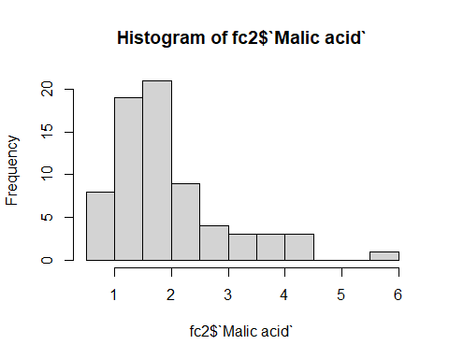

hist(fc2$Ash)

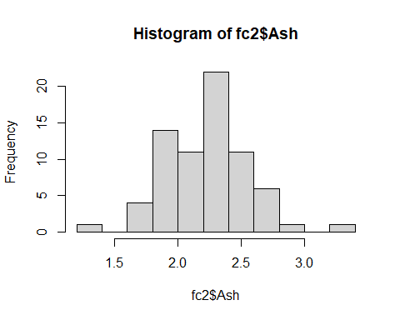

hist(fc2$`Alcalinity of ash`)

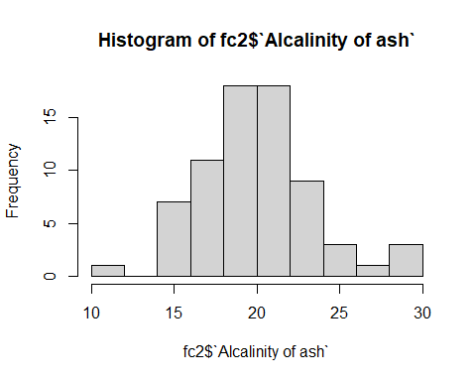

hist(fc2$Magnesium)

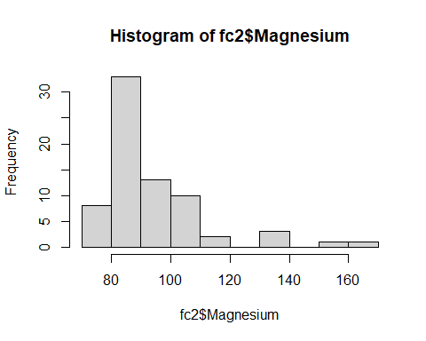

hist(fc2$`Total phenols`)

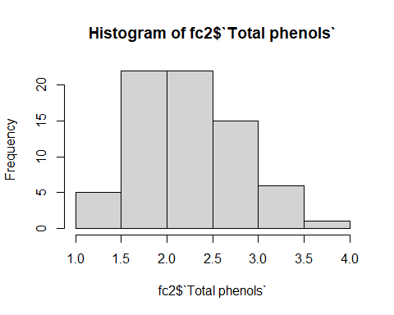

hist(fc2$Flavanoids)

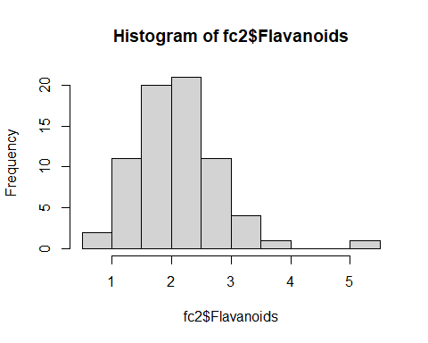

hist(fc2$`Nonflavanoid phenols`)

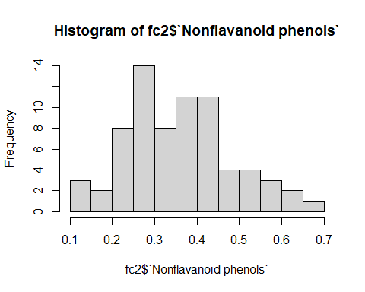

hist(fc2$Proanthocyanins)

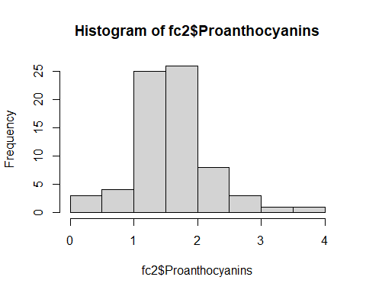

hist(fc2$`Color intensity`)

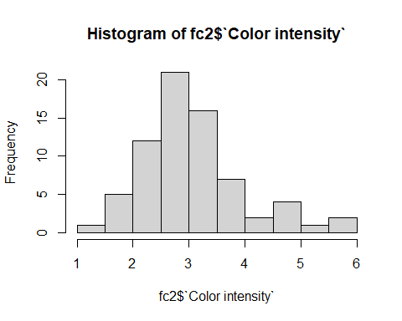

hist(fc2$Hue)

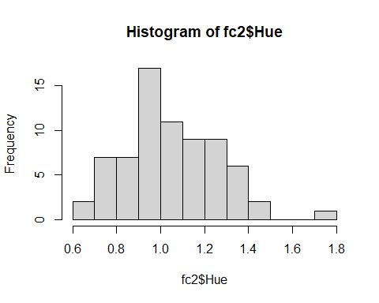

hist(fc2$`OD280/OD315`)

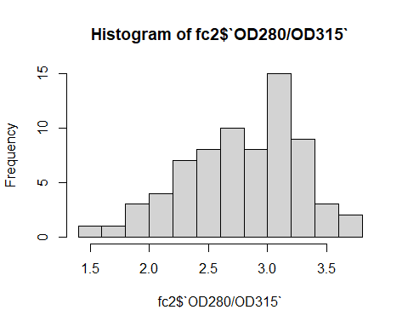

hist(fc2$Proline)

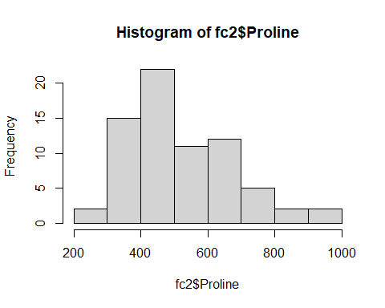

#HISTOGREAMA DE FILTRADO DE CLASE 3  
hist(fc3$Alcohol)

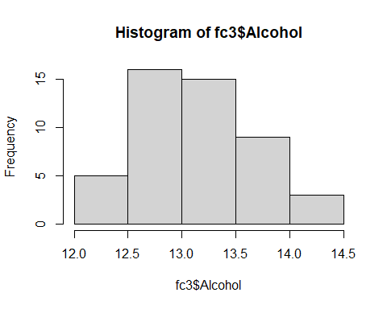

hist(fc3$`Malic acid`)

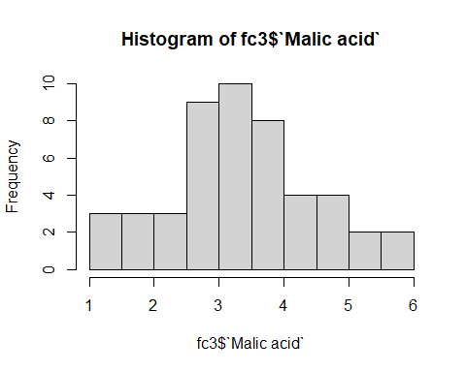

hist(fc3$Ash)

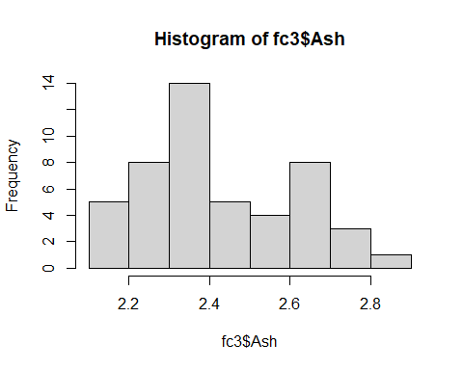

hist(fc3$`Alcalinity of ash`)

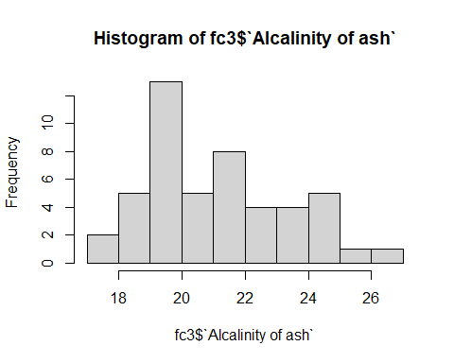

hist(fc3$Magnesium)

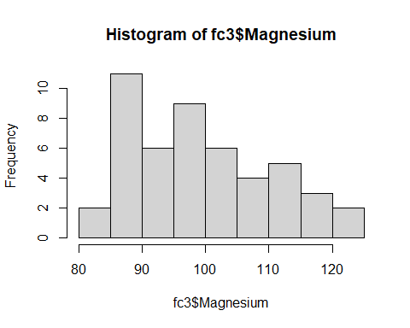

hist(fc3$`Total phenols`)

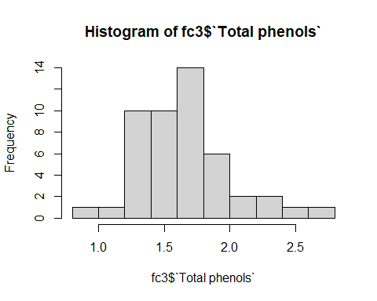

hist(fc3$Flavanoids)

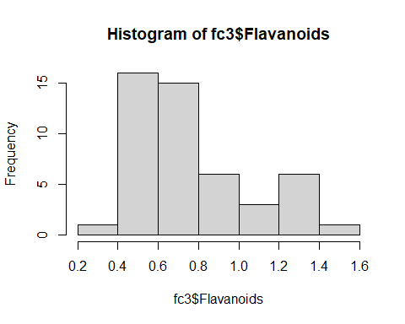

hist(fc3$`Nonflavanoid phenols`)

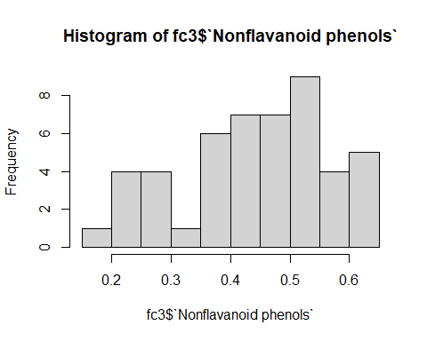

hist(fc3$Proanthocyanins)

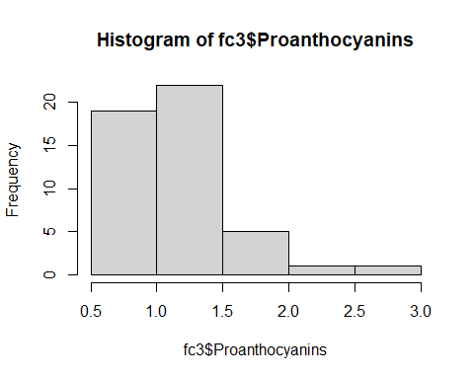

hist(fc3$`Color intensity`)

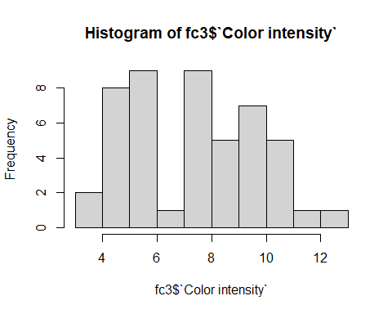

hist(fc3$Hue)

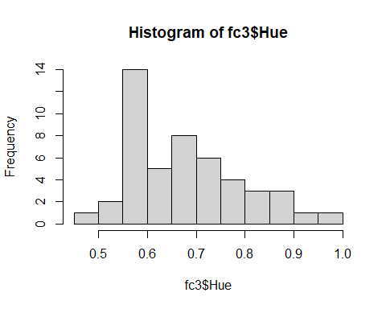

hist(fc3$`OD280/OD315`)

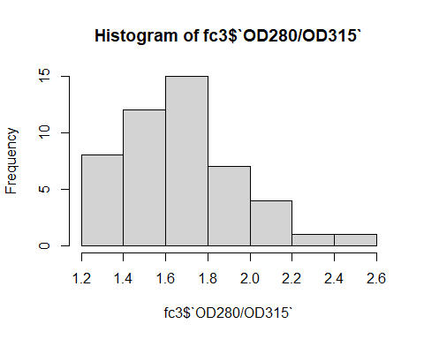

hist(fc3$Proline)

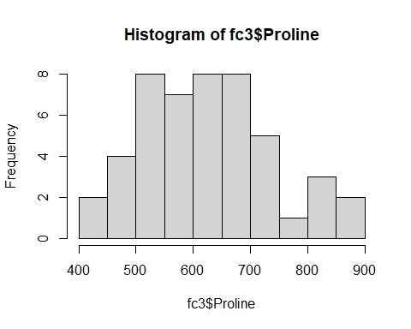

#DIAGRAMA DE CAJAS (CADA VARIABLE CUANTITATIVA VS VARIABLE CUALITATIVA)  
#DIAGRAMA DE CAJAS FILTRADAS CON CLASE 1  
  
  
boxplot(fc1$Alcohol~fc1$Class,horizontal = TRUE,xlab = "Alcohol",ylab="Vino clase 1",main="Diagrama de cajas",col=c(123))

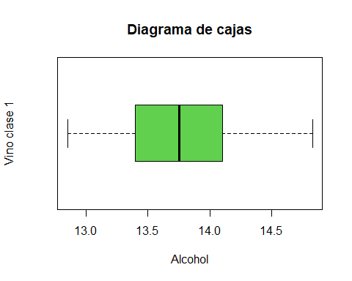

boxplot(fc1$`Malic acid`~fc1$Class,horizontal = TRUE)

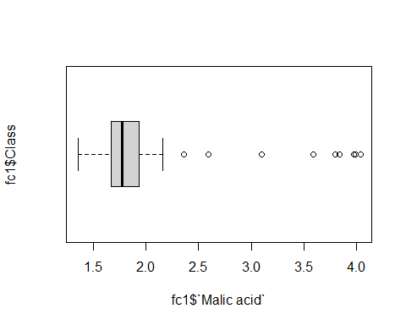

boxplot(fc1$Ash~fc1$Class,horizontal = TRUE)

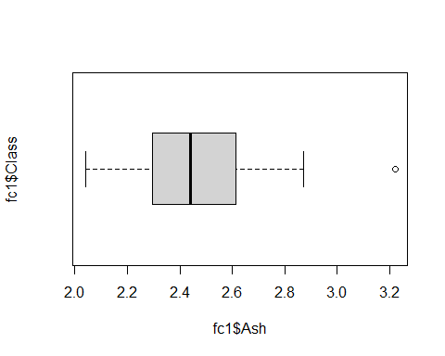

boxplot(fc1$`Alcalinity of ash`~fc1$Class,horizontal = TRUE)

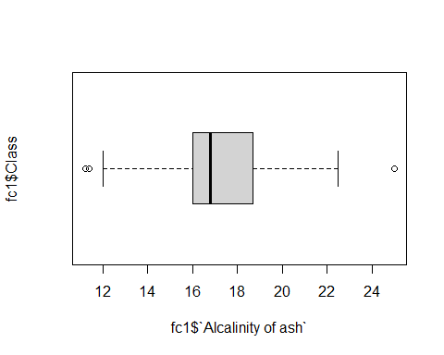

boxplot(fc1$Magnesium~fc1$Class,horizontal = TRUE)

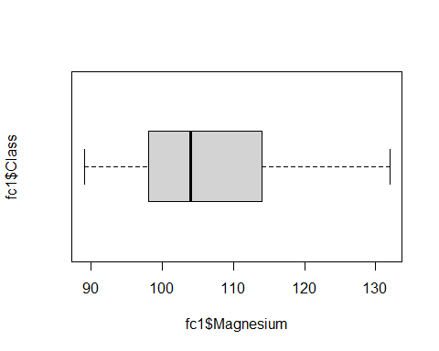

boxplot(fc1$`Total phenols`~fc1$Class,horizontal = TRUE)

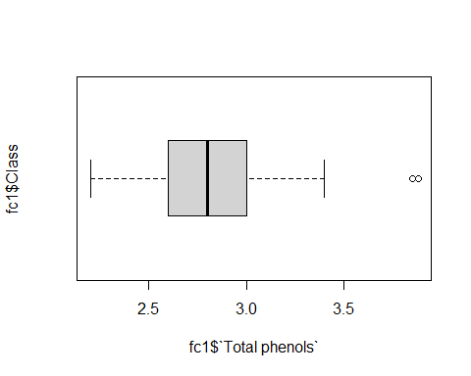

boxplot(fc1$Flavanoids~fc1$Class,horizontal = TRUE)

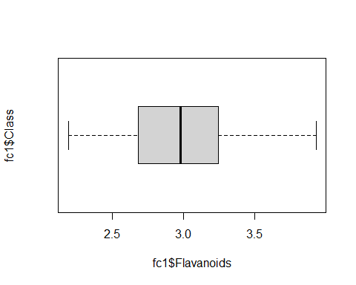

boxplot(fc1$`Nonflavanoid phenols`~fc1$Class,horizontal = TRUE)

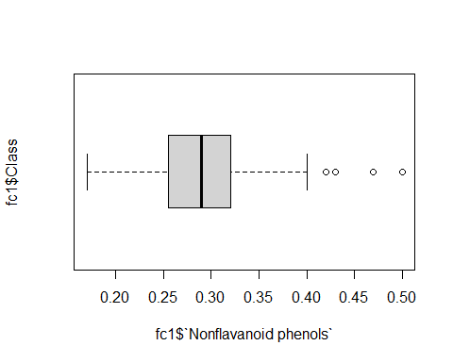

boxplot(fc1$Proanthocyanins~fc1$Class,horizontal = TRUE)

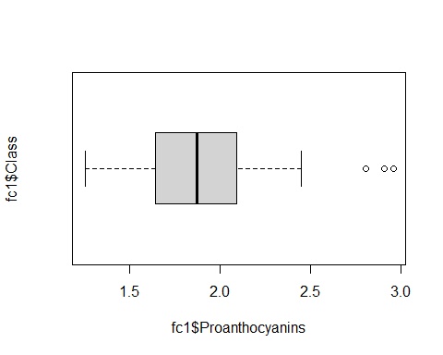

boxplot(fc1$`Color intensity`~fc1$Class,horizontal = TRUE)

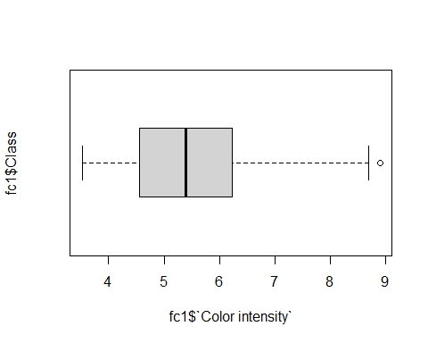

boxplot(fc1$Hue~fc1$Class,horizontal = TRUE)

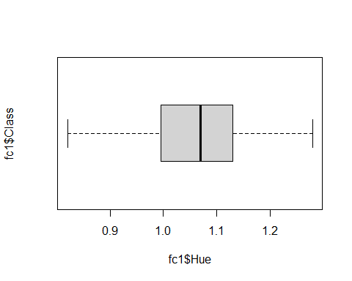

boxplot(fc1$`OD280/OD315`~fc1$Class,horizontal = TRUE)

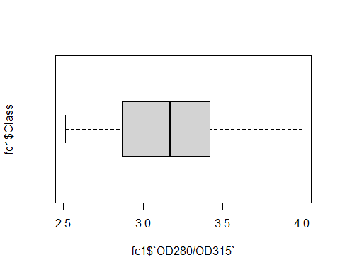

boxplot(fc1$Proline~fc1$Class,horizontal = TRUE)

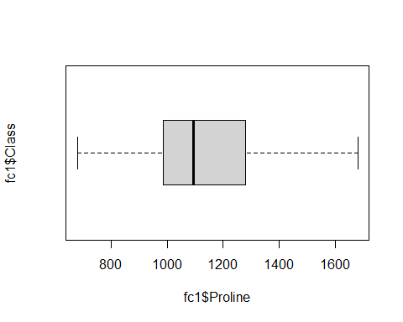

#DIAGRAMA DE CAJAS FILTRADAS CON CLASE 2  
boxplot(fc2$Alcohol~fc2$Class,horizontal = TRUE)

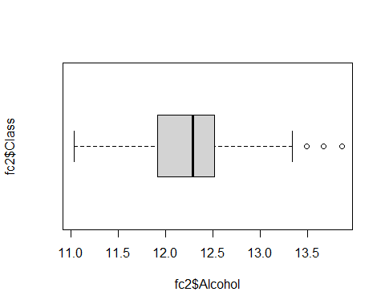

boxplot(fc2$`Malic acid`~fc2$Class,horizontal = TRUE)

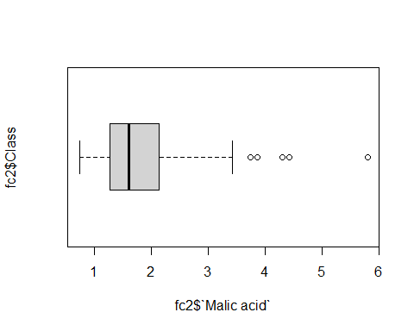

boxplot(fc2$Ash~fc2$Class,horizontal = TRUE)

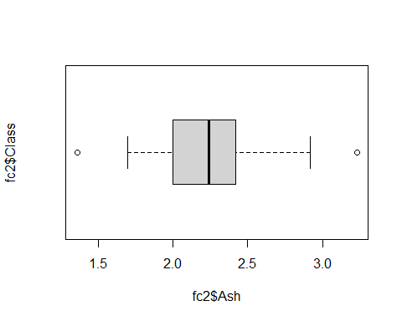

boxplot(fc2$`Alcalinity of ash`~fc2$Class,horizontal = TRUE)

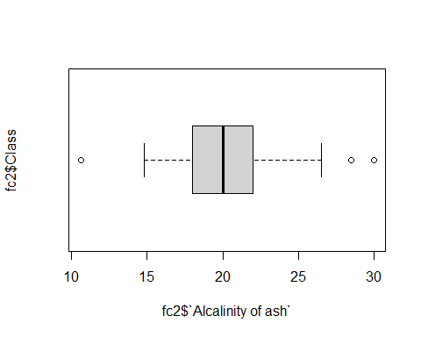

boxplot(fc2$Magnesium~fc2$Class,horizontal = TRUE)

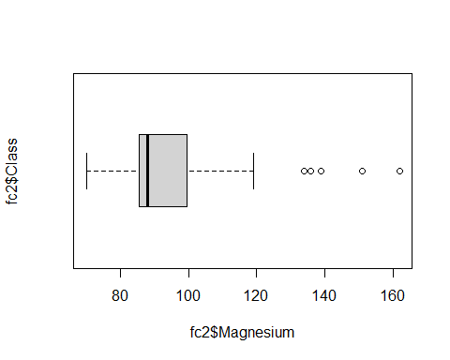

boxplot(fc2$`Total phenols`~fc2$Class,horizontal = TRUE)

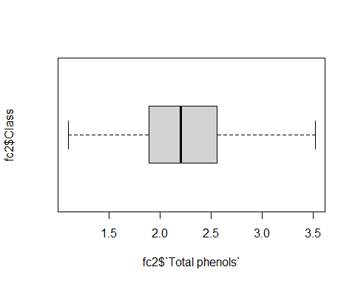

boxplot(fc2$Flavanoids~fc2$Class,horizontal = TRUE)

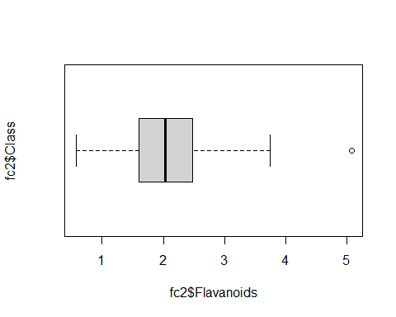

boxplot(fc2$`Nonflavanoid phenols`~fc2$Class,horizontal = TRUE)

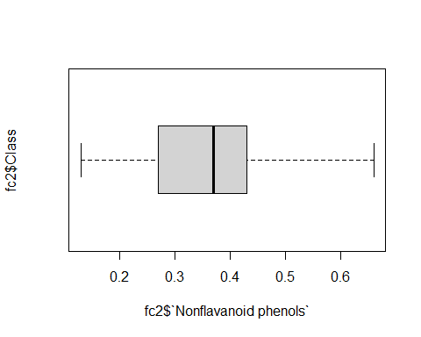

boxplot(fc2$Proanthocyanins~fc2$Class,horizontal = TRUE)

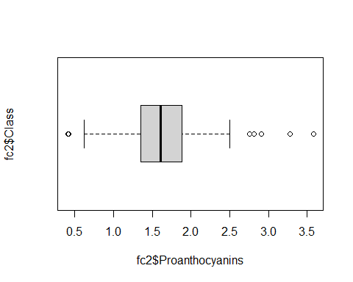

boxplot(fc2$`Color intensity`~fc2$Class,horizontal = TRUE)

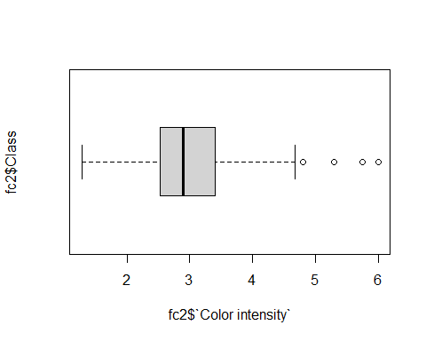

boxplot(fc2$Hue~fc2$Class,horizontal = TRUE)

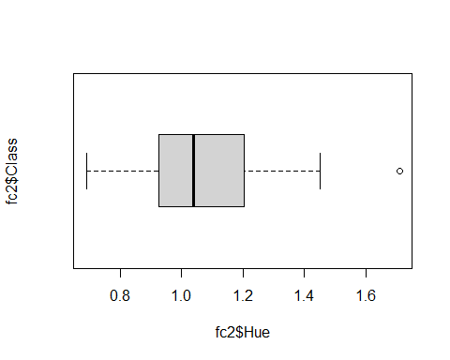

boxplot(fc2$`OD280/OD315`~fc2$Class,horizontal = TRUE)

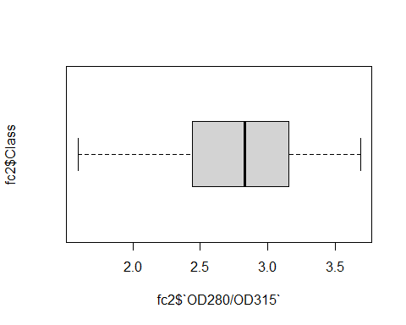

boxplot(fc2$Proline~fc2$Class,horizontal = TRUE)

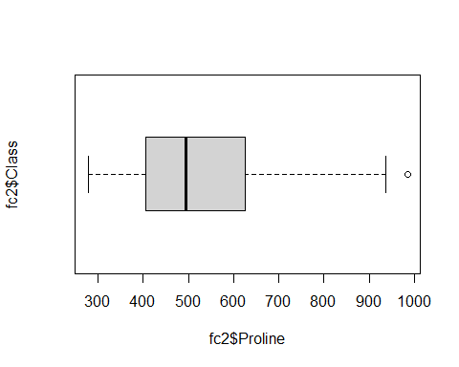

#DIAGRAMA DE CAJAS FILTRADAS CON CLASE 3  
boxplot(fc3$Alcohol~fc3$Class,horizontal = TRUE)

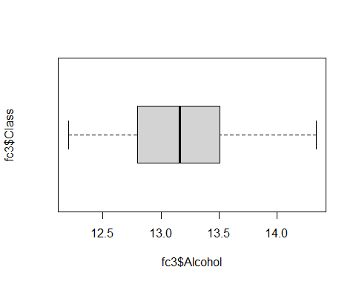

boxplot(fc3$`Malic acid`~fc3$Class,horizontal = TRUE)

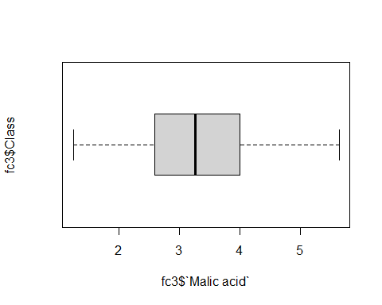

boxplot(fc3$Ash~fc3$Class,horizontal = TRUE)

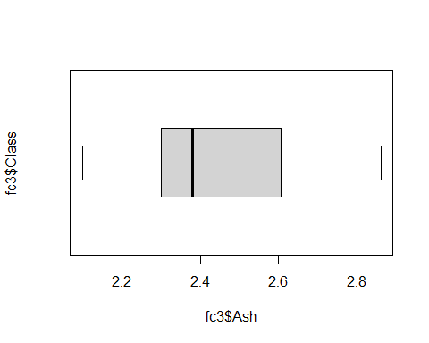

boxplot(fc3$`Alcalinity of ash`~fc3$Class,horizontal = TRUE)

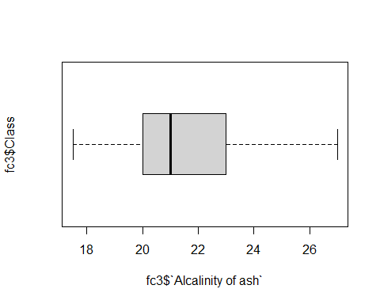

boxplot(fc3$Magnesium~fc3$Class,horizontal = TRUE)

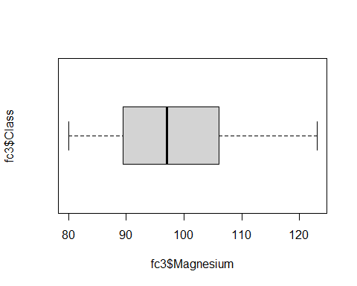

boxplot(fc3$`Total phenols`~fc3$Class,horizontal = TRUE)

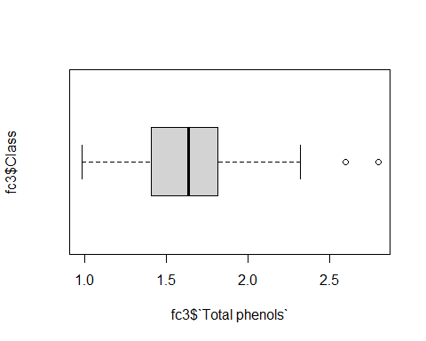

boxplot(fc3$Flavanoids~fc3$Class,horizontal = TRUE)

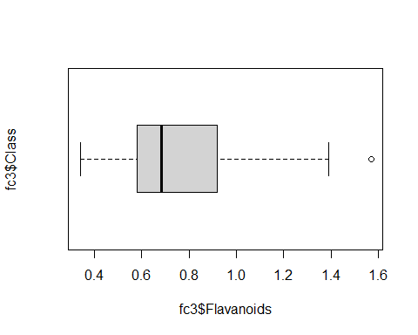

boxplot(fc3$`Nonflavanoid phenols`~fc3$Class,horizontal = TRUE)

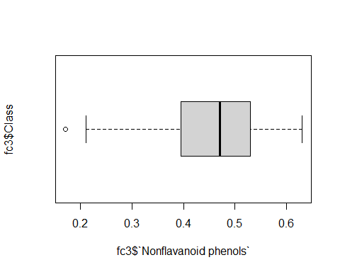

boxplot(fc3$Proanthocyanins~fc3$Class,horizontal = TRUE)

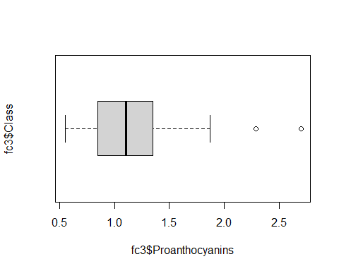

boxplot(fc3$`Color intensity`~fc3$Class,horizontal = TRUE)

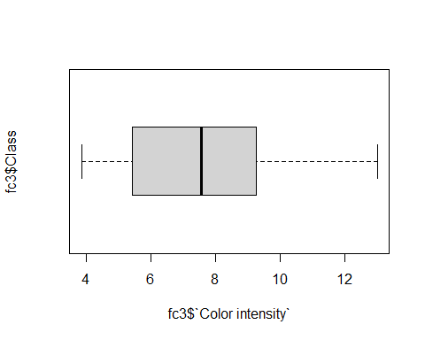

boxplot(fc3$Hue~fc3$Class,horizontal = TRUE)

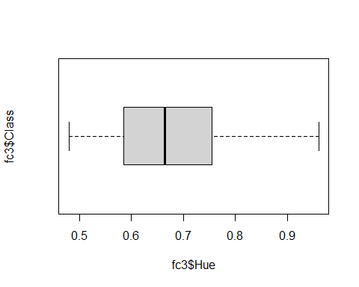

boxplot(fc3$`OD280/OD315`~fc3$Class,horizontal = TRUE)

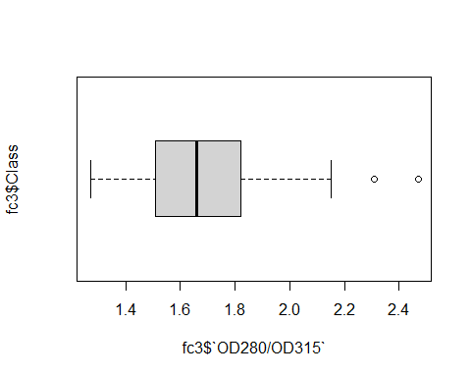

boxplot(fc3$Proline~fc3$Class,horizontal = TRUE)

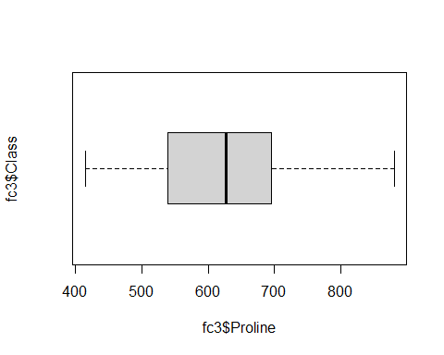

#MEDIDAS ESTADISTICAS (CADA VARIABLE CUANTITATIVA)  
#MEDIDAS FILTRADAS POR CLASE 1  
summary(fc1$Alcohol)

## Min. 1st Qu. Median Mean 3rd Qu. Max.   
## 12.85 13.40 13.75 13.74 14.10 14.83

sd(fc1$Alcohol)

## [1] 0.4621254

summary(fc1$`Malic acid`)

## Min. 1st Qu. Median Mean 3rd Qu. Max.   
## 1.350 1.665 1.770 2.011 1.935 4.040

sd(fc1$`Malic acid`)

## [1] 0.6885489

summary(fc1$Ash)

## Min. 1st Qu. Median Mean 3rd Qu. Max.   
## 2.040 2.295 2.440 2.456 2.615 3.220

sd(fc1$Ash)

## [1] 0.227166

summary(fc1$`Alcalinity of ash`)

## Min. 1st Qu. Median Mean 3rd Qu. Max.   
## 11.20 16.00 16.80 17.04 18.70 25.00

sd(fc1$`Alcalinity of ash`)

## [1] 2.546322

summary(fc1$Magnesium)

## Min. 1st Qu. Median Mean 3rd Qu. Max.   
## 89.0 98.0 104.0 106.3 114.0 132.0

sd(fc1$Magnesium)

## [1] 10.49895

summary(fc1$`Total phenols`)

## Min. 1st Qu. Median Mean 3rd Qu. Max.   
## 2.20 2.60 2.80 2.84 3.00 3.88

sd(fc1$`Total phenols`)

## [1] 0.3389614

summary(fc1$Flavanoids)

## Min. 1st Qu. Median Mean 3rd Qu. Max.   
## 2.190 2.680 2.980 2.982 3.245 3.930

sd(fc1$Flavanoids)

## [1] 0.3974936

summary(fc1$`Nonflavanoid phenols`)

## Min. 1st Qu. Median Mean 3rd Qu. Max.   
## 0.170 0.255 0.290 0.290 0.320 0.500

sd(fc1$`Nonflavanoid phenols`)

## [1] 0.07004924

summary(fc1$Proanthocyanins)

## Min. 1st Qu. Median Mean 3rd Qu. Max.   
## 1.250 1.640 1.870 1.899 2.090 2.960

sd(fc1$Proanthocyanins)

## [1] 0.4121092

summary(fc1$`Color intensity`)

## Min. 1st Qu. Median Mean 3rd Qu. Max.   
## 3.520 4.550 5.400 5.528 6.225 8.900

sd(fc1$`Color intensity`)

## [1] 1.238573

summary(fc1$Hue)

## Min. 1st Qu. Median Mean 3rd Qu. Max.   
## 0.820 0.995 1.070 1.062 1.130 1.280

sd(fc1$Hue)

## [1] 0.1164826

summary(fc1$`OD280/OD315`)

## Min. 1st Qu. Median Mean 3rd Qu. Max.   
## 2.510 2.870 3.170 3.158 3.420 4.000

sd(fc1$`OD280/OD315`)

## [1] 0.3570766

summary(fc1$Proline)

## Min. 1st Qu. Median Mean 3rd Qu. Max.   
## 680.0 987.5 1095.0 1115.7 1280.0 1680.0

sd(fc1$Proline)

## [1] 221.5208

#MEDIDAS FILTRADAS POR CLASE 2  
summary(fc2$Alcohol)

## Min. 1st Qu. Median Mean 3rd Qu. Max.   
## 11.03 11.91 12.29 12.28 12.52 13.86

sd(fc2$Alcohol)

## [1] 0.5379642

summary(fc2$`Malic acid`)

## Min. 1st Qu. Median Mean 3rd Qu. Max.   
## 0.740 1.270 1.610 1.933 2.145 5.800

sd(fc2$`Malic acid`)

## [1] 1.015569

summary(fc2$Ash)

## Min. 1st Qu. Median Mean 3rd Qu. Max.   
## 1.360 2.000 2.240 2.245 2.420 3.230

sd(fc2$Ash)

## [1] 0.3154673

summary(fc2$`Alcalinity of ash`)

## Min. 1st Qu. Median Mean 3rd Qu. Max.   
## 10.60 18.00 20.00 20.24 22.00 30.00

sd(fc2$`Alcalinity of ash`)

## [1] 3.34977

summary(fc2$Magnesium)

## Min. 1st Qu. Median Mean 3rd Qu. Max.   
## 70.00 85.50 88.00 94.55 99.50 162.00

sd(fc2$Magnesium)

## [1] 16.7535

summary(fc2$`Total phenols`)

## Min. 1st Qu. Median Mean 3rd Qu. Max.   
## 1.100 1.895 2.200 2.259 2.560 3.520

sd(fc2$`Total phenols`)

## [1] 0.5453611

summary(fc2$Flavanoids)

## Min. 1st Qu. Median Mean 3rd Qu. Max.   
## 0.570 1.605 2.030 2.081 2.475 5.080

sd(fc2$Flavanoids)

## [1] 0.7057008

summary(fc2$`Nonflavanoid phenols`)

## Min. 1st Qu. Median Mean 3rd Qu. Max.   
## 0.1300 0.2700 0.3700 0.3637 0.4300 0.6600

sd(fc2$`Nonflavanoid phenols`)

## [1] 0.1239613

summary(fc2$Proanthocyanins)

## Min. 1st Qu. Median Mean 3rd Qu. Max.   
## 0.410 1.350 1.610 1.630 1.885 3.580

sd(fc2$Proanthocyanins)

## [1] 0.6020678

summary(fc2$`Color intensity`)

## Min. 1st Qu. Median Mean 3rd Qu. Max.   
## 1.280 2.535 2.900 3.087 3.400 6.000

sd(fc2$`Color intensity`)

## [1] 0.9249293

summary(fc2$Hue)

## Min. 1st Qu. Median Mean 3rd Qu. Max.   
## 0.690 0.925 1.040 1.056 1.205 1.710

sd(fc2$Hue)

## [1] 0.2029368

summary(fc2$`OD280/OD315`)

## Min. 1st Qu. Median Mean 3rd Qu. Max.   
## 1.590 2.440 2.830 2.785 3.160 3.690

sd(fc2$`OD280/OD315`)

## [1] 0.4965735

summary(fc2$Proline)

## Min. 1st Qu. Median Mean 3rd Qu. Max.   
## 278.0 406.5 495.0 519.5 625.0 985.0

sd(fc2$Proline)

## [1] 157.2112

#MEDIDAS FILTRADAS POR CLASE 3  
summary(fc3$Alcohol)

## Min. 1st Qu. Median Mean 3rd Qu. Max.   
## 12.20 12.80 13.16 13.15 13.51 14.34

sd(fc3$Alcohol)

## [1] 0.5302413

summary(fc3$`Malic acid`)

## Min. 1st Qu. Median Mean 3rd Qu. Max.   
## 1.240 2.587 3.265 3.334 3.958 5.650

sd(fc3$`Malic acid`)

## [1] 1.087906

summary(fc3$Ash)

## Min. 1st Qu. Median Mean 3rd Qu. Max.   
## 2.100 2.300 2.380 2.437 2.603 2.860

sd(fc3$Ash)

## [1] 0.1846902

summary(fc3$`Alcalinity of ash`)

## Min. 1st Qu. Median Mean 3rd Qu. Max.   
## 17.50 20.00 21.00 21.42 23.00 27.00

sd(fc3$`Alcalinity of ash`)

## [1] 2.258161

summary(fc3$Magnesium)

## Min. 1st Qu. Median Mean 3rd Qu. Max.   
## 80.00 89.75 97.00 99.31 106.00 123.00

sd(fc3$Magnesium)

## [1] 10.89047

summary(fc3$`Total phenols`)

## Min. 1st Qu. Median Mean 3rd Qu. Max.   
## 0.980 1.407 1.635 1.679 1.808 2.800

sd(fc3$`Total phenols`)

## [1] 0.3569709

summary(fc3$Flavanoids)

## Min. 1st Qu. Median Mean 3rd Qu. Max.   
## 0.3400 0.5800 0.6850 0.7815 0.9200 1.5700

sd(fc3$Flavanoids)

## [1] 0.2935041

summary(fc3$`Nonflavanoid phenols`)

## Min. 1st Qu. Median Mean 3rd Qu. Max.   
## 0.1700 0.3975 0.4700 0.4475 0.5300 0.6300

sd(fc3$`Nonflavanoid phenols`)

## [1] 0.1241396

summary(fc3$Proanthocyanins)

## Min. 1st Qu. Median Mean 3rd Qu. Max.   
## 0.550 0.855 1.105 1.154 1.350 2.700

sd(fc3$Proanthocyanins)

## [1] 0.4088359

summary(fc3$`Color intensity`)

## Min. 1st Qu. Median Mean 3rd Qu. Max.   
## 3.850 5.438 7.550 7.396 9.225 13.000

sd(fc3$`Color intensity`)

## [1] 2.310942

summary(fc3$Hue)

## Min. 1st Qu. Median Mean 3rd Qu. Max.   
## 0.4800 0.5875 0.6650 0.6827 0.7525 0.9600

sd(fc3$Hue)

## [1] 0.1144411

summary(fc3$`OD280/OD315`)

## Min. 1st Qu. Median Mean 3rd Qu. Max.   
## 1.270 1.510 1.660 1.684 1.820 2.470

sd(fc3$`OD280/OD315`)

## [1] 0.2721114

summary(fc3$Proline)

## Min. 1st Qu. Median Mean 3rd Qu. Max.   
## 415.0 545.0 627.5 629.9 695.0 880.0

sd(fc3$Proline)

## [1] 115.097

#DIAGRAMAS DE FRECUENCIAS (VARIABLES CUALITITATIVAS)  
tablaFrecuencia=fdt(data$Class)  
tablaFrecuencia

## Class limits f rf rf(%) cf cf(%)  
## [0.99,1.217) 59 0.33 33.15 59 33.15  
## [1.217,1.443) 0 0.00 0.00 59 33.15  
## [1.443,1.67) 0 0.00 0.00 59 33.15  
## [1.67,1.897) 0 0.00 0.00 59 33.15  
## [1.897,2.123) 71 0.40 39.89 130 73.03  
## [2.123,2.35) 0 0.00 0.00 130 73.03  
## [2.35,2.577) 0 0.00 0.00 130 73.03  
## [2.577,2.803) 0 0.00 0.00 130 73.03  
## [2.803,3.03) 48 0.27 26.97 178 100.00

#DIAGRAMA DE BARRAS (VARIABLES CUALITATIVAS)  
diagramaBarras=barplot(prop.table(table(data$Class)),col=c("yellow","blue","red"),legend.text=c("Vino1","Vino2","Vino3"),ylim=c(0,0.8),main="CLASE DE VINOS")  
diagramaBarras

## [,1]  
## [1,] 0.7  
## [2,] 1.9  
## [3,] 3.1

#FIN DE PARTE 1.................................................................  
  
#PARTE 2........................................................................  
  
  
library(corrplot)

## Warning: package 'corrplot' was built under R version 4.0.2

## corrplot 0.84 loaded

library(ggplot2)

## Warning: package 'ggplot2' was built under R version 4.0.2

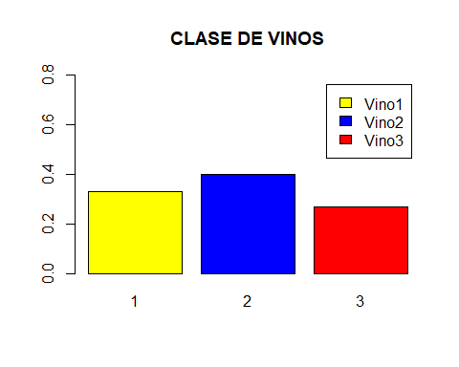

#matriz correlacion vino clase 1  
  
#fc1$Class=NULL  
fc1.cor<-cor(fc1,method="pearson")

## Warning in cor(fc1, method = "pearson"): the standard deviation is zero

round(fc1.cor,digits=2)

## Class Alcohol Malic acid Ash Alcalinity of ash Magnesium  
## Class 1 NA NA NA NA NA  
## Alcohol NA 1.00 -0.04 -0.15 -0.32 0.16  
## Malic acid NA -0.04 1.00 0.03 0.06 0.08  
## Ash NA -0.15 0.03 1.00 0.55 0.38  
## Alcalinity of ash NA -0.32 0.06 0.55 1.00 0.24  
## Magnesium NA 0.16 0.08 0.38 0.24 1.00  
## Total phenols NA 0.42 -0.08 0.00 -0.22 0.31  
## Flavanoids NA 0.41 -0.19 -0.07 -0.29 0.12  
## Nonflavanoid phenols NA 0.02 -0.09 0.47 0.30 0.24  
## Proanthocyanins NA 0.31 -0.08 -0.15 -0.17 -0.06  
## Color intensity NA 0.41 -0.26 -0.12 -0.21 0.18  
## Hue NA 0.08 -0.42 0.24 0.09 -0.11  
## OD280/OD315 NA 0.07 0.17 -0.08 -0.12 0.12  
## Proline NA 0.36 -0.37 -0.03 -0.12 -0.15  
## Total phenols Flavanoids Nonflavanoid phenols  
## Class NA NA NA  
## Alcohol 0.42 0.41 0.02  
## Malic acid -0.08 -0.19 -0.09  
## Ash 0.00 -0.07 0.47  
## Alcalinity of ash -0.22 -0.29 0.30  
## Magnesium 0.31 0.12 0.24  
## Total phenols 1.00 0.80 -0.02  
## Flavanoids 0.80 1.00 -0.09  
## Nonflavanoid phenols -0.02 -0.09 1.00  
## Proanthocyanins 0.37 0.55 -0.14  
## Color intensity 0.65 0.74 -0.15  
## Hue -0.22 0.01 0.41  
## OD280/OD315 0.05 -0.09 -0.32  
## Proline 0.29 0.38 -0.02  
## Proanthocyanins Color intensity Hue OD280/OD315 Proline  
## Class NA NA NA NA NA  
## Alcohol 0.31 0.41 0.08 0.07 0.36  
## Malic acid -0.08 -0.26 -0.42 0.17 -0.37  
## Ash -0.15 -0.12 0.24 -0.08 -0.03  
## Alcalinity of ash -0.17 -0.21 0.09 -0.12 -0.12  
## Magnesium -0.06 0.18 -0.11 0.12 -0.15  
## Total phenols 0.37 0.65 -0.22 0.05 0.29  
## Flavanoids 0.55 0.74 0.01 -0.09 0.38  
## Nonflavanoid phenols -0.14 -0.15 0.41 -0.32 -0.02  
## Proanthocyanins 1.00 0.42 0.10 0.00 0.14  
## Color intensity 0.42 1.00 0.03 -0.19 0.59  
## Hue 0.10 0.03 1.00 -0.31 0.35  
## OD280/OD315 0.00 -0.19 -0.31 1.00 -0.35  
## Proline 0.14 0.59 0.35 -0.35 1.00

corrplot(fc1.cor)

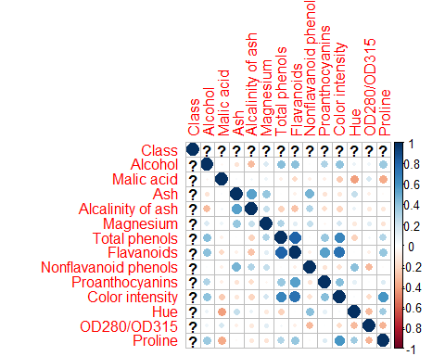

#matriz correlacion vino clase 2  
#fc2$Class=NULL  
fc2.cor<-cor(fc2,method="pearson")

## Warning in cor(fc2, method = "pearson"): the standard deviation is zero

round(fc2.cor,digits=2)

## Class Alcohol Malic acid Ash Alcalinity of ash Magnesium  
## Class 1 NA NA NA NA NA  
## Alcohol NA 1.00 -0.02 -0.21 -0.06 -0.03  
## Malic acid NA -0.02 1.00 0.15 0.24 -0.08  
## Ash NA -0.21 0.15 1.00 0.70 0.13  
## Alcalinity of ash NA -0.06 0.24 0.70 1.00 0.00  
## Magnesium NA -0.03 -0.08 0.13 0.00 1.00  
## Total phenols NA -0.05 0.04 0.11 0.13 0.07  
## Flavanoids NA -0.04 0.11 0.31 0.31 0.00  
## Nonflavanoid phenols NA -0.07 0.13 0.30 0.18 -0.19  
## Proanthocyanins NA -0.19 0.21 0.04 0.11 0.30  
## Color intensity NA 0.27 -0.20 0.06 -0.09 0.04  
## Hue NA 0.00 -0.41 -0.03 -0.08 0.12  
## OD280/OD315 NA -0.13 0.16 0.16 0.38 -0.08  
## Proline NA 0.04 -0.22 0.04 -0.01 0.50  
## Total phenols Flavanoids Nonflavanoid phenols  
## Class NA NA NA  
## Alcohol -0.05 -0.04 -0.07  
## Malic acid 0.04 0.11 0.13  
## Ash 0.11 0.31 0.30  
## Alcalinity of ash 0.13 0.31 0.18  
## Magnesium 0.07 0.00 -0.19  
## Total phenols 1.00 0.77 -0.42  
## Flavanoids 0.77 1.00 -0.24  
## Nonflavanoid phenols -0.42 -0.24 1.00  
## Proanthocyanins 0.38 0.50 -0.32  
## Color intensity 0.17 0.38 0.02  
## Hue 0.04 -0.03 -0.03  
## OD280/OD315 0.48 0.58 -0.41  
## Proline 0.02 -0.12 -0.15  
## Proanthocyanins Color intensity Hue OD280/OD315 Proline  
## Class NA NA NA NA NA  
## Alcohol -0.19 0.27 0.00 -0.13 0.04  
## Malic acid 0.21 -0.20 -0.41 0.16 -0.22  
## Ash 0.04 0.06 -0.03 0.16 0.04  
## Alcalinity of ash 0.11 -0.09 -0.08 0.38 -0.01  
## Magnesium 0.30 0.04 0.12 -0.08 0.50  
## Total phenols 0.38 0.17 0.04 0.48 0.02  
## Flavanoids 0.50 0.38 -0.03 0.58 -0.12  
## Nonflavanoid phenols -0.32 0.02 -0.03 -0.41 -0.15  
## Proanthocyanins 1.00 -0.07 -0.05 0.39 0.12  
## Color intensity -0.07 1.00 -0.03 -0.12 0.10  
## Hue -0.05 -0.03 1.00 -0.05 0.11  
## OD280/OD315 0.39 -0.12 -0.05 1.00 -0.11  
## Proline 0.12 0.10 0.11 -0.11 1.00

#matriz correlacion vino clase 3  
#fc3$Class=NULL  
fc3.cor<-cor(fc3,method="pearson")

## Warning in cor(fc3, method = "pearson"): the standard deviation is zero

round(fc3.cor,digits=2)

## Class Alcohol Malic acid Ash Alcalinity of ash Magnesium  
## Class 1 NA NA NA NA NA  
## Alcohol NA 1.00 0.11 0.25 0.21 -0.08  
## Malic acid NA 0.11 1.00 0.02 0.09 -0.17  
## Ash NA 0.25 0.02 1.00 0.76 0.21  
## Alcalinity of ash NA 0.21 0.09 0.76 1.00 0.16  
## Magnesium NA -0.08 -0.17 0.21 0.16 1.00  
## Total phenols NA 0.21 -0.16 0.47 0.36 -0.04  
## Flavanoids NA 0.08 -0.28 0.28 0.27 0.57  
## Nonflavanoid phenols NA 0.04 0.14 -0.02 -0.02 -0.51  
## Proanthocyanins NA 0.38 -0.22 0.19 0.26 0.15  
## Color intensity NA 0.35 -0.16 0.13 0.16 0.10  
## Hue NA -0.03 0.08 0.18 0.03 0.00  
## OD280/OD315 NA 0.13 0.01 0.23 0.04 -0.22  
## Proline NA -0.09 0.00 -0.15 -0.10 0.19  
## Total phenols Flavanoids Nonflavanoid phenols  
## Class NA NA NA  
## Alcohol 0.21 0.08 0.04  
## Malic acid -0.16 -0.28 0.14  
## Ash 0.47 0.28 -0.02  
## Alcalinity of ash 0.36 0.27 -0.02  
## Magnesium -0.04 0.57 -0.51  
## Total phenols 1.00 0.24 0.33  
## Flavanoids 0.24 1.00 -0.63  
## Nonflavanoid phenols 0.33 -0.63 1.00  
## Proanthocyanins 0.62 0.41 0.17  
## Color intensity 0.34 0.37 0.03  
## Hue -0.03 -0.29 0.15  
## OD280/OD315 0.20 -0.43 0.31  
## Proline 0.04 -0.25 0.20  
## Proanthocyanins Color intensity Hue OD280/OD315 Proline  
## Class NA NA NA NA NA  
## Alcohol 0.38 0.35 -0.03 0.13 -0.09  
## Malic acid -0.22 -0.16 0.08 0.01 0.00  
## Ash 0.19 0.13 0.18 0.23 -0.15  
## Alcalinity of ash 0.26 0.16 0.03 0.04 -0.10  
## Magnesium 0.15 0.10 0.00 -0.22 0.19  
## Total phenols 0.62 0.34 -0.03 0.20 0.04  
## Flavanoids 0.41 0.37 -0.29 -0.43 -0.25  
## Nonflavanoid phenols 0.17 0.03 0.15 0.31 0.20  
## Proanthocyanins 1.00 0.68 -0.42 -0.13 0.20  
## Color intensity 0.68 1.00 -0.57 -0.10 0.12  
## Hue -0.42 -0.57 1.00 0.36 0.00  
## OD280/OD315 -0.13 -0.10 0.36 1.00 0.20  
## Proline 0.20 0.12 0.00 0.20 1.00

#matriz de grafico de dispersion vino clase 1  
  
plot(fc1[,c(1,2,3,4,5,6,7,8,9,10,11,12,13)])

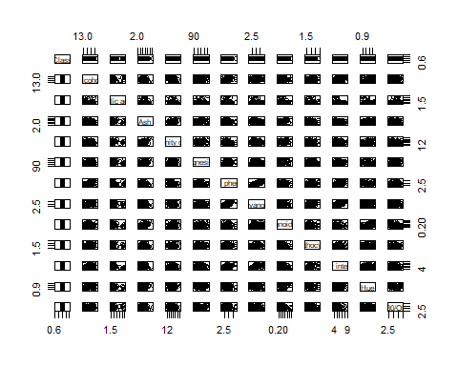

#plot(fc1[,c(1,2,3,4)])  
  
  
#matriz de grafico de dispersion vino clase 2  
  
plot(fc2[,c(1,2,3,4,5,6,7,8,9,10,11,12,13)])

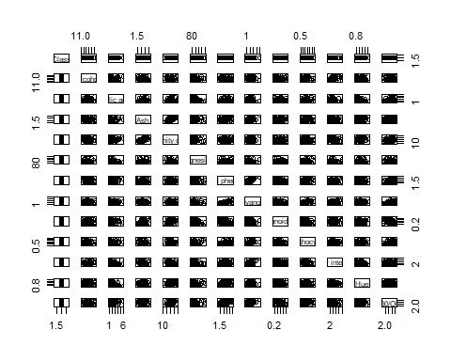

#matriz de grafico de dispersion vino clase 3  
  
plot(fc3[,c(1,2,3,4,5,6,7,8,9,10,11,12,13)])

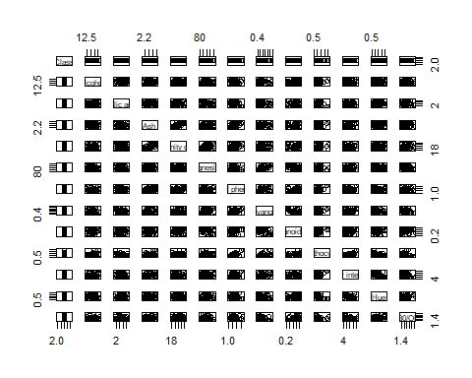

#matriz de varianza y correlacion vino clase 1  
  
cov(fc1[,c(1,2,3,4,5,6,7,8,9,10,11,12,13)])

## Class Alcohol Malic acid Ash  
## Class 0 0.0000000000 0.000000000 0.0000000000  
## Alcohol 0 0.2135598480 -0.012891204 -0.0155994155  
## Malic acid 0 -0.0128912040 0.474099532 0.0041013150  
## Ash 0 -0.0155994155 0.004101315 0.0516043834  
## Alcalinity of ash 0 -0.3746282876 0.105250146 0.3177533606  
## Magnesium 0 0.7731911163 0.573386908 0.9123816482  
## Total phenols 0 0.0658974576 -0.019491496 0.0003697253  
## Flavanoids 0 0.0762144068 -0.052351636 -0.0063617767  
## Nonflavanoid phenols 0 0.0005068966 -0.004310345 0.0074137931  
## Proanthocyanins 0 0.0585756867 -0.022927119 -0.0136185564  
## Color intensity 0 0.2336961134 -0.219674693 -0.0349507013  
## Hue 0 0.0043074226 -0.033684161 0.0063298071  
## OD280/OD315 0 0.0115209819 0.042594623 -0.0066184980  
## Alcalinity of ash Magnesium Total phenols Flavanoids  
## Class 0.00000000 0.0000000 0.0000000000 0.0000000000  
## Alcohol -0.37462829 0.7731911 0.0658974576 0.0762144068  
## Malic acid 0.10525015 0.5733869 -0.0194914962 -0.0523516365  
## Ash 0.31775336 0.9123816 0.0003697253 -0.0063617767  
## Alcalinity of ash 6.48375804 6.3716248 -0.1924719462 -0.2905900058  
## Magnesium 6.37162478 110.2279369 1.0933898305 0.5146990064  
## Total phenols -0.19247195 1.0933898 0.1148947984 0.1082978667  
## Flavanoids -0.29059001 0.5146990 0.1082978667 0.1580011689  
## Nonflavanoid phenols 0.05391379 0.1744828 -0.0004034483 -0.0024931034  
## Proanthocyanins -0.18219842 -0.2554559 0.0521880479 0.0898706020  
## Color intensity -0.66529778 2.4012741 0.2729244302 0.3650885739  
## Hue 0.02757802 -0.1362186 -0.0088572472 0.0003640561  
## OD280/OD315 -0.10701987 0.4523115 0.0064348627 -0.0125653711  
## Nonflavanoid phenols Proanthocyanins Color intensity  
## Class 0.0000000000 0.0000000000 0.000000000  
## Alcohol 0.0005068966 0.0585756867 0.233696113  
## Malic acid -0.0043103448 -0.0229271186 -0.219674693  
## Ash 0.0074137931 -0.0136185564 -0.034950701  
## Alcalinity of ash 0.0539137931 -0.1821984220 -0.665297779  
## Magnesium 0.1744827586 -0.2554558738 2.401274109  
## Total phenols -0.0004034483 0.0521880479 0.272924430  
## Flavanoids -0.0024931034 0.0898706020 0.365088574  
## Nonflavanoid phenols 0.0049068966 -0.0041724138 -0.013227586  
## Proanthocyanins -0.0041724138 0.1698340152 0.216776417  
## Color intensity -0.0132275862 0.2167764173 1.534062595  
## Hue 0.0033603448 0.0049893337 0.004072472  
## OD280/OD315 -0.0080913793 0.0004571011 -0.082658971  
## Hue OD280/OD315  
## Class 0.0000000000 0.0000000000  
## Alcohol 0.0043074226 0.0115209819  
## Malic acid -0.0336841613 0.0425946230  
## Ash 0.0063298071 -0.0066184980  
## Alcalinity of ash 0.0275780245 -0.1070198714  
## Magnesium -0.1362185856 0.4523115137  
## Total phenols -0.0088572472 0.0064348627  
## Flavanoids 0.0003640561 -0.0125653711  
## Nonflavanoid phenols 0.0033603448 -0.0080913793  
## Proanthocyanins 0.0049893337 0.0004571011  
## Color intensity 0.0040724722 -0.0826589714  
## Hue 0.0135682057 -0.0129213033  
## OD280/OD315 -0.0129213033 0.1275036821

#matriz de varianza y correlacion vino clase 2  
  
cov(fc2[,c(1,2,3,4,5,6,7,8,9,10,11,12,13)])

## Class Alcohol Malic acid Ash  
## Class 0 0.000000000 0.00000000 0.000000000  
## Alcohol 0 0.289405513 -0.01167085 -0.036462414  
## Malic acid 0 -0.011670845 1.03137988 0.047642716  
## Ash 0 -0.036462414 0.04764272 0.099519598  
## Alcalinity of ash 0 -0.101422535 0.80939678 0.734715292  
## Magnesium 0 -0.269579477 -1.30649095 0.682474849  
## Total phenols 0 -0.013590020 0.02184449 0.019294044  
## Flavanoids 0 -0.014520342 0.08022056 0.070113038  
## Nonflavanoid phenols 0 -0.004545292 0.01606435 0.011722213  
## Proanthocyanins 0 -0.061415352 0.12873352 0.008158632  
## Color intensity 0 0.134241368 -0.19092654 0.017579276  
## Hue 0 -0.000222495 -0.08408448 -0.002000225  
## OD280/OD315 0 -0.034811690 0.07959833 0.025156861  
## Alcalinity of ash Magnesium Total phenols Flavanoids  
## Class 0.00000000 0.00000000 0.000000000 0.00000000  
## Alcohol -0.10142254 -0.26957948 -0.013590020 -0.01452034  
## Malic acid 0.80939678 -1.30649095 0.021844487 0.08022056  
## Ash 0.73471529 0.68247485 0.019294044 0.07011304  
## Alcalinity of ash 11.22096177 0.18309859 0.233729175 0.73602455  
## Magnesium 0.18309859 280.67967807 0.640342052 0.01995775  
## Total phenols 0.23372918 0.64034205 0.297418712 0.29672811  
## Flavanoids 0.73602455 0.01995775 0.296728109 0.49801356  
## Nonflavanoid phenols 0.07583018 -0.40318310 -0.028714386 -0.02058028  
## Proanthocyanins 0.21950342 3.00370020 0.125617465 0.21214690  
## Color intensity -0.26602676 0.68074044 0.085283280 0.24709718  
## Hue -0.05222515 0.42441449 0.004392036 -0.00420767  
## OD280/OD315 0.63555070 -0.63383903 0.131253260 0.20310827  
## Nonflavanoid phenols Proanthocyanins Color intensity  
## Class 0.0000000000 0.000000000 0.000000000  
## Alcohol -0.0045452918 -0.061415352 0.134241368  
## Malic acid 0.0160643461 0.128733521 -0.190926539  
## Ash 0.0117222133 0.008158632 0.017579276  
## Alcalinity of ash 0.0758301811 0.219503421 -0.266026761  
## Magnesium -0.4031830986 3.003700201 0.680740443  
## Total phenols -0.0287143863 0.125617465 0.085283280  
## Flavanoids -0.0205802817 0.212146901 0.247097183  
## Nonflavanoid phenols 0.0153663984 -0.024001046 0.002125412  
## Proanthocyanins -0.0240010463 0.362485634 -0.041076177  
## Color intensity 0.0021254125 -0.041076177 0.855494125  
## Hue -0.0008481891 -0.006647795 -0.004894748  
## OD280/OD315 -0.0254298793 0.115334185 -0.053783078  
## Hue OD280/OD315  
## Class 0.0000000000 0.000000000  
## Alcohol -0.0002224950 -0.034811690  
## Malic acid -0.0840844789 0.079598330  
## Ash -0.0020002254 0.025156861  
## Alcalinity of ash -0.0522251509 0.635550704  
## Magnesium 0.4244144869 -0.633839034  
## Total phenols 0.0043920362 0.131253260  
## Flavanoids -0.0042076700 0.203108270  
## Nonflavanoid phenols -0.0008481891 -0.025429879  
## Proanthocyanins -0.0066477948 0.115334185  
## Color intensity -0.0048947485 -0.053783078  
## Hue 0.0411833481 -0.005277815  
## OD280/OD315 -0.0052778149 0.246585231

#matriz de varianza y correlacion vino clase 3  
cov(fc3[,c(1,2,3,4,5,6,7,8,9,10,11,12,13)])

## Class Alcohol Malic acid Ash  
## Class 0 0.000000000 0.000000000 0.0000000000  
## Alcohol 0 0.281155851 0.063721809 0.0240005319  
## Malic acid 0 0.063721809 1.183538830 0.0036281915  
## Ash 0 0.024000532 0.003628191 0.0341104610  
## Alcalinity of ash 0 0.251382979 0.208936170 0.3163475177  
## Magnesium 0 -0.485877660 -2.073111702 0.4249734043  
## Total phenols 0 0.039817553 -0.062414362 0.0310154255  
## Flavanoids 0 0.011841223 -0.089907713 0.0150213652  
## Nonflavanoid phenols 0 0.002511702 0.019279787 -0.0004670213  
## Proanthocyanins 0 0.081631117 -0.099383777 0.0146360816  
## Color intensity 0 0.429337774 -0.407798384 0.0534164927  
## Hue 0 -0.002072074 0.009923670 0.0038144504  
## OD280/OD315 0 0.019067287 0.002133245 0.0113275709  
## Alcalinity of ash Magnesium Total phenols Flavanoids  
## Class 0.000000000 0.000000000 0.000000000 0.000000000  
## Alcohol 0.251382979 -0.485877660 0.039817553 0.011841223  
## Malic acid 0.208936170 -2.073111702 -0.062414362 -0.089907713  
## Ash 0.316347518 0.424973404 0.031015426 0.015021365  
## Alcalinity of ash 5.099290780 3.920212766 0.293829787 0.179911348  
## Magnesium 3.920212766 118.602393617 -0.154069149 1.818045213  
## Total phenols 0.293829787 -0.154069149 0.127428191 0.025031649  
## Flavanoids 0.179911348 1.818045213 0.025031649 0.086144637  
## Nonflavanoid phenols -0.004787234 -0.683670213 0.014460638 -0.023117553  
## Proanthocyanins 0.243173759 0.683550532 0.090478989 0.048958555  
## Color intensity 0.838191530 2.622260922 0.277073942 0.248867293  
## Hue 0.007145390 0.005731383 -0.001066755 -0.009844459  
## OD280/OD315 0.025620567 -0.660917553 0.019470479 -0.034318041  
## Nonflavanoid phenols Proanthocyanins Color intensity  
## Class 0.0000000000 0.000000000 0.000000000  
## Alcohol 0.0025117021 0.081631117 0.429337774  
## Malic acid 0.0192797872 -0.099383777 -0.407798384  
## Ash -0.0004670213 0.014636082 0.053416493  
## Alcalinity of ash -0.0047872340 0.243173759 0.838191530  
## Magnesium -0.6836702128 0.683550532 2.622260922  
## Total phenols 0.0144606383 0.090478989 0.277073942  
## Flavanoids -0.0231175532 0.048958555 0.248867293  
## Nonflavanoid phenols 0.0154106383 0.008721809 0.007532978  
## Proanthocyanins 0.0087218085 0.167146764 0.647096553  
## Color intensity 0.0075329780 0.647096553 5.340453617  
## Hue 0.0021750000 -0.019735328 -0.150381115  
## OD280/OD315 0.0103579787 -0.014310683 -0.064773669  
## Hue OD280/OD315  
## Class 0.000000000 0.000000000  
## Alcohol -0.002072074 0.019067287  
## Malic acid 0.009923670 0.002133245  
## Ash 0.003814450 0.011327571  
## Alcalinity of ash 0.007145390 0.025620567  
## Magnesium 0.005731383 -0.660917553  
## Total phenols -0.001066755 0.019470479  
## Flavanoids -0.009844459 -0.034318041  
## Nonflavanoid phenols 0.002175000 0.010357979  
## Proanthocyanins -0.019735328 -0.014310683  
## Color intensity -0.150381115 -0.064773669  
## Hue 0.013096764 0.011343395  
## OD280/OD315 0.011343395 0.074044637