## Question 1

A directed graph $G=\left(V,E\right)$ could be constructed where $v∈V$ is the city of Krypton and $e∈E$ is the time cost between two cities. For each city $C_{i}$, Using Breadth-first search to obtain the minimum time cost $t(C_{i},C_{j})$ from city $C_{i}$ to city $C_{j}$.

Then, constructing a bipartite graph which has a set of $v∈L$ representing the population of each city and a set of $v∈R$ representing the number of pods that each city has. Connecting the two vertexes from $L,R$ respectively only when minimum time cost $t(C_{i},C_{j})$ is less than $X$ days. It could be represented by following diagram.

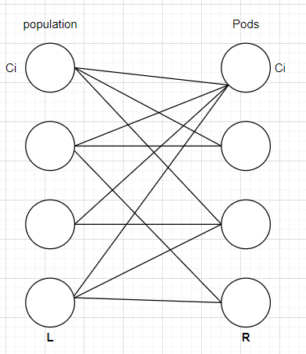

**Example**

­­

Where set $L$ is the set of population of each city and set $R$ is the number of pods of each city.

To obtain the largest population that could take the pods to earth, we need to find the maximum matching of $G$. Thus, constructing a network flow $G^{'}$ that respect to $G$. The capacity of the path from $s$ to the vertex in $L$ and the path from the vertex in $R$ to sink $t$ should be the population of the city and the number of pods of each city. It makes sense because source $s$ can only “transfer” $P_{i}$ to $C_{i}$ where $P_{i}$ is the population of $C_{i}$ and each vertex in set $R$ could only “transfer” $q_{i}$ to sink $t$ where $q_{i}$ is the number of pods of $C_{i}$.

In addition, the capacity of edge between $L$ and $R$ should be infinity because there is not such a limitation about the maximum population flow between each city. Therefore, $G'$ could be represented by following diagram.

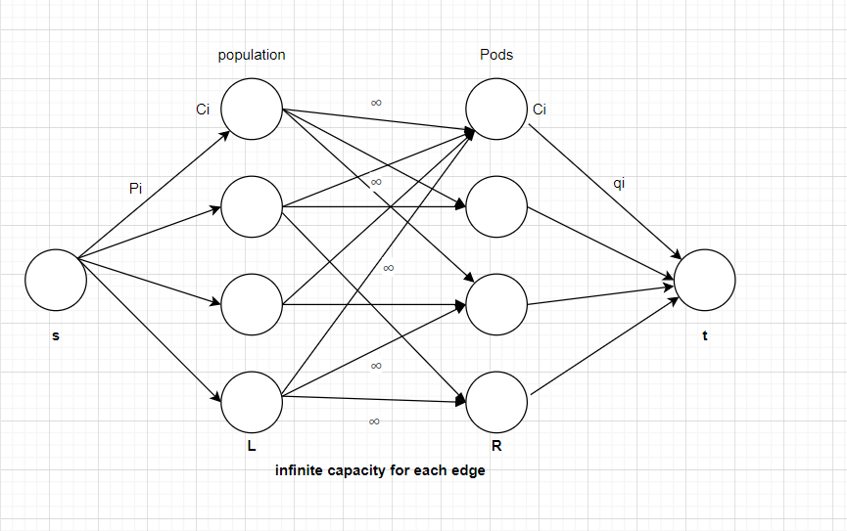

**Example**

Finally, applying ***Ford-Fulkerson algorithm*** to obtain the maximum flow of $G'$ and the number of edge from $L$ to $R$ is the maximum number of invaders the Earth will have to deal with.