## Question 2

For this $n×n$ chessboard, a 2D array $Pos[][]$ could be established to indicate the valid position on the chessboard. Marking the position $(i,j)$ invalid if $(i,j)$ is the coordinate of bishops or it is located at the diagonal position of bishops. Otherwise marking $(i,j)$ valid.

Then, defining that $L$ is the set of vertexes that represent all the columns and $R$ is the set of vertexes that represent all rows. To obtain a bipartite graph, each vertex in $L$ is connected to every vertex in $R$ to form all coordinate combinations. Before the connection, checking the position in $Pos[][]$. The two vertexes are connected only if the position that it represents in chessboard in valid. Otherwise skip to next vertex.

In such way, a bipartite graph $G=(V,E)$ is constructed. The maximum matching of the graph is the maximum number of rooks we can place. To achieve this, constructing a network flows $G'=(V',E')$ correspond to matchings. The capacity of $G'$ is unit capacity 1 such that there is not two rooks at same position. Source $s$ and sink $t$ do not belong to $V$. $G'$ could be shown as following diagram.

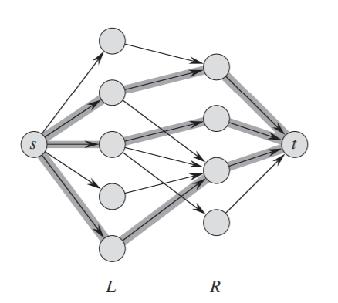

Then applying ***Ford-Fulkerson algorithm*** to find the maximum flow of $G'$. The number of edges from $L$ to $R$ in the maximum flow is the maximum number of rooks that we can place.