InitializingBean和DisposableBean介绍

1.InitializingBean

该接口的作用是：允许一个bean在它的所有必须属性被BeanFactory设置后，来执行初始化的工作，该接口中只有一个方法，afterPropertiesSet
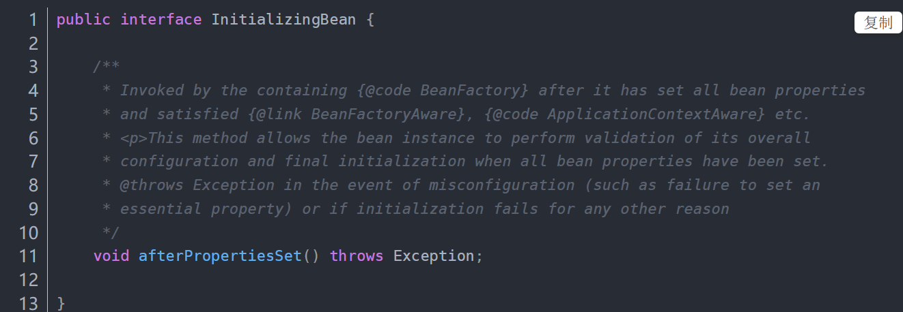

源码：
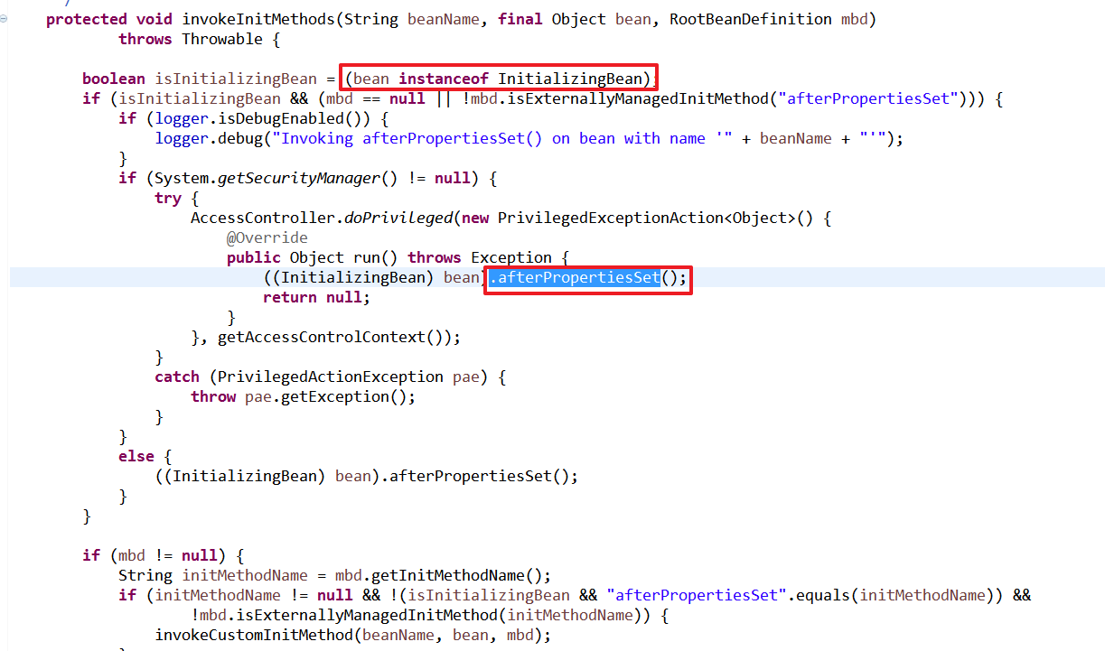

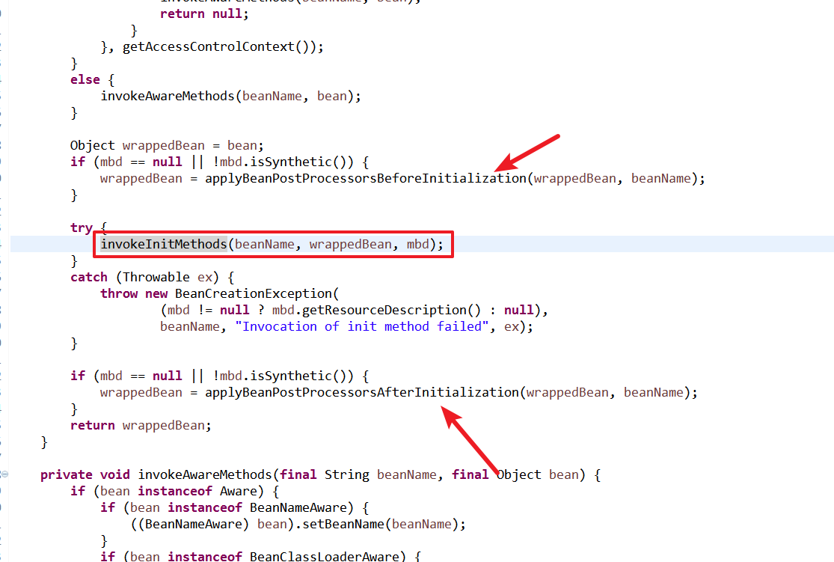

2.DisposableBean

该接口的作用是：允许在容器销毁该bean的时候获得一次回调。DisposableBean接口也只规定了一个方法：destroy
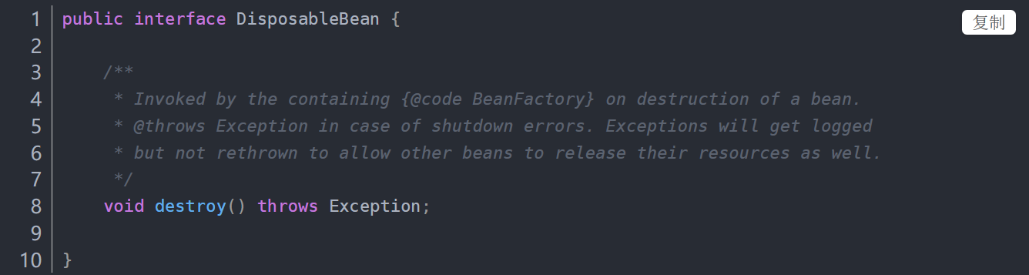

案例演示
/**
* 实现InitializingBean和DisposableBean接口
* @author dengp
*
*/
public class User implements InitializingBean,DisposableBean{

private int id;

private String name;

private String beanName;

public User(){
System.out.println("User 被实例化");
}

public int getId() {
return id;
}

public void setId(int id) {
this.id = id;
}

public String getName() {
return name;
}

public void setName(String name) {
System.out.println("设置："+name);
this.name = name;
}

public String getBeanName() {
return beanName;
}

public void setBeanName(String beanName) {
this.beanName = beanName;
}

@Override
public String toString() {
return "User [id=" + id + ", name=" + name + ", beanName=" + beanName + "]";
}

@Override
public void destroy() throws Exception {
// TODO Auto-generated method stub
System.out.println("destory ....");
}

@Override
public void afterPropertiesSet() throws Exception {
System.out.println("afterPropertiesSet....");
}
}

配置文件
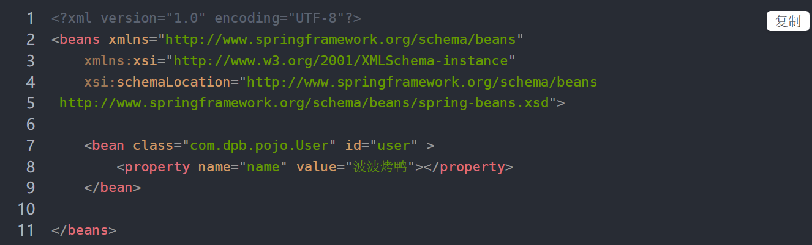

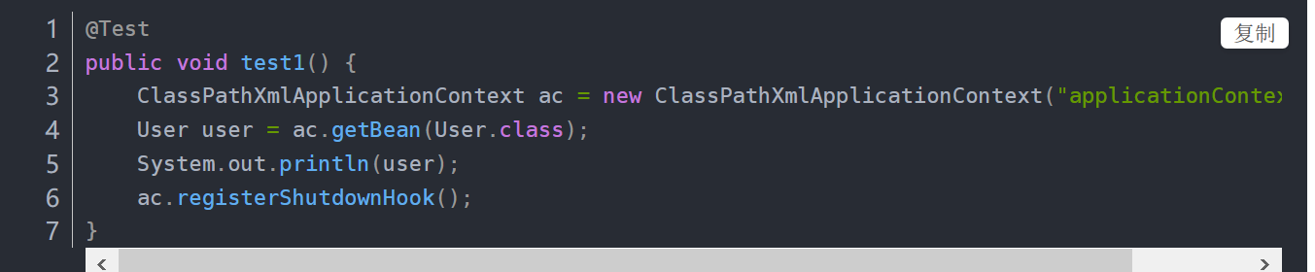
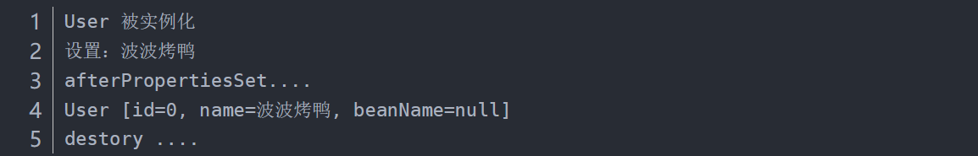

源码分析

