mybatis和spring整合

创建maven项目
创建一个java项目即可

引入相关依赖
<project xmlns="http://maven.apache.org/POM/4.0.0" xmlns:xsi="http://www.w3.org/2001/XMLSchema-instance"
xsi:schemaLocation="http://maven.apache.org/POM/4.0.0 http://maven.apache.org/xsd/maven-4.0.0.xsd">
<modelVersion>4.0.0</modelVersion>
<groupId>com.dpb</groupId>
<artifactId>mybatis11-SS</artifactId>
<version>0.0.1-SNAPSHOT</version>
<properties>
<spirng.version>4.3.3.RELEASE</spirng.version>
</properties>
<dependencies>
<!-- Spring相关jar包 -->
<dependency>
<groupId>org.springframework</groupId>
<artifactId>spring-context</artifactId>
<version>${spirng.version}</version>
</dependency>
<dependency>
<groupId>org.springframework</groupId>
<artifactId>spring-orm</artifactId>
<version>${spirng.version}</version>
</dependency>
<!-- mybatis依赖 -->
<dependency>
<groupId>org.mybatis</groupId>
<artifactId>mybatis</artifactId>
<version>3.4.6</version>
</dependency>
<!-- mybatis和spring整合包 -->
<dependency>
<groupId>org.mybatis</groupId>
<artifactId>mybatis-spring</artifactId>
<version>1.3.2</version>
</dependency>

<!-- mysql驱动包 -->
<dependency>
<groupId>mysql</groupId>
<artifactId>mysql-connector-java</artifactId>
<version>5.1.27</version>
</dependency>
<!-- 日志框架 -->
<dependency>
<groupId>org.slf4j</groupId>
<artifactId>slf4j-api</artifactId>
<version>1.7.25</version>
</dependency>
<dependency>
<groupId>org.slf4j</groupId>
<artifactId>slf4j-log4j12</artifactId>
<version>1.7.25</version>
</dependency>
<dependency>
<groupId>log4j</groupId>
<artifactId>log4j</artifactId>
<version>1.2.17</version>
</dependency>
<!-- c3p0 -->
<dependency>
<groupId>com.mchange</groupId>
<artifactId>c3p0</artifactId>
<version>0.9.5.2</version>
</dependency>
<!-- 单元测试 -->
<dependency>
<groupId>junit</groupId>
<artifactId>junit</artifactId>
<version>3.8.1</version>
</dependency>
</dependencies>
</project>

创建对应的配置文件

mybatis的全局配置文件
<?xml version="1.0" encoding="UTF-8" ?>
<!DOCTYPE configuration
PUBLIC "-//mybatis.org//DTD Config 3.0//EN"
"http://mybatis.org/dtd/mybatis-3-config.dtd">
<configuration>
<settings>
<!-- 开启延迟加载 -->
<setting name="lazyLoadingEnabled" value="true"/>
<setting name="aggressiveLazyLoading" value="false"/>
</settings>
</configuration>

spring的配置文件
<beans xmlns="http://www.springframework.org/schema/beans"
xmlns:xsi="http://www.w3.org/2001/XMLSchema-instance" xmlns:context="http://www.springframework.org/schema/context"
xmlns:aop="http://www.springframework.org/schema/aop" xmlns:tx="http://www.springframework.org/schema/tx"
xsi:schemaLocation="http://www.springframework.org/schema/beans http://www.springframework.org/schema/beans/spring-beans.xsd
http://www.springframework.org/schema/context http://www.springframework.org/schema/context/spring-context-4.3.xsd
http://www.springframework.org/schema/aop http://www.springframework.org/schema/aop/spring-aop-4.3.xsd
http://www.springframework.org/schema/tx http://www.springframework.org/schema/tx/spring-tx-4.3.xsd">
<!-- 关联数据属性文件 -->
<context:property-placeholder location="classpath:db.properties"/>
<!-- 开启扫描 -->
<context:component-scan base-package="com.dpb.service.impl"/>

<!-- 配置数据源 -->
<bean class="com.mchange.v2.c3p0.ComboPooledDataSource"
id="dataSource" >
<property name="driverClass" value="${driver}"></property>
<property name="jdbcUrl" value="${url}"></property>
<property name="user" value="${names}"></property>
<property name="password" value="${password}"></property>
</bean>
<!-- 整合mybatis -->
<bean class="org.mybatis.spring.SqlSessionFactoryBean"
id="sqlSessionFactoryBean" >
<!-- 关联数据源 -->
<property name="dataSource" ref="dataSource"/>
<!-- 关联mybatis的配置文件 -->
<property name="configLocation" value="classpath:mybatis-config.xml"/>
<!-- 添加别名设置 -->
<property name="typeAliasesPackage" value="com.dpb.bean"/>
</bean>
<!-- 配置扫描的路径 -->
<bean class="org.mybatis.spring.mapper.MapperScannerConfigurer" >
<property name="basePackage" value="com.dpb.mapper"/>
</bean>
</beans>

db.properties文件
driver=com.mysql.jdbc.Driver
url=jdbc:mysql://localhost:3306/ssm?useUnicode=true&characterEncoding=utf-8
names=root
password=123456

log4j.properties文件
log4j.rootCategory=DEBUG, stdout , R

log4j.appender.stdout=org.apache.log4j.ConsoleAppender
log4j.appender.stdout.layout=org.apache.log4j.PatternLayout
log4j.appender.stdout.layout.ConversionPattern=[QC] %p [%t] %C.%M(%L) | %m%n

log4j.appender.R=org.apache.log4j.DailyRollingFileAppender
log4j.appender.R.File=C:\\tools\\logs\\dpb.log
log4j.appender.R.layout=org.apache.log4j.PatternLayout
log4j.appender.R.layout.ConversionPattern=%d-[TS] %p %t %c - %m%n

业务测试

javaBean
package com.dpb.bean;

public class User {

private int id;

private String name;

private int age;

public int getId() {
return id;
}

public void setId(int id) {
this.id = id;
}

public String getName() {
return name;
}

public void setName(String name) {
this.name = name;
}

public int getAge() {
return age;
}

public void setAge(int age) {
this.age = age;
}

@Override
public String toString() {
return "User [id=" + id + ", name=" + name + ", age=" + age + "]";
}
}

Mapper接口和映射文件
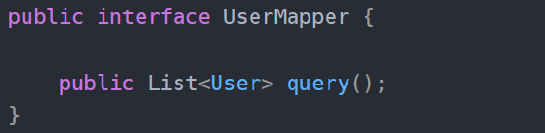
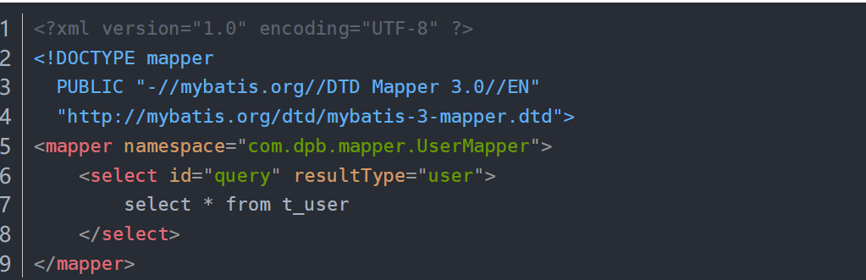

service
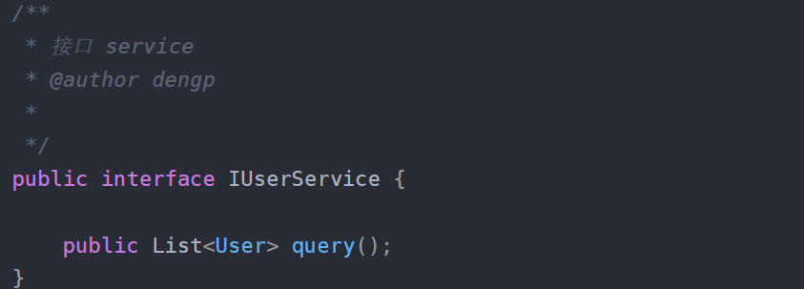

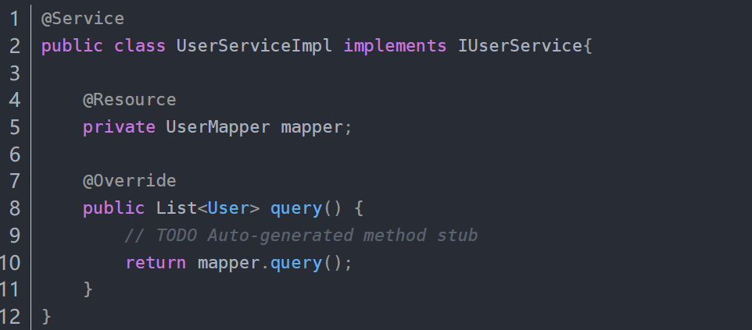

测试方法
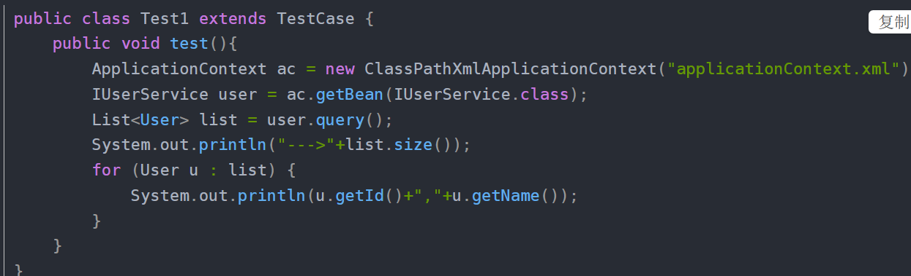
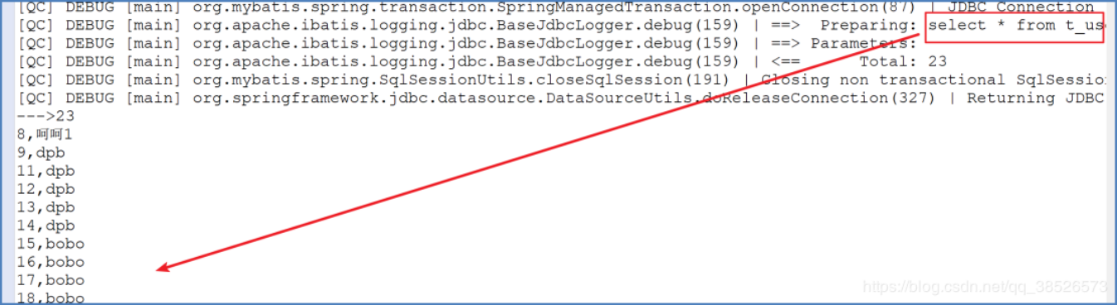

项目目录结构:
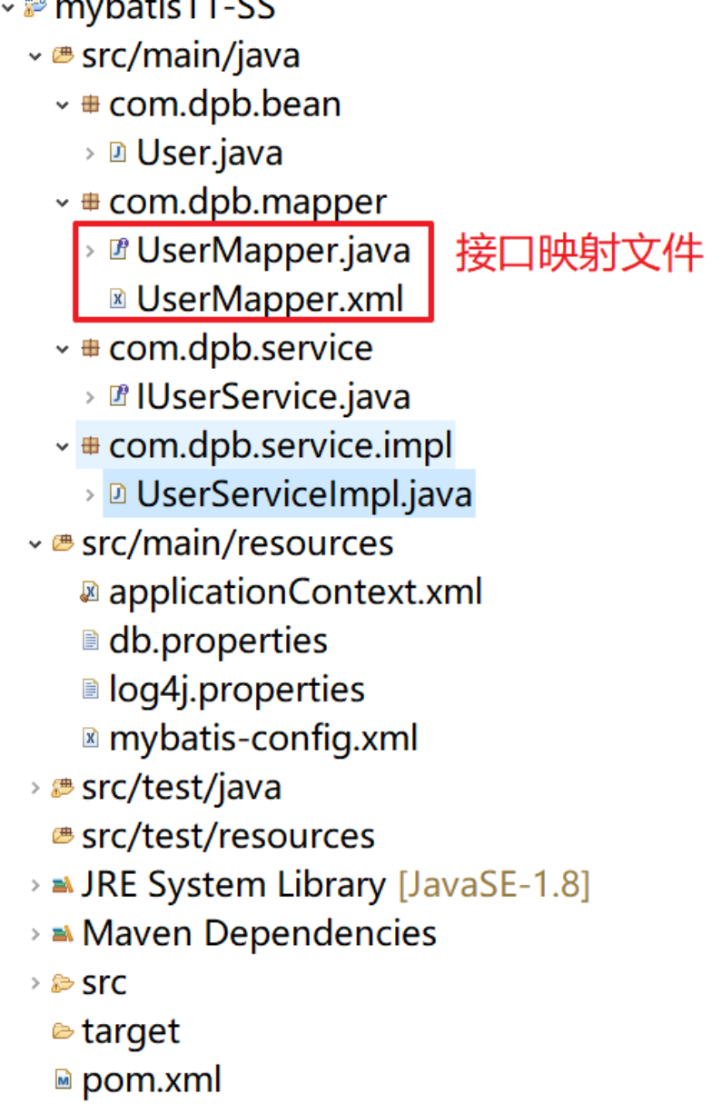

注意如果接口映射文件和接口文件不在同一个包下可以如下配置:
