**Detectron2**

**一、网络结构**

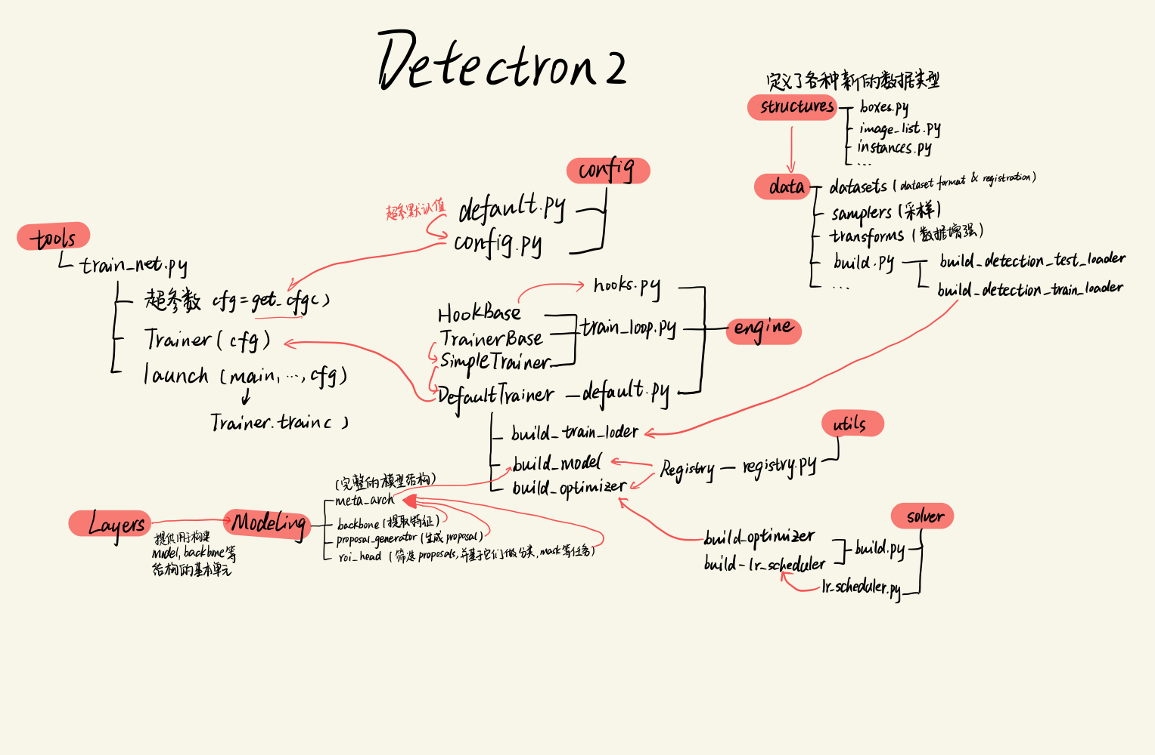

**二、添加新的主干网络**

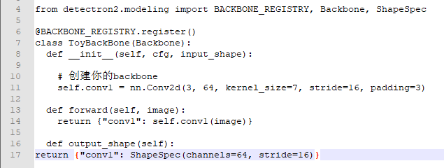

**然后,可以在配置对象中使用cfg.MODEL.BACKBONE.NAME ='ToyBackBone'。build_model(cfg)将调用你的ToyBackBone。**<https://www.eda365.com/article-146056-1.html>

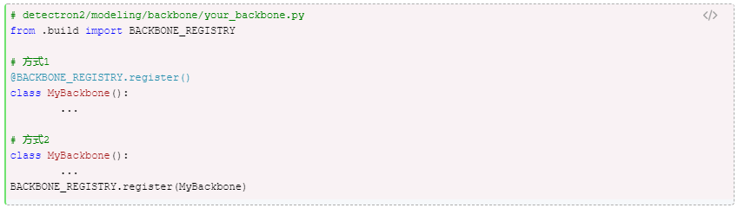

1. **VoVNet2**

|  |  |  |
| --- | --- | --- |
| **Layer name** | **Output size** | **19-layer** |
| Stem-conv1  Stem-conv2  Stem-conv3 | H,W/ 2  —  H,W/ 4 | Conv 3*64 k =3, s = 2, p = 1  Conv 64*64 k =3, s= 1, p = 1  Conv 64*128 k = 3, s=2, p = 1 |
|  | | |
| Stage2 | H,W/ 4 | Conv 128*128, k=3,s=1,p =1  Conv 128*128, k=3,s=1,p =1  Conv 128*128, k=3,s=1,p =1 |
| Concat  eSE | Conv 512*256,k=1,s=1,p =0  Avg_pool + fc + Hsigmiod |
|  | | |
| Stage3 | H,W/8 | **MaxPool k =3,s=2,p =0**  Conv 256*160, k=3,s=1,p =1  Conv 160*160, k=3,s=1,p =1  Conv 160*160, k=3,s=1,p =1 |
| Concat  eSE | Conv 736*512,k=1,s=1,p =0  Avg_pool + fc + Hsigmiod |
| Stage4 | H,W/16 | **MaxPool k =3,s=2,p =0**  Conv 512*192, k=3,s=1,p =1  Conv 192*192, k=3,s=1,p =1  Conv 192*192, k=3,s=1,p =1 |
| Concat  eSE | Conv 1088*768,k=1,s=1,p =0  Avg_pool + fc + Hsigmiod |
| Maxpool  Stage5 | H,W/32 | **MaxPool k =3,s=2,p =0**  Conv 768*224, k=3,s=1,p =1  Conv 224*224, k=3,s=1,p =1  Conv 224*224, k=3,s=1,p =1 |

