OPTech

Contents

Updates
Creating an .OPZ file

Compiling the .OPT
Editing Data

View Navigating

Geometry Editor
Texture Editor
Hitzone Editor
Transformation Editor
Hardpoint Editor
Engine Glow Editor

Terminology
---OPT
------mesh
---------hitzone
---------transformation
---------hardpoint
---------engine glow
---------LOD
------------face
---------------face normal
---------------software vector
---------------texture
------------------transparency
------------------illumination
---------------vertex
------------------vertex normal
------------------texture coordinate
Errors and Solutions
Other Features and Issues
Credits and Disclaimer
# Updates

v2.0
- Converted the code from VB6 to C# and WPF.
- Bug fixes.
- New features.
- New icons.

v1.1
Fixes
- Vertex Z coordinate repositioning is fixed.
- Resolved error that occurred when deleting faces.
Features
- Revamped mesh-to-mesh and face-to-mesh assignment functionality.
- Sizes greater than 1000 meters now displayed in kilometers in the meter dimensions report.
- One new error check: Mesh quantity limit.

v1.0
Fixes
- Unused textures IDs are removed from the texture list.
- Target ID value assignments fixed.
- Improved OBJ support.
- Hitzone error-checking precision.
Features
- Window interface.
- XvT OPT importing and exporting.
- Mesh hiding checkbox.
- Refreshable texture list.
- Value changing with page up and page down.
- Calculation of software vectors for high resolution.
- One new error check: Texture quantity limit.

v0.9
Fixes
- Remaining hardpoints and mesh types added to their respective lists.
- OPZ importing bug is fixed.
- Correct model dimensions are reported.
- Rotational up/down key controls reversed.
- The translation editor has been renamed to “transformation editor”.
- Normals can no longer be directly edited.
Features
- Help menu.
- Individual tri and quad face counts.
- Texture multiplying and magnifying.
- Face normal flipper.
- Graphical display influenced by face normal directions.
- One new error check: face normal-to-vertex order correspondence.

v0.8
Fixes
- Texture rotation is repaired.
- Meshes are now initialized with a cloaking distance of infinity.
- List boxes can now be manipulated with the arrow keys in addition to the mouse.
- The rotation menu has been renamed to “translation menu”.
- The engine glow density vectors are now called direction vectors.
Features
- Non-uniform mesh and face scaling, translation, and rotation.
- Removable faces.
- Antialiasing option.
- Save prompt upon attempt to close a changed model.
- Meshes pop out of view when zoomed out to the cloaking distance of the mesh.
- Easier engine glow orientation.
- Transparency and illumination filters assigned their own tolerance and transparency/brightness levels.
- Report of meter dimensions of the model.

v0.7
Fixes
- Improved OBJ file support.
- Coplanar checking is performed in the Tri2Quad function.
Features
- Two new error checks: vertex ordering and hitzone volume.

v0.6
Fixes
- Now supports the OpenGL driver that comes with your video card.
- Reversing the vertex order no longer ruins the texture coordinates.
Features
- Tri2Quad fix option.
- Color-coded hardpoints.
- Graphically-displayed density vectors of an engine glow.
- Error report generator.
- The user’s options are saved in a file.
- Face-displaying option.
- OBJ support.

v0.4
Fixes
- The engine glow editor now correctly displays the height of an engine glow.
Features
- DXF importing.
- Texture stitching.
- Texture rotating/flipping.
- Flight group previewing.

v0.2
Fixes
- OPTech now runs normally in resolutions of 800x600 and above.
- The clipping plane problem I was having has been fixed.
- Pressing a key does not make the control you were typing in lose focus.
- Multi assignment of software vectors and normals has been removed.

v0.1
Features
- This is the first version of OPTech, so there are no “new” features. This version is beta, so if there are bugs you want to report see the disclaimer section of this help file to find my E-Mail address.
# Creating an .OPZ file

Creating an .OPZ file is the first step in creating an OPT with OPTech. The OPZ file is a text-based file used by the program to read in data about the model you are creating, and contains all the data necessary to create a working OPT file (except for the actual textures, which are placed in the project folder). When you launch OPTech, you will need to either open an existing OPZ file or create a new project, both of which can be done from the “File” menu. If you create a new OPZ file then you will need to import data into it for editing. Files currently supported for importing include OPTs, DXFs (Autocad v12), OBJ files, and other OPZ files. Importing data does not overwrite the data already contained in the OPZ, but actually adds onto it so that it is possible to merge several files together. You can save your work at any time by selecting “save .OPZ” from the file menu.
#Compiling the .OPT

You should only try to compile the OPT once you feel that your model is complete enough to do so. However, in theory the OPT should be ready to compile any time you want. Selecting the Error Check option from the “Info” menu will inform you of any known problems in the model. To generate the OPT, select “create .OPT” from the file menu. The processing can take up to a minute for complex OPTs. The newly created file will then be placed in the appropriate project directory. If the OPT was compiled in the X-Wing Alliance format, the name of the file will have the structure “name(xwa).opt”. If it was compiled in X-Wing vs. TIE Fighter format, it will have the structure “name(xvt).opt”. The naming convention is used simply to help the user identify which game the OPT was compiled for, and the file can be renamed at any time.
#Editing Data

Almost all data is entered into OPTech via the use of text boxes. The data in these text boxes can be changed in two ways: type in the new value, or increment and decrement the value using the PAGE UP and PAGE DOWN keys, respectively. When typing in the value, the user must hit ENTER or click out of the text box for the change to register. When using the PAGE UP and PAGE DOWN keys, the change is processed automatically. Holding down the PAGE UP and PAGE DOWN keys for an extended period increases the rate that the value increments.
# View Navigating

All camera panning and rotating can be performed with just the shift and arrow keys, or alternatively with the mouse. At the bottom right of the OPTech screen is a frame labeled “view controls”. By default the camera control is set to rotation, but there is also a panning option. Here is the function of the keyboard and mouse in each control mode:

Rotation:
Left and Right Arrows: Camera rotates around Y-axis
Up and Down Arrows: Camera rotates around X-axis
Shift + Left and Right Arrows: Camera rotates around Z-axis
Right Click and Drag: Camera rotates
Shift + Right Click and Drag: Camera rotates around Z-axis

Panning:
Left and Right Arrows: Camera pans left and right
Up and Down Arrows: Camera pans up and down
Shift + Up and Down Arrows: Camera zooms in and out
Right Click and Drag: Camera pans
Shift + Right Click and Drag: Camera zooms in and out

Selection:
Left-click on mesh/face/vertice: Select
Left-click on background: Deselect
SHIFT + Left-click on mesh/face/vertice: Add to selection
SHIFT + Left-click on background: Do nothing
CTRL + Left-click on mesh/face/vertice: Remove from selection
CTRL + Left-click on background: Do nothing

You can automatically change viewpoints by pressing one of the buttons at the top of the frame. OPTech supports up to 2 levels of detail, each of which can be viewed separately by clicking the A-Wing icons at the top of the screen. Next to the LOD buttons are the buttons that switch between mesh, face, and vertex view/edit modes. To the right of the edit mode buttons are two buttons that can be toggled between wireframe viewing and textured viewing. To the right of these are two buttons that give you the option to view the normals when you are in face or vertex edit mode. They are left on by default. If a particular mesh is set to cloak at a certain distance, then it will emulate this effect when you zoom the screen in and out.
One method of selecting geometric shapes is by left clicking them in the graphical display. Multiple objects can be selected by holding down shift and left clicking each desired object. The type of geometry you can select depends on which editing mode you are in. Also, an object can only be picked if its parent is selected (for example, to pick the 5th face of the 3rd mesh, the 3rd mesh must be selected. The same rule applies for vertices). The object which is most recently picked is colored green (by default) and all other selected shapes are red. The object that is in green is known as the primary selected object, and can receive more modification commands than the secondary selected objects. For example, you can only add hardpoints and engine glows to the primary selected mesh, but you can scale and translate all selected meshes simultaneously.
# Geometry Editor
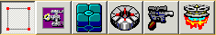
The geometry editor contains all data regarding the OPT’s shape and texture placement. It is divided into two sub-editors: the geometry sub-editor and the texture sub-editor. Depending on whether you are in mesh editing mode, face editing mode, or vertex editing mode, the geometry and texture sub-editors will show different data.

Geometry sub-editor:
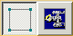
Mesh editing mode:
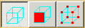
The mesh list shows all the meshes in the OPT. Clicking on a name will select that mesh for editing, and it is also possible to multiselect meshes in order to edit several meshes at once. The mesh names are assigned by default as “MESH x” where x represents the ID, but it is possible to rename a mesh to something else, such as “FUSELAGE” so that it will be easier to identify. To do so, just double click on the mesh you want to rename. A checkbox labeled “Visible” is placed under the mesh list, and can toggle on and off the rendering of the selected meshes. It should be noted that this does not affect the actual model, but simply helps the user during the editing process. The “Delete” button will delete all selected meshes, and the “Assign” button allows you to merge selected meshes with another mesh. To do this, first select the meshes you want to reassign, then click the button to display a list of meshes in the OPT. High LOD meshes can be merged with other high LOD meshes, or can be assigned as a low LOD of a high LOD mesh.
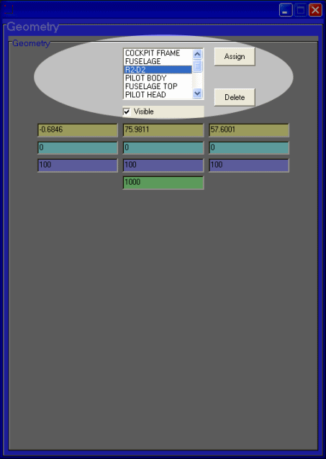
The text boxes below the mesh list can be used to alter the positioning and shape of the selected meshes. The yellow boxes specify the position of the mesh, the blue boxes rotate the mesh the specified amount of degrees, and the purple boxes scales the mesh by the specified percentage. There is also a green text box under the mesh list which is used to specify the cloaking distance of the mesh in kilometers. OPTech interprets a value of 1000 as infinity (never cloaks).
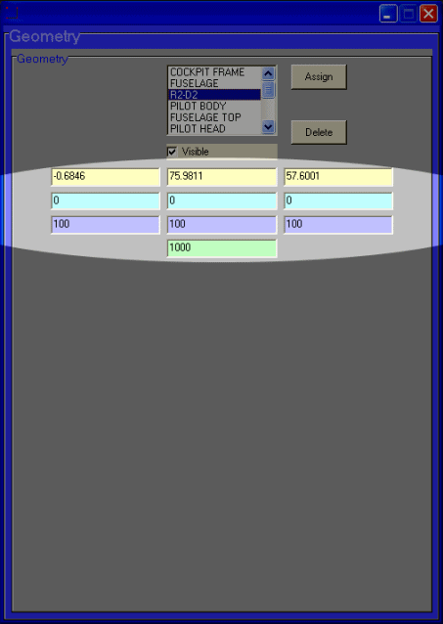
Face editing mode:
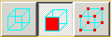
The face list shows all of the faces in the selected meshes. Below the face list are position, rotation, and scaling text boxes that serve the same function as the ones in mesh editing mode. Also below the face list are three pink text boxes stating the I, J, and K face normal values. The “Flip normal” button reverses the normal direction of all selected faces. The “Assign” button allows you to transfer faces between meshes. Faces can only be transferred between meshes of the same LOD.
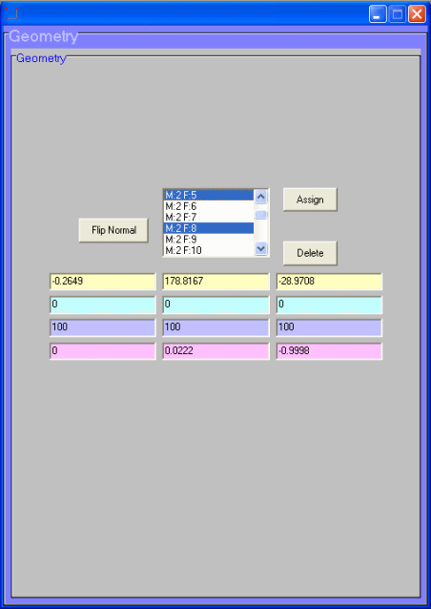
Vertex editing mode:
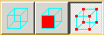
The X, Y, and Z vertex lists contain coordinates of all the vertices in the selected faces. Below the vertex lists are the I, J, and K vertex normal lists. The yellow text boxes tell the position of the vertex. The pink text boxes display the vertex normal coordinates of the selected vertex.
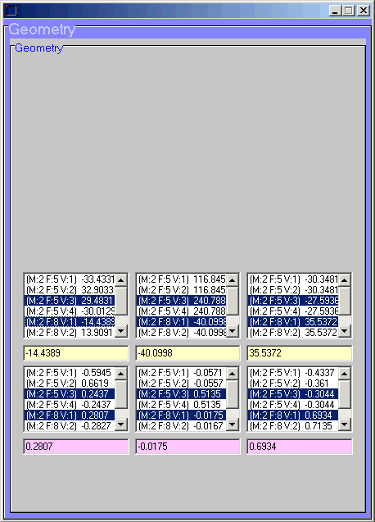

Texture sub-editor:
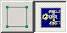
Mesh editing mode:
The texture sub-editor cannot be opened in this mode.
Face editing mode:
The large picture box shows the texture currently applied to the selected face. To apply a different texture, double-click a bitmap from the texture list at the bottom of the frame. The texture list can be refreshed by right-clicking on it. Flight group textures can be assigned by clicking the different flight group buttons and applying a texture. Pressing each flight group button shows a preview of the OPT using those FG textures. Once the selected face has a texture assigned to all four flight group buttons, the “FG On” button will become activated. To disable flight group textures for a selected face, click the “FG Off” button.
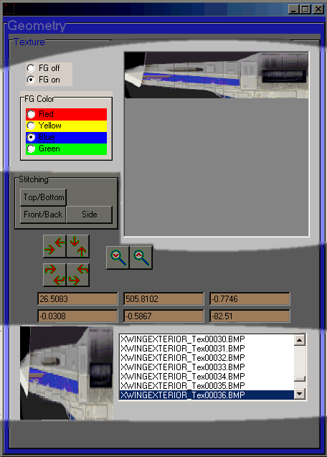
The stitching frame gives you different methods of stretching a single texture over multiple faces. Once you apply the stitching, it may be necessary to flip the textures by using the flipping/rotation buttons below. Two tiling buttons are also available for creating repeating textures on the faces.
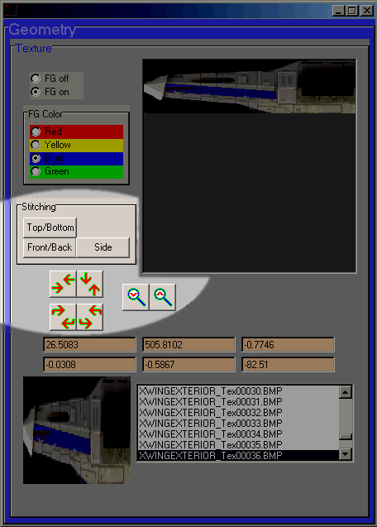
The orange text boxes in the center contain the software vector data. The vectors are represented in the graphical display as yellow and orange lines (by default).
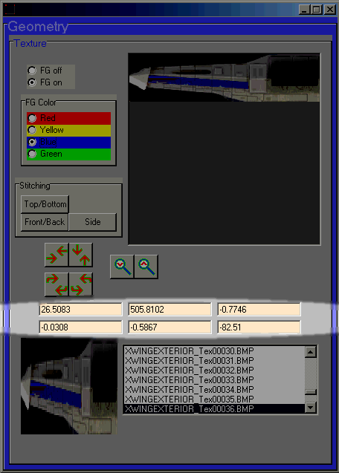
Vertex editing mode:
The texture coordinates of each vertex can be altered from here.
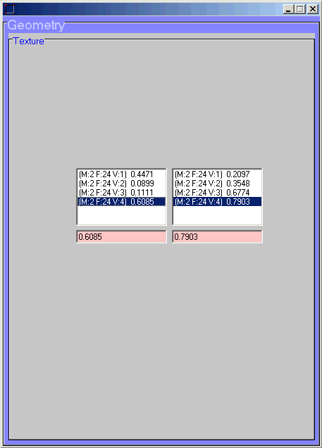
# Texture Editor
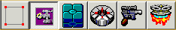
The texture editor is used to give textures transparency and illumination. It is divided into two sub-editors: the transparency sub-editor and the illumination sub-editor.

Transparency sub-editor:
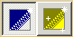
The texture list shows all of the textures used by the OPT, but shows their texture ID rather than their bitmap name. If a texture has a check mark next to it, it means that it is set to use transparency. Clicking on the picture box will add the RGB values of the chosen pixel to the transparency filter lists. The layering priority of the filter can be altered using the arrow buttons.
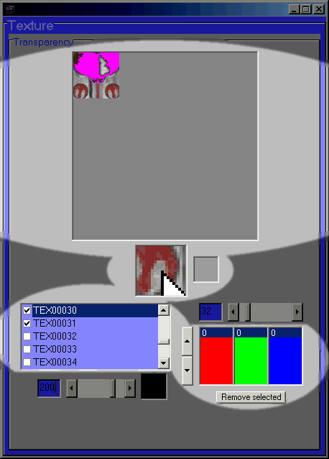
The scroll bar to the right of the texture list is the color tolerance of the selected color filter, and indicates how much above and below the RGB values of the transparency filter values it is allowed to make transparent. Below the texture list is the transparency opacity of the color filter. A value of 255 (black) means that the texture is completely solid, and a value of 0 (white) means it is completely transparent. A value of 111 is the standard level of translucency. The texture you gave transparency to should look translucent in the graphical display on the right.
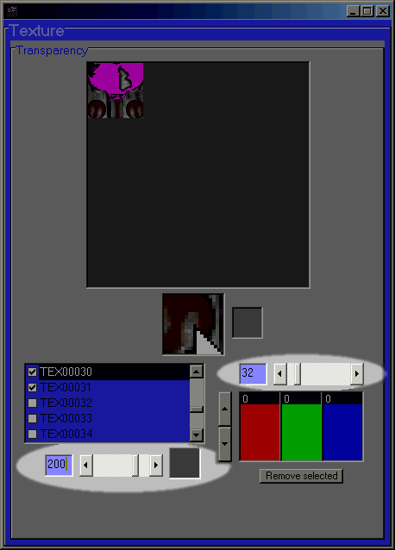

Illumination sub-editor:

The texture list shows all of the textures used by the OPT, but shows their texture ID rather than their bitmap name. If a texture has a check mark next to it, it means that it is set to use illumination. Clicking on the picture box will add the RGB values of the chosen pixel to the illumination filter lists. The layering priority of the filter can be altered using the arrow buttons.
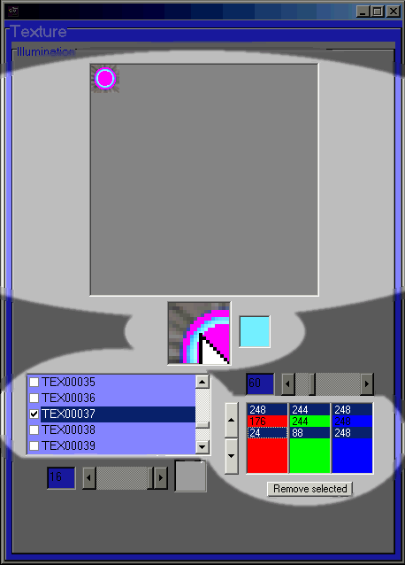
The scroll bar to the right of the texture list is the color tolerance of the selected color filter, and indicates how much above and below the RGB values of the illumination filter values it is allowed to make illuminated. Below the texture list is the illumination brightness of the color filter. A value of 16 (white) is the brightest level, and a value of 0 (black) is the darkest level. A value of 8 is the standard level of brightness.
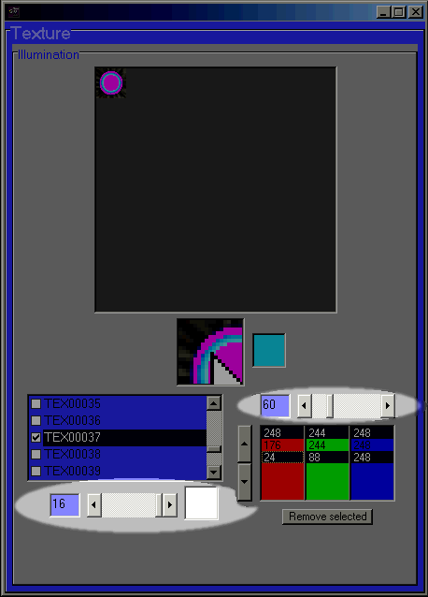
# Hitzone Editor
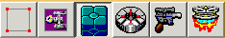
The hitzone editor defines the hittable portion of the mesh and other properties. The drop-down lists at the top of the frame show the mesh type and the explosion type. The first row of text boxes shows the span of the hitzone area, and the second row shows the center of the hitzone area. The next two rows are the minimum and maximum boundaries of the hitzone.
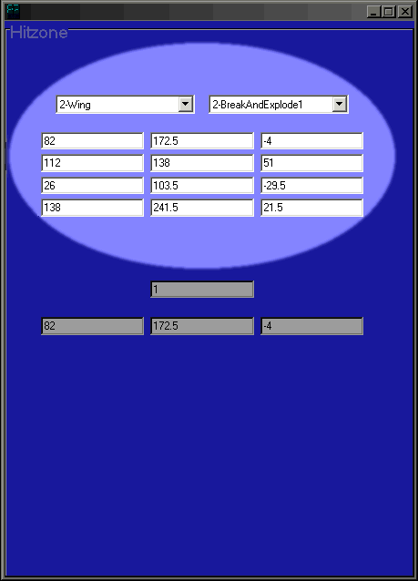
At the bottom of the frame is the targeting data. The first text box is the target ID, and below this are the center coordinates of the targeting box.
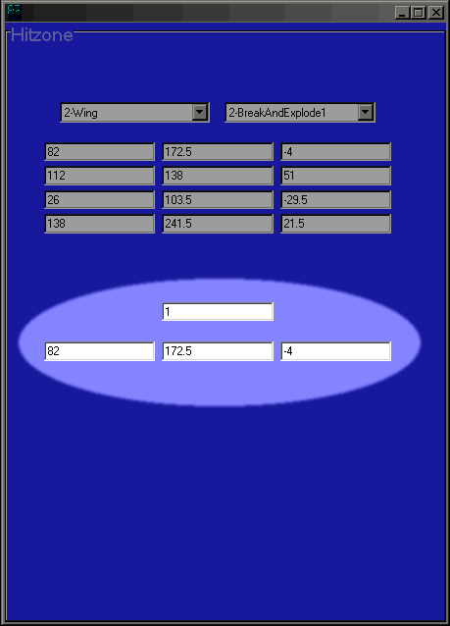
The graphical window by default draws the hitzones as purple boxes, and the targeting boxes as smaller pink boxes. Hitzones can be calculated automatically from the “calculate” menu.
# Transformation Editor
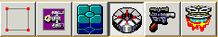
The transformation editor not only indicates the mesh’s rotation, but its translation and scale as well. The first row of text boxes is the mesh’s pivot. The second row of text boxes is the mesh’s rotation vector. This is the vector that the mesh rotates around. The third row is the translation vector. The mesh moves along this vector. The last row is the scale editor. The mesh stretches along this vector. Note, however, that the mesh will not rotate, translate, and scale all the time in the game. The behavior of the mesh depends on the mesh type, as well as values hardcoded into the executable.
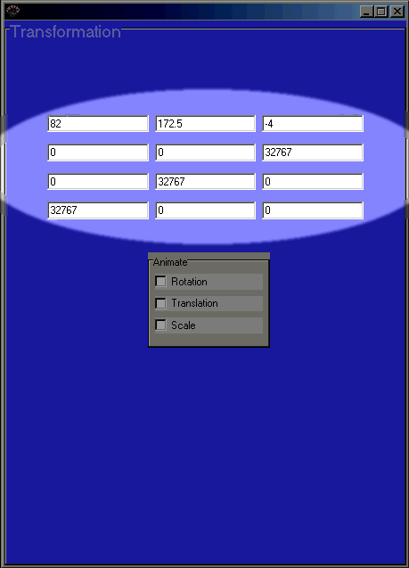
The check boxes in the “Animate” frame can be turned on and off to show a rough preview of how the mesh would behave in the game.
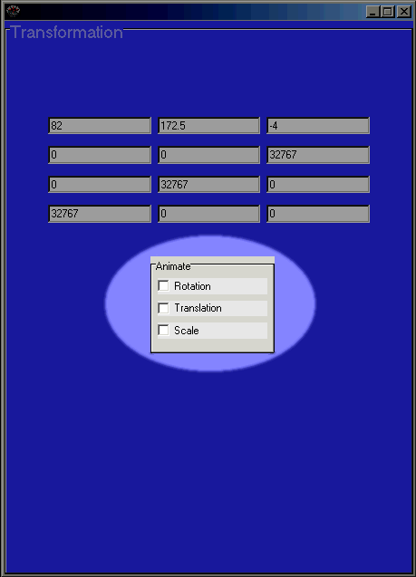
The graphical window by default draws the rotation axis as a red line, the translation axis as a green line, and the scale axis as a blue line. Transformations can be calculated automatically from the “calculate” menu.
# Hardpoint Editor
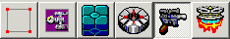
The hardpoint editor adds, removes, and alters the hardpoints in the selected meshes. The hardpoint list near the top only lists the hardpoints in the selected meshes, not all the hardpoints in the OPT. To change the properties of a particular hardpoint, click it in the list. The drop-down list shows the hardpoint type.
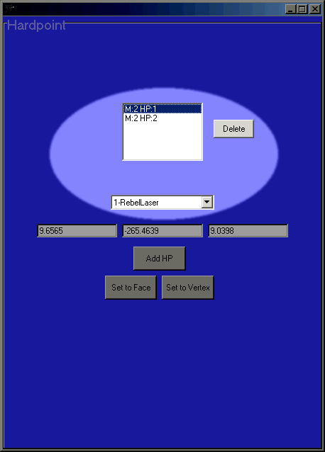
The text boxes below show the position of the hardpoint. To add a hardpoint to the selected mesh, click on the “Add HP” button. To position it over a face, select a face and press the “Set to Face” button. To position it over a vertex, select a vertex and press the “Set to Vertex” button.
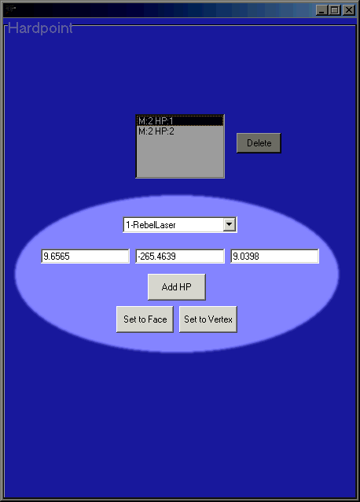
# Engine Glow Editor
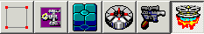
The engine glow editor adds, removes, and alters the engine glows in the selected meshes. The engine glow list near the top only lists the engine glows in the selected meshes, not all the engine glows in the OPT. To change the properties of a particular engine glow, click it in the list. The top row of text boxes show the position of the engine glow. The second row is the width, height, and length of the engine glow. The third row can be used to rotate the engine glow by the specified number of degrees.
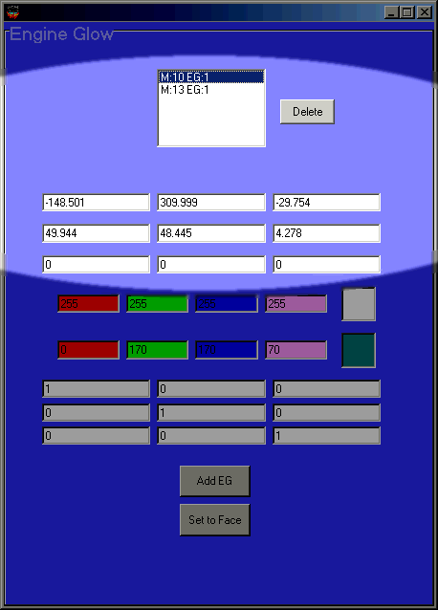
In the center of the frame are the RGBA values of the core and the outer of the engine glow. These can be changed by typing in new RGBA values or by clicking in the color preview box to the right.
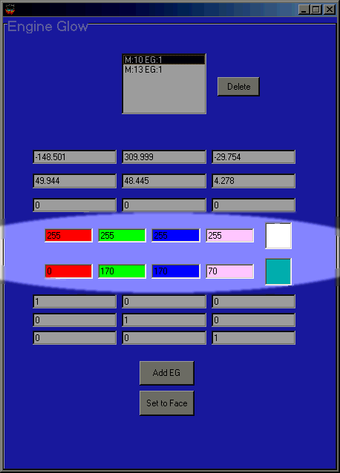
Below these are the three sets of direction values. The direction vectors will be drawn on the rendering display over the selected engine glows, and a yellow line will be drawn to represent the orientation of the engine glow. Clicking the direction text boxes will reset the orientation of the engine glows to point out the back of the OPT. To add an engine glow to the selected mesh, click on the “Add EG” button. To position it over a face, select a face and press the “Set to Face” button.
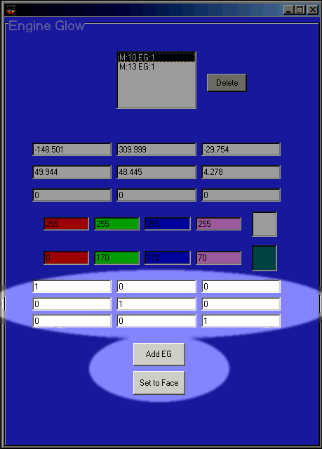
# OPT

OPT is the extension of the proprietary model format used in the X-Wing series. They define all the visual characteristics and geometry of the spacecraft and objects in the game, in addition to some data used by the game engine to determine hitzones and hardpoints.
# mesh

A mesh is a group of faces that make up a common part of the OPT. Ideally all faces in a mesh should be contiguous i.e. there should not be two distinct groups of faces combined into one mesh. Meshes also should not contain excessive amounts of faces. A mesh can be divided into two modes known as LODs.
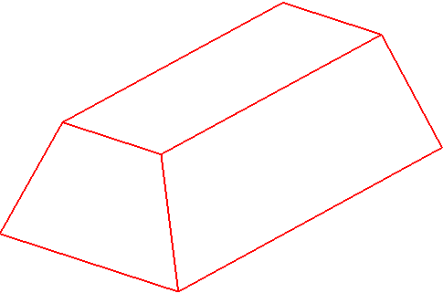
# hitzone

All meshes have hitzones that define how they react to collisions and laser blasts in the game. There are 32 possible hitzone types that define the role of the mesh, and in some cases activate transformation behavior on the OPT. There are also 11 different explosion types for the mesh. Hitzone data includes targeting information which is used when selecting subcomponents of the OPT within the game. Default hitzones can be calculated under the “Calculate” menu.
# transformation

All meshes have defined transformations, but are typically not activated in the game. The interpretation of transformation data is largely tied in with the hitzone data assigned to the same mesh. Meshes are given three vectors which define how the OPT might rotate, shift, or scale in the game. The magnitude and direction of the vectors are both significant. S-foils on craft as well as the rotation of R2 units and turrets are programmed using these vectors in conjunction with values hardcoded in the executable. Default transformations can be calculated under the “Calculate” menu.
# hardpoint

Hardpoints are an optional part of the OPT. There are 40 different types. Most types define where various weapon loads launch from on the OPT, but others serve other functions such as helping AI craft land in hangars and defining where in the OPT sparks are emitted.
# engine glow

Engine glows are an optional part of the OPT. They contain two colors relating to the inner and outer portion of the engine glow, in addition to an opacity value for transparency. The width and height of the engine glow are independent of each other, but the length is a factor dependent on these two values. The values assigned to engine glows are simply average dimensions, since they change length in the game depending on the amount of thrust. Engine glows point towards the back of the OPT by default, but can be rotated to flame in any direction.
# LOD

LODs, or Levels Of Detail, are used to help increase frame rates when using OPTs with large face counts. A mesh can contain just a high detail LOD or both a high detail and low detail LOD. A low detail LOD should have less faces than its high detail counterpart, but there is no enforced requirement that it be this way. When two LODs are used, the first should be set to vanish at a certain distance from the player. When the OPT reaches a distance beyond the vanishing distance of the high detail LOD, the low detail LOD is automatically displayed. If only a high detail LOD is used the vanishing distance is normally set to infinity, but if this changed to a realistic number then the OPT can be set to “cloak” when it is a certain distance from the player.
# face

A face is a polygon consisting of three or four vertices ideally arranged in counter-clockwise order. A quad must have all of its vertices lie on the same plane. All faces in an OPT are assigned at least one texture.
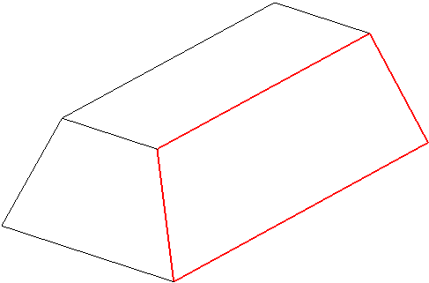
# face normal

Faces contain a set of values (I, J, K) that represent a normal vector. The normal determines which side of the face is the viewable side. The normal should always be perpendicular to the face. Face normals can be calculated from the “Calculate” menu. It should be noted that face normals are calculated based on the vertex ordering of each face. The model should use counter-clockwise vertex ordering in order to display correctly in the game, but as the diagram below shows the face normal ultimately determines the appearance of the face. However, interesting affects can be achieved by setting the face normal to contradict the face direction. If for some reason your model is imported in a clockwise order, you should select “vertex order” from the “fix” menu. This will change them to counter-clockwise, and you can proceed with editing.
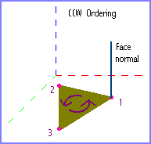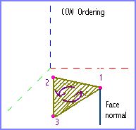
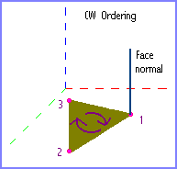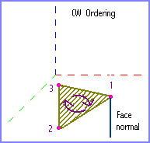
# software vector

The faces in OPT files are each assigned two vectors known as software vectors. These vectors are used to stretch the texture in 3D space, and are used only when the game is run in software mode. However, they also play a role in the texture quality when running in hardware mode. If they are set to 0 the textures will be at maximum sharpness, but when they are calculated they provide maximum compatibility. The usage of software vectors can be selected from the “Calculate” menu.
# texture

Textures are the artwork that is applied to all faces in an OPT. When flight group textures are used, four similar textures are applied to a single face with each varying in color or design. Their dimensions can only be a power of 2, but must be between 8 and 256 pixels.
# transparency

Transparency is a characteristic that can be assigned to textures in an OPT. Nomenclature notwithstanding, transparency can be actually be anything from completely invisible to completely solid, and is implemented by applying a mask over certain colors in a texture. Textures can have several layers of transparency, known as filters, with each having its own level of opacity.
# illumination

Illumination is a characteristic that can be assigned to textures in an OPT. The illumination effect occurs because colors in the texture can be made to not respond to light or shadow. Textures can have several layers of illumination, known as filters, with each having its own level of brightness.
# vertex

A vertex is the simplest component of any geometrical shape. Vertices are simply the corners of polygons, or faces. These vertices have a couple of attributes, namely texture coordinates for texture mapping and vertex normals for lighting calculations.
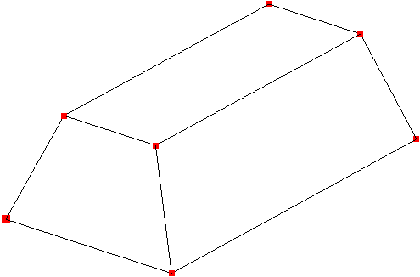
# vertex normal

Vertices contain a set of values (I, J, K) that represent a normal vector. The normal of a vertex is calculated by averaging the face normals of all faces that contain the same vertex, and in the game they play a role in how the faces are affected by a light source. Vertex normals can be calculated from the “Calculate” menu. Vertex normals are calculated based on the face normals, so you should calculate vertex normals after the face normals.
# texture coordinate

Each vertex of a face is assigned a texture coordinate, which consists of a U and V value. A texture is mapped to the face depending on these values. When measuring the dimensions of a texture using the UV system, the texture will always be 1 unit wide and 1 unit high, regardless of the actual dimensions. Therefore, to make a texture fit exactly into a quad face, you simply need to set the bottom left vertex to 0,0, the bottom right to 1,0, the top right to 1,1, and the top left to 0,1. Although a texture is 1x1 units in dimension, it is possible to use a value greater than 1 when mapping the texture to a face. Doing this causes the texture to repeat over the face X number of times. Using values less than 1 will crop the texture in order to make it fit in the face. Negative numbers are also acceptable. Texture coordinates can be set to default from the “Calculate” menu.
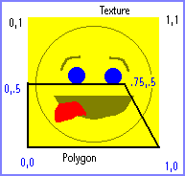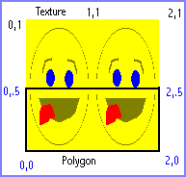
# Errors and Solutions

The following are errors that can be generated by the built-in error report generator, and their respective descriptions and solutions for fixing them.

Error: Mesh X has wrong hitzone dimensions.
Description: Mesh X has a hitzone boundary that does not exactly match up to the true geometrical boundary of the mesh.
Solution: Calculate the hitzones from the “Calculate” menu.

Error: Mesh X, LOD X, Face X normal does not correspond to orientation of face.
Description: A face is expected by the game to face a certain way depending on the ordering of its vertices. However, the face normal attributed to Face X is pointing in the direction opposite than what is expected.
Solution: Calculate the face normals from the “Calculate” menu.

Error: Mesh X, LOD X, Face X uses default.bmp
Description: Face X is still using the default texture assigned to it when the model is loaded as a DXF or OBJ.
Solution: Apply a new texture to the face.

Error: TEXxxxxx contains dimension(s) that is less than 8 pixels in size.
Description: Textures must have dimensions greater than or equal to 8 pixels to work in the game.
Solution: Open the texture in a paint program and resize it proportionally until both the width and height in pixels meet the size requirement.

Error: TEXxxxxx contains dimension(s) that is greater than 256 pixels in size.
Description: Textures must have dimensions less than or equal to 256 pixels to work in the game.
Solution: Open the texture in a paint program and resize it proportionally until both the width and height in pixels meet the size requirement.

Error: There are too many textures in the model.
Description: The model has over 100 textures, and will not work in the game.
Solution: Reduce the number of textures.

Error: The faces in this model appear to be in clockwise order.
Description: A great majority of the faces in the OPT use a clockwise vertex ordering, rather than the counterclockwise ordering that is preferred by the game.
Solution: Reverse the vertex order from the “Fix” menu.

Error: This model will not work in software mode.
Description: A face in the model was found to contain zeroed out software vectors, which is unacceptable when running in software mode.
Solution: Run the game in hardware mode instead of software mode.

Error: No model is loaded.
Description: A project has not been completely initialized with a loaded model.
Solution: Import an OPT, OPZ, DXF, or OBJ from the “File” menu.
# Other Features and Issues

Features
OPTech has a few other accessories for the user’s convenience. Under the “Options” menu, most of the rendering colors can be changed and you can toggle between displaying only the visible faces or all faces on your model. You can also toggle antialiasing on and off. Turning it off will increase rendering performance but lower the quality in turn. Your options will be saved in a file so that you don’t have to change them every time you launch the program. Under the “Info” menu is an item that will display a message box indicating the number of faces in the OPT. You can also view the model dimensions in meters by clicking the “model dimensions” option. Under the “Fix” menu are items that will convert all quad faces in the OPT to tri faces and vice versa.
Known Issues
- The “software vectors (compatibility)” under the “Calculate” menu has been disabled because it does not work yet.
- Certain procedures such as compiling the OPT, calculating vertex normals, etc. can take a while with large OPTs. I mention this because everyone is probably used to lightning fast processing with other OPT tools. I will be working on making the code faster in successive versions.
- The transformation emulator accurately depicts how the meshes would rotate in the game, although the translation and scale preview is a little iffy.
- The cones which are rendered to represent the engine glows are accurate in most cases, but sometimes they are drawn with too much length. I’m still searching for a better equation for this. They also do not represent their actual orientation, the yellow line coming out of them does this.
- Some retail OPTs will not import, but I will be trying to increase the success rate with later versions.
- Transparency and illumination are the only parts of the OPT that aren’t imported.

Future possibilities
These are things that I will attempt to add in later versions.
- Texture maps for transparency and lighting.
- Working software vectors.
- An option to reduce the number of faces in a model.
- Illumination representation.
- And more!

# Credits and Disclaimer

Disclaimer
This program is designed to be able to open and edit all OPT files, both Totally Games and fan-made, so please put the original maker into consideration if you ever think of releasing a modified version to the public. I am not responsible for any adverse affects that may occur by running this program. With that out of the way, have fun!

Credits
First, I owe special thanks to Defiant and Stealth for giving me pointers on getting parts of my code to work, and for making their OPT specs available. I also thank Darksaber for additional information on the hardpoint and mesh types. And thanks to the rest of the people at the XWAUP and X-Wing Legacy for their support and for being patient while I worked on this thing, as well as using it to produce some excellent OPTs.
Of course, Totally Games deserves credit for developing the X-Wing series, and I suppose Lucasarts deserves some credit also even though they probably don’t even approve of this program…

- Derek del Rio (Jedi Hunter/Com Trooper) for OPTech v1
- Jérémy Ansel (JeremyaFr) for OPTech v2
- General_Trageton for the new icons

Special thanks to Darksaber, Driftwood, DTM, General_Trageton for testing

Contact
v1:
Keep an eye out for more versions of this program at http://www.abstraction.com/derek2

I can be reached by E-Mail through derek@paxorbis.com

v2:
The latest version can be found at
https://github.com/JeremyAnsel/OPTech/releases/latest

You can discuss about OPTech at https://www.xwaupgrade.com

©2000 Derek del Rio (Jedi Hunter/Com Trooper)
©2018 Jérémy Ansel (JeremyaFr)

