

Final Examination
PART A

COE 312 – Software Design for Engineers

Fall 2019

Imran A. Zualkernan

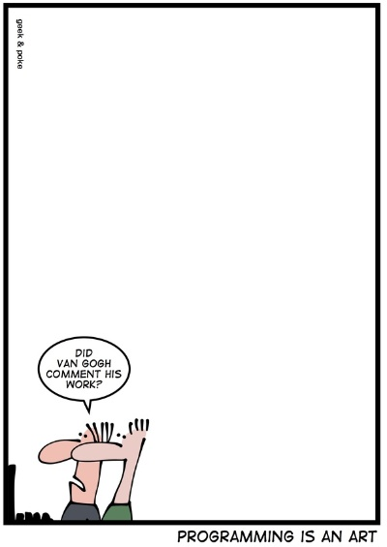

Name: __________________________________

ID: __________________________________

Please use this template to upload your answer. Make sure that you show screenshots of the output of your program. Failure to do so will result in an automatic deduction of 20% grade even if your program works and may result in no grade at all.

Q. (50 points). Write a game that consists of three types of Teletubby characters; La-La, Po and Noo-Noo.

La-La

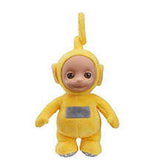

La-La is either dancing or singing. If La-La is dancing and Noo-Noo is sucking, then La-La starts to sing. Alternatively, if La-La is singing and Noo-Noo starts slurping, then La-La starts dancing again.

Po

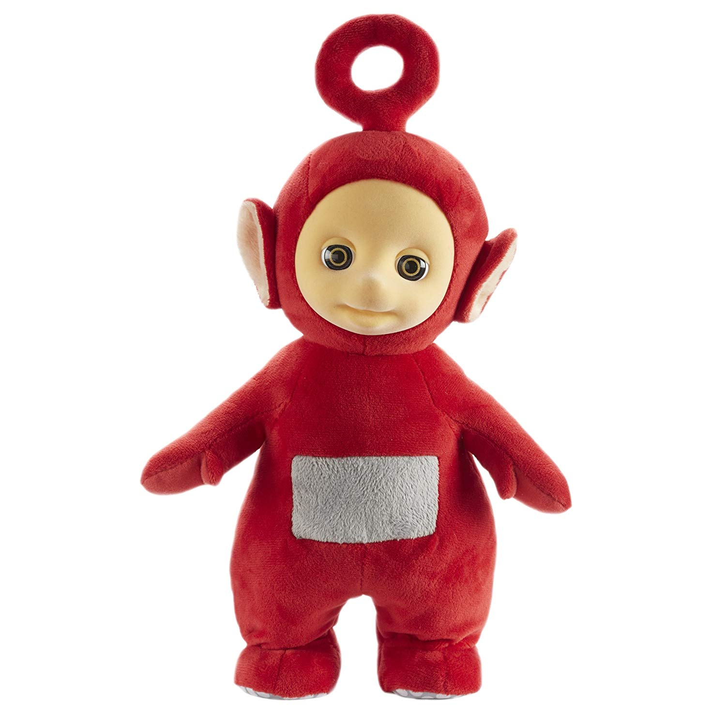

Po is either sleeping or speaking. If Po is sleeping and Noo-Noo is sucking, then La-La starts speaking. Alternatively, if Po is singing and Noo-Noo starts slurping, then Po starts sleeping.

Noo-Noo

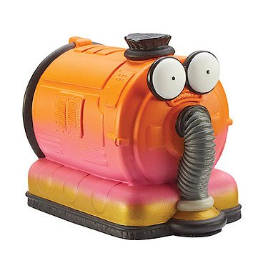

Noo-Noo is either slurping or sucking. It slurps for 3 seconds and then switches to sucking and then back to slurping after another 3 seconds.

In the game, there is one Noo-Noo but many La-La’s and Po’s. The characters must print when they switch their state.

Show how your game works with 3 La-La’s and 2 Po’s. Use all appropriate good software design techniques to implement your game.

Sample Output:
…
Po@6e67326 changing state to Speaking@8218d8a
Lala@5778204d changing state to Singing@59bfd4d2
Lala@3bf5838f changing state to Singing@35326a81
NooNoo state=slurping
Lala@5d7ba504 changing state to Dancing@1c46af3f
Po@561d9d91 changing state to Sleeping@172097aa
Po@6e67326 changing state to Sleeping@c1e1856
Lala@3bf5838f changing state to Dancing@310de8ff
Lala@5778204d changing state to Dancing@5d804b3d
NooNoo state=sucking
Po@561d9d91 changing state to Speaking@1c36a00c
Lala@5778204d changing state to Singing@1882dee9
Po@6e67326 changing state to Speaking@491c87b1
Lala@3bf5838f changing state to Singing@740f60ba
Lala@5d7ba504 changing state to Singing@2dc3c1fd
NooNoo state=slurping
…

