Robotics Project Report
Jeremy Hendrikse & Julius Ortstadt
ROBO5

Table of Contents
1. Project Overview 1
2. Robot Model 1
3. Kalman Filter Implementation 3
3.1 Filter Initialization 4
3.2 Filter Loop 4
3.3 Simulation 4
4. Results and Performance 5
5. Improvements and Implementation 6
6. Conclusion 6
7. Appendices 7

Table of Figures
Figure 1 - Grabby 1
Figure 2 - Robot representation 1
Figure 3 - Generated accelerometer data 5
Figure 4 - Generated encoder data 5

Appendix figure 1 - Data generation graphic 7
Appendix figure 2 - Kalman Filter estimates 7
Appendix figure 3 - Errors 8
Appendix figure 4 - Trajectory plot 8

Appendices
Appendix 1 (Filter results) 7
Appendix 2 (Motor model) 9
Appendix 3 (Sources) 9

1. Project Overview
This project proposed designing and implementing a Kalman filtering approach to a robot. In this case it was Grabby, an autonomous warehouse robot capable of autonomously mapping and navigating a warehouse like environment with the help of various actuators, sensors and algorithms.
To achieve this, it is equipped with a 2D LiDAR sensor, an Inertial Measurement Unit (IMU) and motor encoders. This non-exhaustive list doesn’t include all the necessary components but only those relevant to the scope of this project.
The mapping and navigation capabilities are obtained by using a ROS Navstack combined with AMCL (Advanced Monte Carlo Localization) and Google cartographer.
For the SLAM algorithm to localize the robot, it needs a pose estimation of the robot in its environment. It combines this first basic estimate with the LiDAR data to further enhance its positioning but also to acknowledge present obstacles and more. The Kalman filter that will be implemented in the scope of the project sits at the first step of the robots pose estimation. It will have access to the encoder data for each wheel as well as the IMU readings.
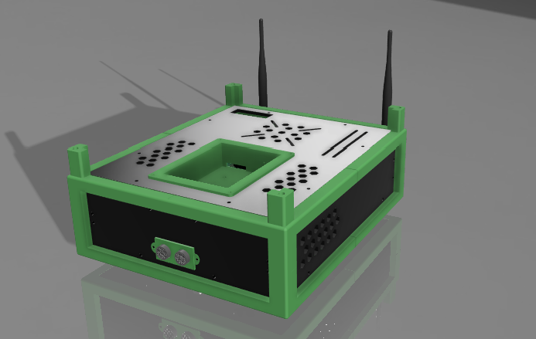
Figure 1 - Grabby

2. Robot Model
The warehouse robot Grabby used for this project is a differential-drive mobile robot. It is modeled as a rigid rectangular platform with two driven wheels and uniform mass distribution. Each wheel is controlled by a DC motor through a gearbox, and the robot moves by applying different voltages on the right and left motors.
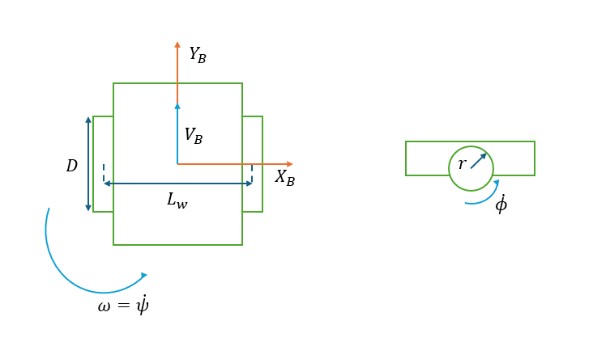
Figure 2 - Robot representation

The main parameters of the robot are:
$$m=5 [kg]$$ | Mass of the robot
$$L*l=0.49*0.33 [m]$$ | Dimensions of the rectangular base
$$D=0.1m ⇒r=0.05 [m]$$ | Wheel diameter and radius
$$L_{w}=0.2 [m]$$ | Wheelbase (wheel separation)
$$N=98.78$$ | Gear ratio
$$J=0.145 [kg.m^{2}]$$ | Moment of inertia of the robot
$$b=1.0$$ | Friction coefficient of the wheels
$$X_{B}-Y_{B}$$ | Body frame
$$ψ [rad]$$ | Heading of the robot (yaw angle)
$$ω=\dot{ψ} [rad/s]$$ | Angular velocity of the robot
$$V_{B} [m/s]$$ | Linear velocity of the robot in the body frame
${\dot{ϕ}}_{l} \& {\dot{ϕ}}_{r} [rad/s]$ | Angular velocity of the left and right wheels respectively
$σ_{v} [m/s], σ_{ψ} \left[rad\right], σ_{\dot{ψ}} [rad/s]$ | Standard deviations for the velocity (integrated from the accelerometer), yaw from the magnetometer and yaw rate from the gyrometer measurements respectively
$$q$$ | Process noise scaling factor controlling the amount added to the model

To design the Kalman filter, a mathematical model of the robot is needed to rule the dynamics and kinematics of the filter. And based on the available sensors, the IMU readings will be used for the prediction step while the wheel encoders will serve as input to the system. This allows the system to have a greater robustness while limiting the effect of slip on the wheels and correcting the potential drift (and bias) of the encoder readings.
Since the filter’s goal is to provide a pose estimate of the robot, the corresponding state vector is defined as:
$$X=\left[\begin{aligned}V_{B} \\ ψ \\ \dot{ψ}\end{aligned}\right]$$
The robot’s dynamics are described by a linearized dynamic model derived from the torque balance on each wheel using both forms of Newton’s second law:
$$\left\{\begin{aligned}m{\dot{V}}_{B}=\left(\frac{τ_{r}}{r}-b{\dot{ϕ}}_{r}\right)+\left(\frac{τ_{l}}{r}-b{\dot{ϕ}}_{l}\right) \\ J\dot{ω}=\left(\frac{τ_{r}}{r}-b{\dot{ϕ}}_{r}\right)\frac{L_{w}}{2}-\left(\frac{τ_{l}}{r}-b{\dot{ϕ}}_{l}\right)\frac{L_{w}}{2}\end{aligned}\right.$$
where $τ_{l} \& τ_{r} [N.m]$ is the torque exerted by the left and right wheel on the ground respectively.
The previous equations can be rewritten in matrix form:
$$\left[\begin{aligned}{\dot{V}}_{B} \\ \dot{ω}\end{aligned}\right]=\left[\begin{matrix}\frac{1}{mr} & \frac{1}{mr} \\ \frac{L_{w}}{2rJ} & -\frac{L_{w}}{2rJ}\end{matrix}\right]\left[\begin{aligned}τ_{r} \\ τ_{l}\end{aligned}\right]+\left[\begin{matrix}-\frac{b}{m} & -\frac{b}{m} \\ -\frac{bL_{w}}{2J} & \frac{bL_{w}}{2J}\end{matrix}\right]\left[\begin{aligned}{\dot{ϕ}}_{r} \\ {\dot{ϕ}}_{l}\end{aligned}\right]$$
The rotational velocity of the wheels is not directly used but rather the state vector and its components. Using the inverse kinematics, $\left[\begin{aligned}{\dot{ϕ}}_{r} \\ {\dot{ϕ}}_{l}\end{aligned}\right]$ can be substituted by $X$:
$$\left\{\begin{aligned}V_{B}+\frac{L_{w}}{2} \dot{ψ}= r{\dot{ϕ}}_{r} \\ V_{B}-\frac{L_{w}}{2} \dot{ψ}= r{\dot{ϕ}}_{l}\end{aligned}\right.⇔\left\{\begin{aligned}{\dot{ϕ}}_{r}=\frac{V_{B}}{r}+\frac{L_{w}}{2r}\dot{ψ} \\ {\dot{ϕ}}_{l}=\frac{V_{B}}{r}-\frac{L_{w}}{2r}\dot{ψ}\end{aligned}\right.⇒\left[\begin{aligned}{\dot{ϕ}}_{r} \\ {\dot{ϕ}}_{l}\end{aligned}\right]=\left[\begin{matrix}\frac{1}{r} & \frac{L_{w}}{2r} \\ \frac{1}{r} & -\frac{L_{w}}{2r}\end{matrix}\right]\left[\begin{aligned}V_{B} \\ \dot{ψ}\end{aligned}\right]$$
Therefore:
$$\left[\begin{matrix}-\frac{b}{m} & -\frac{b}{m} \\ -\frac{bL_{w}}{2J} & \frac{bL_{w}}{2J}\end{matrix}\right]\left[\begin{aligned}{\dot{ϕ}}_{r} \\ {\dot{ϕ}}_{l}\end{aligned}\right]=\left[\begin{matrix}-\frac{b}{m} & -\frac{b}{m} \\ -\frac{bL_{w}}{2J} & \frac{bL_{w}}{2J}\end{matrix}\right]\left[\begin{matrix}\frac{1}{r} & \frac{L_{w}}{2r} \\ \frac{1}{r} & -\frac{L_{w}}{2r}\end{matrix}\right]\left[\begin{aligned}V_{B} \\ \dot{ψ}\end{aligned}\right]=\left[\begin{matrix}-\frac{2b}{mr} & 0 \\ 0 & -\frac{b{L_{w}}^{2}}{2Jr}\end{matrix}\right]\left[\begin{aligned}V_{B} \\ \dot{ψ}\end{aligned}\right]$$
It is now possible to write the continuous-time linear dynamics model of the system in the form $\dot{X}=FX+GU$ :
$$\left[\begin{aligned}\dot{V_{B}} \\ \dot{ψ} \\ \ddot{ψ}\end{aligned}\right]=\left[\begin{matrix}-\frac{2b}{mr} & 0 & 0 \\ 0 & 0 & 1 \\ 0 & 0 & -\frac{b{L_{w}}^{2}}{2Jr}\end{matrix}\right]\left[\begin{aligned}V_{B} \\ ψ \\ \dot{ψ}\end{aligned}\right]+\left[\begin{matrix}\frac{1}{mr} & \frac{1}{mr} \\ 0 & 0 \\ \frac{L_{w}}{2Jr} & -\frac{L_{w}}{2Jr}\end{matrix}\right]\left[\begin{matrix}τ_{r} \\ τ_{l}\end{matrix}\right]$$
This continuous time state-space model is used to generate the simulation data and in the prediction step of the filter.
The matrices $F$ and $G$ are given by:
$$F=\left[\begin{matrix}-\frac{2b}{mr} & 0 & 0 \\ 0 & 0 & 1 \\ 0 & 0 & -\frac{bL^{2}}{2Jr}\end{matrix}]\right] G=\left[\begin{matrix}\frac{1}{mr} & \frac{1}{mr} \\ 0 & 0 \\ \frac{L}{2Jr} & -\frac{L}{2Jr}\end{matrix}\right]$$
This model accounts for the frictional losses in the wheels and the rotational coupling between the left and right torques.
For discrete-time simulation, the matrices were discretized using the sampling time $T_{s} [s]$ :
$$Φ=I+FT_{s} and G_{d}=GT_{s}$$This representation allows the robot’s position, speed, and orientation (heading) to be estimated at each time step during simulation.

3. Kalman Filter Implementation
As previously explained, the objective of the Kalman Filter (KF) is to estimate the robot’s pose (speed, yaw, and yaw rate) from noisy sensor measurements. The simulation setup includes two types of sensor data:
- IMU: provides noisy measurements of the three states $[v,ψ,\dot{ψ}]$ where the speed $v$ is obtained by integrating the acceleration measurement.
- Motor encoders: used indirectly to compute the estimated wheel torques applied to the robot through the motor equations.

3.1 Filter Initialization
The initial state estimate $X_{0}$was set to zero, and the state-estimate error covariance matrix $P_{0}$was initialized with large values (${10}^{9}$) to represent complete uncertainty at the beginning.
$$P=\left[\begin{matrix}{10}^{9} & 0 & 0 \\ 0 & {10}^{9} & 0 \\ 0 & 0 & {10}^{9}\end{matrix}\right]$$The process and measurement noise covariances were found to be:
$$Q=q×\left[\begin{matrix}T_{s}σ_{v}^{2} & 0 & 0 \\ 0 & σ_{ψ}^{2}\left(\frac{T_{s}^{3}}{3}\right) & σ_{ψ}σ_{\dot{ψ}}\left(\frac{T_{s}^{2}}{2}\right) \\ 0 & σ_{ψ}σ_{\dot{ψ}}\left(\frac{T_{s}^{2}}{2}\right) & σ_{\dot{ψ}}^{2}T_{s}\end{matrix}\right] ; R=\left[\begin{matrix}σ_{v}^{2} & 0 & 0 \\ 0 & σ_{ψ}^{2} & 0 \\ 0 & 0 & σ_{\dot{ψ}}^{2}\end{matrix}\right]$$
These matrices were tuned empirically to achieve stable convergence and realistic noise behavior. The robot is currently undergoing design changes; this also concerns the sensors. Since these haven’t been chosen yet, typical values found through research were used to tune the noise parameters of the sensors in the simulation.

3.2 Filter Loop
At each iteration:
- Update step: the filter corrects the predicted state using accelerometer data
$$K=PH^{T}(HPH^{T}+R)^{-1} \\ X_{k∣k}=X_{k∣k-1}+K(Y_{k}-HX_{k∣k-1}) \\ P_{k∣k}=(I-KH)P_{k∣k-1}$$
- Prediction step: the state is projected forward using the robot model and estimated torques
$$X_{k+1∣k}=ΦX_{k∣k}+G_{d}U_{k} \\ P_{k+1∣k}=ΦP_{k∣k}Φ^{T}+Q$$
where $H=\left[\begin{matrix}1 & 0 & 0 \\ 0 & 1 & 0 \\ 0 & 0 & 1\end{matrix}\right]=I_{3}$ since all three states are measured directly by the simulated IMU.
The filter therefore fuses sensor readings (accelerometer) and motor/encoder information (torque estimates) to produce a smooth, physically consistent estimate of the robot’s motion.

3.3 Simulation
To evaluate the filter in different motion conditions (straight line, rotation and variable speed), the simulation runs with different voltage profiles applied to the two motors:
- 12 V on both motors, reduced to 8 V on one side to simulate turning behavior.
- Later variations in voltage create curved trajectories and speed changes.

4. Results and Performance
The simulation first generates true states (velocity, yaw, yaw rate) using the robot model.
Noisy accelerometer and encoder signals are then created by adding Gaussian noise, simulating realistic sensors. It generates accurate data and can, if wanted, introduce bias or wheel slip in the simulation. This is the data that the KF will receive. A graphical representation of this procedure can be found in Appendix 1.
Note: The accelerometer data is integrated to get the values for the robot’s speed.
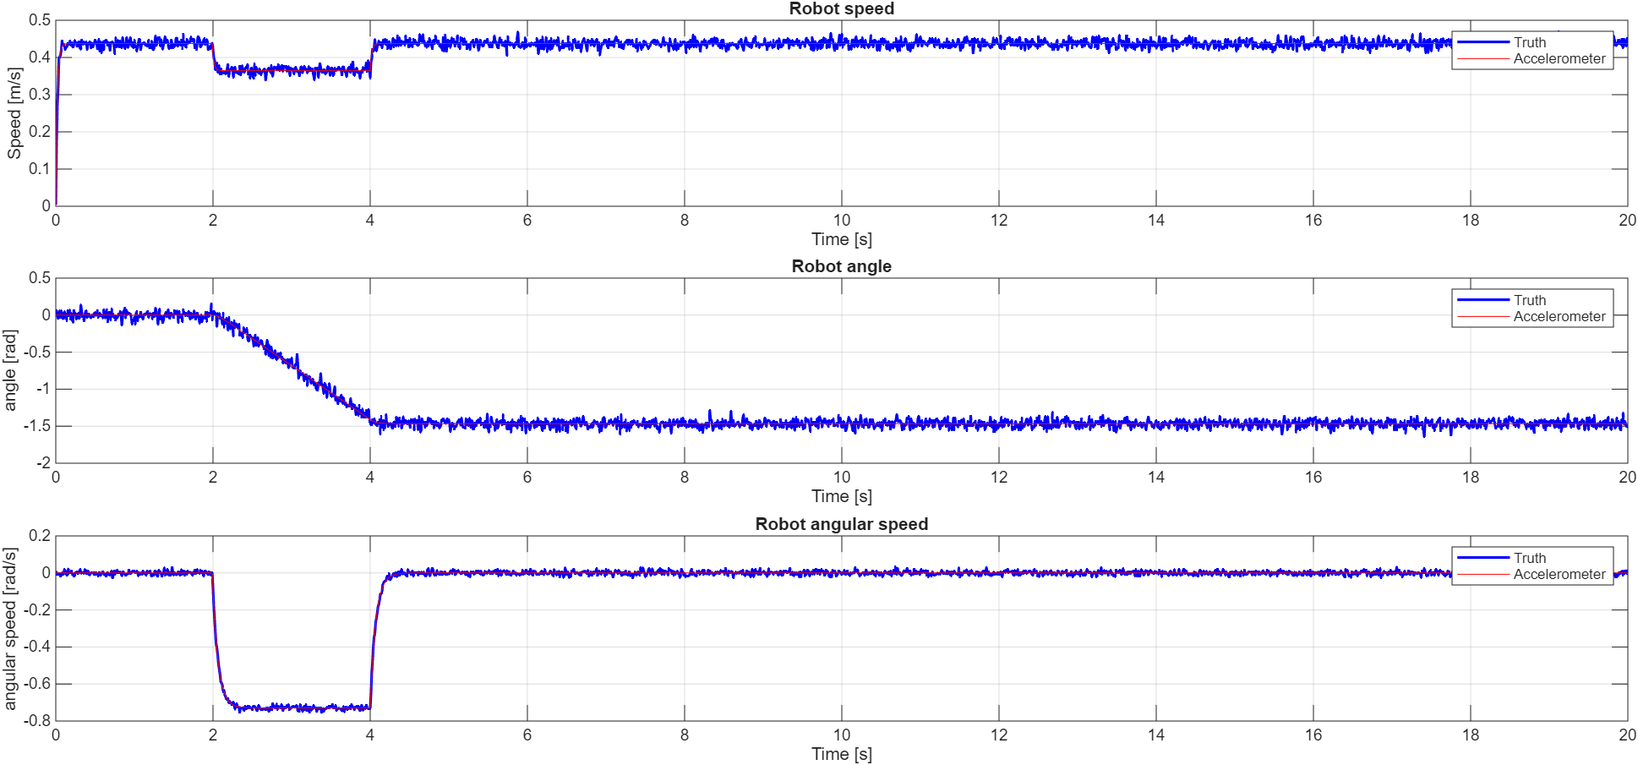
Figure 3 - Generated accelerometer data
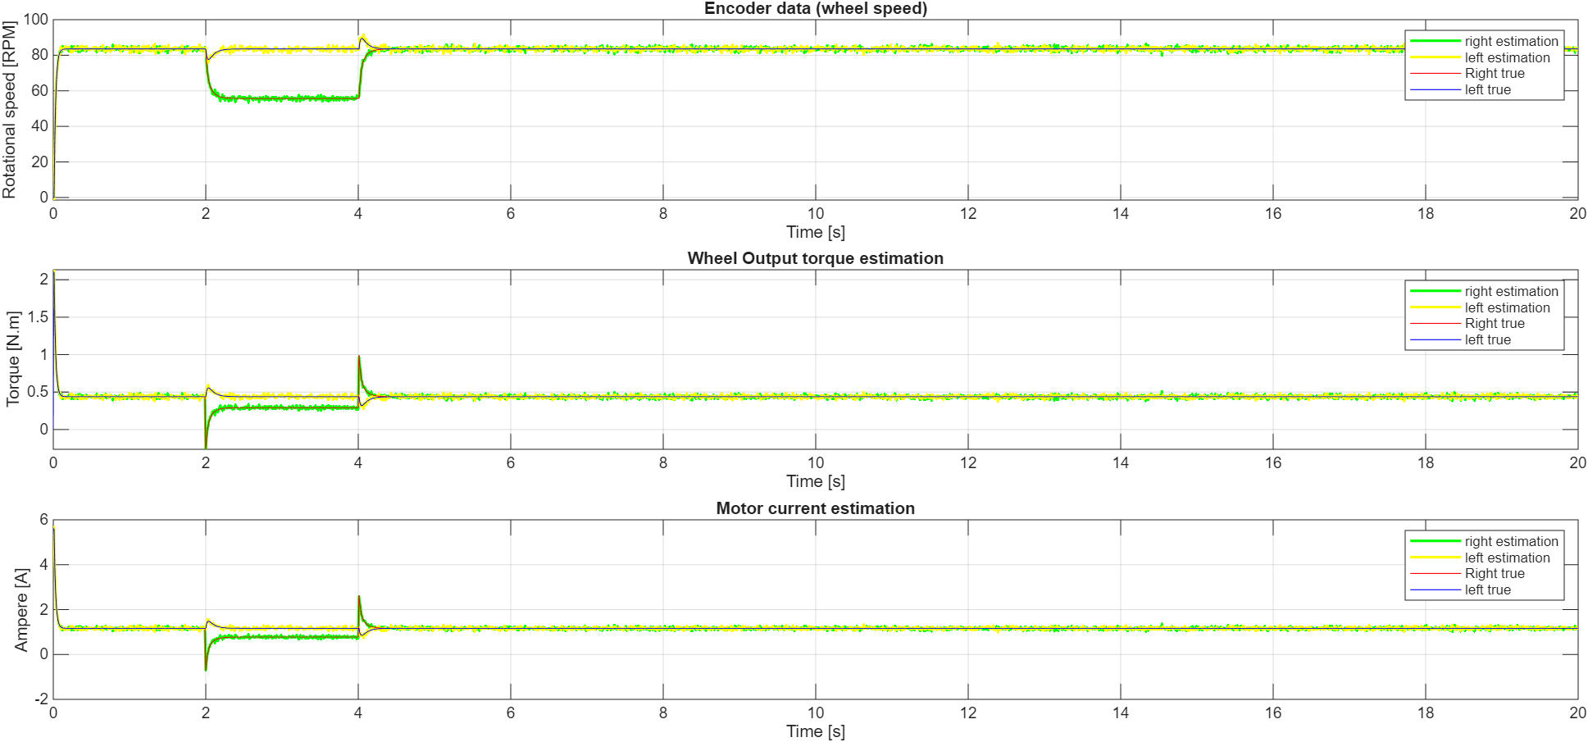
Figure 4 - Generated motor data
Regarding the motor data, additional information on that topic can be found in Appendix 2.
The filter output $X_{\text{KF}}$ closely follows the true robot state $X_{\text{truth}}$.
Plots of speed, yaw angle, and angular velocity show that:
- The estimated curves rapidly converge to the true values after a short transient phase. Something that is common in most types of filters.
- The noise in the accelerometer data is strongly reduced.
- The orientation estimate remains stable and smooth even when sensor noise increases.
By taking the given estimate and integrating the necessary components to obtain the robots position in a 2D plane, it can be observed that the robot trajectory also matches well with the ground truth path. Therefore, demonstrating that the KF provides reliable pose estimates for navigation and SLAM.
Moreover, by storing the square root of the covariance matrix $P$, the expected uncertainty bounds were plotted alongside the real estimation errors. All three state components remain within the expected error boundaries, confirming correct filter tuning and numerical stability.
The estimation errors for linear speed stay below ±0.02 m/s, and the yaw and yaw-rate errors remain minimal across the full simulation. Graphs showing the results are in Appendix 1.

5. Improvements and Implementation
The current linear Kalman filter doesn’t consider non-linearity that will be introduced by projecting from the body frame into the navigation/inertial frame. By extending the filter to an EKF, this non-linearity can be considered. However, if the estimates of the linear filter are viable, like in this case, the projection can also be handled outside of the filter with a simple transformation.
Also, the state vector can be expanded to include the bias estimation for the IMU. This would finetune the implemented model and further enhance estimate precision as the sensor bias and noise would be compensated online.
Whether the filter is a standard KF or an EKF, its position in the control architecture of the robot will remain the same. Its output will either be directly used by the SLAM to combine with the LiDAR data or first transformed into the navigation frame. It will directly source its pre-processed (converted from raw to usable units) data from the encoders and the IMU. Furthermore, the code implementation will be as a ROS2 package with a node subscribing and publishing to/on the required topics.
In the current setup, we still rely on simulated robot constants such as inertia and friction, even though these aren’t known a priori on the real platform. Initial tests without these fixed values showed that the filter remains fairly robust, but integrating these parameters directly into the state vector similar to how IMU bias is handled would let the filter estimate them and compensate for their variability. This would naturally tighten the model and improve consistency once deployed on the actual robot.
We also explored scenarios with wheel slip, where the estimation quality degraded noticeably. To recover accurate behaviour, the process noise matrix had to be manually retuned for each case, which is neither scalable nor desirable. Introducing an adaptive mechanism that adjusts the process covariance based on innovation statistics would let the filter react to changing conditions in real time. This kind of feedback loop would make the system more resilient to slip, parameter drift, and other unmodelled disturbances without requiring case-by-case tuning.

6. Conclusion
To conclude, it was shown that by modelling the robot with a kinematic and dynamic approach, and by simulating sensor data using the physical properties of the robots’ components, a linear Kalman filter can produce a viable estimate of the robots’ pose relative to the body frame. This estimate can be projected into the navigation frame to offer a relative pose of the robot.
Down the line this estimate will be used in the AMCL (Advanced Monte Carlo Localization) algorithm, to precisely position the robot on the map by combining the estimate with the LiDAR data.
Therefore, the implemented filter meets its main objective:
- It reduces sensor noise and provides smooth and reliable state estimates.
- It maintains real-time feasibility and can be extended for onboard implementation.
- The results validate the dynamic model of the robot and the correctness of the KF structure.
Although only done in simulation, the implementation onto the physical robot is possible as the current ROS EKF package works just fine but has a more general model approach. If the model is finetuned for the specific robot, the workload can be reduced and offer better performances.

7. Appendices
Appendix 1 (Filter results)
The below diagram shows the workflow of how the simulation data is generated.
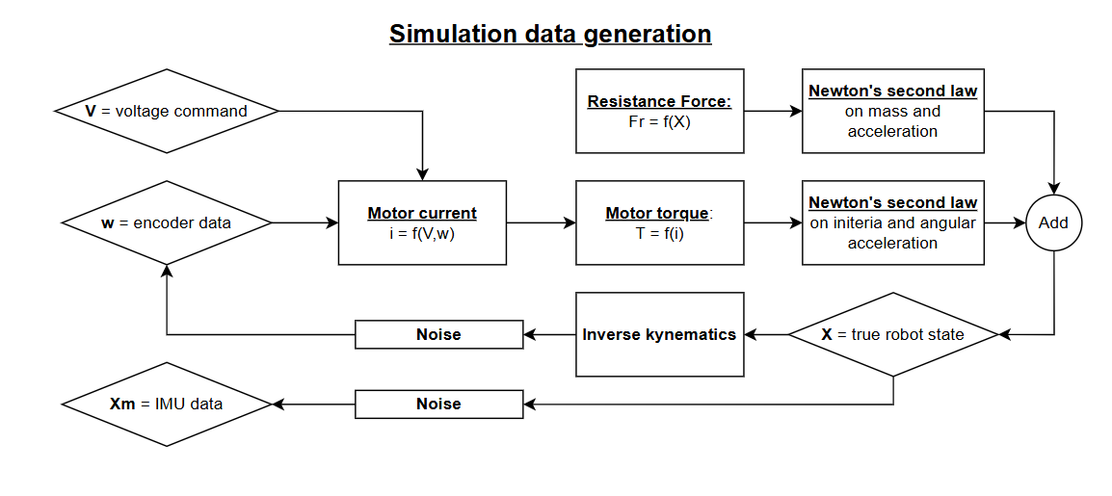
Appendix figure 1 - Data generation graphic

Also, by plotting the output of the Kalman filter, it can be observed that the state estimates closely follow the true robot states.
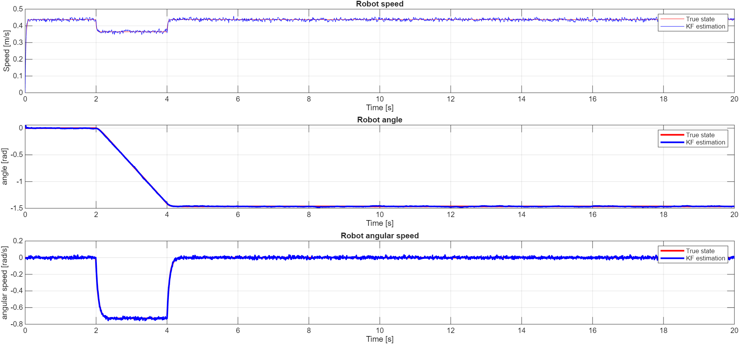
Appendix figure 2 - Kalman Filter estimates

The above result is verified by plotting the expected deviations against the estimation errors:
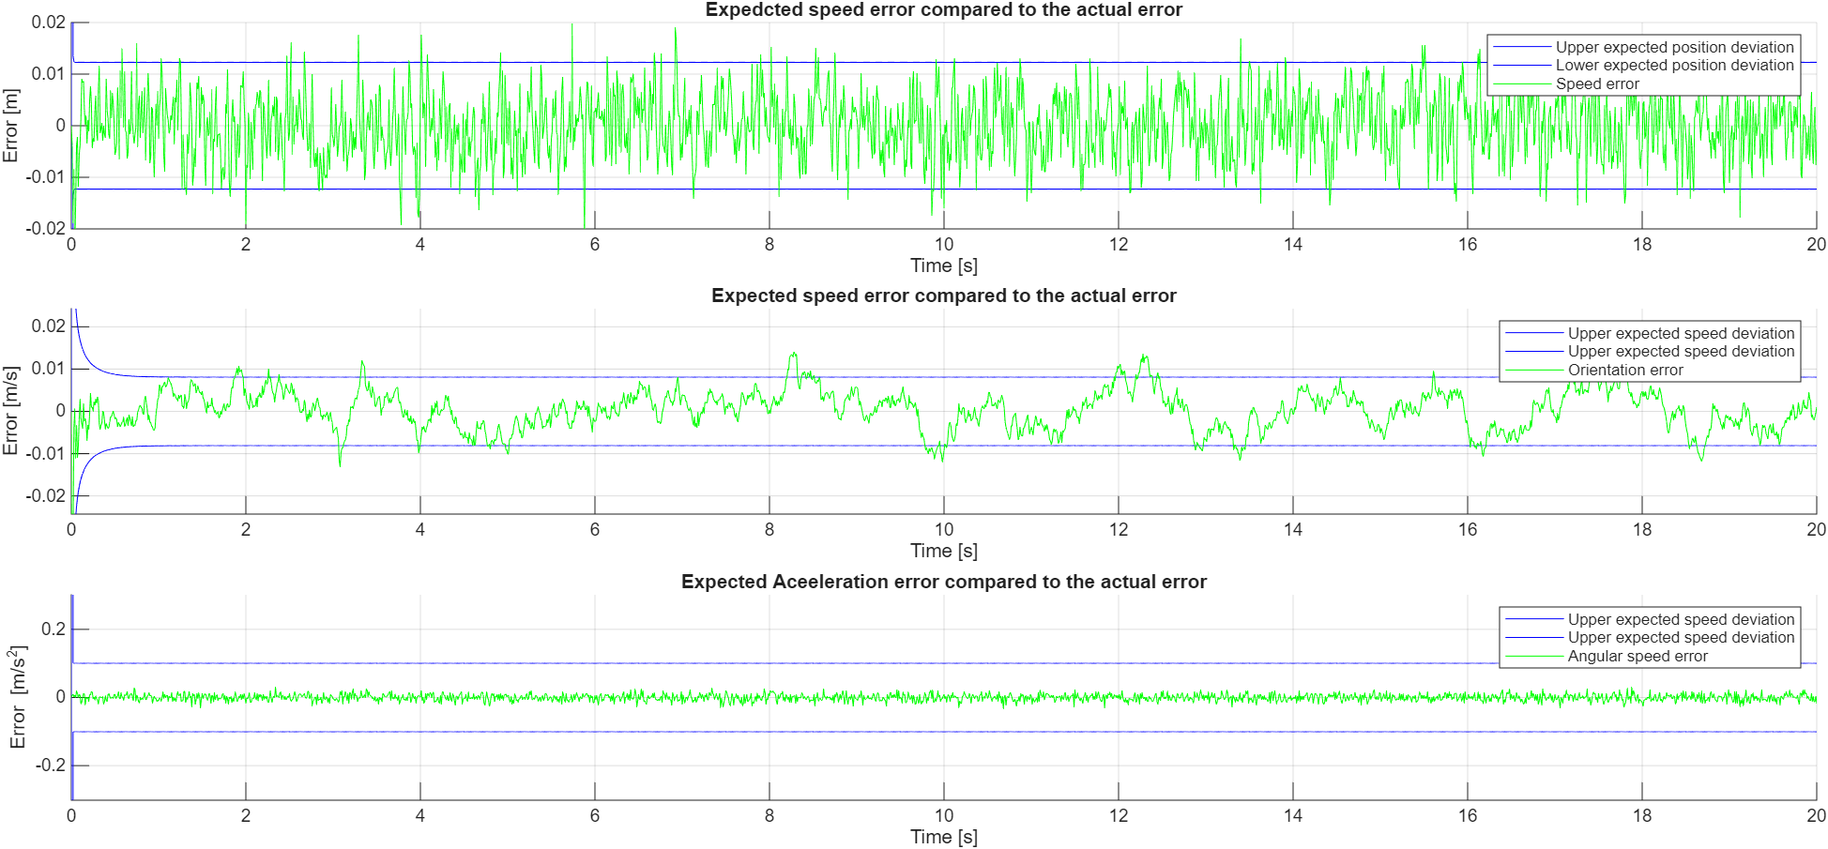
Appendix figure 3 - Errors

Finally, since both the estimates and the errors are within the expected bounds, integrating the necessary information and projecting into the navigation/inertial frame shows that the 2D trajectory of the robot which has been estimated by the filter closely matches the true trajectory.
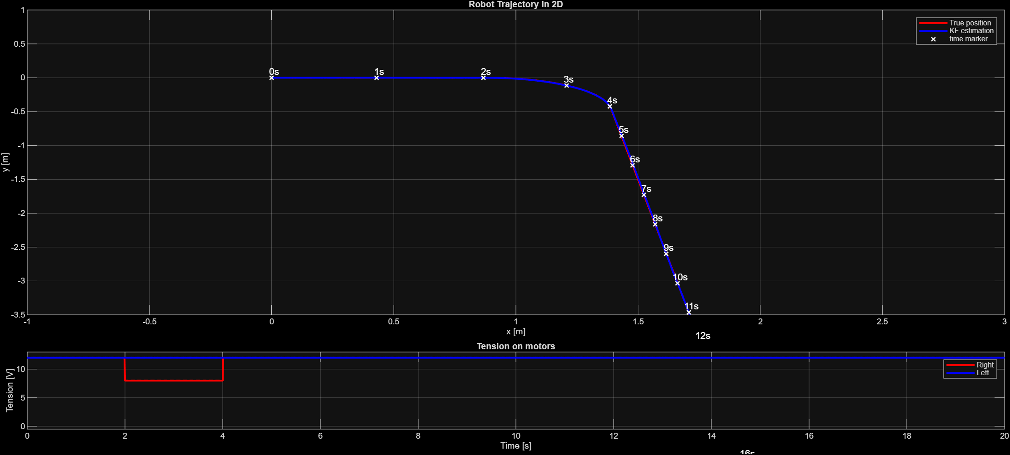
Appendix figure 4 - Trajectory plot

Appendix 2 (Motor model)
The available data from the motos are:
- Encoder ticks that can be converted to RPM or m/s
- The applied voltage and current measured through voltage and current sensors respectively.
The equations linking the above-mentioned data to the motor torque used in the Kalman filter equations are:
$$τ_{m}=k_{r}*i$$
$$i=\frac{v-k_{e}*ω_{m}}{R}$$
$$τ_{w}=τ_{m}*A$$
$$ω_{m}=ω_{w}*A$$
Where:
$$τ_{m} [N.m]$$ | Torque at the motor shaft
$$k_{r} [N.m/A]$$ | Torque constant of the motor
$$i [A]$$ | Current applied to the motor
$$v [V]$$ | Voltage applied to the motor
$$k_{e} [V.s/rad]$$ | Back-EMF constant of the motor
$$ω_{m} [rad/s]$$ | Angular velocity of the motor shaft
$$R [Ω]$$ | Electrical resistance of the motor
$$τ_{w} [N.m]$$ | Torque applied at the wheel
$$A$$ | Motor gear ratio
$$ω_{w} [rad/s]$$ | Wheel angular velocity

The equations were used to compute the output torque required for the model, based on the applied voltage and current.

Appendix 3 (Sources)
Different sources were utilized in the completion of this project. The list below references the different elements:
- Lectures by Prof. Guillaume Ducard
- Control of Differential Driven Rover by Means of Sensor Fusion [Link]
  - Master Thesis: Andreas Holst Thøgersen & Jesper Skovager Thomsen - Mechatronic Control Engineering (MCE4- 1025) - Aalborg University
- Torque-Speed Characteristics of DC Gear Motors: A Complete Analysis [Link]

