Healthy, The AI Diagnostic Tool
Jeremy Farnsworth

Contents
Pitch: 3
Introduction 5
Features 6
Technical Information 7
Conclusion 8
References 11

Pitch
Welcome potential investor. My name is Jeremy Farnsworth, and I have an opportunity for you. Have you ever been to a doctor’s appointment, and waited too long for a diagnosis? Let me introduce you to Healthy. (name in progress) The AI that receives symptom inputs, pictures and spits out accurate information. Doctors or primary care physicians input a case into a LLM (Large Language Model) and get back possible outcomes based on likelihood. Along with the recommended treatment plan.
The application itself, when prompted, would provide summarized results {name} {likelihood score}, with a card to click on for more details and recommended treatment of said illness. You will be able to upload pictures, files, or talk to the LLM itself. Providing easily accessible guidance to healthcare professionals to better patient care. Considerably cutting down the time it takes to get an accurate diagnosis.
When compared to other LLMS, like ChatGPT, Claude, etc. It will behave in similar ways and be heavily trained on anonymous patient data.

Features:
- File upload and prompt
- Result cards with brief descriptions
- Detailed view of results with treatment plans

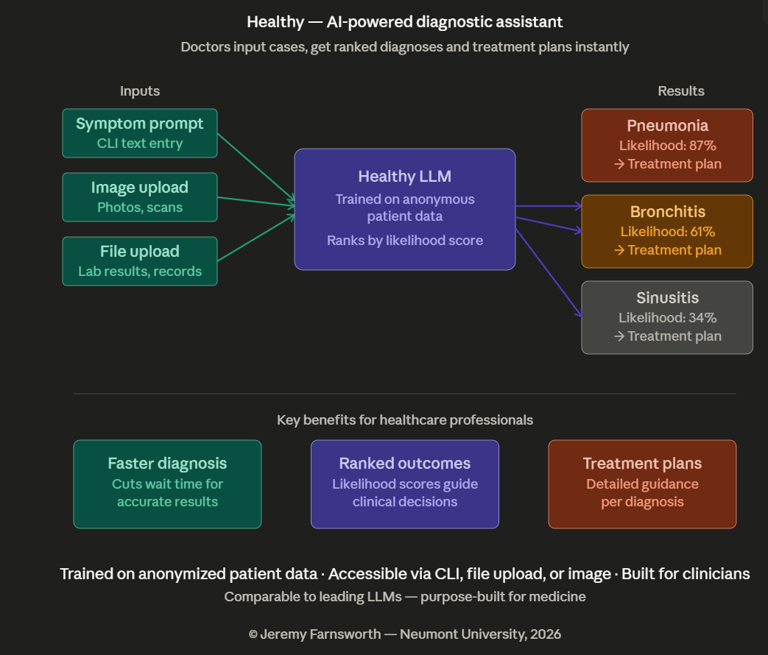

Introduction
Healthy is an AI tool designed to bring advancements in AI directly into the hands of healthcare professionals. Healthy is a diagnostic assistant that allows healthcare professionals to input patient cases; through text prompts, image uploads, or file attachments. To receive a ranked list of possible diagnoses accompanied by likelihood scores and recommended treatment plans. Healthy empowers healthcare professionals to deliver faster, more informed care to their patients.
The likelihood score produced by Healthy will be generated using a deep learning classifier with a softmax output layer. When a physician inputs a case, the model processes all available information and passes it through a softmax function at the final layer. This function converts the model's raw outputs into a probability distribution across all candidate diagnoses. Every possible condition receives a score between 0% and 100%, and all scores sum to 100%.
However, producing a number is not the same as producing a trustworthy number. A model that assigns 87% likelihood to a diagnosis should be correct roughly 87% of the time. To ensure Healthy's scores are clinically meaningful rather than simply confident sounding. A post-hoc calibration technique such as Platt scaling or isotonic regression will be applied after training. Additionally, Bayesian priors, baseline disease prevalence rates drawn from population health data. Which will be incorporated to further ground the scores in medical reality. Together, these methods ensure that Healthy's likelihood scores are reliable indicators that physicians can genuinely act on which is the final goal. A referential tool for healthcare professionals to use to speed up diagnosis and potentially save lives.
According to a study published on the National Library of Medicine in South Korea. Researchers found across 51 studies that AI improved diagnostic time by 90% or more. With the increase in diagnostic demands and workforce shortages, AI is finding itself used more to help with workloads.
There are a few products similar to Healthy already on the market. One I would like to discuss is the Isabel DDx Companion. Isabel has a lot of the same features, where Healthy would differentiate is in its information input and processing. Where Isabel uses a probabilistic matching algorithm for speed, Healthy uses LLM based reasoning for increased understanding of each case. Leading to a more accurate result. Healthy will also allow image and file upload which Isabel doesn’t offer.

Features
Simply put, Healthy takes input and outputs relevant information. Input is all the case information associated with the patient. Input can be files, pictures or scans, or written text. Output is all possible solutions ranked in probability, or the most probable disease with the associated treatment plan. Displayed on cards or ordered views with structured easy to follow and understand data.
Each tappable or clickable card will have a name, a probability score and a few top common symptoms. To lead into detailed descriptions, which will entail the following: The associated probability score, description of the disease, common symptoms, a recommended treatment plan and suggested tests to administer to confirm diagnosis if applicable or necessary.
Until an undefined stable state of the product is reached, Healthy will not be released to the public. Healthy will be marketed toward healthcare companies and facilities. The application will be a package of downloadable software, where a company buys a group license for individual access keys. Healthy will be distributed through a further developed website.
Development will start with training a separate model on the probability score. This model will be trained on sets of anonymous patient data from around the world. Training will be an iterative process for each new release. This model will be hooked up to an LLM, to then use at its discretion. Then implementing the GUI or interface the user interacts with. A database for user data persistence, then finally the website.

Technical Information
Healthy is projected to take 10 weeks to develop into its first releasable state. First 4 weeks will be allocated to developing and training the probability model. The following 2 weeks will be development for the GUI portion and database. Weeks 7 and 8 will be development of the website. Last 2 weeks will be for testing and polish for release.
Tech stack will be as follows: Python will be used for the development of the model. The GUI and website will be built in Next.Js for its easy integration with AI. Backend will be API calls to the AI, persistence will be accomplished through PostgreSQL.
The knowledge required to accomplish Healthy, is quite extensive. Experience in machine learning, web development, databases, and a general understanding of distributed systems are all fundamental. Several other areas are critical to developing a functional product.
An understanding of medical terminology and clinical workflows are required to ensure that Healthy’s outputs are meaningful. An understanding of HIPAA compliance for data privacy as Healthy handles sensitive patient information. Data engineering will be required in training Healthy to an acceptable level. Along with the knowledge of model evaluation, specifically the ability to assess the AI’s performance. Applying adjustment techniques when necessary to ensure the most probable outcome. This aligns with findings from Gazquez-Garcia et al. (2025), whose systematic review identified key competency areas for clinical AI development. "AI fundamentals knowledge, data analysis skills (including data acquisition, cleaning, visualization, management, and governance), and ethical and legal considerations."
Given the sensitive nature of Healthy, the most important section is security. Healthy must be developed with extensive encryption. Implementing severe roll based access control to prevent common vulnerabilities, such as SQL injection and API abuse. All culminating in the understanding of cloud infrastructure and platforms. To connect every piece of the system back to each other. Docker, CI/CD pipelines, AWS, all to support reliable releases.

Conclusion
Healthy represents an opportunity to improve one of the most critical aspects of healthcare, accurate and timely diagnosis. By combining advanced machine learning models, large language model reasoning, and healthcare-specific workflows. Healthy is designed to provide physicians with faster access to reliable diagnostic information and treatment recommendations. Through text prompts, image uploads, and file attachments. Healthcare professionals can receive ranked diagnostic possibilities with calibrated likelihood scores. That supporting clinical information, helping them make informed decisions more efficiently.
Research supports the growing role of artificial intelligence in healthcare. According to Jeong et al. (2025), studies have shown that AI systems can significantly reduce diagnostic workload and improve diagnostic speed. With some studies reporting improvements of 90% or more. The development of clinical AI requires expertise in data management, machine learning, ethical considerations, and healthcare processes. As identified by Gazquez-Garcia et al. (2025). Healthy has been designed with these requirements in mind. By incorporating probability calibration methods, medical data analysis, secure infrastructure, and healthcare-focused workflows. These foundations ensure that the system is not only innovative but also practical and trustworthy for real-world clinical environments.
The technical architecture of Healthy supports its long-term viability. The platform utilizes Python for machine learning development, Next.js for the user interface and web platform, PostgreSQL for persistent storage, and cloud-based infrastructure for scalability and reliability. Security remains a primary concern throughout development. With HIPAA-conscious design principles, encryption, role-based access controls, and secure deployment practices to help protect sensitive patient information. Combined with a focused ten-week development roadmap, these technologies provide a realistic path toward a functional and marketable first release.
Healthy is more than a software product. It is a tool designed to support healthcare professionals, reduce diagnostic delays, and improve patient outcomes. By investing in Healthy, stakeholders have the opportunity to support a solution that leverages modern AI technology. That helps to address a growing need within healthcare systems worldwide. With a clear development plan, strong technical foundation, and research-backed benefits. Healthy has the potential to become a valuable asset for healthcare organizations.
I am a student studying Computer Science at Neumont University. My education has been extensive in multiple frameworks, languages, software principles and appropriate AI use. I want to build Healthy to push myself in my education machine learning and how to properly implement a distributed system. I want to use my knowledge to apply it in serving others, while pushing the boundaries of technology.
Interested? Questions? Comments? Reach out to me at my email: jdog1123@gmail.com. I would love to discuss numbers and finalize any details. Thank you for reading this far, and considering Healthy for the opportunity it is.

Core Requirements
1. Data Ingestion
- The system must ingest a raw patient dataset and produce a cleaned, structured dataset file.
  - The dataset must be de-identified (no direct patient identifiers) before it is used for training.
  - The ingestion process must be reproducible via a documented script.
  - Each processed dataset must be versioned (e.g., a filename or tag identifying which version was used to train a given model).
2. Diagnosis Probability Model
- The system must accept a structured case (a list of symptoms) as input.
- The system must return a ranked list of candidate diagnoses for a given case.
  - Each candidate diagnosis must include a name and a probability score.
  - All probability scores for a single case must sum to 100%.
  - The output must be returned as a structured JSON array of {diagnosis, score} pairs.
- The system must produce this output for a held-out test case as part of acceptance testing.
3. Model Calibration
- The system must apply a post-hoc calibration technique (Platt scaling or isotonic regression) to the raw model output.
- The system must generate a reliability diagram (calibration curve) comparing raw vs. calibrated scores.
  - The calibration curve must demonstrate measurable improvement over the uncalibrated output.
4. LLM Reasoning Layer
- The user may submit a free-text case description instead of a structured symptom list.
- The system must convert free-text input into the same structured diagnosis output format defined in Requirement 2.
  - The system must incorporate the calibrated probability model's output when generating the LLM's response.
  - The system must return a valid structured response within 15 seconds of submission. ( this is flexible depending on the strength of the model )
- The system cannot return an unstructured or free-form response to a diagnosis request.
5. Text-Based Case Input UI
- The user may enter a case description into a web form.
- The system must display a loading state while a submitted case is being processed.
- The system must send the submitted text to the backend for analysis upon submission.
6. Result Card Display
- The system must display a result card for each candidate diagnosis returned.
  - Each card must show the diagnosis name.
  - Each card must show the probability score.
  - Each card must show the top 3 most common symptoms for that diagnosis.
- The system must render a minimum of 3 ranked cards for a standard test case.
7. Detailed Diagnosis View
- The user may click a result card to open a detailed view.
- The detailed view must display:
  - The full probability score.
  - A description of the disease.
  - A list of common symptoms.
  - A recommended treatment plan.
  - A list of suggested confirmatory tests.
- The system must navigate to a fully populated detail page for any card clicked.
8. User Authentication
- The admin may generate individual access keys for staff members.
- The user must log in with a valid access key to reach any page beyond login.
- The system must deny access to any user without a valid access key.
9. Case History Persistence
- The system must store each submitted case and its results in PostgreSQL.
- The user may view a list of their previously submitted cases.
  - Stored cases must remain retrievable after the user logs out and logs back in.
10. HIPAA-Conscious Data Handling
- The system must encrypt patient data in transit using TLS on all endpoints.
- The system must encrypt patient data at rest.
  - Database fields containing case data must use column-level encryption.
- The system cannot store any PII in an unencrypted state.
11. Role-Based Access Control
- The admin may restrict which users can view which cases within a facility.
- The user cannot query or view another user's cases via the API.
  - This restriction must be enforced server-side, not only hidden in the UI.
12. MVP Demo Readiness
- The system must support an unassisted end-to-end demo flow consisting of:
  - Submitting a case.
  - Viewing ranked results.
  - Opening a detail view.
  - Confirming the case appears in persisted history.

Stretch Requirements
S1. Image & File Upload
- The user may upload a medical image or file (X-ray, skin photo, lab report) alongside or instead of text input.
- The system must extract relevant findings from the uploaded file using a vision-capable model or OCR pipeline.
- The system must display uploaded files alongside their associated case in case history.
S2. Analytics Dashboard
- The admin may view a dashboard of usage metrics, including:
  - Cases submitted per week.
  - Most common diagnoses.
  - Average model confidence.
- The admin may export usage reports as a CSV file.
S3. Physician Feedback Loop
- The user may mark a diagnosis as "confirmed" or "incorrect" after receiving an actual outcome.
- The system must store this feedback for use in future model recalibration.
S4. CI/CD Pipeline
- The developer may push code to the main branch to trigger automated testing and deployment.
- The system must run automated tests on every merge to main.
- The system must deploy successfully to a staging environment when tests pass.

Proposed Schedule:
Week 1 and 2
- Find data and clean it for use, train the model
Week 3
- Calibration of model output
Week 4
- LLM integration
Week 5
- Add persistence and role-based architecture
Week 6 and 7
- Front end implementation
Week 8
- Case history persistence
Week 9 and 10
- Polish and presentation

References
Isabel Healthcare. (n.d.). Isabel DDx companion. Isabel Healthcare. https://www.isabelhealthcare.com/products/isabel-ddx-companion

Jeong, J., Kim, S., Pan, L., Hwang, D., Kim, D., Choi, J., Kwon, Y., Yi, P., Jeong, J., & Yoo, S. (2025, February 7). Reducing the workload of medical diagnosis through artificial intelligence: A narrative review. Medicine, 104(6). https://pmc.ncbi.nlm.nih.gov/articles/PMC11813001/

Gazquez-Garcia, J., Sánchez-Bocanegra, C. L., & Sevillano, J. L. (2025). AI in the health sector: Systematic review of key skills for future health professionals. JMIR Medical Education. https://pmc.ncbi.nlm.nih.gov/articles/PMC11822726/

