Stage 1 Portfolio choice

Introduction

Portfolio universe and data
We use 29 stocks from the Dow Jones Industrial Average roster dated 31 October 2015, retaining members that later leave the index. The sample contains 130 monthly USD returns from November 2015 to August 2026, the latest complete month also covered by the official factor release. The instructor provides monthly stock-price data, which we use for covered ordinary months; Yahoo Finance supplies other stocks and date extensions, with dividend and stock-split adjustments. We account for mandatory spin-off distributions in the return series using a consistent reinvestment convention. Old E. I. du Pont is excluded because identity-consistent 2015–2017 historical prices could not be recovered from the data sources; the current DD series could not substitute for the missing old-DuPont history. UTX continues under RTX. Monthly risk-free returns are the Kenneth French one-month Treasury-bill series, converted from published percentages to decimals.
We keep the stocks after index removal and do not add their index replacements. This historical membership rule helps mitigate potential upward bias in historical returns from selecting only current constituents.

1a Summary statistics
We estimate arithmetic means and the sample covariance of raw monthly returns. Here Rₜ is the 29-stock monthly return vector, and the full-sample estimates are
$$\hat{μ} = \frac{1}{130}\sum_{t = 1}^{130}{R_{t}}, \hat{Σ} = \frac{1}{129}\sum_{t = 1}^{130}{\left(R_{t} - \hat{μ}\right){\left(R_{t} - \hat{μ}\right)}^{T}}.$$
Monthly means and volatility are shown as percentages in Table 1.1. Blue shading identifies retained DJIA members; amber identifies later index removals.
Table 1.1 Monthly return statistics
Stock | Mean %  (monthly) | Volatility %  (monthly) | Stock | Mean %  (monthly) | Volatility %  (monthly) | Stock | Mean %  (monthly) | Volatility %  (monthly)
MMM | 0.703 | 6.887 | GS | 1.817 | 8.239 | PFE | 0.490 | 6.486
AXP | 1.566 | 7.517 | HD | 1.160 | 6.478 | PG | 0.837 | 4.759
AAPL | 2.226 | 7.917 | INTC | 1.831 | 14.775 | TRV | 1.250 | 5.710
BA | 0.977 | 11.099 | IBM | 1.090 | 7.909 | RTX | 1.512 | 7.496
CAT | 2.465 | 9.210 | JNJ | 1.095 | 4.844 | UNH | 1.384 | 8.085
CVX | 1.305 | 8.001 | JPM | 1.782 | 6.876 | VZ | 0.637 | 5.447
CSCO | 1.533 | 7.120 | MCD | 0.978 | 4.846 | V | 1.444 | 5.617
KO | 0.937 | 4.613 | MRK | 1.240 | 6.002 | WMT | 1.618 | 5.398
XOM | 1.183 | 7.940 | MSFT | 2.081 | 6.556 | DIS | 0.380 | 8.530
GE | 1.314 | 10.344 | NKE | 0.040 | 8.019

1b Portfolio weights
The tangency direction z uses estimated monthly excess returns and the inverse sample covariance matrix. Normalizing z gives fully invested weights w_{F} that sum to one:
$$z = {\hat{Σ}}^{-1}(\hat{μ} - \overline{R_{F}}1), w_{F} = \frac{z}{1^{T}z}.$$
Model Sharpe divides annualized arithmetic mean excess return by annualized portfolio volatility. Monthly portfolio and risk-free means are multiplied by 12, and monthly volatility by the square root of 12:
$$S_{model}=\frac{{\hat{μ}}_{p,ann}-{\hat{μ}}_{RF,ann}}{{\hat{σ}}_{p,ann}}.$$
We compare three portfolios over the same 29 stocks. Unrestricted tangency uses the full-sample estimates, with weights summing to one and short sales permitted. Value weighting normalizes Yahoo company market capitalizations dated 31 August 2026. It is a descriptive comparator. Long-only tangency maximizes the same model Sharpe with nonnegative weights summing to one, testing the effect of prohibiting short sales. Each weight vector is held fixed with monthly rebalancing.
Table 1.2 Portfolio weights
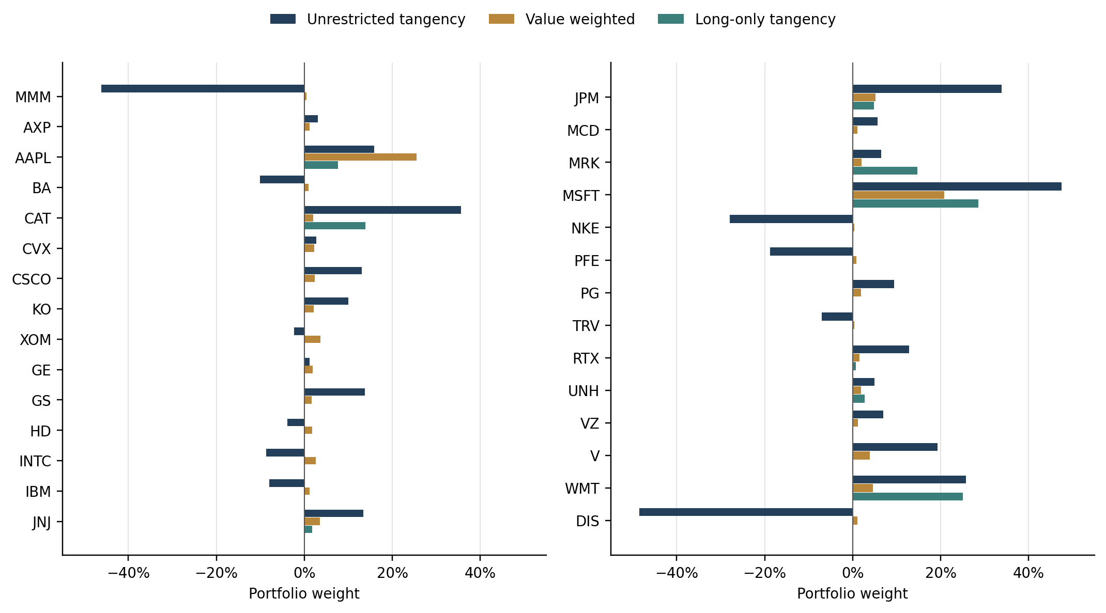
Portfolio | Mean % | Volatility % | Model Sharpe | Gross %
Unrestricted tangency | 44.547 | 19.794 | 2.142 | 462.588
Value weighted | 20.790 | 15.712 | 1.186 | 100.000
Long only | 22.207 | 13.946 | 1.438 | 100.000
Tangency and value weighting produce markedly different portfolio weights. MSFT receives 47.520% in tangency versus 20.785% by size; DIS has a -48.498% tangency weight versus 1.025% by size. For the unrestricted tangency portfolio, long positions total 281.294% and shorts 181.294%, giving 462.588% gross exposure despite 100% net investment.
In sample, unrestricted tangency has an annualized arithmetic mean of 44.547%, volatility of 19.794% and model Sharpe of 2.142. The corresponding figures are 20.790%, 15.712% and 1.186 for value weighting, and 22.207%, 13.946% and 1.438 for long-only tangency. Requiring nonnegative weights gives 9 positive positions, a largest weight of 28.609% in MSFT, 100% gross exposure and model Sharpe 1.438. This removes extreme offsetting holdings at the cost of a lower fitted optimum, without guaranteeing better subsequent returns. Prohibiting short sales lowers the fitted maximum Sharpe because nonnegative weights narrow the feasible set and remove leveraged long-short allocations.

1c A short discussion and re-estimating
Table 1.2 shows a sharp difference between tangency and value weights, with the unrestricted tangency portfolio reaching 462.588% gross exposure. These extreme positions raise concerns about estimation error in $\hat{μ}$ and $\hat{Σ}$. Errors in $\hat{μ}$ can lead the optimizer to favor stocks whose expected returns are overstated and short those whose returns are understated. Errors in $\hat{Σ}$ can distort estimated risk and hedging benefits, making large offsetting positions appear attractive. Since tangency weights depend on ${\hat{Σ}}^{-1}{\hat{μ}}_{e}$, covariance inversion can amplify these errors, particularly for stock combinations with low estimated variance. The optimizer may therefore exploit sampling noise. Its higher in-sample Sharpe ratio offers limited reassurance, because the same data are used to select and evaluate the weights.
Table 1.3 Re-estimation across time subsamples
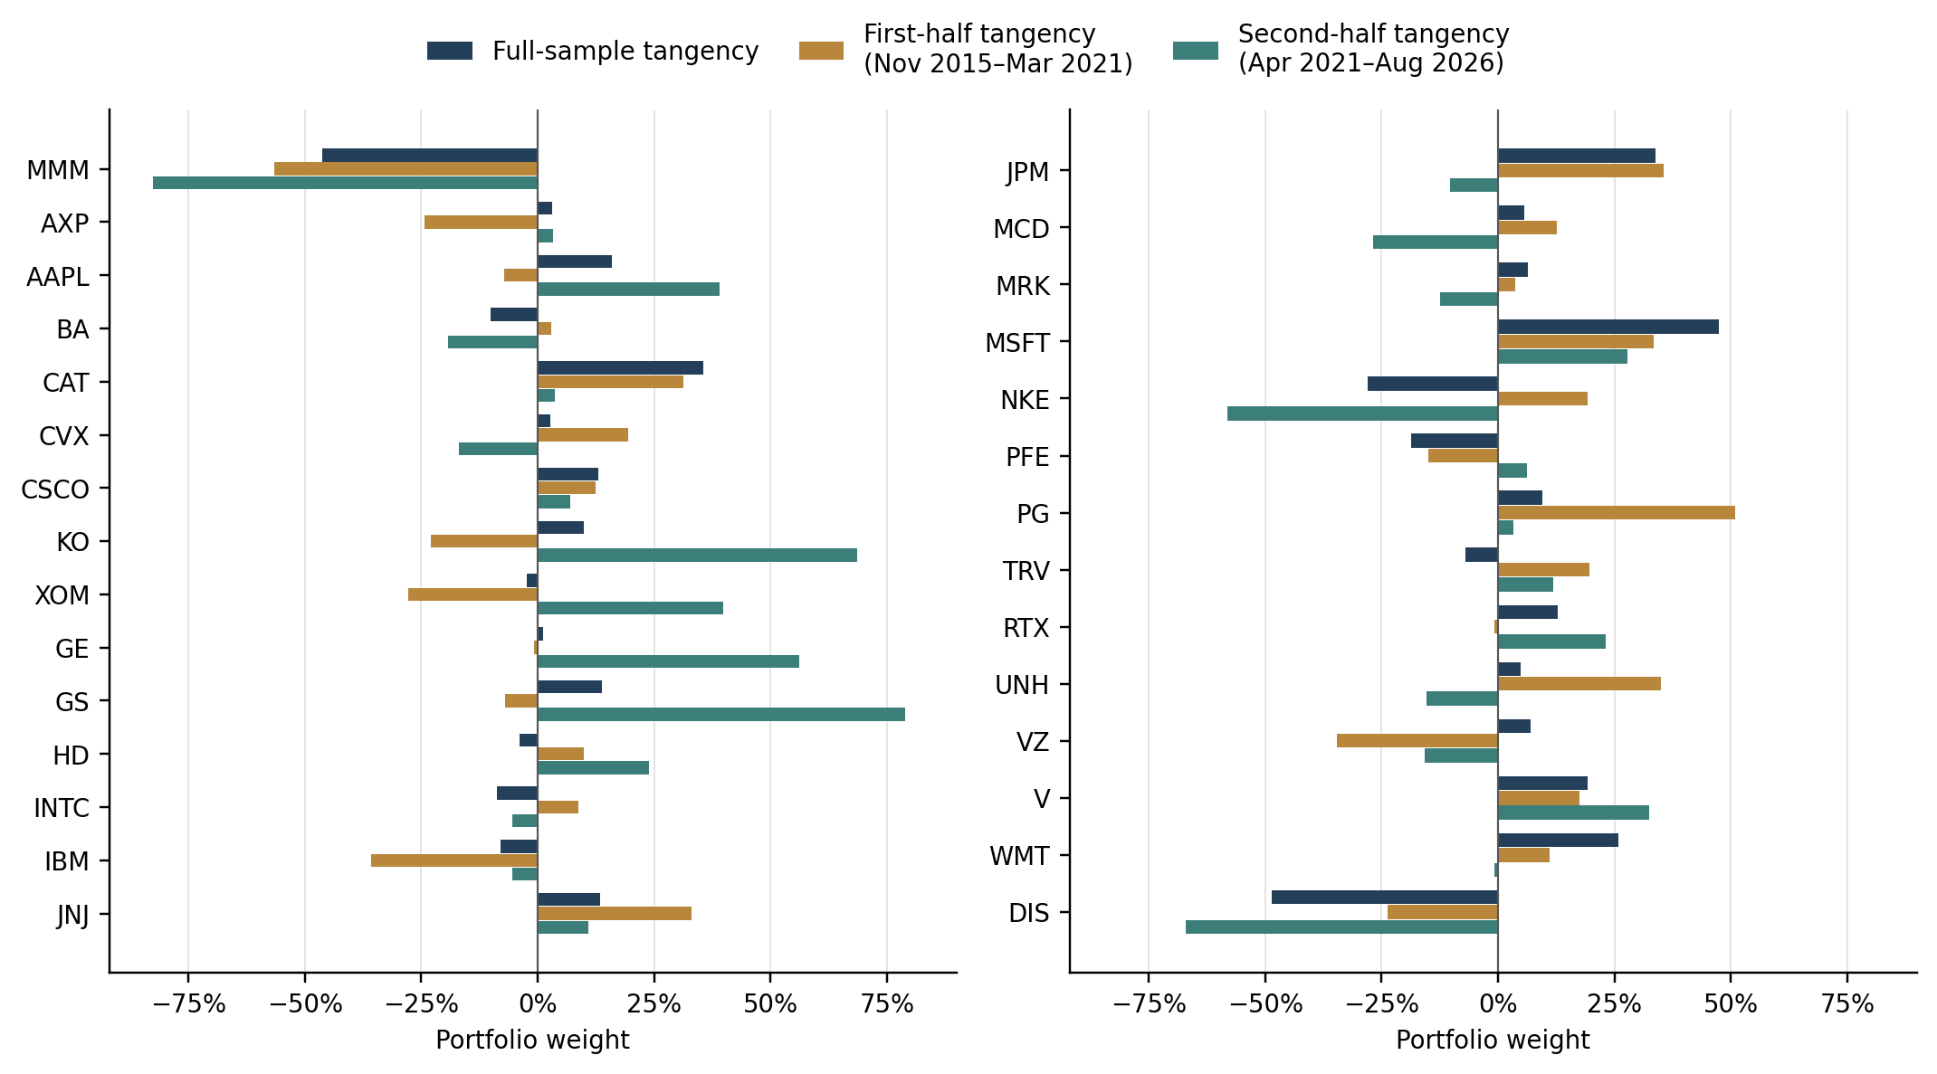
Portfolio | Mean % | Volatility % | Model Sharpe | Gross %
Full-sample tangency | 44.547 | 19.794 | 2.142 | 462.588
First-half tangency | 44.215 | 13.739 | 3.146 | 612.580
Second-half tangency | 84.477 | 23.051 | 3.521 | 772.765
To examine sensitivity to the estimation sample, we re-estimate mean returns, covariance and average risk-free returns for the same 29 stocks in two 65-month windows. The resulting weights differ substantially: 17 stocks change sign, and the weight vectors correlate only 0.106. These changes indicate that the estimated tangency allocation depends heavily on the chosen sample, consistent with the optimizer amplifying differences in estimated returns and covariance. Applying the first-half weights to second-half returns also reduces model Sharpe from 3.146 to 0.432, showing that the fitted allocation transfers poorly across these periods. Sampling error and differences in market conditions across periods can both contribute, so this exercise does not completely identify the effects of mean and covariance estimation errors.
Table 1.4 Re-estimation across asset universes
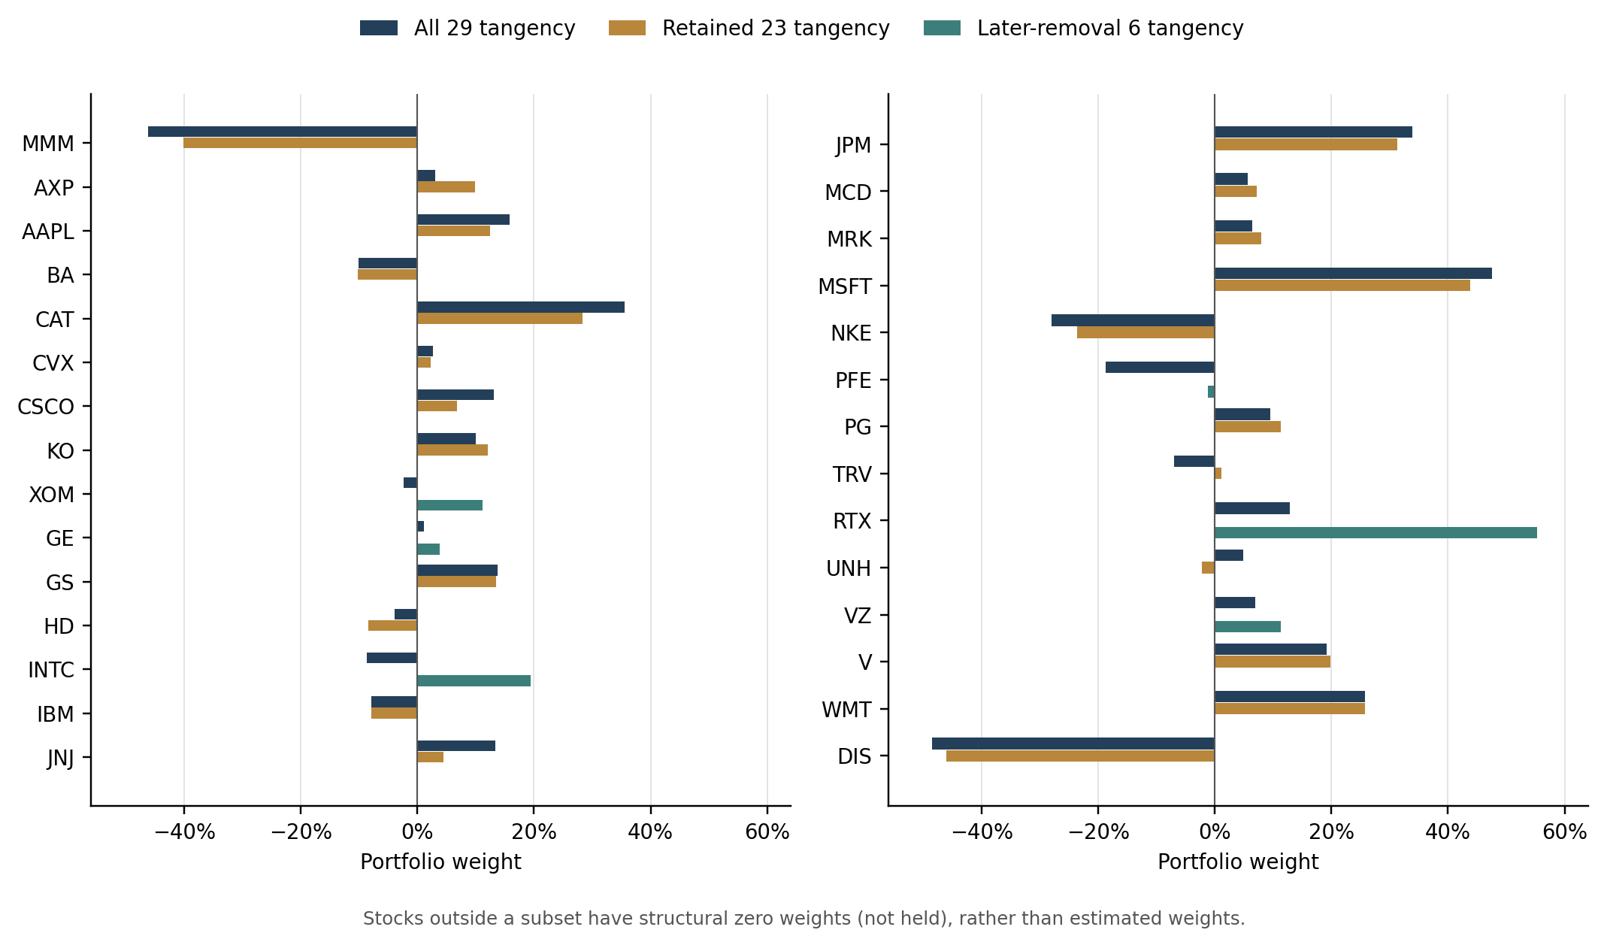
Portfolio | Mean % | Volatility % | Model Sharpe | Gross %
All 29 tangency | 44.547 | 19.794 | 2.142 | 462.588
Retained 23 tangency | 40.144 | 18.350 | 2.071 | 376.473
Later-removal 6 tangency | 17.298 | 20.907 | 0.725 | 102.224
We also examine sensitivity to asset selection by estimating tangency portfolios for all 29 stocks, the retained 23 and the six later index removals over the same 130 months. The estimated means and pairwise covariances of common stocks remain unchanged, but removing assets changes the covariance matrix being inverted and the available hedging opportunities. Across the 23 common stocks, weights correlate 0.983 and only two change sign, indicating relative stability under this particular universe change. The six-stock portfolio has a fitted Sharpe ratio of 0.725, compared with 2.071 for the retained 23. This difference is better interpreted as reflecting distinct investment opportunity sets rather than directly indicating the relative size of estimation errors. The comparison therefore complements the time-subsample exercise by assessing how the allocation depends on the assets included.

GE, XOM, PFE, UTX (later RTX), INTC and VZ.

