Contents

1.0 Collection Creation Steps 2

1. Fetch the collection information from the Collection Builder 2

2. Login to Database Server as novus user 3

3. Verify novus user have access to scripts 4

4. List out the databases on the server with the following command 4

5. Verify Database Server Replication Technology 4

6. Find Database file systems 5

7. Choose the file system 6

8. Create the Configuration file 6

9. Find the instance name by grep the DB Name in CHG 7

10. Make sure to cross verify the collections doesn’t exists 7

11. Collection Creation: Execute the following command 8

12. Check for errors 12

13. Verify Collection is created 12

14. Get the Resource name from the dansfield 13

15. Update the required Info in Collection Builder and close the task 14

2.0 Rollback Steps 14

Novus do not have permission to run any rollback steps. Please contact ORACLE-SUPPORT-TR to execute rollback steps. 14

Steps for ORACLE-SUPPORT-TR: 14

**Login as oracle on the primary (NOT THE SECONDARY) server and** 14

**enter the following commands.** 14

# Collection Creation Steps

## 1. Fetch the collection information from the Collection Builder

<http://novusgui.int.westgroup.com/cb/AmsDbaUnix/Collections/Index.aspx>

**Click on the cylinder symbol icon will get Database size information details.**

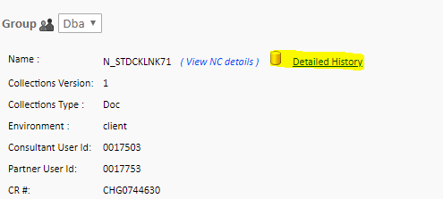

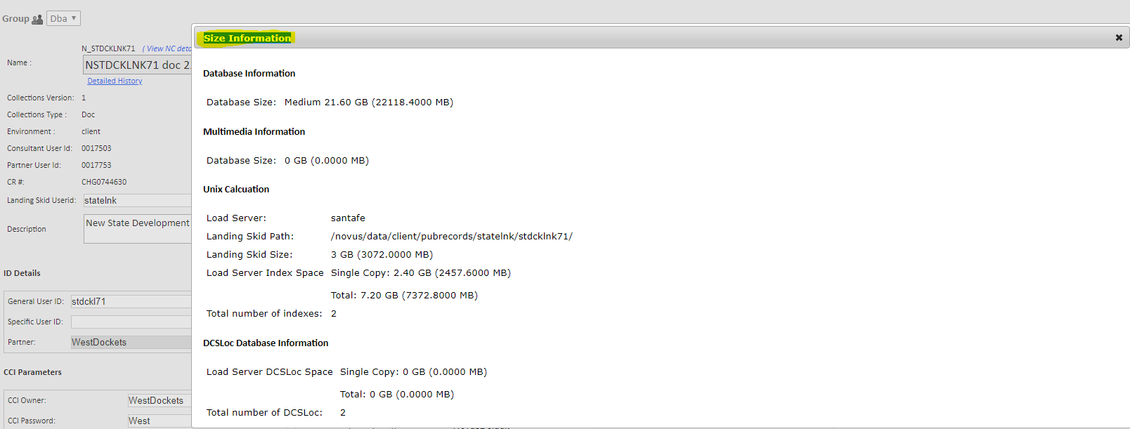

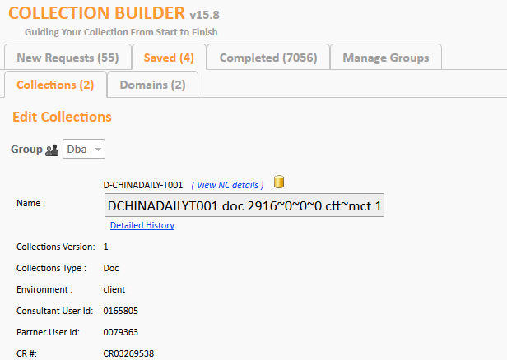

## 2. Login to Database Server as novus user

We can find DB server name through ConfigMon/Hosting GUI. Once we find Database server login to server as NOVUS user.

[http://ns9187:8196/ConfigMonGUI/#](http://ns9187:8196/ConfigMonGUI/)

<http://tsi.qed.int.westgroup.com/he/HostsView?type=Novus&env=client>

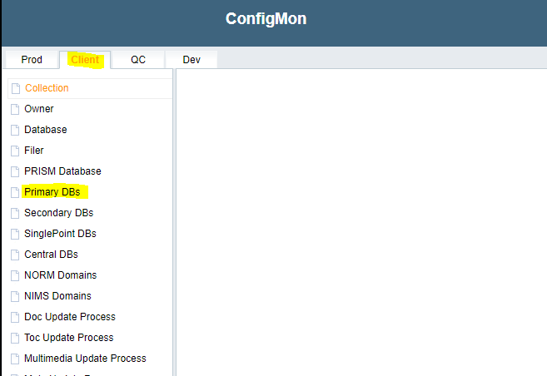

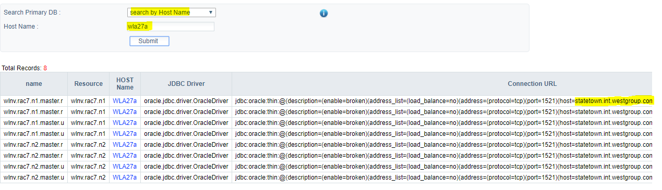

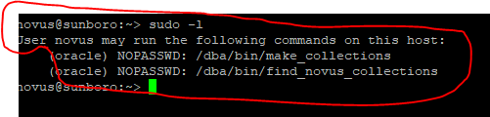

## 3. Verify novus user have access to scripts

**novus@sunboro:~> sudo -l**



## 4. List out the databases on the server with the following command

**novus@sunboro:~> sudo -u oracle /dba/bin/find_novus_collections**

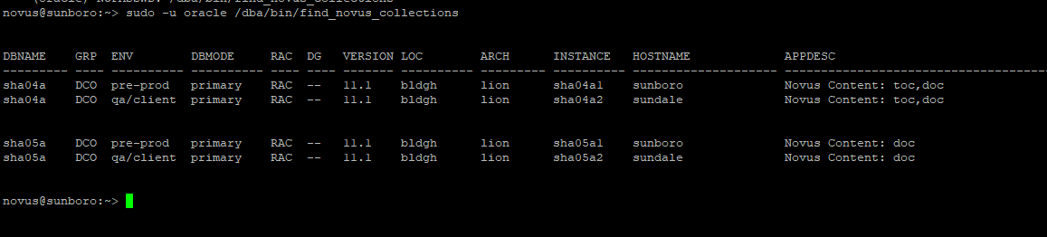

## 5. Verify Database Server Replication Technology

* **If there is no Replication follow Step 6.**
* **If the Replication is Active Data Guard follow 6 on Primary Database server.**

**If replication is being used and if it is a Logical Standby, DO NOT proceed with this document. Follow document “Logical Standby Database Collection Creation.docx”.**

<https://trten.sharepoint.com/sites/AMS-Novus/AMS%20Wiki%20Documents/Novus/StandbyDatabase_Collection_Creation_ORACLE.docx>

Ex. output for No replication:

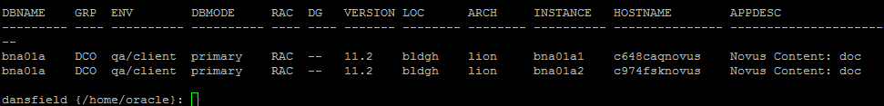

Ex. output for DataGuard(activedg):

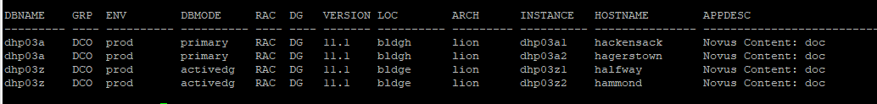

Ex. output for Logical Standby(standby/secondary):

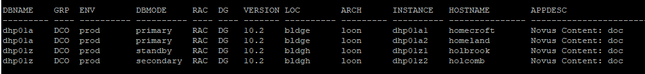

## 6. Find Database file systems

**Choose the file system to put the collection in using the following command. File /dba/cfg/filesystem_mapping will be useful when there are multiple databases in a database server. The group number (1/2/3) maps to filesystems**

Cat **/dba/cfg/filesystem_mapping**

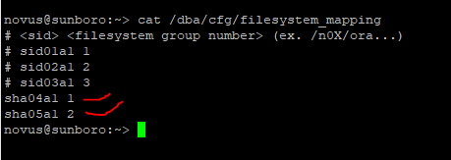

**cat /dba/cfg/filesystem_mapping**

This is how /dba/cfg/filesystem_mapping file looks like when there is single database in database server.

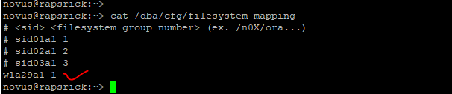

## 7. Choose the file system

**Decide which filesystems to use for the collection by picking the ones with the lowest percentage of utilization. Make sure file system should not cross 89%**

Use the previous step to find filesystems belong to the Database the collection being created.

In our example(sunboro/sha04a), the file system belongs to sha04a1 is /s01/oradata1. i.e. all the database file systems belong to sha04a1 start with “/s01/”. If the file system /s01/oradata1 capacity is full, we will have /s01/oradata2, /s01/oradata3 and so on.

novus@sunboro:~> df -h /s*/oradata*

Filesystem Size Used Avail Use% Mounted on

cisclnt-h0219:/nv_shareddoc4a_s01ora1_snap/s01oradata1

5.9T 5.2T 766G 88% /s01/oradata1 2.1T 1.6T 543G 75% /s01/oradata1

## 8. Create the Configuration file

**Create a file of the form CHG#######.txt under /tmp directory where ####### is the seven-digit number for the ServiceNow change control associated with the collections that you will be creating.**

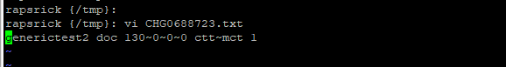

**CHG######.txt file format can be fetched from Collection Builder output from step 1:**

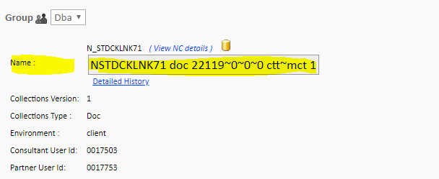

## 9. Find the instance name by grep the DB Name in CHG

ps -e -o command | grep pmon | grep -v grep | cut -d '_' -f3 | grep {***instance_name}***

Note:

Instance_name is the name mentioned in CR



## 10. Make sure to cross verify the collections doesn’t exists

sudo -u oracle /dba/bin/make_collections -d sha04a1 -f /tmp/CHG0775880.txt -v

New option -v is introduced to verify the collections (mentioned in /tmp/change_config.txt)

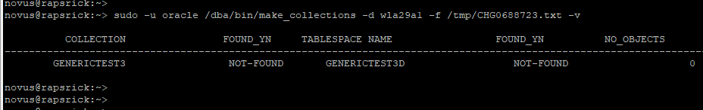

## 11. Collection Creation: Execute the following command

For Oracle 11g Databases, <db_name> must be Instance Name.

For Oracle 12c Container Databases , <db_name> must be CDB Instance Name

**Oracle 11g Database:**

sudo -u oracle /dba/bin/make_collections -d sha04a1 -f /tmp/CHG0775880.txt -t -s

**Oracle 12c Container Databases:**

sudo -u oracle /dba/bin/make_collections -d cdq0232a1 -f /tmp/change_config.txt -t -s

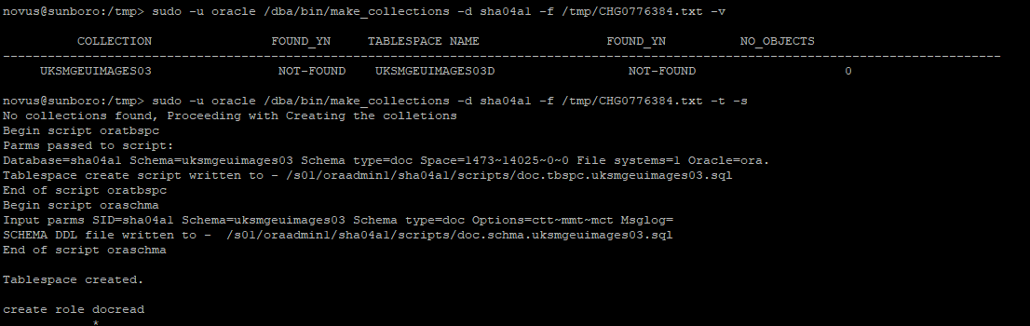

Full output from the make_collection script should be similar to below. Ignore ORA-01921/ORA-01920 errors.

sudo -u oracle /dba/bin/make_collections -d sha04a1 -f /tmp/CHG0775880.txt -v

novus@sunboro:~> sudo -u oracle /dba/bin/make_collections -d sha04a1 -f /tmp/CHG0775880.txt -t -s

No collections found, Proceeding with Creating the colletions

Begin script oratbspc

Parms passed to script:

Database=wla29a1 Schema=generictest3 Schema type=doc Space=130~0~0~0 File systems=1 Oracle=ora.

Tablespace create script written to - /s01/oraadmin1/wla29a1/scripts/doc.tbspc.generictest3.sql

End of script oratbspc

Begin script oraschma

Input parms SID=wla29a1 Schema=generictest3 Schema type=doc Options=ctt~mct Msglog=

SCHEMA DDL file written to - /s01/oraadmin1/wla29a1/scripts/doc.schma.generictest3.sql

End of script oraschma

Tablespace created.

create role docread

*

ERROR at line 1:

ORA-01921: role name 'DOCREAD' conflicts with another user or role name

create role docupd

*

ERROR at line 1:

ORA-01921: role name 'DOCUPD' conflicts with another user or role name

create user docr identified by docr default tablespace users

*

ERROR at line 1:

ORA-01920: user name 'DOCR' conflicts with another user or role name

create user docu identified by docu default tablespace users

*

ERROR at line 1:

ORA-01920: user name 'DOCU' conflicts with another user or role name

create user novusr1 identified by novusr1 default tablespace users

*

ERROR at line 1:

ORA-01920: user name 'NOVUSR1' conflicts with another user or role name

create user novusr2 identified by novusr2 default tablespace users

*

ERROR at line 1:

ORA-01920: user name 'NOVUSR2' conflicts with another user or role name

create user devr identified by devr default tablespace users

*

ERROR at line 1:

ORA-01920: user name 'DEVR' conflicts with another user or role name

create user novusu1 identified by novusu1 default tablespace users

*

ERROR at line 1:

ORA-01920: user name 'NOVUSU1' conflicts with another user or role name

create user novusu2 identified by novusu2 default tablespace users

*

ERROR at line 1:

ORA-01920: user name 'NOVUSU2' conflicts with another user or role name

User created.

Grant succeeded.

Grant succeeded.

Grant succeeded.

Grant succeeded.

Grant succeeded.

Grant succeeded.

Grant succeeded.

Grant succeeded.

Grant succeeded.

Grant succeeded.

Grant succeeded.

Grant succeeded.

User altered.

Table created.

1 row created.

1 row created.

1 row created.

1 row created.

Table created.

Index created.

Table created.

Table created.

Index created.

Grant succeeded.

Grant succeeded.

Grant succeeded.

Grant succeeded.

Grant succeeded.

Grant succeeded.

Grant succeeded.

Grant succeeded.

All collections created Successfully

COLLECTION FOUND_YN TABLESPACE NAME FOUND_YN NO_OBJECTS

--------------------------------------------------------------------------------------------------------------------------------------

GENERICTEST3 FOUND GENERICTEST3D FOUND 26

novus@sunboro:~>

## 12. Check for errors

**Check the files of the form <type>.[tbspc/schma].<schema_name>.out for any error messages related to the schema/tablespace creations**

All the output(.out) files can be found under /s01/oraadmin1/<instance_name>/scripts.

Ex : /s01/oraadmin1/wla29a1/scripts/

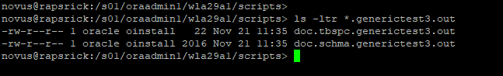

## 13. Verify Collection is created

novus@sunboro:~> sudo -u oracle /dba/bin/make_collections -d sha04a1 -f /tmp/CHG0775880.txt -v

COLLECTION FOUND_YN TABLESPACE NAME FOUND_YN NO_OBJECTS

--------------------------------------------------------------------------------------------------------------------------------------

GENERICTEST3 FOUND GENERICTEST3D FOUND 26

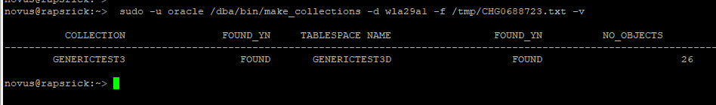

## 14. Get the Resource name from the dansfield

Dansfield(dansfield.int.thomsonreuters.com) is a database server that stores all the collection relation information.

Login to dansfield.int.thomsonreuters.com as novus user.

Execute below commands to find resource names:

sudo -u oracle /s01/oraadmin1/nvp32a1/scripts/cir/find_ldap_resource -e client -h sunboro

/s01/oraadmin1/nvp32a1/scripts/cir/find_ldap_resource: line 30: /bin/ora_standard_functions: No such file or directory

Sunboro

**sha.rac4.n1 sha.rac4.n2 sha.rac5.n1 sha.rac5.n2**

If find_ldap_resource doesn’t work use find_resource.jeff -d <DBNAME>

sudo -u oracle /s01/oraadmin1/nvp32a1/scripts/cir/find_resource.jeff -d sha04a

**LDAP resource names for wla29a1:** wla.rac29.n1 and wla.rac29.n2.



**find_ldap_resource -e <ENV> -h <SERVER_NAME>**

## 15. Update the required Info in Collection Builder and close the task

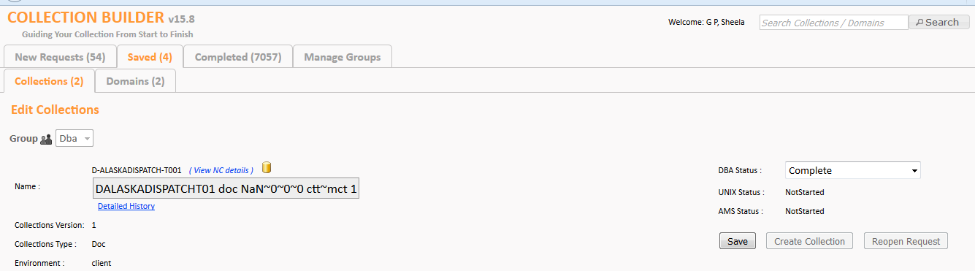

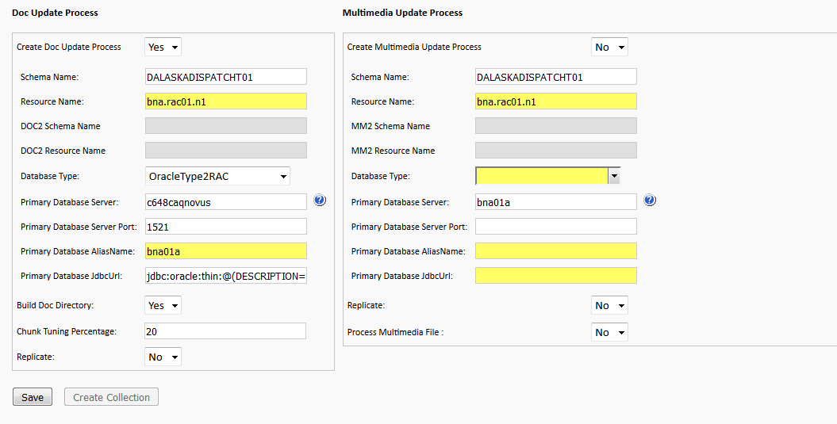

If the collection has mmt content, make sure to change the “Create Multimedia Update Process” to “Yes”.

# Rollback Steps

## Novus do not have permission to run any rollback steps. Please contact ORACLE-SUPPORT-TR to execute rollback steps.

## Steps for ORACLE-SUPPORT-TR:

### **Login as oracle on the primary (NOT THE SECONDARY) server and**

### **enter the following commands.**

**For 11g Databases:**

**sqlplus ‘/ as sysdba’**

**drop user <schema_name> cascade;**

**drop tablespace <schema_name>l including contents and datafiles;**

**drop tablespace <schema_name>b including contents and datafiles;**

**drop tablespace <schema_name>t including contents and datafiles;**

**For 12c Databases:**

**sqlplus ‘/ as sysdba’**

**alter session set container=<PDB_Name>;**

**drop user <schema_name> cascade;**

**drop tablespace <schema_name>l including contents and datafiles;**

**drop tablespace <schema_name>b including contents and datafiles;**

**drop tablespace <schema_name>t including contents and datafiles;**

**==**

# NIMS Collections

**Get the NIMS Domain Name in the collection builder and check whether the Domain is present in dansfield server or not. Just close the DB task as completed if NIMS Domain present.**

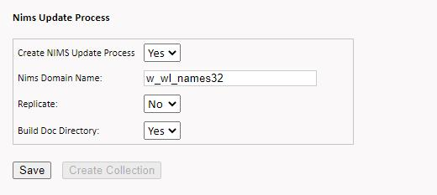

[dansfield {/home/oracle}: ]$ find_domain w_wl_names32  
Matching NORM domains

no rows selected

Matching NIMS domains

NIMS_DOMAIN_NAME                    SRVR_NAME       DB_NAME  ENV DB_ TSPC_NAME  
----------------------------------- --------------- -------- --- --- --------------------  
W_WL_NAMES32                        napier-vip      nia05a   A   A   WWLNAMES321D  
W_WL_NAMES32                        napier          nia05a   A   A   WWLNAMES321D  
W_WL_NAMES32                        nahma-vip       nia05a   A   A   WWLNAMES321D  
W_WL_NAMES32                        nahma           nia05a   A   A   WWLNAMES321D  
W_WL_NAMES32                        napier-vip      nia05a   A   A   WWLNAMES320D  
W_WL_NAMES32                        napier          nia05a   A   A   WWLNAMES320D  
W_WL_NAMES32                        nahma-vip       nia05a   A   A   WWLNAMES320D  
W_WL_NAMES32                        nahma           nia05a   A   A   WWLNAMES320D