

**Fisheye Data Processing Manual**

Last updated on 2020-11-30

By Li-Wei Hung



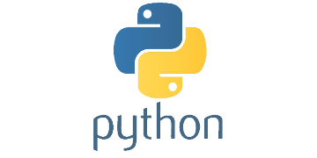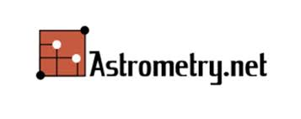**I. Required Software:**

1. Python 3
2. Astrometry.net account
3. 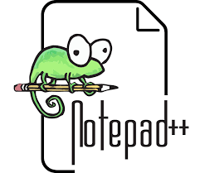Notepad++ / VS Code / other text editor
4. Git and GitHub account

**II. Setting up for running a data set:**

1. Install Anaconda (<https://www.anaconda.com/>) with Python 3
2. Create an account on Astrometry.net (<http://nova.astrometry.net/>). Find the API key under the API tab. You’ll need this API key for processing the data.
3. Fork the code from GitHub
   * Introduction to Git – Branching and Merging: <https://www.youtube.com/watch?v=FyAAIHHClqI>
   * Contribute to someone's repository:

<http://kbroman.org/github_tutorial/pages/fork.html>

**III. Processing Flow Chart:**

1. Generate the fisheye mask: run mask.py

mask.py

mask_input.py

Fisheye mask

1. Use a reference image to measure zeropoint, extinction coefficient, and pointing

center.txt

sky background observed sky

MF_*.fit

zeropoint.csv; zeropoint.png

(zeropoint & extinction)

all other images

reference image

detected_stars.csv

center.txt

reduction.py

astrometry.py

(client.py)

photometry.py

filepath.py

centering.py

(need to add distortion correction)

photometric_calibration.py

median_filter.py

projection.py – to be finished

fisheye.png & hammer.png

1. Process all the images

For each camera-lens combination, save the following files in Calibration_files folder:

1. Get the flat -- Jeremy
2. Get the linearity curve -- Jeremy
3. Generate the fisheye mask -- see the above flowchart
   1. Edit the file names and fitting parameters in mask_input.py
   2. Run mask.py
   3. Check the output file

Select a reference image in each data set:

1. Measure Zeropoint
   1. Define all fields in filepath.py
   2. Enter the file name to be used in determining the zeropoint in filepath.py under measure_zeropoint
   3. Run reduction.py, reduced image should be saved in filepath.data_cal
2. Measure extinction coefficient
3. Measure the image center RA and Dec

For all the images:

1. Edit filepath.py
2. (Optional)If you would like to measure the zeropoint, extinction coefficient, and the center coordinate, set measure_reference = ‘yes’ and define the next two items: reference image and API key.
3. Data reduction
4. Centering
5. Photometric calibration
6. (Median filter)
7. Projection
8. **III. Scripts Documentation:**

* python client.py -help