**Context**

We began this investigation of Big Mountain's competitive position with a need to raise revenue or cut costs because of increased expenses from a new ski lift. We also had a sense that our ticket prices were too low. And we wanted to explore a more data-driven approach for analyzing our options.

**Methods**

We started with a data set of information about the ticket prices and other descriptive information from 330 ski resorts in the United States. Our data on each resort included 24 numerical factors describing conditions and facilities such as snowfall, snow-making, vertical drop, runs, skiable acres, and several types of transport systems such as lifts and trams. For the full list of factors included in our completed model, see section 5.5 of the modeling notebook.

Following a standard data science protocol to validate, clean and prepare the data, we incorporated some state-by-state area and population statistics. We built and tested a model that uses the numerical factors to predict ski resort ticket prices. Finally, we used the model, and the lessons its development taught us about the most relevant factors in modeling ticket prices, to

* analyze Big Mountain's competitive position in the market on price and other important factors,
* make a recommendation about increasing ticket prices, and
* analyze a limited set of other scenarios for increasing revenue and cutting costs.

The model was created using tools from scikit-learn's modeling and machine learning packages. Details of the complete process of data preparation, analysis, model-generation, and model-driven exploration can be found in the technical notebooks. (Note there are summaries at the end of each notebook.)

The four technical notebooks are as follows:

**02_data_wrangling**

Includes some initial exploration of factor distribution, a comparison of adult weekday prices vs. weekend, and a look at missing data to we proceed only with factors that contain useful data.

**03_exploratory_data_analysis**

Includes scaling and PCA analysis, a comparison by state, an examination of some additional data on state statistics as they relate to each resort, and an analysis of feature correlation.

**04_preprocessing_and_training**

Includes model training, testing with cross-validation, and comparing a "best k features" model with a "random forest" model.

**05_modeling**

Includes an analysis of Big Mountain's competitive position vs. other resorts, use of the final random-forest model to make a ticket-price recommendation, and use of the model to analyze a select set of change scenarios under consideration.

**Results**

Before we look at modeling, it is important to get an idea of how Big Mountain is positioned within our national market. We used adult weekend ticket price for our analysis and modeling because there were fewer missing values for that column.

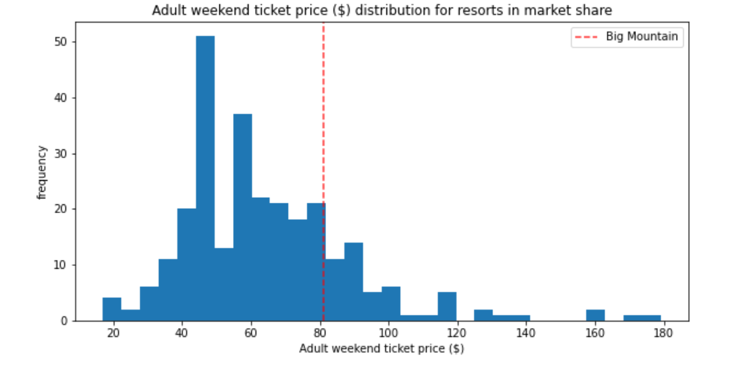

Big Mountain’s $81 ticket price places it in the 4th quartile nationally, above most of the other resorts, but well shy of the priciest.

Looking at the Montana local market, Big Mountain is the priciest:

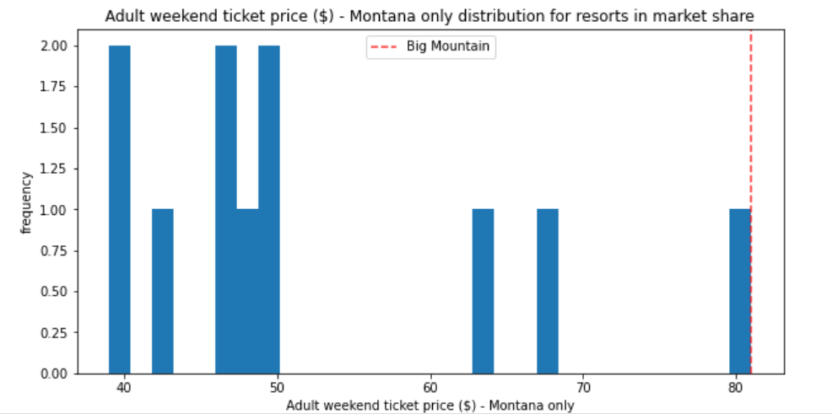

One of the benefits of machine modeling is that we can find the features that are most important in our price model. The best k analysis produced 8 optimal features, presented here with their regression coefficients:

vertical_drop 10.767857

Snow Making_ac 6.290074

total_chairs 5.794156

fastQuads 5.745626

Runs 5.370555

LongestRun_mi 0.181814

Trams -4.142024

SkiableTerrain_ac -5.249780

Vertical_drop, total_chairs, fastQuads, and runs are all somewhat related to the size of our resort. Snow Making stands out as something under our control, and we should include it in our future development plans. Happily, we are a snow-making leader among all resorts:

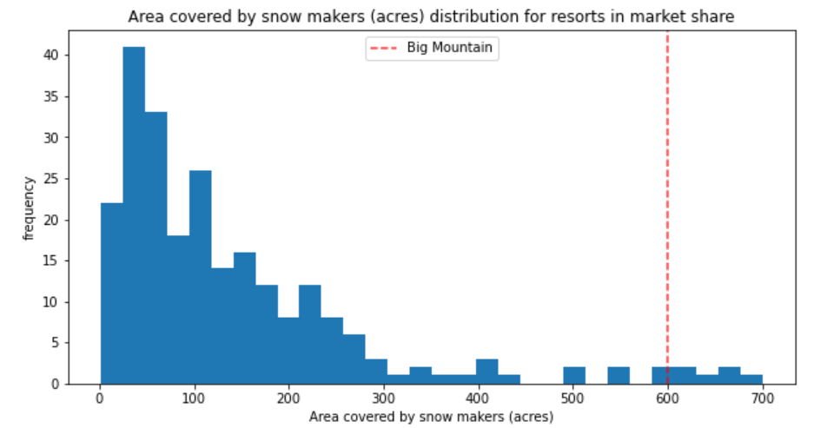

As for vertical drop, Big Mountain here, too, is in the 4th quartile, but below the top resorts:

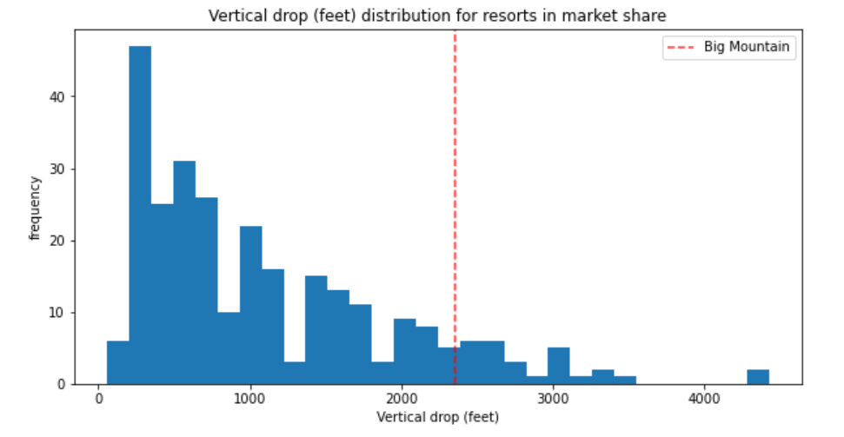

In number of chairs and number of runs Big Mountain is similarly high.

***Price Modeling***

Once we settled on a random forest model to get the best possible fit to our data, and trained it on our complete data set, we ran the model on Big Mountain’s parameters. Taking an average from 5 cross-validated runs, the model "predicted" a mean adult weekend ticket price of $95.87. In other words, based on the data we analyzed, a resort with parameters like Big Mountain's would be expected to charge $95.87 for an adult weekend ticket.

This is significantly higher than our current price of $81, but we need to be careful how we interpret these results. The results had a mean absolute error (average from 5 cross-validated runs of the model) of $10.39, with a standard deviation of $1.47. A 95% range for the MAE would be $10.39 +/- 2 standard deviations. So the range for the error would be (7.45, 13.33). Conservatively using the high end of the MAE range to subtract as much as 13.33 from the “predicted” 95.87 gives us roughly $82.50, a $1.50 increase.

A price increase of $1.50, with our assumption of 350,000 annual visitors buying 5 tickets each, would yield additional annual revenue of $2,625,000. This is more than enough to offset the increased operating costs of $1,540,000 expected this season due to a new chair lift. Even with this conservative calculation, I would recommend caution. Big Mountain is not an “average” resort. It is in remote, underpopulated Montana. And it is already the highest-priced resort in Montana. And we don’t ha

***Price Modeling for change scenarios***

We set up a decision engine to easily alter an arbitrary set of parameters by arbitrary amounts. We used this engine to test 4 change scenarios:

Scenario 1: Closing runs

We presented a plot showing the ticket price effect of closing 1 run, 2 runs, 3 runs, ... up to 10 runs. The results showed a price effect ranging from no effect for closing 1 run, to more than a dollar decrease from closing more than 5.

Scenario 2: Adding a run, increasing the vertical drop by 150 feet, and installing an additional chair lift

This scenario increases support for ticket price by $1.99. Over the season, this could be expected to increase revenue by approximately $3,475,000.

Scenario 3: Repeat the conditions in scenario 2, but add 2 acres of snow-making

This small increase in snow-making has no effect on our model. (Based on the next scenario, which requires 4 acres of snow-making for 0.2 miles of added run, it's probably also not enough snow-making to cover the new run added in scenarios 2 and 3.)

Scenario 4: Increasing the longest run by .2 miles and guaranteeing its snow coverage by adding 4 acres of snow making capability

This scenario has no effect on our pricing model. Note that longest run is low in the feature importance list of our final model.

***A note on the scenarios***

The modeling exhibited some curious results. The run-closing scenarios had break-points, suggesting the data is not granular enough for this type of analysis.

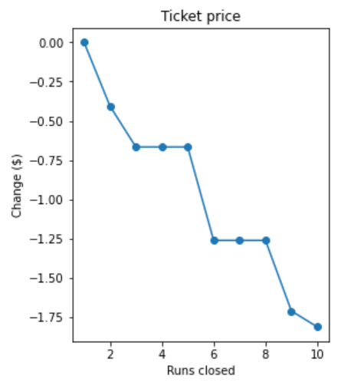

At best, the analysis is highly theoretical, based on some un-examined notion that there is some sort of ideal number of runs in the appeal of a ski resort. Our runs were planned by experts, tailored to our mountain, part of a connectivity map in sync with the placement of our lifts. In terms of ideals, we have not examined number of runs ratio to skiable terrain or to vertical drop. We also do not know which of our runs, though less used overall, might be highly valued by expert skiers and thus a crucial part of our overall cachet in the market.

We also have no information on how much we might save by closing a run, and thus not needing to groom it, patrol it, and make snow for it.

The very fact that tampering with the number of runs, in isolation, has a negative impact on pricing, is reason enough to proceed with extreme caution. This is not something to embark on from the type of data modeling we have done. And as a general rule, we want to develop our resources, not shrink them. Terrain utilization and crowd-flow modeling might be more on point.

The theoretical price increase support from Scenario 2 would be subject to all the caveats presented above with regard to increasing prices. It also needs to be considered together with information on how much this would increase our costs.

Scenarios 3 and 4 seem to suggest that incremental snow making has no effect on projected prices. But we know that snow-making is a crucial part of our model, probably because it is highly valued by customers. This may be a threshold problem, like the curious break points in scenario 1. Or a scale problem with certain parameters. Or it might be an indication that our model is not sensitive to changes when we are already at the high end on this parameter.

These limited scenarios are probably more valuable as examples of how our model might be used than as an in-depth analysis of possible changes we might make to support increased prices.

**Recommendations and Next Steps**

In our modeling analysis we make a recommendation for increasing ticket prices. There are several reasons to be wary of blindly using our model's price prediction as a pricing *formula*. For one, the model is descriptive, not prescriptive. It is excellent at telling us what the other resorts are doing and what features tend to support higher prices. It is less successful at giving us a plan to increase revenue.

In a competitive business environment, pricing is not a spigot that can simply be opened wider to raise revenue. Pricing is a key element of competitive strategy. It is also a major factor in a customer's choice of where to ski. Raising prices might not raise revenue at all, if increases lead to fewer customers. (On the other hand, a higher price might be a quality signal that may attract a certain clientele. We should take a closer look at the resorts in the long right tail of the pricing distribution.)

We need to learn more about our customers--where they live, how much time and money they spend to get to our resort, what they like about our resort, and what they don't like. How many of our customers come from Montana and neighboring states and is that the local market we should be using to compare our pricing? (Montana is pretty remote, and not near major population centers.) To understand the perception of Big Mountain as a destination, we need to know how plentiful and attractive are the local lodging, dining, and nightlife.

To analyze scenarios, we need information about costs as well as price modeling. To explore other sources of revenue, we need information on programs for kids, food service, parking fees and capacity, equipment rental, spa services, etc.

See the page of questions raised by our analysis, organized in 11 categories, under "cost and competitive information" in section 5.11 of the phase 05 technical notebook. If we can get answers to these questions along with data from other resorts, we can add this information to our model. If our data is limited to Big Mountain, we can analyze it scientifically and present our results graphically, as we did with the competitive positioning charts presented above.