DATA 624: Group 2 Homework; Part 1

This document contains all homework assignments for Group 2 from week 1-7. Participants of this group include Vinicio Haro, Juliann McEachern, Jeremy O’Brien, Bethany Poulin, and Sang (Andy) Yoon.

# Dependencies

The following packages were used in R for completion of our homework assignments:

#Textbook Packages  
library(fpp2)  
library(AppliedPredictiveModeling)  
library(mlbench)  
  
#Graphing  
library(ggplot2)  
library(gridExtra)  
  
#Math  
library(caret)  
library(randomForest)  
library(seasonal)  
  
#Formatting  
library(knitr)

# Assignment 1

Week 1: HA #2.1; HA #2.3

## 2.1: Use the help function to explore what the series gold, woolyrnq and gas represent.

#help("gold")  
#help("woolyrnq")  
#help("gas")

Per the help function, the gold series represents “daily morning gold prices in US dollars. 1 January 1985-31 March 1989”; the woolyrnq series represents “quarterly production of woollen yarn in Australia: tonnes. Mar 1965-Sep 1994”; and, the gas series represents “Australian monthly gas production: 1956-1995.”

### (a). Use autoplot() to plot each of these in separate plots.

The time plots below were generated from the autoplot function.

The gold plot follows a general incrementral trend until a large spike around the indexed date of appromately 775. At which point, the value of gold begins to decrease over the remaining time captured in this series.

autoplot(gold) +   
 labs(title = "Daily Morning Gold Prices",   
 subtitle = "Time Series: 01 Jan 1985 - 31 Mar 1989",   
 x = "Day",   
 y = "Price (USD)")

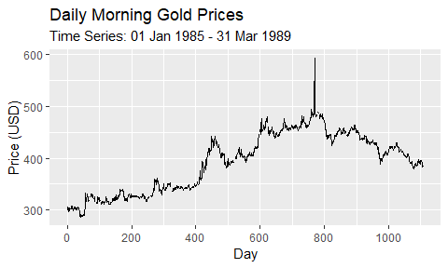

The woolyrnq plot follows a decremental trend. There is a large, downward spike at the start of 1975 worth noting.

autoplot(woolyrnq) +  
 labs(title = "Quarterly Australian Woollen Yarn Production",   
 subtitle = "Time Series: Mar 1965 - Sep 1994",   
 x = "Year",   
 y = "Quantity (Tons)")

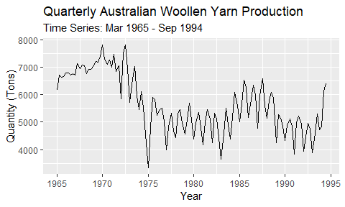

Lastly, the gas plot shows monthly changes to the Australian gas production. The seasonal pattern of this series appears to decrease, while the overall trend in production increases.

autoplot(gas) +  
 labs(title = "Monthly Australian Gas Production",   
 subtitle = "Time Series: 1956 - 1995",   
 x = "Year",   
 y = "Quantity")

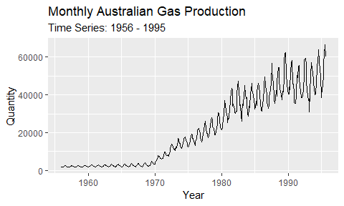

### (b). What is the frequency of each series? Hint: apply the frequency() function.

The frequency of timeseries shows us the number of observations within a singular seasonal pattern.

frequency(gold)

## [1] 1

frequency(woolyrnq)

## [1] 4

frequency(gas)

## [1] 12

Our output from the frequency function informs us that gold is an annual time series, woolyrnq is a quarterly series, and gas is a monthly series.

### (c). Use which.max() to spot the outlier in the gold series. Which observation was it?

The which.max() function returns an index value of the maximum value within a series. Using this function, the maximum value for gold is shown below:

which.max(gold)

## [1] 770

This number aligns with the observed spike in gold price from the time series plot in part (a).

## 2.3: Download some monthly Australian retail data from the book website. These represent retail sales in various categories for different Australian states, and are stored in a MS-Excel file.

### (a). You can read the data into R with the following script:

retaildata <- readxl::read_excel("data/retail.xlsx", skip=1)

*The second argument (skip=1) is required because the Excel sheet has two header rows.*

### (b). Select one of the time series as follows (but replace the column name with your own chosen column):

myts <- ts(retaildata[,"A3349335T"], frequency=12, start=c(1982,4))

### (c). Explore your chosen retail time series using the following functions: autoplot(), ggseasonplot(), ggsubseriesplot(), gglagplot(), ggAcf().

The output from the autoplot function shows a general, incremental trend over the observed period; however, there appears to be small, decremental trends within individual seasonal pattern.

autoplot(myts) +   
 labs(title = "Monthly Australian Book Retail Data: A3349335T",   
 subtitle = "Time Plot: Apr 1982 - Dec 2013",  
 x = "Year",   
 y = "Sales")

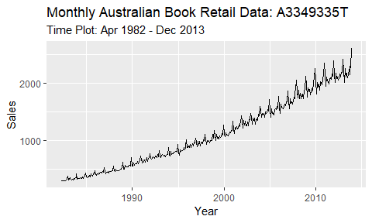

Seaonal plots shows the observed data plotted against each season within our time series. The seasons are overlapped, which allows for us to view underlying seasonal patterns and the years in which these trends occur. Our seaonal plot below shows that book sales tend to generally decrease in from Jan-Feb, Mar-Apr, May-Jun, Aug-Sep, and Oct-Nov. Sales generally appear to increase seasonally between the other observed months.

ggseasonplot(myts,year.labels=TRUE, year.labels.left=TRUE) +   
 labs(title = "Monthly Australian Book Retail Data: A3349335T",   
 subtitle = "Seasonal Plot: Apr 1982 - Dec 2013",   
 x = "Month",   
 y = "Sales")

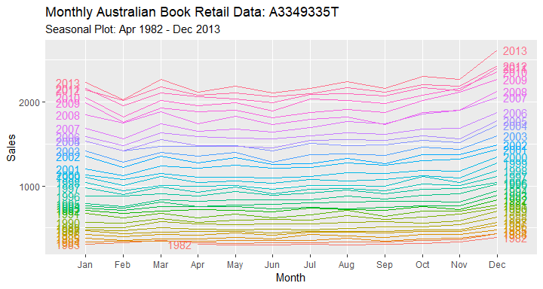

The subseries plot provides a different way to view underlying seasonal patterns by separating each season in a year into an individual plot. The horizonal line shows the mean value of each month. The plot below reveals that, on average, the month of Feburary holds the lowest sales and the month of December contains the highest sales throughout all observed time periods.

ggsubseriesplot(myts) +  
 labs(title = "Monthly Australian Book Retail Data: A3349335T",   
 subtitle = "Subseries Plot: Apr 1982 - Dec 2013",   
 x = "Month",   
 y = "Sales")

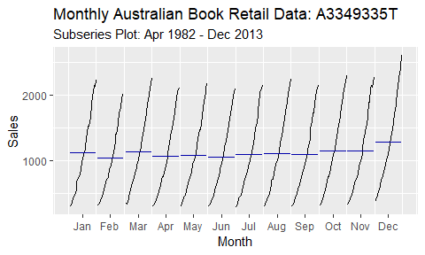

Lag plots is used to examine the correlation between the X and Y axis over a fixed period of time using a scatterplot. Per the text, “each graph shows $y_{t}$ plotted against $y_{t}−k$ for different values of $k$”. Our lag plot below shows an overall positive relationship at each lag, which indicates a strong seaonal relationship in our data.

gglagplot(myts)+  
 labs(title = "Monthly Australian Book Retail Data: A3349335T",   
 subtitle = "Lag Plot: Apr 1982 - Dec 2013",   
 x = "Month",   
 y = "Sales")

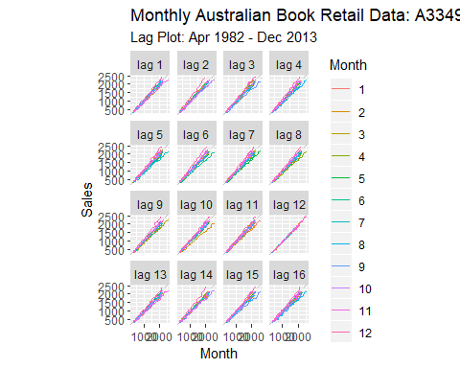

Lastly, our autocorrelation plot (also referred to as correlogram plot) measures the linear relationship between the time series’ lagged values. We used an autocorrelation function (ACF) below (ggAcf) to examine this relationship within our selected variable from the book retail data. From the graph, we can tell that $r1$ is our highest lag and $r25$ is our smallest lag. We can tell our data is trended because our plot depicts positive values that decrease slowly as our lags increase.

ggAcf(myts) +  
 labs(title = "Monthly Australian Book Retail Data: A3349335T",   
 subtitle = "Correlogram Plot: Apr 1982 - Dec 2013",   
 x = "Month",   
 y = "Sales")

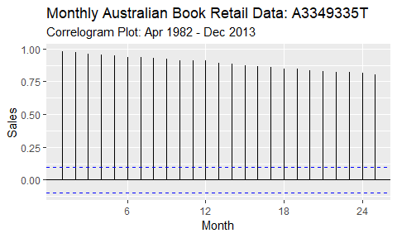

# Assignment 2

Week 2: HA #6.2

## 6.2: The plastics data set consists of the monthly sales (in thousands) of product A for a plastics manufacturer for five years.

### (a). Plot the time series of sales of product A. Can you identify seasonal fluctuations and/or a trend-cycle?

The plastics time plot below shows monthly, seasonal fluctionations in each one-year period. The overall trend-cycle gruadually increases across the full 5-year period.

autoplot(plastics) +   
 labs(title = "Product A: Monthly Sales for a Plastics Manufacturer",   
 subtitle = "Time Plot over a 5-Year Period",   
 x = "Year",   
 y = "Monthly Sales")

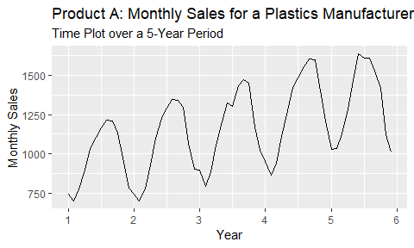

### (b). Use a classical multiplicative decomposition to calculate the trend-cycle and seasonal indices.

Using the decompose function from the stats package, we can view the trend-cycle and seasonal indices for our plastics data. The graphs below show the sales rise and fall within each season. The trend-cycle increases throughout our observed 5-year period.

plastics %>%   
 decompose(type="multiplicative") %>%   
 autoplot() +   
 labs(title = "Product A: Monthly Sales for a Plastics Manufacturer",   
 subtitle = "Classical Multiplicative Decomposition Graphs over a 5-Year Period",   
 x = "Year")

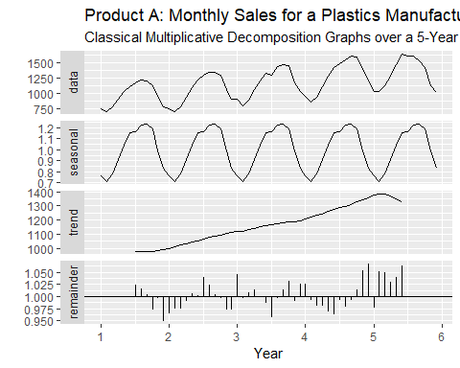

### (c). Do the results support the graphical interpretation from part a?

The results from part b align with our initial interpretation of the time plot from part a. The trend-cycle appears to decrease at the end of year 5. This may be due to the fact that the trend-cycle data is unavailable for the few and last few observations of a series. This is a recognized limitation of classical decomposition.

### (d). Compute and plot the seasonally adjusted data.

The graph below overlays our original plastics time plot for product A with a plot containing seasonally adjusted data. The adjustments smooth out the observed seasonal fluctuations and the data follows the same overall trend-cycle we observed in part a and b.

# decompose data using classical multiplicative decomposition  
plastics_cmd <- decompose(plastics, type = "multiplicative")  
  
# calculate and stare seasonal adjustments of data  
plastics_seas <- seasadj(plastics_cmd)  
  
# plot seasonally adjusted data; compare to original time series  
autoplot(plastics, series="Data") +  
 autolayer(plastics_seas, series="Seasonally Adjusted") +  
 labs(title = "Product A: Monthly Sales for a Plastics Manufacturer",   
 subtitle = "Time Plot over a 5-Year Period",   
 x = "Year",   
 y = "Monthly Sales")+  
 scale_colour_manual(values=c("gray","blue"),  
 breaks=c("Data","Seasonally Adjusted","Trend"))

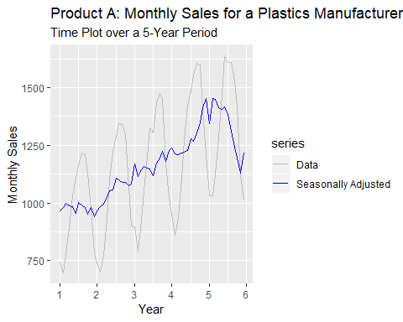

### (e). Change one observation to be an outlier (e.g., add 500 to one observation), and recompute the seasonally adjusted data. What is the effect of the outlier?

# duplicate data; change a singular observation to an outlier  
plastics2 <- plastics; plastics2[12] <- plastics2[12]+500  
  
#recompute seasonal adjustment  
plastics2 %>%   
 decompose(type="multiplicative") %>%   
 autoplot() +   
 labs(title = "Product A: Monthly Sales for a Plastics Manufacturer",   
 subtitle = "Classical Multiplicative Decomposition Graphs over a 5-Year Period",  
 caption = "*Changes made to the 12th oberserved value.",  
 x = "Year")

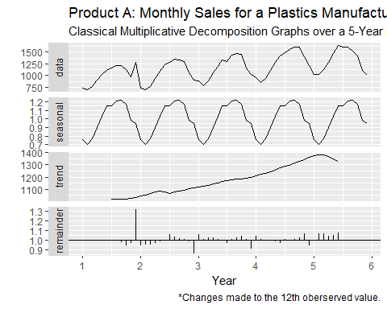

We changed the last observation in year one to be an outlier by adding 500 to the observed value in the 12th month. From our original data, we know that our data follows a decremental trend towards the end of the year. By altering the value of December of Year 1, we can see that an outlier creates a large spike in our data and remainder plots; however, the outlier has little affect on our seasonal and trend cycles.

### (f). Does it make any difference if the outlier is near the end rather than in the middle of the time series?

Yes, the location of the outlier affects the time series graph. In the example below, we moved the outlier from Year 1, Month 12 to Year 2, Month 6. During the middle of the seasonal cycle, we expect to see the data peak. Unlike part e, our new outlier shows a much more prominent spike in the seasonally adjusted data.

# duplicate data; change a singular observation to an outlier  
plastics3 <- plastics; plastics3[18] <- plastics3[18]+500  
  
#recompute seasonal adjustment  
plastics3 %>%   
 decompose(type="multiplicative") %>%   
 autoplot() +   
 labs(title = "Product A: Monthly Sales for a Plastics Manufacturer",   
 subtitle = "Classical Multiplicative Decomposition Graphs over a 5-Year Period",  
 caption = "*Changes made to the 18th oberserved value.",  
 x = "Year")

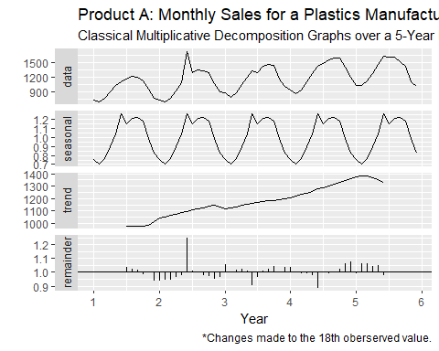

# Assignment 3

Week 3: KJ #3.1; KJ #3.2

## 3.1: The UC Irvine Machine Learning Repository contains a data set related to glass identification. The data consist of 214 glass samples labeled as one of seven class categories. There are nine predictors, including the refractive index and percentages of eight elements: Na, Mg, Al, Si, K, Ca, Ba, and Fe. The data can be accessed via:

data(Glass)  
str(Glass)

FALSE 'data.frame': 214 obs. of 10 variables:  
FALSE $ RI : num 1.52 1.52 1.52 1.52 1.52 ...  
FALSE $ Na : num 13.6 13.9 13.5 13.2 13.3 ...  
FALSE $ Mg : num 4.49 3.6 3.55 3.69 3.62 3.61 3.6 3.61 3.58 3.6 ...  
FALSE $ Al : num 1.1 1.36 1.54 1.29 1.24 1.62 1.14 1.05 1.37 1.36 ...  
FALSE $ Si : num 71.8 72.7 73 72.6 73.1 ...  
FALSE $ K : num 0.06 0.48 0.39 0.57 0.55 0.64 0.58 0.57 0.56 0.57 ...  
FALSE $ Ca : num 8.75 7.83 7.78 8.22 8.07 8.07 8.17 8.24 8.3 8.4 ...  
FALSE $ Ba : num 0 0 0 0 0 0 0 0 0 0 ...  
FALSE $ Fe : num 0 0 0 0 0 0.26 0 0 0 0.11 ...  
FALSE $ Type: Factor w/ 6 levels "1","2","3","5",..: 1 1 1 1 1 1 1 1 1 1 ...

### (a). Using visualizations, explore the predictor variables to understand their distributions as well as the relationships between predictors.

#code

### (b). Do there appear to be any outliers in the data? Are any predictors skewed?

#code

### (c). Are there any relevant transformations of one or more predictors that might improve the classification model?

#code

## 3.2: The soybean data can also be found at the UC Irvine Machine Learning Repository. Data were collected to predict disease in 683 soybeans. The 35 predictors are mostly categorical and include information on the environmental conditions (e.g., temperature, precipitation) and plant conditions (e.g., left spots, mold growth). The outcome labels consist of 19 distinct classes. The data can be loaded via:

data(Soybean)

### (a). Investigate the frequency distributions for the categorical predictors. Are any of the distributions degenerate in the ways discussed earlier in this chapter?

#code

### (b). Roughly 18% of the data are missing. Are there particular predictors that are more likely to be missing? Is the pattern of missing data related to the classes?

#code

### (c). Develop a strategy for handling missing data, either by eliminating predictors or imputation.

#code

# Assignment 4

Week 4: HA #7.1; HA #7.3

## 7.1: Consider the pigs series – the number of pigs slaughtered in Victoria each month.

### (a). Use the ses() function in R to find the optimal values of $α$ and $ℓ_{0}$, and generate forecasts for the next four months.

#code

### (b). Compute a 95% prediction interval for the first forecast using $\overset{̂}{y}±1.96s$ where $s$ is the standard deviation of the residuals. Compare your interval with the interval produced by R.

#code

## 7.3: Modify your function from the previous exercise to return the sum of squared errors rather than the forecast of the next observation. Then use the optim() function to find the optimal values of $α$ and $ℓ_{0}$. Do you get the same values as the ses() function?

#code

# Assignment 5

Week 5: HA #7.5; HA #7.6; HA #7.10

## 7.5: Data set books contains the daily sales of paperback and hardcover books at the same store. The task is to forecast the next four days’ sales for paperback and hardcover books.

### (a). Plot the series and discuss the main features of the data.

#code

### (b). Use the ses() function to forecast each series, and plot the forecasts.

#code

### (c). Compute the RMSE values for the training data in each case.

#code

## 7.6: Continuation of exercise 7.5.

### (a). Now apply Holt’s linear method to the paperback and hardback series and compute four-day forecasts in each case.

#code

### (b). Compare the RMSE measures of Holt’s method for the two series to those of simple exponential smoothing in the previous question. (Remember that Holt’s method is using one more parameter than SES.) Discuss the merits of the two forecasting methods for these data sets.

#code

### (c). Compare the forecasts for the two series using both methods. Which do you think is best?

#code

### (d). Calculate a 95% prediction interval for the first forecast for each series, using the RMSE values and assuming normal errors. Compare your intervals with those produced using ses and holt.

#code

## 7.10: For this exercise use data set ukcars, the quarterly UK passenger vehicle production data from 1977Q1-2005Q1.

### (a). Plot the data and describe the main features of the series.

#code

### (b). Decompose the series using STL and obtain the seasonally adjusted data.

#code

### (c). Forecast the next two years of the series using an additive damped trend method applied to the seasonally adjusted data. (This can be done in one step using stlf() with arguments etsmodel="AAN", damped=TRUE.)

#code

### (d). Forecast the next two years of the series using Holtâ-s linear method applied to the seasonally adjusted data (as before but with damped=FALSE).

#code

### (e). Now use ets() to choose a seasonal model for the data.

#code

### (f). Compare the RMSE of the ETS model with the RMSE of the models you obtained using STL decompositions. Which gives the better in-sample fits?

#code

### (g). Compare the forecasts from the three approaches? Which seems most reasonable?

#code

### (h). Check the residuals of your preferred model.

#code

# Assignment 6

Week 6-7: HA #8.1; HA #8.2; HA #8.6; HA #8.8

## 8.1: Figure 8.31 shows the ACFs for 36 random numbers, 360 random numbers and 1,000 random numbers.

### (a). Explain the differences among these figures. Do they all indicate that the data are white noise?

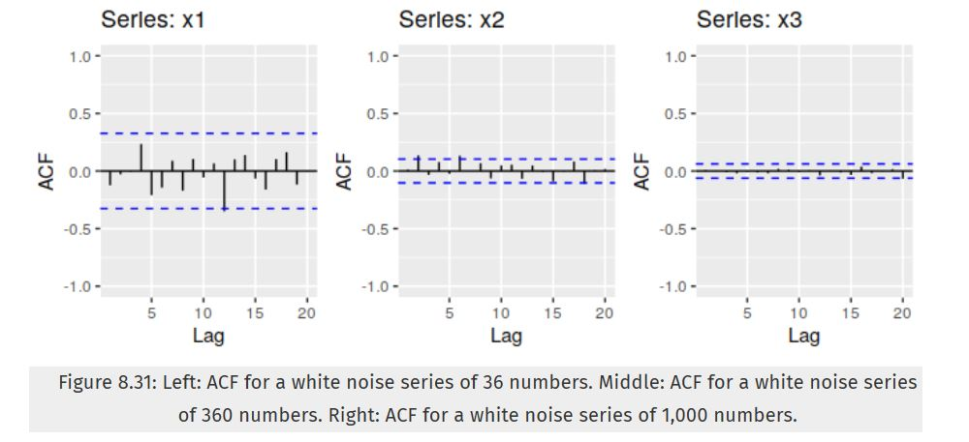

### (b). Why are the critical values at different distances from the mean of zero? Why are the autocorrelations different in each figure when they each refer to white noise?

#code

## 8.2: A classic example of a non-stationary series is the daily closing IBM stock price series (data set ibmclose). Use R to plot the daily closing prices for IBM stock and the ACF and PACF. Explain how each plot shows that the series is non-stationary and should be differenced.

#code

## 8.6: Use R to simulate and plot some data from simple ARIMA models.

### (a). Use the following R code to generate data from an AR(1) model with $ϕ_{1}=0.6$ and $σ^{2}=1$. The process starts with $y_{1}=0$.

y <- ts(numeric(100))  
e <- rnorm(100)  
for(i in 2:100)  
 y[i] <- 0.6*y[i-1] + e[i]

### (b). Produce a time plot for the series. How does the plot change as you change $ϕ_{1}$?

#code

### (c). Write your own code to generate data from an MA(1) model with $θ_{1}=0.6$ and $sigma^{2}=1$.

#code

### (d).Produce a time plot for the series. How does the plot change as you change $θ_{1}$?

#code

### (e). Generate data from an ARMA(1,1) model with $ϕ_{1}=0.6$, $θ_{1}=0.6$, and $σ^{2}=1$.

#code

### (f). Generate data from an AR(2) model with $ϕ_{1}=−0.8$, $ϕ_{2}=0.3$, and $σ^{2}=1$. (Note that these parameters will give a non-stationary series.)

#code

### (g). Graph the latter two series and compare them.

#code

## 8.8: Consider austa, the total international visitors to Australia (in millions) for the period 1980-2015.

### (a). Use auto.arima() to find an appropriate ARIMA model. What model was selected. Check that the residuals look like white noise. Plot forecasts for the next 10 periods.

#code

### (b). Plot forecasts from an ARIMA(0,1,1) model with no drift and compare these to part a. Remove the MA term and plot again.

#code

### (c). Plot forecasts from an ARIMA(2,1,3) model with drift. Remove the constant and see what happens.

#code

### (d). Plot forecasts from an ARIMA(0,0,1) model with a constant. Remove the MA term and plot again.

#code

### (e). Plot forecasts from an ARIMA(0,2,1) model with no constant.

#code