**Course: Programming Fundamental – ENSF 337**

**Lab #: Lab 9**

**Instructor: M. Moussavi**

**Student Name: Michael Jeremy Olea (30045602)**

**Lab Section: B01**

**Date submitted: Nov. 28, 2018**

**Exercise B:**

*void* print_from_binary(*char*\* filename) {

/* Studnets must complete the implementaiton of this file. */

ifstream input(filename,ios::in|ios::binary);

if(input.fail())

{

cout << "Error: Cannot open" << filename << endl;

exit(1);

}

*int* i = 0;

while(i == 0)

{

City x;

input.read((*char*\*)&x,sizeof(City));

if(input.eof())

i=1;

if(i==0)

{

cout <<"Name: " << x.name << ", ";

cout <<"x coordinate: " << x.x << ", ";

cout <<"y coordinate: " << x.y << " \n";

}

}

input.close();

}

Output:

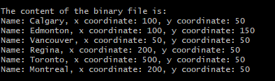

**Exercise C:**

String_Vector transpose (const String_Vector& sv) {

// STUDENTS MUST COMPLETE THE DEFINITION OF THIS FUNCTION.

*int* size = (*int*)sv.at(0).size();

String_Vector vs(size);

cout << "\n"; //just to put a space when printing

for(*int* i=0; i<(*int*)vs.size();i++)

{

vs.at(i).resize((*int*)sv.size());

}

for( *int* i = 0; i<(*int*)sv.size();i++)

{

for(*int* j = 0;j<(*int*)sv.at(i).size();j++)

{

vs.at(j).at(i) = sv.at(i).at(j);

}

}

return vs;

}

Output:

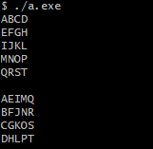

Exercise D:

AR-Diagram:

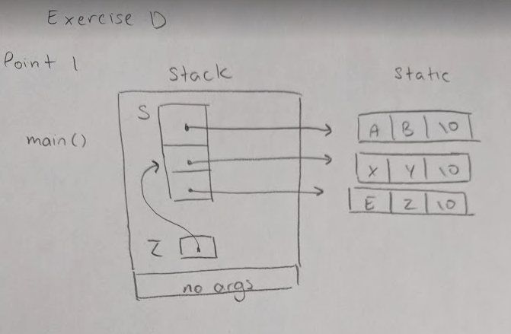

#include <iostream>

using *namespace* std;

#include <string.h>

*void* insertion_sort(*int* *int_array, *int* n);

/* REQUIRES

* n > 0.

* Array elements int_array[0] ... int_array[n - 1] exist.

* PROMISES

* Element values are rearranged in non-decreasing order.

*/

*void* insertion_sort(const *char*\*\* str_array, *int* n);

/* REQUIRES

* n > 0.

* Array elements str_array[0] ... str_array[n - 1] exist.

* PROMISES

* pointers in str_array are rearranged so that strings:

* str_array[0] points to a string with the smallest string (lexicographicall) ,

* str_array[1] points to the second smallest string, ..., str_array[n-2]

* points to the second largest, and str_array[n-1] points to the largest string

*/

*int* main(*void*)

{

const *char*\* s[] = { "AB", "XY", "EZ"};

const *char*\*\* z = s;

z += 1;

cout << "The value of **z is: " << **z << endl;

cout << "The value of *z is: " << *z << endl;

cout << "The value of **(z-1) is: " << **(z-1)<< endl;

cout << "The value of *(z-1) is: " << *(z-1)<< endl;

cout << "The value of z[1][1] is: " << z[1][1]<< endl;

cout << "The value of *(*(z+1)+1) is: " << *(*(z+1)+1)<< endl;

// point 1

*int* a[] = { 413, 282, 660, 171, 308, 537 };

*int* i;

*int* n_elements = sizeof(a) / sizeof(*int*);

cout << "Here is your array of integers before sorting: \n";

for(i = 0; i < n_elements; i++)

cout << a[i] << endl;

cout << endl;

insertion_sort(a, n_elements);

cout << "Here is your array of ints after sorting: \n" ;

for(i = 0; i < n_elements; i++)

cout << a[i] << endl;

#if 1

const *char*\* strings[] = { "Red", "Blue", "pink","apple", "almond","white",

"nut", "Law", "cup"};

n_elements = sizeof(strings) / sizeof(*char*\*);

cout << "\nHere is your array of strings before sorting: \n";

for(i = 0; i < n_elements; i++)

cout << strings[i] << endl;

cout << endl;

insertion_sort(strings, 9);

cout << "Here is your array of strings after sorting: \n" ;

for(i = 0; i < n_elements; i++)

cout << strings[i] << endl;

cout << endl;

#endif

return 0;

}

*void* insertion_sort(*int* *a, *int* n)

{

*int* i;

*int* j;

*int* value_to_insert;

for (i = 1; i < n; i++) {

value_to_insert = a[i];

/* Shift values greater than value_to_insert. */

j = i;

while ( j > 0 && a[j - 1] > value_to_insert ) {

a[j] = a[j - 1];

j--;

}

a[j] = value_to_insert;

}

}

*void* insertion_sort(const *char*\*\* str_array, *int* n)

{

*int* i;

*int* j;

const *char* *select;

for(i = 1; i < n; i++)

{

select = str_array[i];

j = i;

while(j > 0 && strcmp(str_array[j-1],select) > 0)

{

str_array[j] = str_array[j-1];

j--;

}

str_array[j] = select;

}

}

Output:

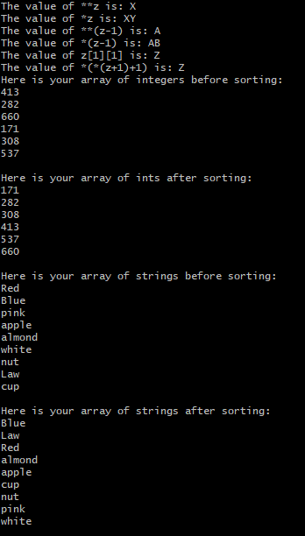

Exercise E:

#include "matrix.h"

Matrix::Matrix(*int* r, *int* c):rowsM(r), colsM(c)

{

matrixM = new *double*\* [rowsM];

assert(matrixM != NULL);

for(*int* i=0; i < rowsM; i++){

matrixM[i] = new *double*[colsM];

assert(matrixM[i] != NULL);

}

sum_rowsM = new *double*[rowsM];

assert(sum_rowsM != NULL);

sum_colsM = new *double*[colsM];

assert(sum_colsM != NULL);

}

Matrix::~Matrix()

{

destroy();

}

Matrix::Matrix(const Matrix& source)

{

copy(source);

}

Matrix& Matrix::operator= (const Matrix& rhs)

{

if(&rhs != this){

destroy();

copy(rhs);

}

return *this;

}

*double* Matrix::get_sum_col(*int* i) const

{

assert(i >= 0 && i < colsM);

return sum_colsM[i];

}

*double* Matrix::get_sum_row(*int* i) const

{

assert(i >= 0 && i < rowsM);

return sum_rowsM[i];

}

*void* Matrix::sum_of_rows()const

{

for(*int* i = 0; i < rowsM; i++)

{

*double* sum = 0;

for(*int* j = 0; j < colsM; j++)

{

sum += matrixM[i][j];

}

sum_rowsM[i] = sum;

}

}

*void* Matrix::sum_of_cols()const

{

for(*int* i = 0; i < colsM; i++)

{

*double* sum = 0;

for(*int* j = 0; j < rowsM; j++)

{

sum += matrixM[j][i];

}

sum_colsM[i] = sum;

}

}

*void* Matrix::copy(const Matrix& source)

{

if(source.matrixM == NULL){

matrixM = NULL;

sum_rowsM = NULL;

sum_colsM = NULL;

rowsM = 0;

colsM = 0;

return;

}

rowsM = source.rowsM;

colsM = source.colsM;

sum_rowsM = new *double*[rowsM];

assert(sum_rowsM != NULL);

sum_colsM = new *double*[colsM];

assert(sum_colsM != NULL);

matrixM = new *double*\*[rowsM];

assert(matrixM !=NULL);

for(*int* i =0; i < rowsM; i++){

matrixM[i] = new *double*[colsM];

assert(matrixM[i] != NULL);

}

for(*int* i = 0; i < rowsM; i++)

{

for(*int* j = 0; j < colsM; j++)

{

matrixM[i][j] = source.matrixM[i][j];

}

}

sum_of_rows();

sum_of_cols();

}

*void* Matrix::destroy()

{

for(*int* i = 0; i < rowsM; i++)

{

delete[] matrixM[i];

}

delete[] matrixM;

delete[] sum_rowsM;

delete[] sum_colsM;

}

Output:

