Name: Michael Jeremy Olea

Course: ENSF 409

Lab #: 2

Exercise 1:

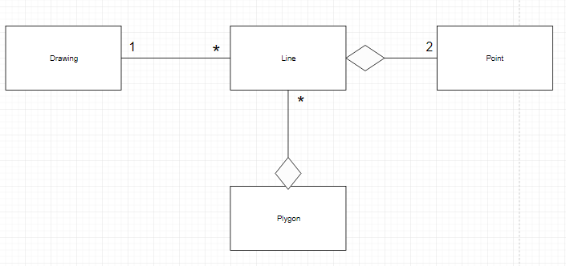

Exercise 2:

Point-Lab3.java:

class Point {

    private *int* x, y;

    public Point(*int* *x*, *int* *y*) {

    this.x = x;

    this.y = y;

    }

    static public *double* distance(*Point* *a*, *Point* *b*){

*double* diffx = a.x - b.x;

*double* diffy = a.y - b.y;

        return Math.sqrt(diffx \* diffx + diffy \* diffy);

    }

    public *String* toString(){

*String* s = "(" + x + ", " + y + ")";

        return s;

    }

}

Line.java:

class Line {

*Point* start, end;

    private static *int* classID = 0;

    private *int* objID;

    public Line(*Point* *a*, *Point* *b*) {

    start = a;

    end = b;

     objID = ++ classID;

    }

    public *double* distance(){

     return Point.distance(start, end);

}

public *String* toString()

{

*String* s = "Line " + objID + ": starts at " + start.toString() + ", and ends at " + end.toString();

    return s;

}

}

Polygon.java:

import java.util.\*;

class Polygon {

    private final *LinkedHashSet* <*Line*> polygon;

    private *int* objID;

    private static *int* classID;

*Iterator* <*Line*> it;

    public Polygon(*LinkedHashSet*<*Line*> *polygon*) {

         this.polygon = new *LinkedHashSet*<*Line*>();

         for(*Line* l: polygon)

             this.polygon.add (l);

         objID = ++ classID;

         it = this.polygon.iterator();

    }

    public *Iterator* <*Line*> getLine() {

        it = polygon.iterator();

        return it;

    }

    public static *int* classID(){

        return classID;

    }

public *String* toString() {

*String* s = new String("");

            System.out.printf("\nThe lines of polygon " + objID + " are:");

            for(*Line* line: polygon) {

                s += "\n" + line.toString();

            }

        return s;

}

}

OUTPUT:

