# Operation Manual (Dream)

Requirement:

Based on the size of dataset, a GPU whose memory is equal or larger than 8GB is needed in this experiment. And the expected running time is about 40 minutes (running on Nvidia RTX 3060Ti)

Environment:

Python >= 3.6

PyTorch >= 1.0

1. Download and unzip the pre-trained language model from <https://github.com/google-research/bert>. (in our experiment, I chose BERT-Base, Uncased and BERT-Large, Uncased)

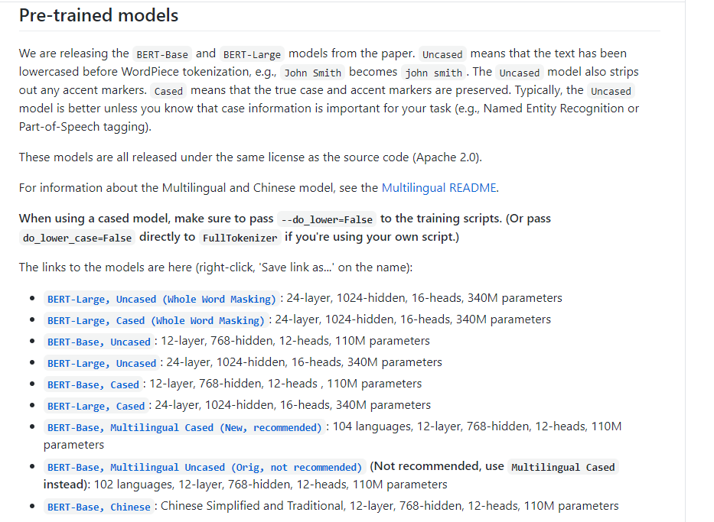

1. Set the path of pre-trained language model in /Dream_model/bert/bert_path.py like below,



1. In /bert, execute python convert_tf_checkpoint_to_pytorch.py, which can convert the format of TensorFlow to py-torch and save it as pytorch_model.bin



1. Execute python run_classifier.py to train the model and evaluate the result.



Result:

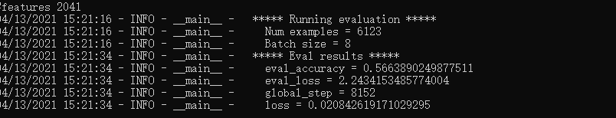

Meanwhile, the hyperparameter can be tuned in run_classifier.py. However, because of hardware’s limitation, the batch size and max sequence length can’t be increased, which could help us to obtain the better result.

The algorithm referenced <https://arxiv.org/abs/1904.09679> and <https://arxiv.org/abs/1902.00993>