**SWE-30011 IoT Programming**

**Smart Farming Design Doc**

Group Assignment

6/06/2020

Team Members:

Adam Knox

Jeremy Vun

Henil Kalpeshbhai Patel

# 1. Scope

# 2. Requirements

The system needs to,

* Monitor soil moisture
* Monitor temperature and humidity
* be modular
* Have a small footprint by offloading processing and data storage into the cloud
* Provide historical insights into farm resources
* Provide predictive insights into farm resources
* Be low cost

# 3. Architecture

## 3.1 Component list

|  |  |
| --- | --- |
| **System Components** | **Description** |
| Raspberry Pi | Edge processing device for interfacing between sensors and cloud |
| Arduino | Sensor devices |
| AWS | Cloud platform for hosting data and processing |

Figure 1.0 – List of system components

# 4. Deliverables Checklist

Develop IoT system

Demonstrate understanding of API

Statistical data anslysis

Report

* Code snipp

Video of the Hardware

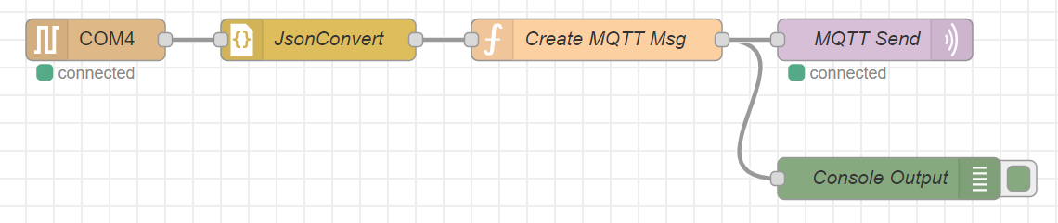

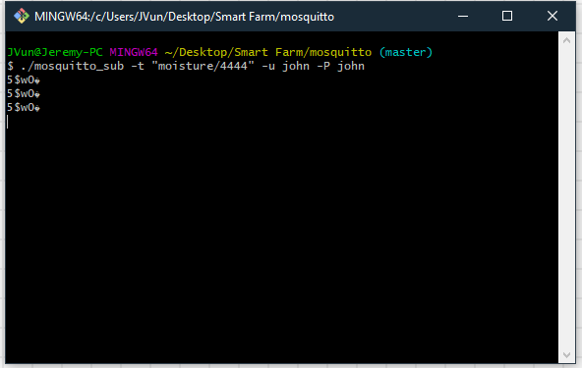

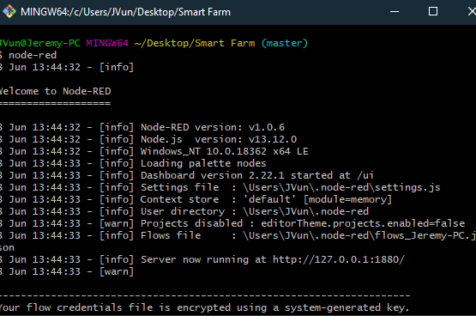

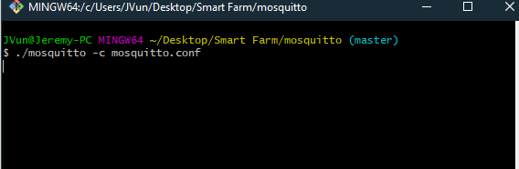

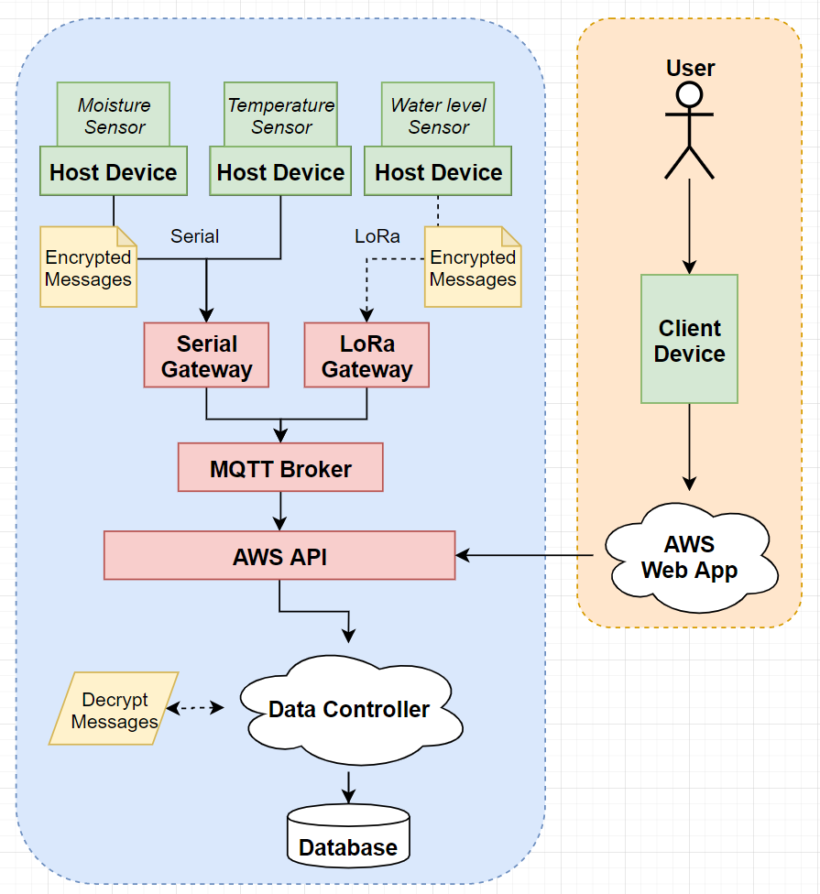

Demonstration plan (Friday 2:30)

