Automatice Report for aapl

# Analyzing the Headline Accuracy

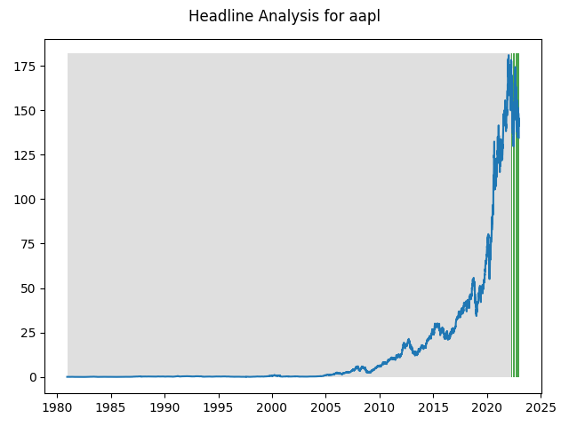

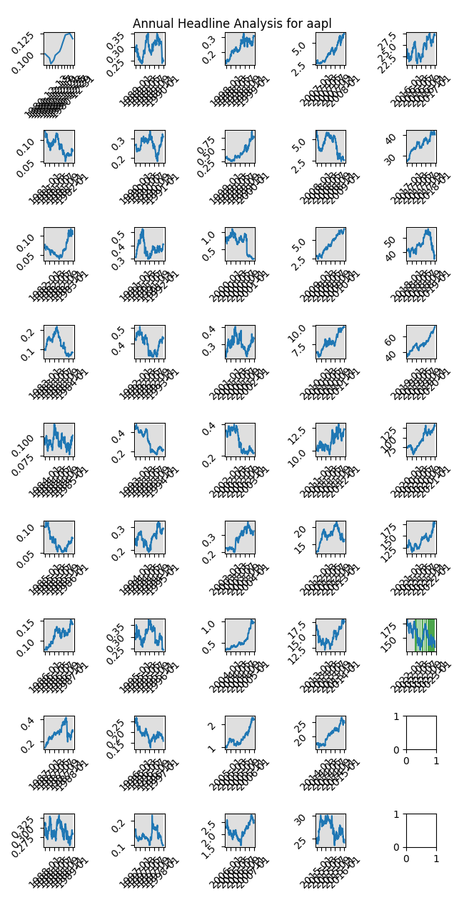

# A Little Bit More Insight Into the Headlines

The best headline was"Buy Smart to Win Big in ‘The Great EV Consolidation’" which occured on 2022-08-02 and had a Sentiment Score of 0.891

The worst headline was"Stock Market Today: Stocks Suffer Worst Losses of 2022" which occured on 2022-05-05 and had a Sentiment Score of -0.8834

|  |  |  |  |  |  |  |
| --- | --- | --- | --- | --- | --- | --- |
| Timeframe | -1_min | -1_mean | -1_max | 1_min | 1_mean | 1_max |
| 1-day | -6.05 | 1.26 | 10.92 | -9.57 | -0.36 | 7.04 |
| 3-day | -8.17 | 1.25 | 10.88 | -16.03 | -0.79 | 9.25 |
| 7-day | -12.75 | 1.24 | 14.17 | -19.27 | -1.29 | 13.94 |
| 14-day | -19.66 | 3.02 | 21.76 | -25.34 | -2.12 | 19.33 |
| 21-day | -22.21 | 1.75 | 24.71 | -29.54 | -2.61 | 26.12 |
| 28-day | -29.32 | 1.52 | 32.66 | -32.92 | -2.71 | 30.86 |

# Analyzing the Technical Indicators

## Looking at RSI

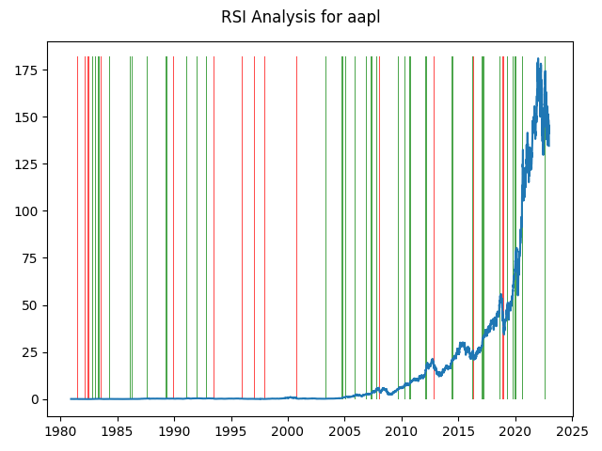

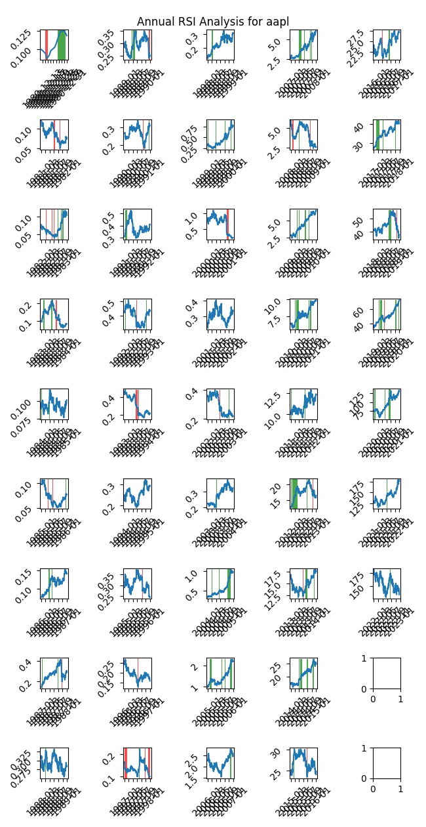

|  |  |  |  |  |  |  |
| --- | --- | --- | --- | --- | --- | --- |
| Timeframe | -1_min | -1_mean | -1_max | 1_min | 1_mean | 1_max |
| 1-day | -1.47 | 0.06 | 6.46 | -10.38 | 0.03 | 6.01 |
| 3-day | -1.32 | 0.13 | 8.19 | -18.33 | 0.1 | 10.01 |
| 7-day | -4.58 | 0.09 | 5.08 | -21.88 | 0.24 | 11.75 |
| 14-day | -7.02 | 0.09 | 6.2 | -23.95 | 0.41 | 20.88 |
| 21-day | -7.23 | 0.08 | 15.11 | -23.81 | 0.44 | 25.09 |
| 28-day | -8.39 | 0.09 | 9.01 | -24.27 | 0.45 | 27.92 |

## Looking at OBV

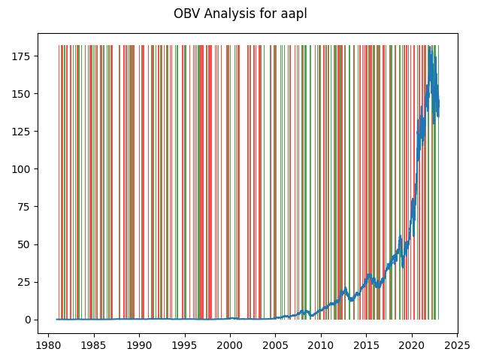

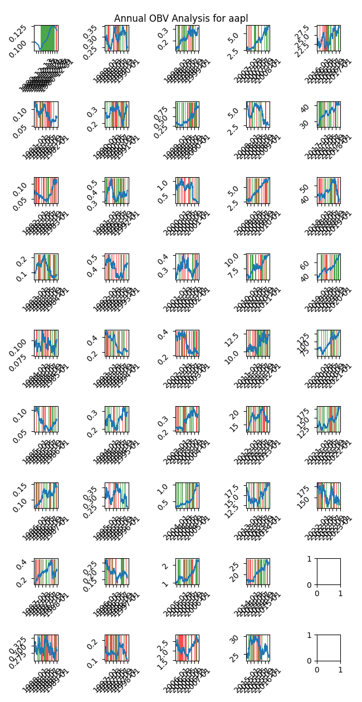

|  |  |  |  |  |  |  |
| --- | --- | --- | --- | --- | --- | --- |
| Timeframe | -1_min | -1_mean | -1_max | 1_min | 1_mean | 1_max |
| 1-day | -10.38 | 0.02 | 11.05 | -9.57 | 0.01 | 9.92 |
| 3-day | -18.33 | 0.05 | 15.3 | -13.67 | 0.03 | 13.68 |
| 7-day | -18.22 | 0.09 | 20.33 | -21.88 | 0.11 | 18.89 |
| 14-day | -23.95 | 0.18 | 23.58 | -25.34 | 0.23 | 23.24 |
| 21-day | -29.54 | 0.24 | 32.98 | -26.25 | 0.36 | 29.78 |
| 28-day | -32.39 | 0.35 | 40.94 | -32.92 | 0.44 | 31.51 |

## Looking at ADX

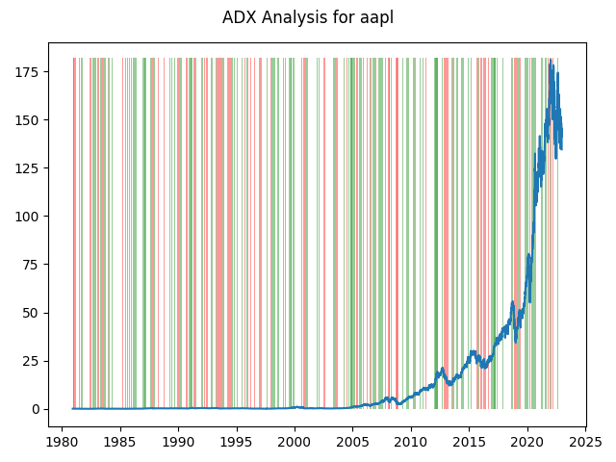

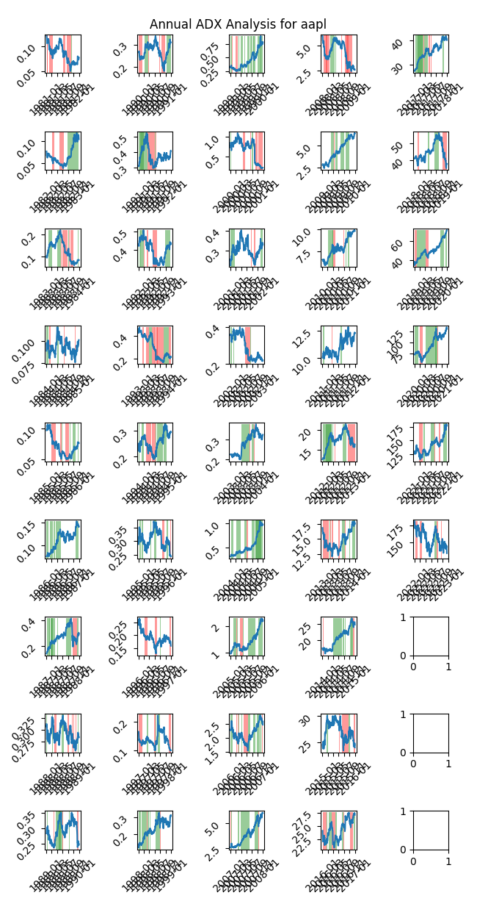

|  |  |  |  |  |  |  |  |  |  |  |  |  |
| --- | --- | --- | --- | --- | --- | --- | --- | --- | --- | --- | --- | --- |
| Timeframe | -2_min | -2_mean | -2_max | -1_min | -1_mean | -1_max | 1_min | 1_mean | 1_max | 2_min | 2_mean | 2_max |
| 1-day | -0.27 | 0.02 | 1.17 | -8.78 | 0.02 | 11.05 | -9.57 | 0.03 | 9.92 | -10.38 | -0.03 | 5.07 |
| 3-day | -0.51 | -0.0 | 1.04 | -12.27 | 0.05 | 15.3 | -11.1 | 0.09 | 13.68 | -18.33 | -0.08 | 9.05 |
| 7-day | -0.76 | 0.02 | 1.7 | -15.54 | 0.13 | 19.5 | -15.47 | 0.18 | 20.33 | -21.88 | -0.26 | 5.47 |
| 14-day | -0.54 | 0.02 | 0.48 | -17.08 | 0.23 | 23.58 | -25.19 | 0.28 | 22.26 | -23.95 | -0.42 | 2.55 |
| 21-day | -0.5 | 0.04 | 0.77 | -18.99 | 0.31 | 21.41 | -24.41 | 0.34 | 32.98 | -18.48 | -0.25 | 3.16 |
| 28-day | -0.91 | 0.06 | 1.12 | -21.25 | 0.35 | 30.86 | -29.32 | 0.36 | 40.94 | -13.18 | -0.03 | 3.56 |

# Analyzing the Analyst Agencies

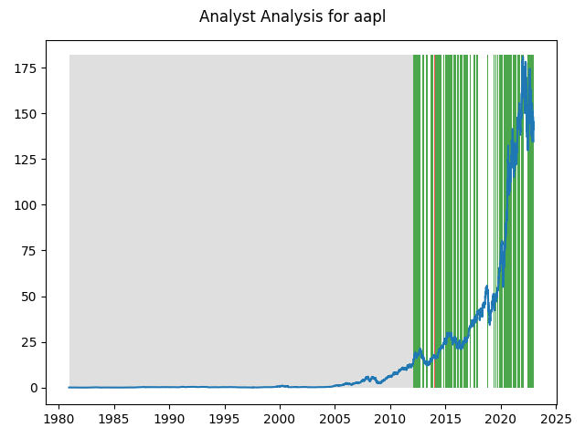

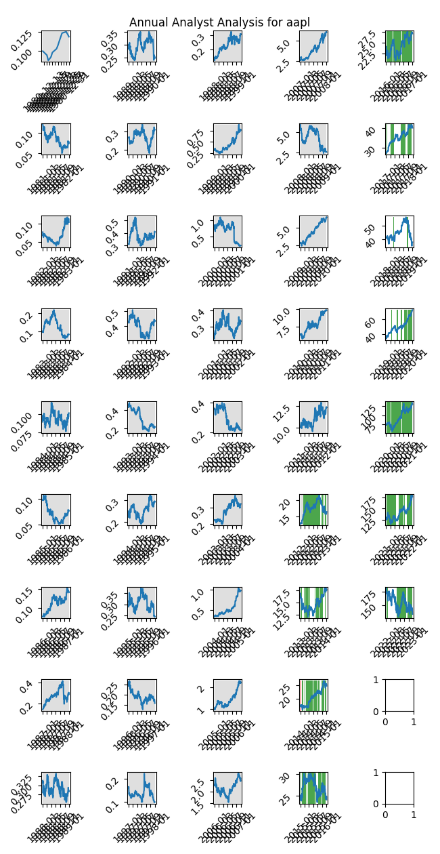

|  |  |  |  |  |  |  |
| --- | --- | --- | --- | --- | --- | --- |
| Timeframe | -1_min | -1_mean | -1_max | 1_min | 1_mean | 1_max |
| 1-day | -0.43 | 0.08 | 0.76 | -10.38 | 0.06 | 11.05 |
| 3-day | -0.26 | 0.17 | 0.89 | -18.33 | 0.17 | 15.3 |
| 7-day | -1.5 | 0.03 | 0.91 | -21.88 | 0.44 | 20.33 |
| 14-day | -1.41 | -0.83 | 0.72 | -25.19 | 0.8 | 22.26 |
| 21-day | -0.99 | 0.14 | 4.22 | -24.41 | 1.32 | 32.98 |
| 28-day | -1.16 | 0.34 | 6.68 | -29.32 | 1.73 | 40.94 |