Automatice Report for bbby

# Analyzing the Headline Accuracy

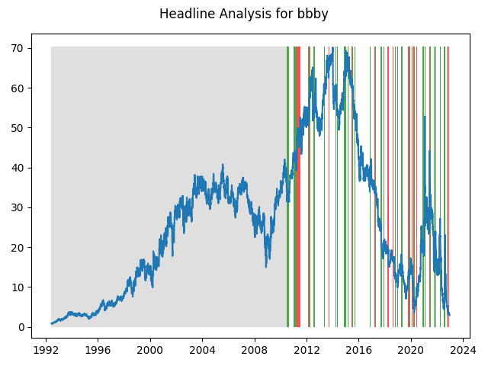

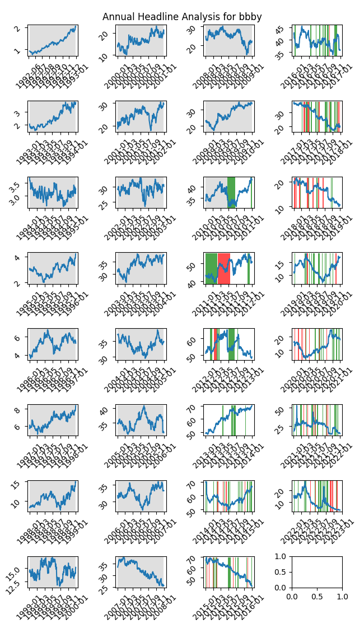

# A Little Bit More Insight Into the Headlines

The best headline was"Best Black Friday Deals From Target, Best Buy and More" which occured on 2016-11-18 and had a Sentiment Score of 0.8555

The worst headline was"Bed Bath & Beyond CFO's death ruled a suicide" which occured on 2022-09-05 and had a Sentiment Score of -0.8555

|  |  |  |  |  |  |  |
| --- | --- | --- | --- | --- | --- | --- |
| Timeframe | -1_min | -1_mean | -1_max | 1_min | 1_mean | 1_max |
| 1-day | -19.25 | -0.07 | 4.5 | -12.29 | -0.0 | 16.93 |
| 3-day | -22.63 | -0.16 | 5.71 | -13.84 | -0.02 | 22.68 |
| 7-day | -26.35 | -0.18 | 10.36 | -12.38 | -0.14 | 27.29 |
| 14-day | -26.51 | -0.3 | 14.91 | -15.53 | -0.35 | 18.24 |
| 21-day | -26.03 | -0.46 | 12.61 | -15.13 | -0.26 | 17.83 |
| 28-day | -23.1 | -0.56 | 17.99 | -16.7 | -0.25 | 18.0 |

# Analyzing the Technical Indicators

## Looking at RSI

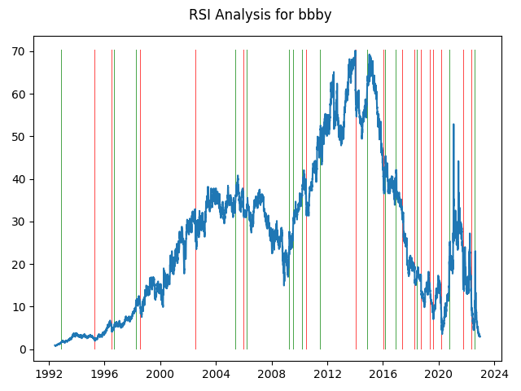

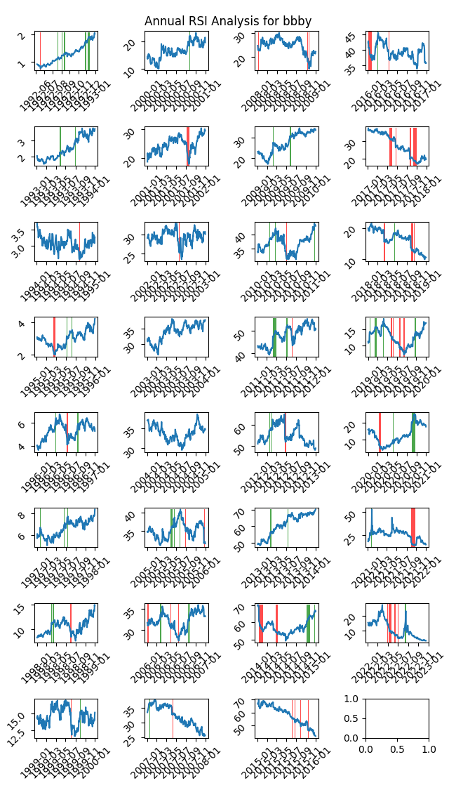

|  |  |  |  |  |  |  |
| --- | --- | --- | --- | --- | --- | --- |
| Timeframe | -1_min | -1_mean | -1_max | 1_min | 1_mean | 1_max |
| 1-day | -2.76 | 0.01 | 2.46 | -19.25 | -0.1 | 16.02 |
| 3-day | -3.7 | -0.0 | 3.79 | -22.63 | -0.24 | 22.68 |
| 7-day | -4.5 | 0.07 | 8.9 | -26.35 | -0.42 | 12.49 |
| 14-day | -5.43 | 0.23 | 8.89 | -26.51 | -0.68 | 5.69 |
| 21-day | -5.49 | 0.47 | 9.7 | -26.03 | -0.88 | 3.62 |
| 28-day | -6.6 | 0.53 | 11.53 | -23.1 | -0.79 | 4.96 |

## Looking at OBV

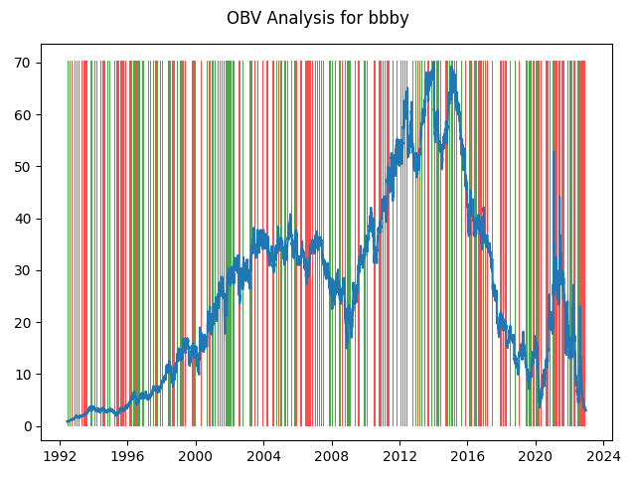

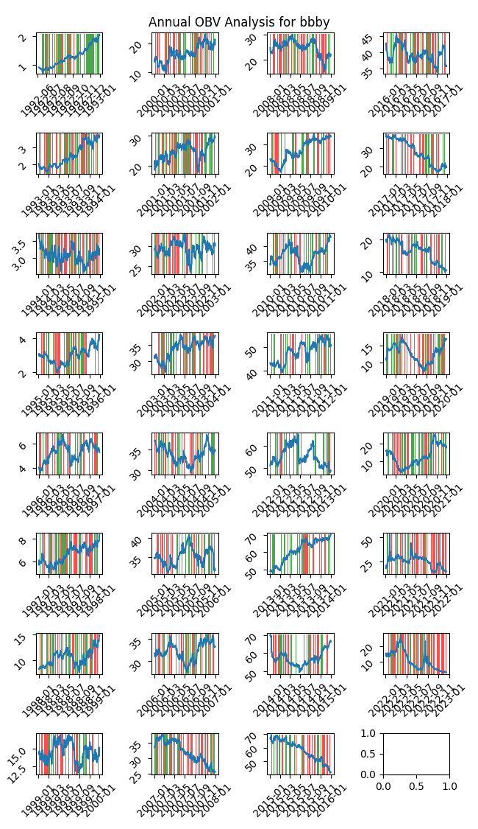

|  |  |  |  |  |  |  |
| --- | --- | --- | --- | --- | --- | --- |
| Timeframe | -1_min | -1_mean | -1_max | 1_min | 1_mean | 1_max |
| 1-day | -10.9 | 0.02 | 16.93 | -19.25 | -0.02 | 16.02 |
| 3-day | -12.49 | 0.04 | 6.35 | -22.63 | -0.04 | 22.68 |
| 7-day | -10.35 | 0.08 | 27.29 | -26.35 | -0.08 | 20.04 |
| 14-day | -13.46 | 0.08 | 20.53 | -26.51 | -0.07 | 31.86 |
| 21-day | -14.21 | 0.11 | 34.29 | -26.03 | -0.09 | 17.83 |
| 28-day | -13.59 | 0.12 | 18.0 | -23.1 | -0.1 | 33.36 |

## Looking at ADX

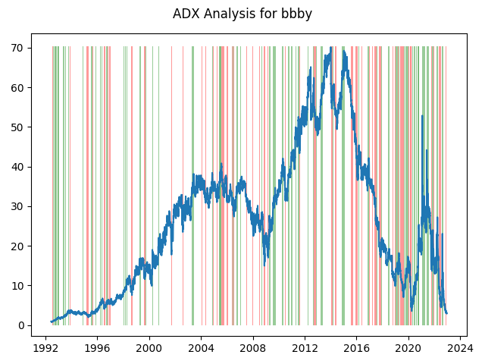

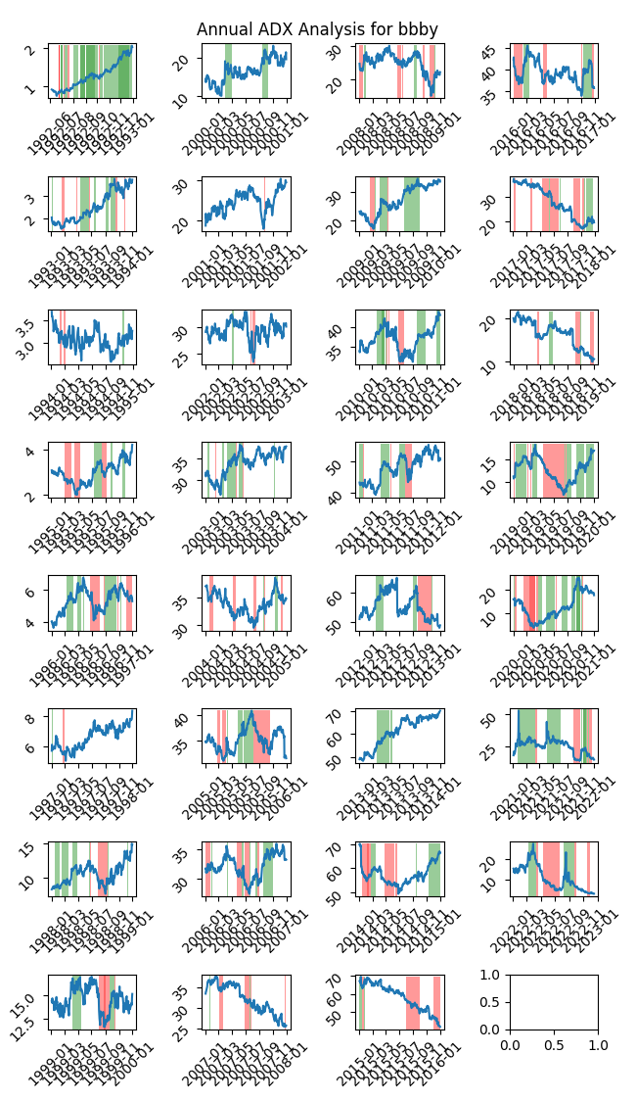

|  |  |  |  |  |  |  |  |  |  |  |  |  |
| --- | --- | --- | --- | --- | --- | --- | --- | --- | --- | --- | --- | --- |
| Timeframe | -2_min | -2_mean | -2_max | -1_min | -1_mean | -1_max | 1_min | 1_mean | 1_max | 2_min | 2_mean | 2_max |
| 1-day | -1.2 | -0.0 | 1.26 | -3.62 | 0.01 | 2.86 | -19.25 | -0.02 | 16.02 | -2.91 | -0.05 | 1.8 |
| 3-day | -2.67 | 0.06 | 1.76 | -3.98 | 0.03 | 5.26 | -22.63 | -0.05 | 22.68 | -4.26 | -0.18 | 3.41 |
| 7-day | -2.16 | 0.22 | 2.54 | -6.96 | 0.04 | 8.9 | -26.35 | -0.09 | 12.49 | -6.14 | -0.66 | 3.02 |
| 14-day | -3.73 | 0.89 | 4.44 | -6.52 | 0.11 | 8.89 | -26.51 | -0.23 | 10.43 | -7.45 | -1.19 | 2.32 |
| 21-day | -1.92 | 1.78 | 5.33 | -9.03 | 0.16 | 17.83 | -26.03 | -0.35 | 12.96 | -8.38 | -1.39 | 3.64 |
| 28-day | -2.38 | 1.89 | 4.59 | -10.15 | 0.21 | 17.99 | -23.1 | -0.43 | 13.21 | -8.92 | -1.57 | 2.78 |

# Analyzing the Analyst Agencies

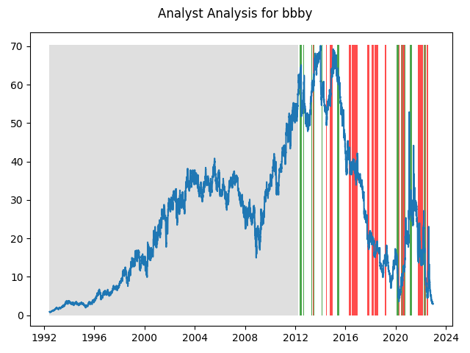

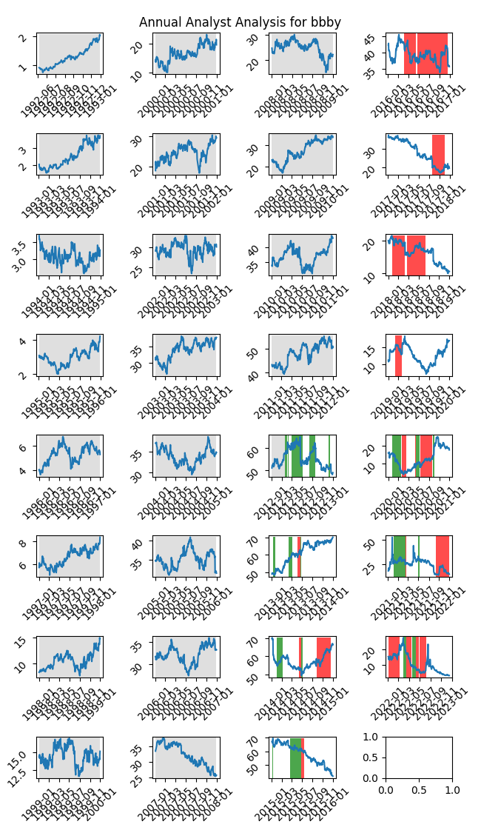

|  |  |  |  |  |  |  |
| --- | --- | --- | --- | --- | --- | --- |
| Timeframe | -1_min | -1_mean | -1_max | 1_min | 1_mean | 1_max |
| 1-day | -3.85 | 0.02 | 5.53 | -10.9 | -0.05 | 3.77 |
| 3-day | -5.02 | 0.04 | 6.35 | -12.49 | -0.12 | 6.09 |
| 7-day | -6.14 | 0.11 | 12.49 | -13.15 | -0.33 | 7.25 |
| 14-day | -8.06 | 0.32 | 18.24 | -11.68 | -0.71 | 10.43 |
| 21-day | -9.47 | 0.55 | 17.83 | -12.48 | -1.43 | 10.2 |
| 28-day | -9.18 | 0.75 | 17.99 | -16.26 | -2.2 | 8.17 |