Automatice Report for goog

# Analyzing the Headline Accuracy

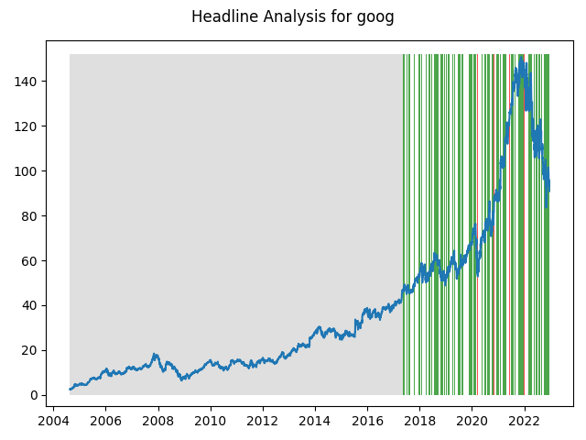

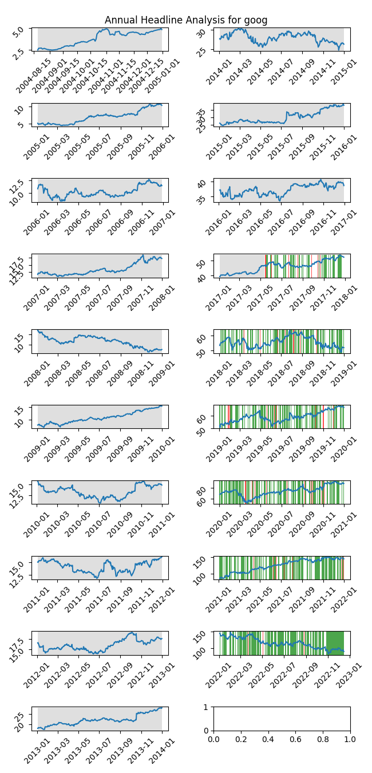

# A Little Bit More Insight Into the Headlines

The best headline was"The Top 5 Best TVs for Your Super Bowl Party" which occured on 2018-01-29 and had a Sentiment Score of 0.9118

The worst headline was"An AI-Powered ETF Failed Miserably at Beating the Market in 2018 -- Here's What You Can Learn From Its Mistakes" which occured on 2019-01-06 and had a Sentiment Score of -0.8979

|  |  |  |  |  |  |  |
| --- | --- | --- | --- | --- | --- | --- |
| Timeframe | -1_min | -1_mean | -1_max | 1_min | 1_mean | 1_max |
| 1-day | -10.11 | -0.0 | 6.76 | -6.77 | 0.04 | 10.16 |
| 3-day | -10.37 | 0.18 | 8.6 | -11.17 | 0.07 | 11.2 |
| 7-day | -21.44 | 0.06 | 15.92 | -13.91 | 0.28 | 17.66 |
| 14-day | -16.65 | 0.42 | 16.11 | -22.16 | 0.48 | 18.09 |
| 21-day | -22.49 | 1.18 | 19.09 | -27.68 | 0.59 | 19.61 |
| 28-day | -25.69 | 1.35 | 16.5 | -30.17 | 0.81 | 19.65 |

# Analyzing the Technical Indicators

## Looking at RSI

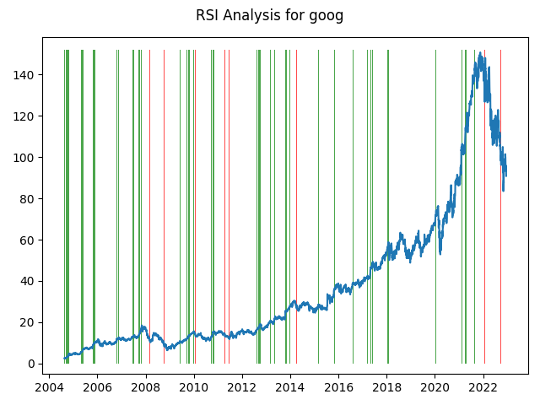

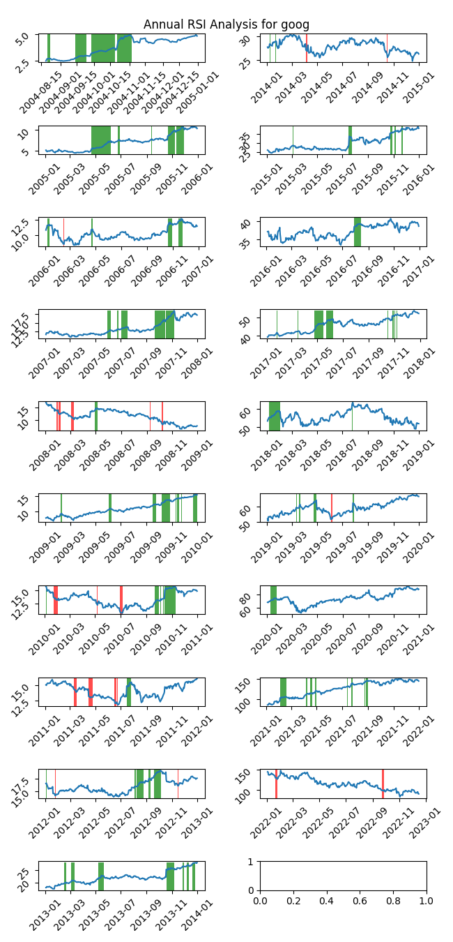

|  |  |  |  |  |  |  |
| --- | --- | --- | --- | --- | --- | --- |
| Timeframe | -1_min | -1_mean | -1_max | 1_min | 1_mean | 1_max |
| 1-day | -3.64 | 0.32 | 5.24 | -4.95 | -0.01 | 4.65 |
| 3-day | -5.03 | 0.35 | 6.55 | -9.79 | -0.05 | 5.16 |
| 7-day | -5.94 | 0.93 | 17.66 | -10.45 | -0.02 | 7.26 |
| 14-day | -11.06 | 0.64 | 15.33 | -15.65 | 0.05 | 10.23 |
| 21-day | -10.37 | 0.51 | 16.38 | -13.49 | 0.11 | 7.07 |
| 28-day | -15.32 | 0.08 | 11.82 | -11.42 | 0.24 | 11.46 |

## Looking at OBV

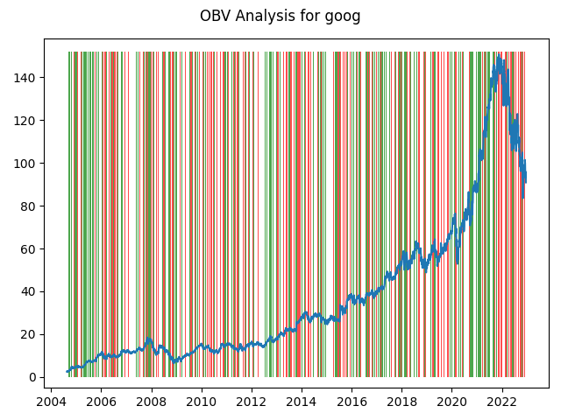

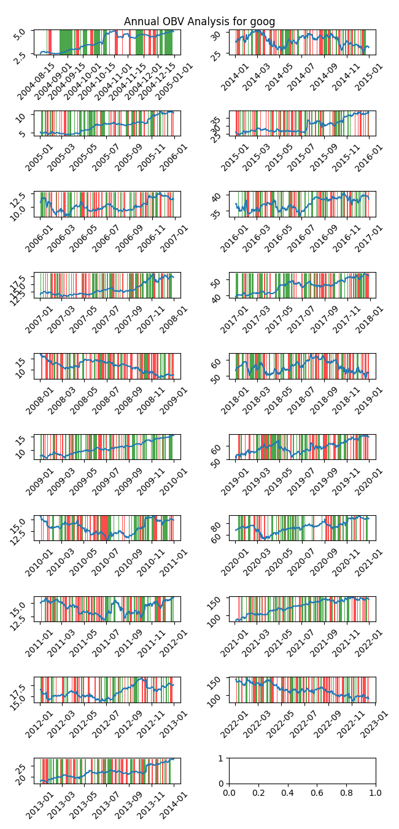

|  |  |  |  |  |  |  |
| --- | --- | --- | --- | --- | --- | --- |
| Timeframe | -1_min | -1_mean | -1_max | 1_min | 1_mean | 1_max |
| 1-day | -6.76 | 0.04 | 8.16 | -10.11 | 0.0 | 10.16 |
| 3-day | -11.17 | 0.12 | 11.72 | -10.92 | -0.0 | 14.75 |
| 7-day | -13.81 | 0.22 | 15.92 | -21.44 | 0.06 | 17.66 |
| 14-day | -22.16 | 0.37 | 18.09 | -21.09 | 0.21 | 15.78 |
| 21-day | -27.68 | 0.51 | 19.61 | -26.93 | 0.36 | 17.49 |
| 28-day | -28.06 | 0.62 | 19.65 | -30.17 | 0.52 | 19.33 |

## Looking at ADX

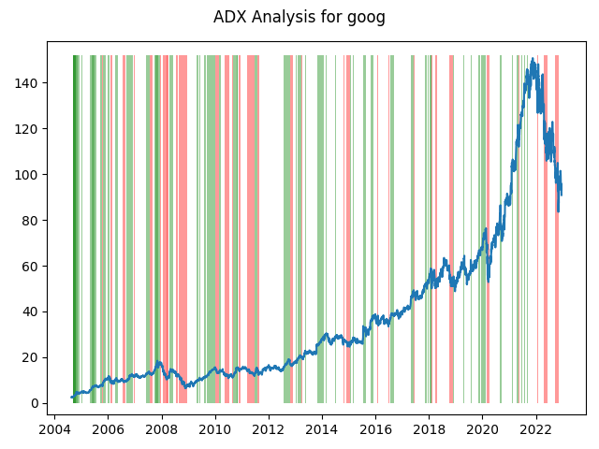

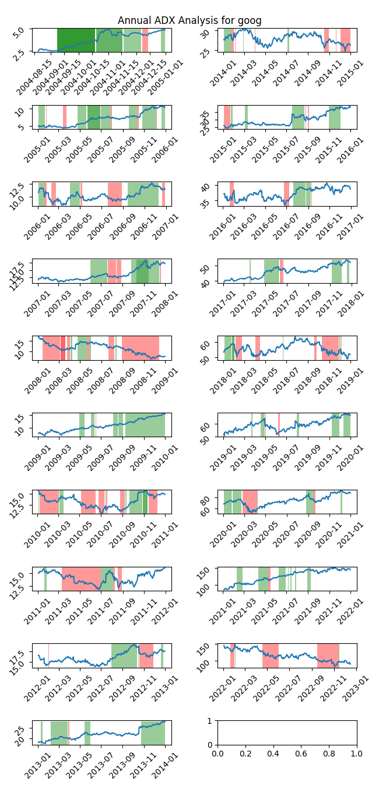

|  |  |  |  |  |  |  |  |  |  |  |  |  |
| --- | --- | --- | --- | --- | --- | --- | --- | --- | --- | --- | --- | --- |
| Timeframe | -2_min | -2_mean | -2_max | -1_min | -1_mean | -1_max | 1_min | 1_mean | 1_max | 2_min | 2_mean | 2_max |
| 1-day | -0.49 | 0.06 | 0.67 | -10.11 | -0.0 | 10.16 | -5.39 | -0.02 | 3.64 | -2.81 | -0.09 | 0.71 |
| 3-day | -0.51 | 0.2 | 0.73 | -11.17 | -0.01 | 14.75 | -9.79 | -0.04 | 5.16 | -5.71 | -0.2 | 1.17 |
| 7-day | -0.32 | 0.27 | 0.8 | -21.44 | -0.05 | 17.66 | -13.91 | -0.0 | 8.38 | -8.11 | -0.43 | 1.67 |
| 14-day | 0.12 | 0.66 | 1.42 | -17.45 | -0.23 | 15.33 | -20.45 | 0.07 | 8.97 | -5.03 | -0.21 | 2.73 |
| 21-day | 0.22 | 1.02 | 2.68 | -18.73 | -0.07 | 16.38 | -22.29 | 0.13 | 12.36 | -4.71 | -0.34 | 1.68 |
| 28-day | 0.4 | 2.47 | 3.51 | -17.73 | 0.03 | 15.05 | -22.61 | 0.29 | 13.61 | -7.38 | -0.03 | 1.88 |

# Analyzing the Analyst Agencies

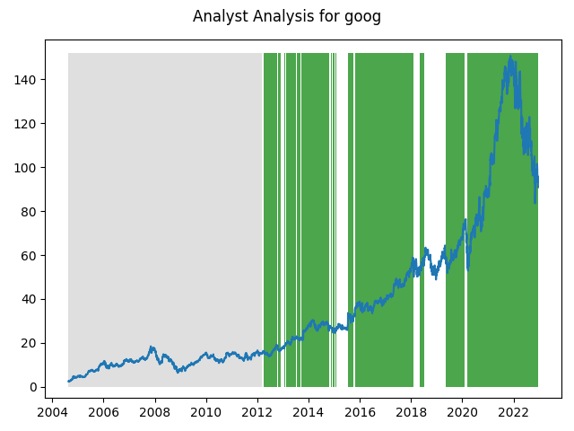

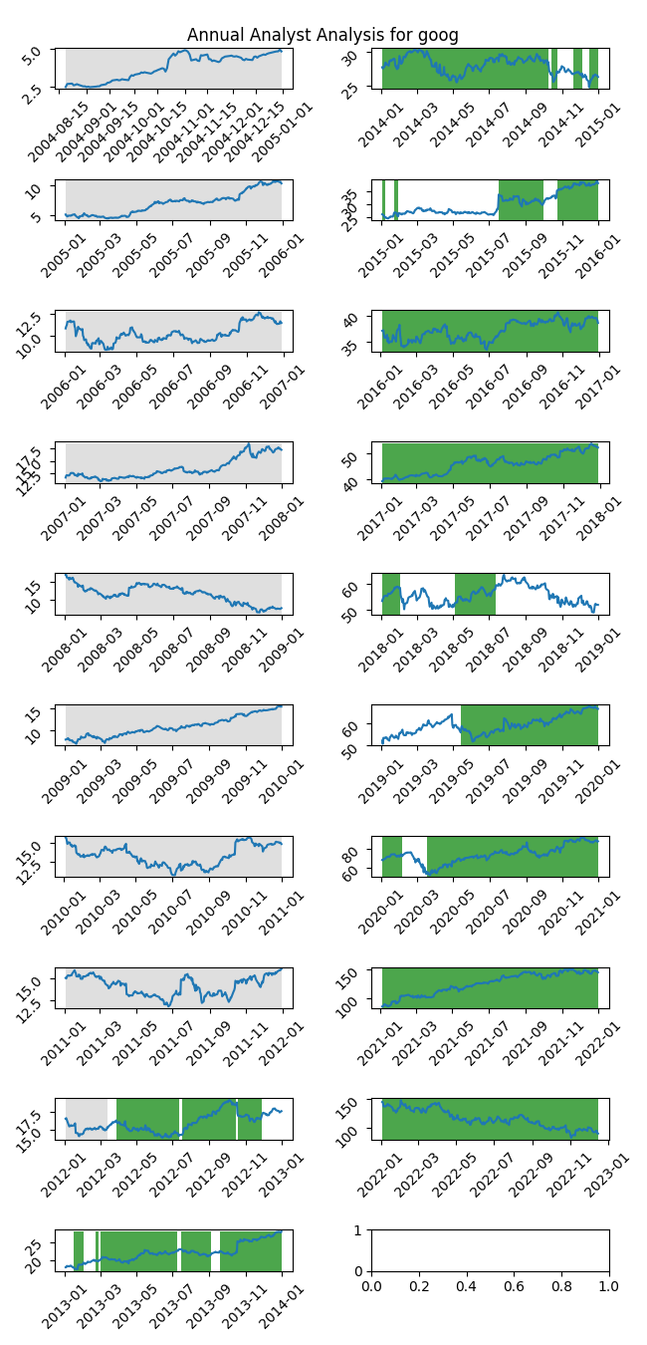

|  |  |  |  |  |  |  |
| --- | --- | --- | --- | --- | --- | --- |
| Timeframe | -1_min | -1_mean | -1_max | 1_min | 1_mean | 1_max |
| 1-day | nan | nan | nan | -10.11 | 0.04 | 10.16 |
| 3-day | nan | nan | nan | -11.17 | 0.12 | 14.75 |
| 7-day | nan | nan | nan | -21.44 | 0.29 | 17.66 |
| 14-day | nan | nan | nan | -22.16 | 0.6 | 18.09 |
| 21-day | nan | nan | nan | -27.68 | 0.9 | 19.61 |
| 28-day | nan | nan | nan | -30.17 | 1.12 | 19.65 |