Automatice Report for ko

# Analyzing the Headline Accuracy

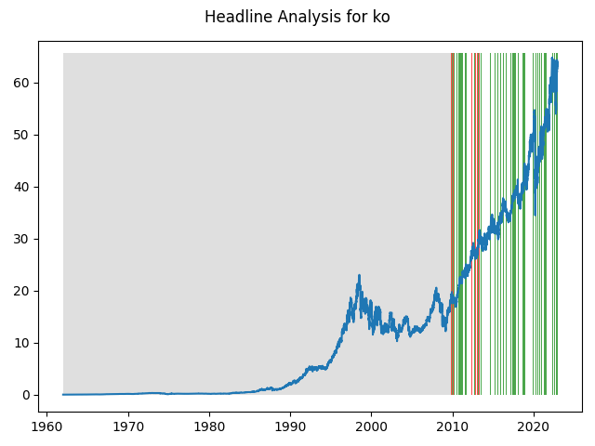

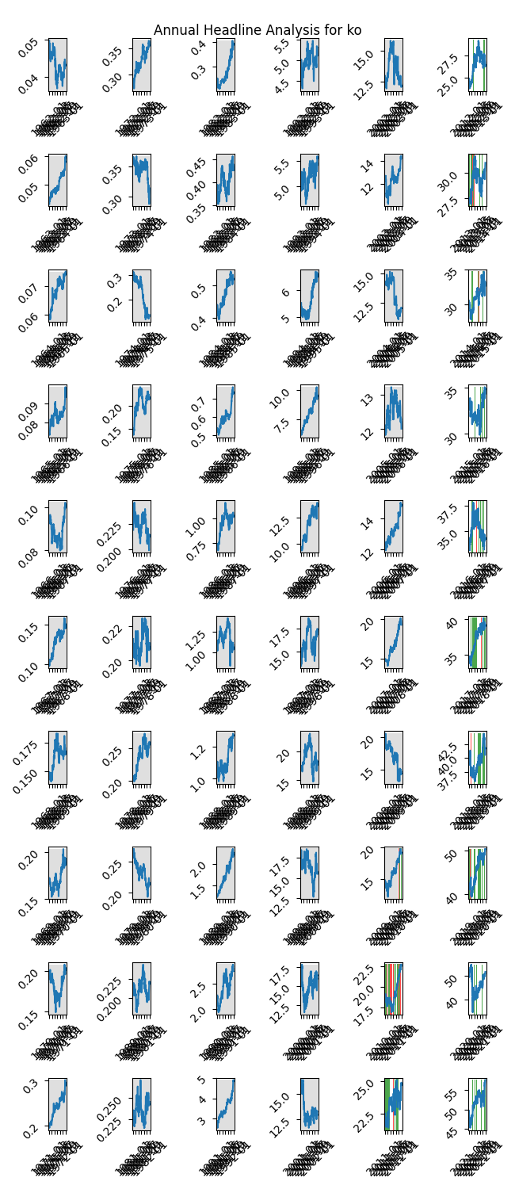

# A Little Bit More Insight Into the Headlines

The best headline was"Dow Jones Industrial Average Ends Week With Record Win; S&P Nabs Best Win Streak Since '14" which occured on 2016-12-09 and had a Sentiment Score of 0.9153

The worst headline was"Wall Street falls as U.S. crude collapse worsens pandemic woes" which occured on 2020-04-21 and had a Sentiment Score of -0.9169

|  |  |  |  |  |  |  |
| --- | --- | --- | --- | --- | --- | --- |
| Timeframe | -1_min | -1_mean | -1_max | 1_min | 1_mean | 1_max |
| 1-day | -4.6 | 0.05 | 2.61 | -4.48 | 0.01 | 2.6 |
| 3-day | -6.7 | 0.06 | 6.18 | -4.7 | 0.05 | 4.24 |
| 7-day | -12.36 | 0.18 | 4.56 | -10.09 | 0.09 | 5.53 |
| 14-day | -6.89 | 0.31 | 8.61 | -16.54 | 0.18 | 9.83 |
| 21-day | -11.25 | 0.36 | 7.46 | -20.25 | 0.26 | 6.56 |
| 28-day | -13.9 | 0.4 | 7.92 | -19.76 | 0.38 | 8.92 |

# Analyzing the Technical Indicators

## Looking at RSI

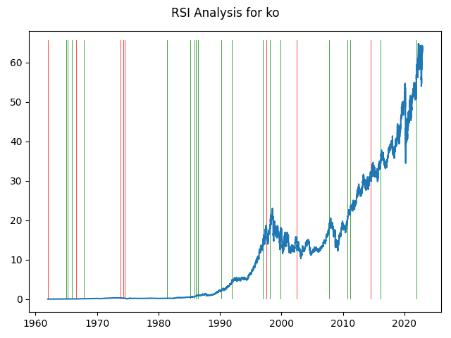

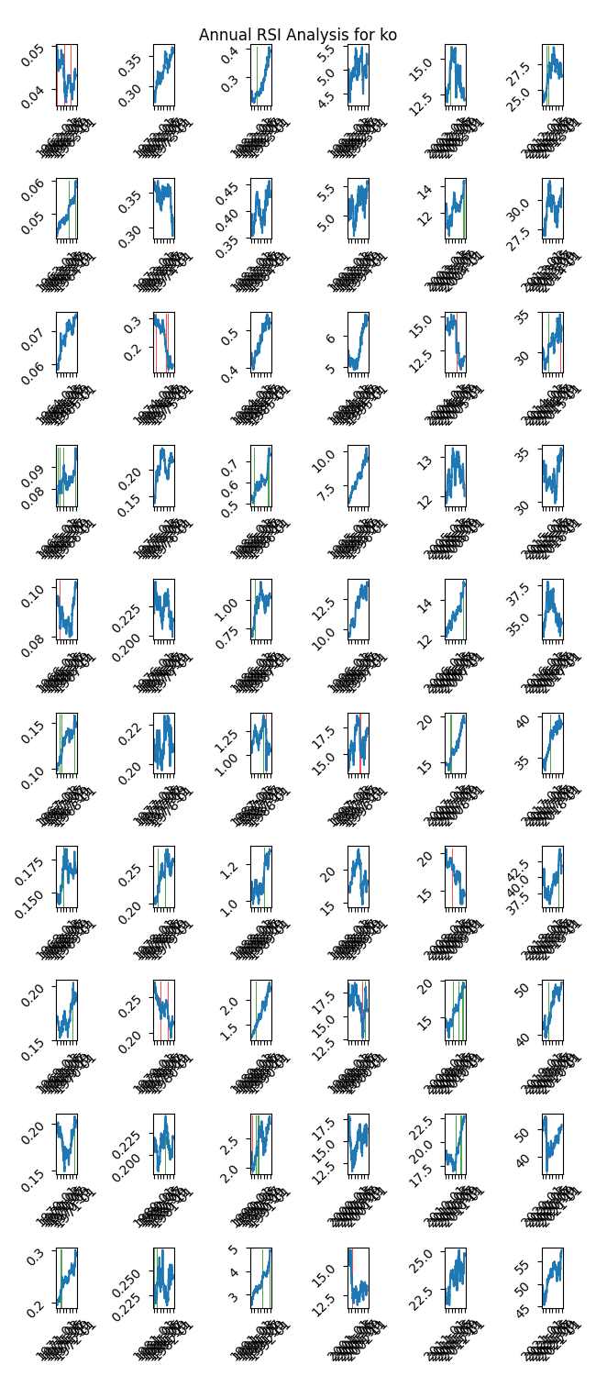

|  |  |  |  |  |  |  |
| --- | --- | --- | --- | --- | --- | --- |
| Timeframe | -1_min | -1_mean | -1_max | 1_min | 1_mean | 1_max |
| 1-day | -3.24 | 0.03 | 2.21 | -1.35 | -0.01 | 0.87 |
| 3-day | -3.15 | 0.09 | 6.18 | -2.3 | -0.01 | 1.26 |
| 7-day | -8.44 | 0.06 | 5.46 | -3.71 | -0.03 | 1.54 |
| 14-day | -10.28 | 0.17 | 9.83 | -11.81 | -0.08 | 2.35 |
| 21-day | -10.69 | 0.33 | 7.46 | -20.25 | -0.12 | 2.96 |
| 28-day | -7.29 | 0.41 | 7.38 | -19.76 | -0.16 | 2.8 |

## Looking at OBV

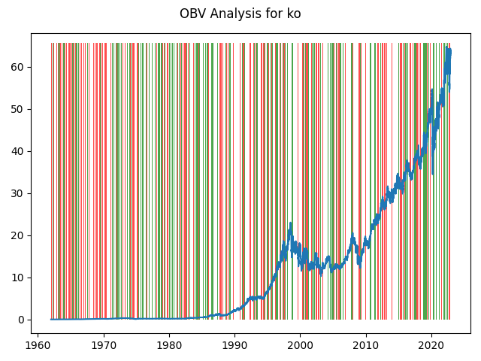

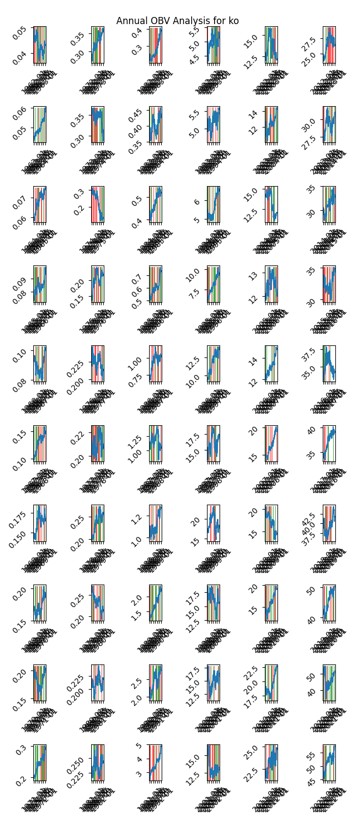

|  |  |  |  |  |  |  |
| --- | --- | --- | --- | --- | --- | --- |
| Timeframe | -1_min | -1_mean | -1_max | 1_min | 1_mean | 1_max |
| 1-day | -4.6 | 0.01 | 2.79 | -3.71 | 0.0 | 2.91 |
| 3-day | -6.7 | 0.02 | 6.18 | -8.16 | 0.01 | 4.24 |
| 7-day | -12.36 | 0.04 | 5.46 | -10.44 | 0.02 | 5.53 |
| 14-day | -13.44 | 0.08 | 9.83 | -17.41 | 0.04 | 8.7 |
| 21-day | -19.2 | 0.12 | 7.46 | -20.25 | 0.06 | 6.56 |
| 28-day | -19.76 | 0.15 | 8.92 | -19.22 | 0.09 | 8.54 |

## Looking at ADX

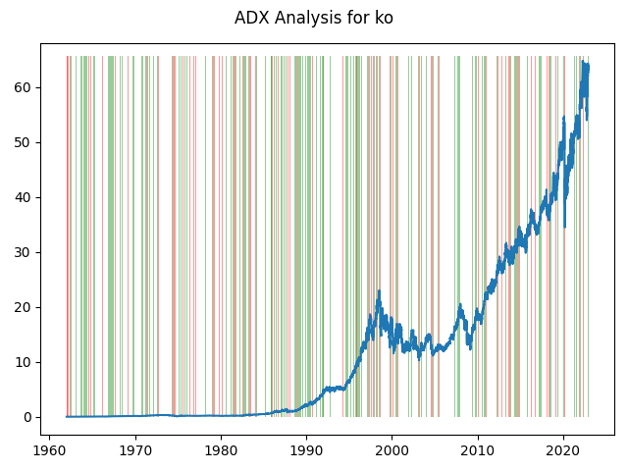

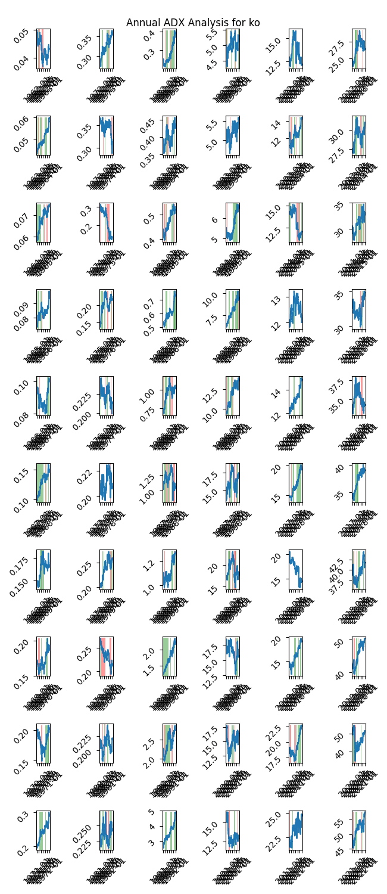

|  |  |  |  |  |  |  |  |  |  |  |  |  |
| --- | --- | --- | --- | --- | --- | --- | --- | --- | --- | --- | --- | --- |
| Timeframe | -2_min | -2_mean | -2_max | -1_min | -1_mean | -1_max | 1_min | 1_mean | 1_max | 2_min | 2_mean | 2_max |
| 1-day | -0.36 | 0.07 | 0.71 | -4.6 | 0.01 | 2.61 | -4.48 | 0.0 | 1.91 | -0.52 | -0.02 | 0.46 |
| 3-day | -0.26 | 0.23 | 1.73 | -8.16 | 0.03 | 6.18 | -5.83 | 0.0 | 1.98 | -1.74 | -0.09 | 0.46 |
| 7-day | -0.03 | 0.58 | 1.74 | -12.36 | 0.05 | 5.46 | -5.72 | 0.01 | 2.57 | -2.91 | -0.17 | 0.64 |
| 14-day | 0.0 | 1.15 | 3.14 | -17.41 | 0.14 | 9.83 | -11.81 | 0.03 | 3.52 | -3.07 | -0.19 | 1.34 |
| 21-day | 0.0 | 1.42 | 3.6 | -14.43 | 0.26 | 7.46 | -20.25 | 0.03 | 5.95 | -1.74 | -0.13 | 1.53 |
| 28-day | 0.0 | 1.77 | 4.27 | -12.39 | 0.33 | 8.92 | -19.76 | 0.04 | 5.59 | -1.25 | -0.04 | 1.44 |

# Analyzing the Analyst Agencies

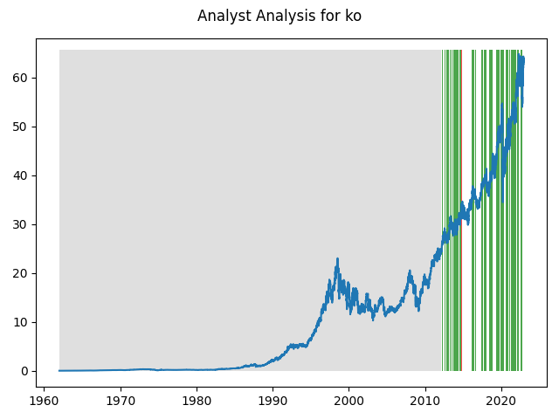

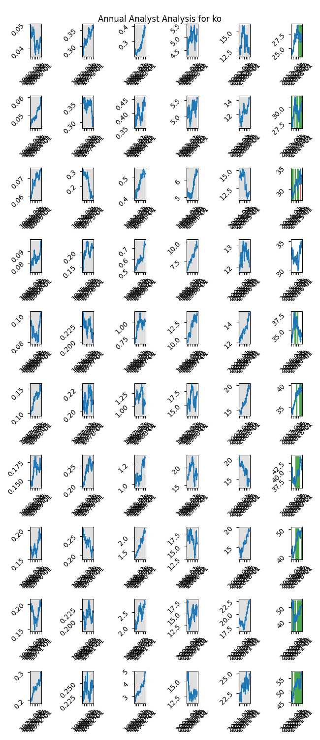

|  |  |  |  |  |  |  |
| --- | --- | --- | --- | --- | --- | --- |
| Timeframe | -1_min | -1_mean | -1_max | 1_min | 1_mean | 1_max |
| 1-day | -0.69 | 0.07 | 0.53 | -4.6 | 0.02 | 2.91 |
| 3-day | -0.89 | 0.15 | 1.14 | -8.16 | 0.04 | 6.18 |
| 7-day | -2.28 | 0.29 | 1.41 | -12.36 | 0.1 | 5.53 |
| 14-day | -2.89 | 0.38 | 2.17 | -17.41 | 0.23 | 9.83 |
| 21-day | -1.8 | 0.3 | 3.21 | -20.25 | 0.3 | 7.46 |
| 28-day | -1.59 | -0.03 | 3.25 | -19.76 | 0.35 | 8.54 |