Automatice Report for meta

# Analyzing the Headline Accuracy

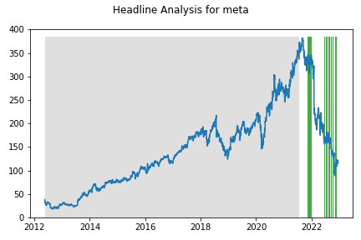

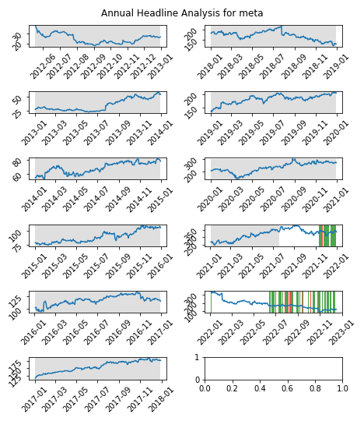

# A Little Bit More Insight Into the Headlines

The best headline was"Meta’s Version of the Metaverse Is a Joke. But This Emerging VR Tech Holds Great Promise" which occured on 2022-09-24 and had a Sentiment Score of 0.8807

The worst headline was"One dead in India unrest over military hiring, some gatherings banned" which occured on 2022-06-17 and had a Sentiment Score of -0.8074

|  |  |  |  |  |  |  |
| --- | --- | --- | --- | --- | --- | --- |
| Timeframe | -1_min | -1_mean | -1_max | 1_min | 1_mean | 1_max |
| 1-day | -31.88 | -0.81 | 10.43 | -15.83 | -0.56 | 13.15 |
| 3-day | -38.31 | -3.06 | 15.94 | -31.78 | -0.97 | 23.72 |
| 7-day | -48.6 | -7.27 | 25.31 | -39.18 | -1.67 | 26.9 |
| 14-day | -36.76 | -5.81 | 23.33 | -43.25 | -7.35 | 28.4 |
| 21-day | -50.07 | -11.79 | 33.52 | -98.77 | -10.24 | 32.95 |
| 28-day | -49.87 | -13.12 | 32.68 | -122.76 | -20.88 | 29.61 |

# Analyzing the Technical Indicators

## Looking at RSI

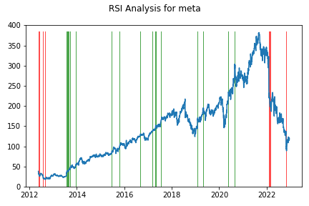

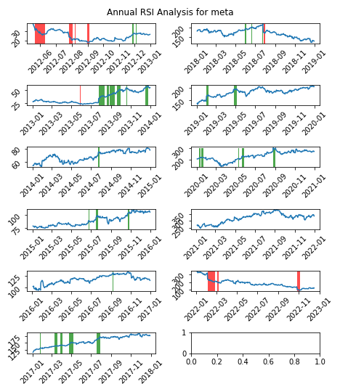

|  |  |  |  |  |  |  |
| --- | --- | --- | --- | --- | --- | --- |
| Timeframe | -1_min | -1_mean | -1_max | 1_min | 1_mean | 1_max |
| 1-day | -12.59 | 1.01 | 30.78 | -41.24 | -0.36 | 23.09 |
| 3-day | -17.58 | 0.58 | 36.18 | -46.44 | -1.12 | 12.84 |
| 7-day | -25.99 | 0.82 | 36.41 | -39.72 | -1.89 | 16.79 |
| 14-day | -42.79 | 0.53 | 38.22 | -53.48 | -1.73 | 24.78 |
| 21-day | -50.29 | 3.21 | 44.37 | -49.09 | -0.78 | 26.32 |
| 28-day | -47.46 | 4.16 | 44.06 | -46.34 | -1.29 | 25.61 |

## Looking at OBV

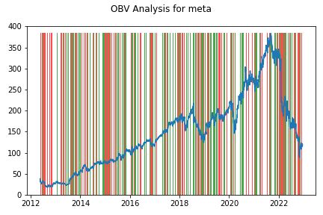

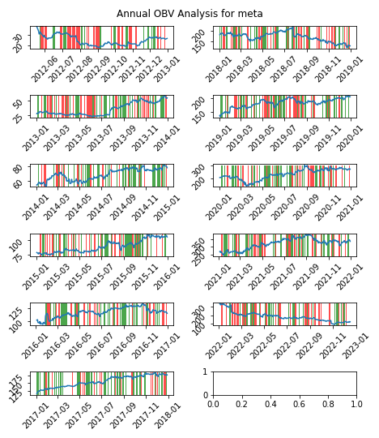

|  |  |  |  |  |  |  |
| --- | --- | --- | --- | --- | --- | --- |
| Timeframe | -1_min | -1_mean | -1_max | 1_min | 1_mean | 1_max |
| 1-day | -31.88 | 0.18 | 30.78 | -85.24 | -0.12 | 23.09 |
| 3-day | -36.66 | 0.53 | 36.9 | -98.09 | -0.33 | 28.13 |
| 7-day | -62.39 | 0.77 | 42.75 | -103.45 | -0.3 | 36.42 |
| 14-day | -93.24 | 1.01 | 42.38 | -124.55 | -0.1 | 41.86 |
| 21-day | -113.71 | 0.92 | 73.79 | -122.94 | 0.44 | 59.93 |
| 28-day | -134.81 | 1.35 | 71.79 | -132.37 | 0.49 | 61.88 |

## Looking at ADX

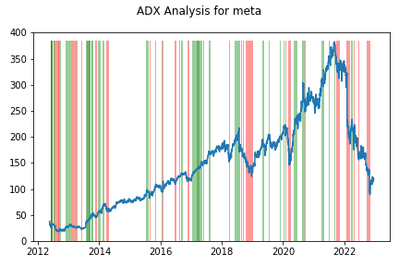

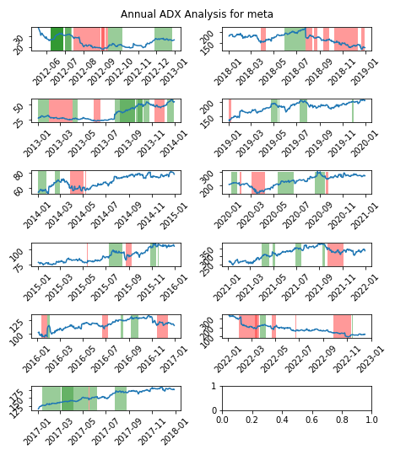

|  |  |  |  |  |  |  |  |  |  |  |  |  |
| --- | --- | --- | --- | --- | --- | --- | --- | --- | --- | --- | --- | --- |
| Timeframe | -2_min | -2_mean | -2_max | -1_min | -1_mean | -1_max | 1_min | 1_mean | 1_max | 2_min | 2_mean | 2_max |
| 1-day | -7.6 | 1.51 | 11.6 | -85.24 | -0.02 | 30.78 | -41.24 | -0.09 | 23.09 | -3.38 | 0.12 | 2.56 |
| 3-day | -3.18 | 7.69 | 24.46 | -98.09 | -0.43 | 36.18 | -46.44 | -0.5 | 36.9 | -4.27 | 0.33 | 3.47 |
| 7-day | 2.56 | 14.41 | 29.04 | -103.45 | -1.13 | 36.42 | -39.72 | -1.06 | 31.11 | -4.1 | 0.99 | 6.95 |
| 14-day | 1.66 | 20.77 | 41.86 | -124.55 | -1.29 | 35.89 | -53.48 | -1.83 | 29.52 | -9.26 | 2.68 | 8.53 |
| 21-day | 1.95 | 14.07 | 28.85 | -122.94 | -0.5 | 52.89 | -53.24 | -2.06 | 37.99 | -11.45 | 3.65 | 10.75 |
| 28-day | -22.68 | -2.18 | 5.21 | -132.37 | 1.15 | 56.6 | -51.92 | -1.29 | 56.74 | -12.42 | 5.06 | 13.95 |

# Analyzing the Analyst Agencies

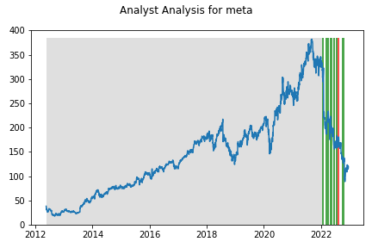

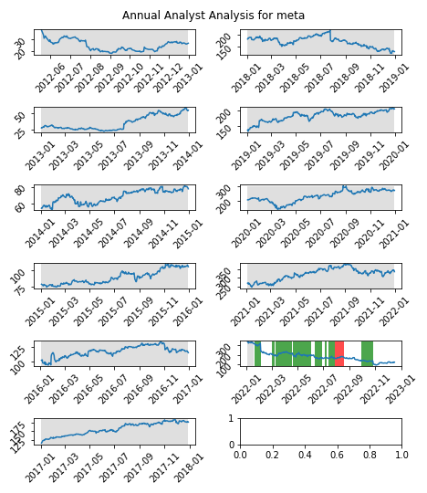

|  |  |  |  |  |  |  |
| --- | --- | --- | --- | --- | --- | --- |
| Timeframe | -1_min | -1_mean | -1_max | 1_min | 1_mean | 1_max |
| 1-day | -6.7 | 0.59 | 9.81 | -85.24 | -1.05 | 30.78 |
| 3-day | -13.55 | 0.86 | 11.97 | -98.09 | -3.25 | 36.18 |
| 7-day | -19.39 | -0.72 | 18.41 | -103.45 | -8.32 | 36.42 |
| 14-day | -21.18 | -8.28 | 15.56 | -124.55 | -15.16 | 41.86 |
| 21-day | -29.92 | -13.21 | 2.74 | -122.94 | -20.62 | 44.37 |
| 28-day | -43.1 | -22.55 | 9.22 | -132.37 | -24.08 | 22.71 |