Automatice Report for mmm

# Analyzing the Headline Accuracy

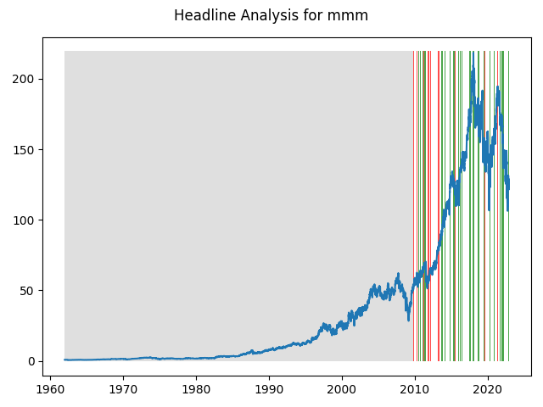

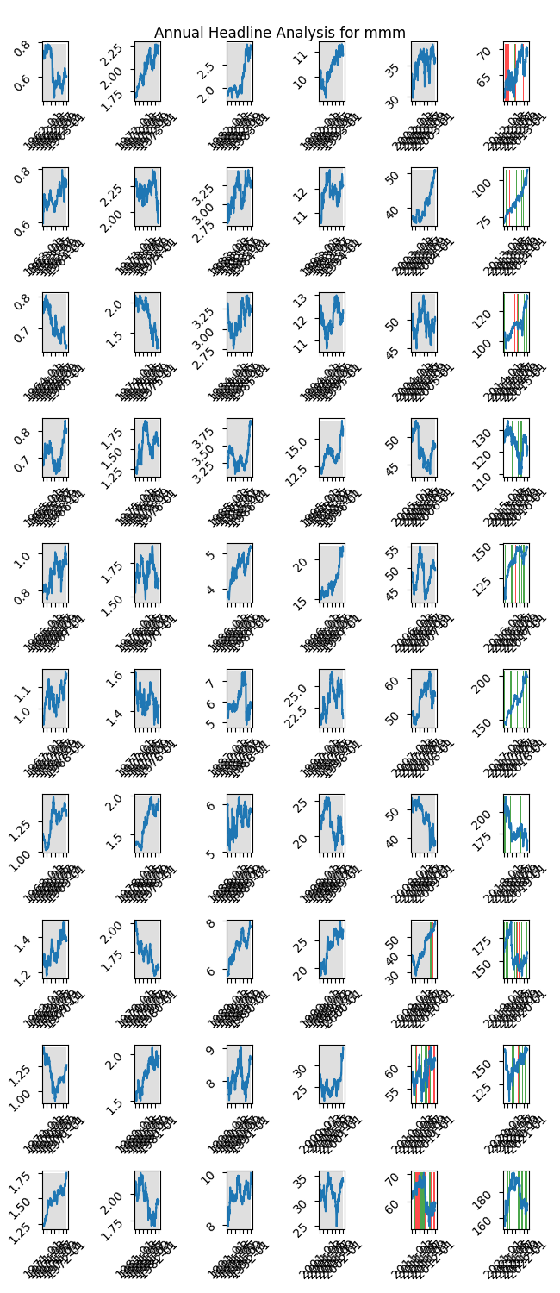

# A Little Bit More Insight Into the Headlines

The best headline was"Say Congratulations with a Gift That Keeps on GROWING: 5 Great DRIPs to Buy" which occured on 2017-05-24 and had a Sentiment Score of 0.9236

The worst headline was"Can Weak Organic Sales & Cost Woes Hurt 3M's (MMM) Q4 Earnings?" which occured on 2019-01-25 and had a Sentiment Score of -0.8481

|  |  |  |  |  |  |  |
| --- | --- | --- | --- | --- | --- | --- |
| Timeframe | -1_min | -1_mean | -1_max | 1_min | 1_mean | 1_max |
| 1-day | -10.52 | 0.07 | 9.57 | -13.46 | 0.07 | 13.43 |
| 3-day | -16.1 | 0.31 | 11.21 | -24.29 | 0.06 | 16.56 |
| 7-day | -24.2 | 0.48 | 19.02 | -28.35 | 0.3 | 19.62 |
| 14-day | -25.62 | 0.89 | 27.48 | -37.27 | 0.22 | 25.81 |
| 21-day | -28.22 | 0.75 | 21.08 | -44.74 | 0.41 | 23.41 |
| 28-day | -30.59 | 0.74 | 19.77 | -50.14 | 0.51 | 27.8 |

# Analyzing the Technical Indicators

## Looking at RSI

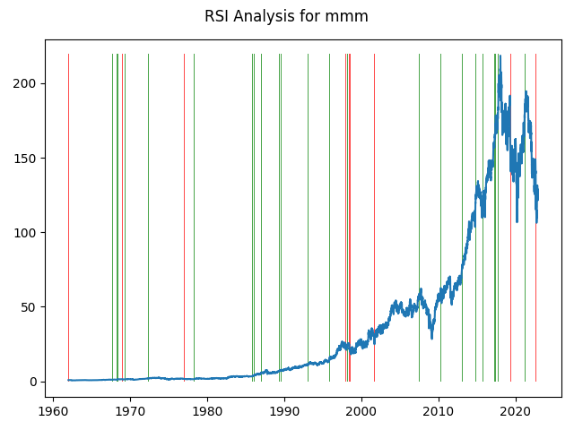

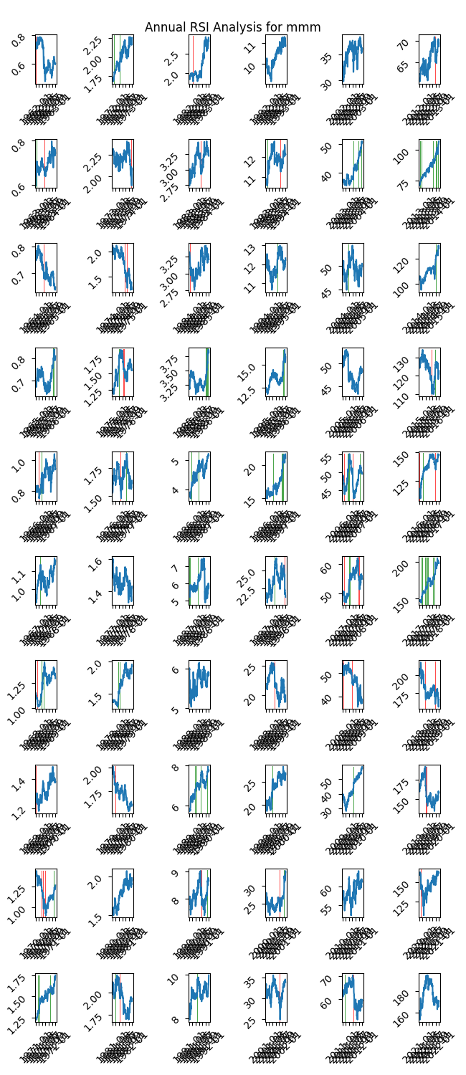

|  |  |  |  |  |  |  |
| --- | --- | --- | --- | --- | --- | --- |
| Timeframe | -1_min | -1_mean | -1_max | 1_min | 1_mean | 1_max |
| 1-day | -5.33 | 0.02 | 6.63 | -4.46 | 0.02 | 11.01 |
| 3-day | -7.96 | 0.01 | 9.32 | -13.24 | -0.01 | 13.75 |
| 7-day | -12.43 | 0.12 | 13.35 | -21.12 | 0.04 | 15.94 |
| 14-day | -20.31 | 0.04 | 19.99 | -27.91 | 0.02 | 17.91 |
| 21-day | -24.06 | 0.41 | 20.91 | -31.99 | 0.03 | 13.32 |
| 28-day | -22.54 | 0.86 | 21.28 | -36.47 | 0.19 | 20.45 |

## Looking at OBV

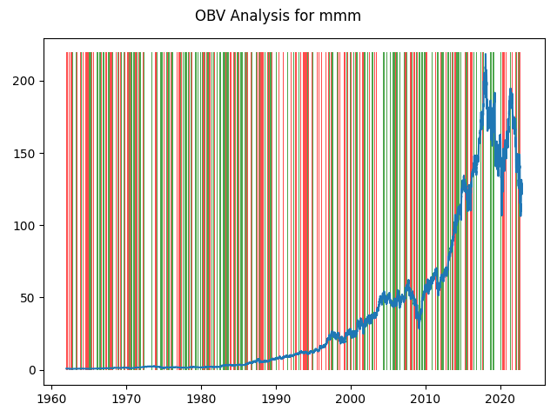

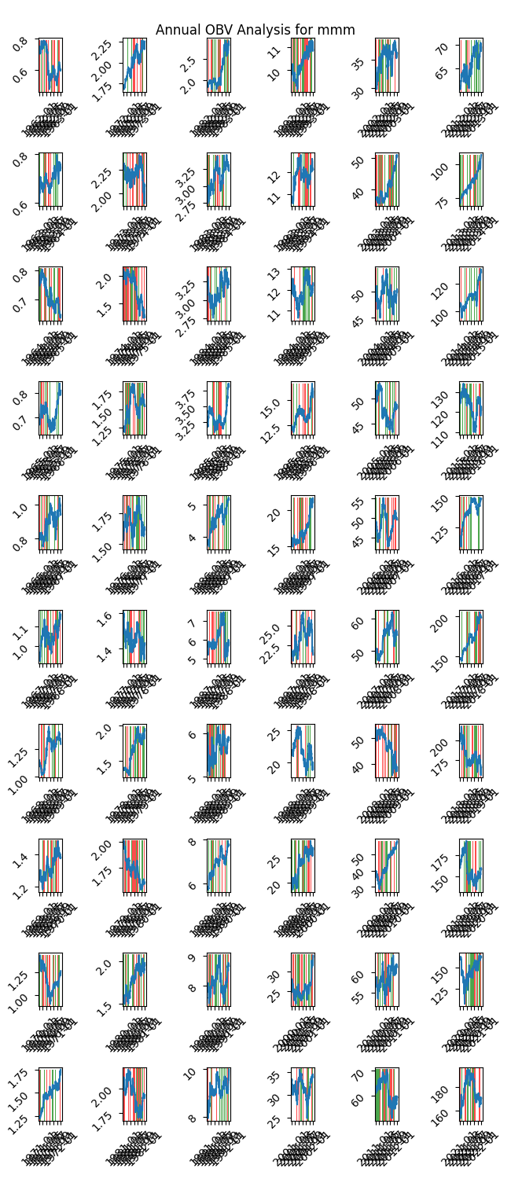

|  |  |  |  |  |  |  |
| --- | --- | --- | --- | --- | --- | --- |
| Timeframe | -1_min | -1_mean | -1_max | 1_min | 1_mean | 1_max |
| 1-day | -24.76 | 0.01 | 13.43 | -13.46 | 0.01 | 11.01 |
| 3-day | -25.21 | 0.03 | 16.56 | -24.3 | 0.02 | 13.75 |
| 7-day | -29.57 | 0.07 | 19.62 | -30.34 | 0.05 | 19.02 |
| 14-day | -38.31 | 0.15 | 25.81 | -39.67 | 0.1 | 27.48 |
| 21-day | -45.22 | 0.23 | 23.35 | -45.96 | 0.13 | 22.4 |
| 28-day | -50.14 | 0.33 | 27.8 | -50.73 | 0.16 | 21.74 |

## Looking at ADX

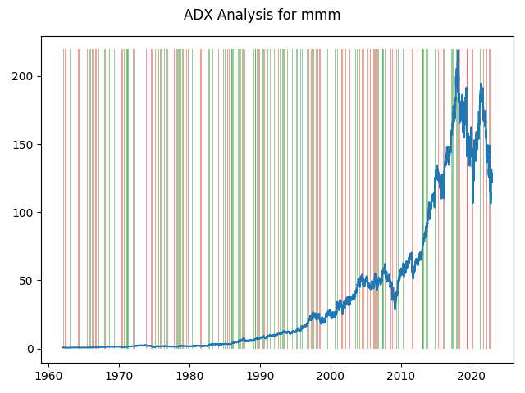

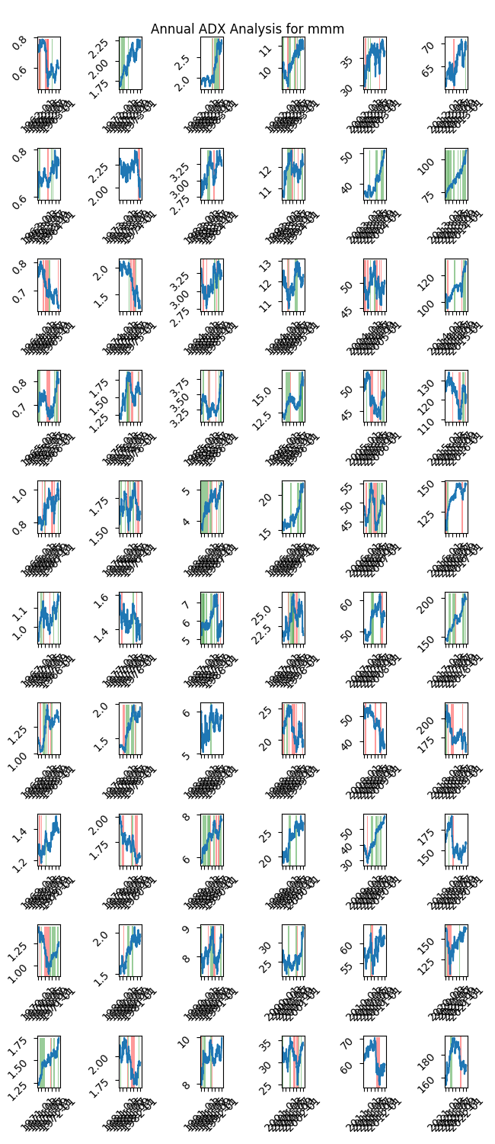

|  |  |  |  |  |  |  |  |  |  |  |  |  |
| --- | --- | --- | --- | --- | --- | --- | --- | --- | --- | --- | --- | --- |
| Timeframe | -2_min | -2_mean | -2_max | -1_min | -1_mean | -1_max | 1_min | 1_mean | 1_max | 2_min | 2_mean | 2_max |
| 1-day | -0.73 | 0.16 | 3.74 | -12.36 | 0.03 | 13.43 | -24.76 | -0.01 | 11.01 | -4.46 | -0.09 | 0.99 |
| 3-day | -0.05 | 0.51 | 4.12 | -17.32 | 0.06 | 16.56 | -25.21 | 0.0 | 13.75 | -5.39 | -0.17 | 1.69 |
| 7-day | -0.06 | 1.04 | 8.07 | -20.79 | 0.16 | 13.81 | -29.57 | 0.02 | 10.82 | -8.75 | -0.26 | 2.19 |
| 14-day | -0.02 | 1.48 | 12.5 | -25.44 | 0.26 | 25.81 | -38.31 | 0.05 | 17.73 | -31.76 | -0.49 | 3.5 |
| 21-day | -0.01 | 1.64 | 13.0 | -35.33 | 0.47 | 23.41 | -45.22 | 0.1 | 19.58 | -31.99 | -0.49 | 5.15 |
| 28-day | -0.01 | 1.12 | 11.71 | -39.01 | 0.63 | 27.8 | -46.62 | 0.14 | 19.37 | -36.47 | -0.47 | 7.75 |

# Analyzing the Analyst Agencies

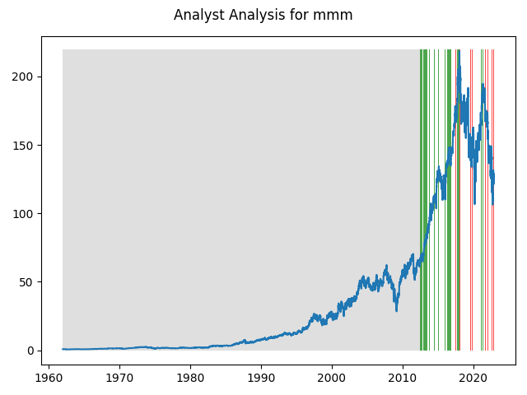

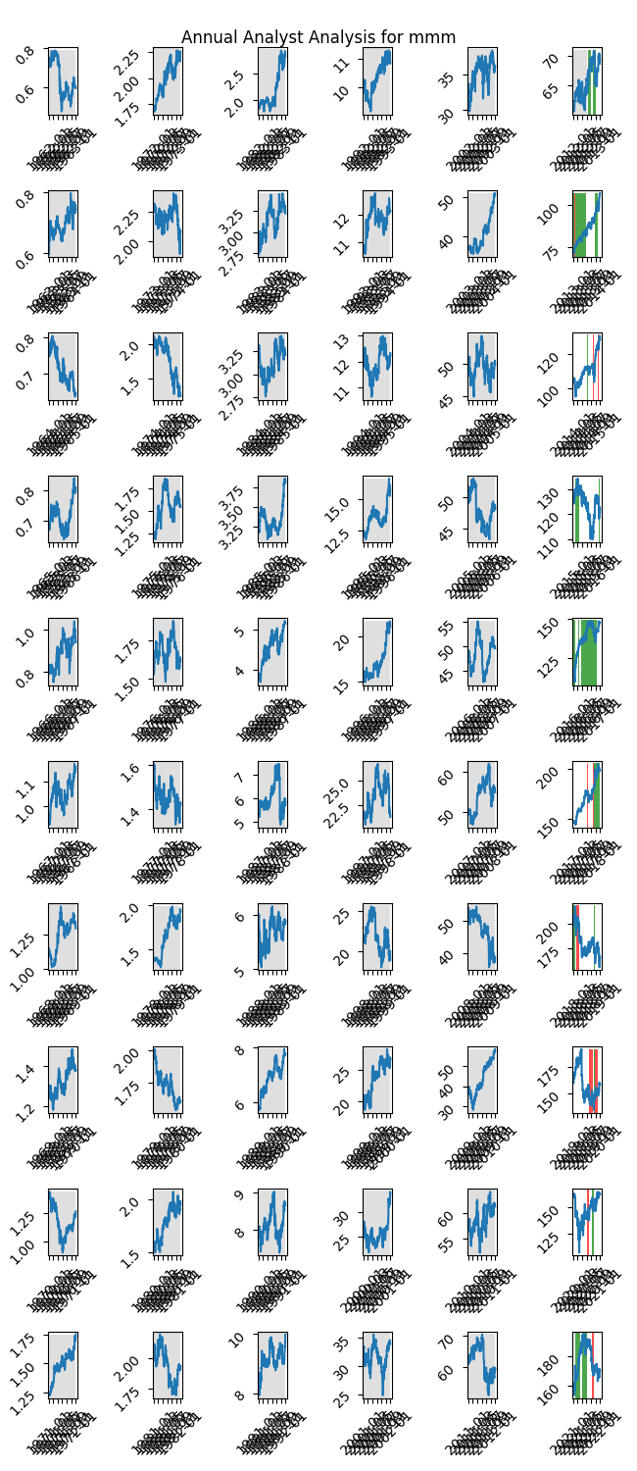

|  |  |  |  |  |  |  |
| --- | --- | --- | --- | --- | --- | --- |
| Timeframe | -1_min | -1_mean | -1_max | 1_min | 1_mean | 1_max |
| 1-day | -13.46 | -0.12 | 6.6 | -7.59 | 0.07 | 11.01 |
| 3-day | -17.69 | -0.5 | 10.16 | -14.1 | 0.27 | 13.75 |
| 7-day | -25.86 | -1.12 | 12.11 | -15.49 | 0.73 | 15.94 |
| 14-day | -31.76 | -1.72 | 17.93 | -21.37 | 1.5 | 15.26 |
| 21-day | -31.99 | -1.69 | 22.4 | -15.54 | 2.15 | 19.58 |
| 28-day | -36.47 | -2.3 | 20.97 | -13.42 | 2.94 | 20.24 |