Automatice Report for msft

# Analyzing the Headline Accuracy

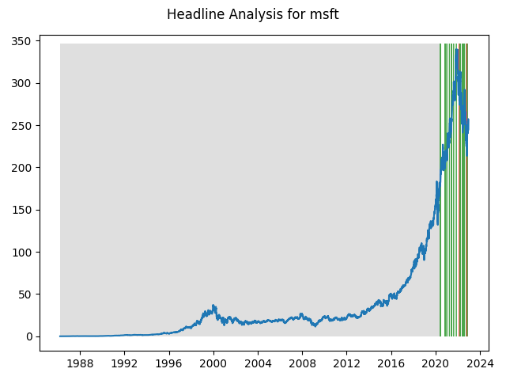

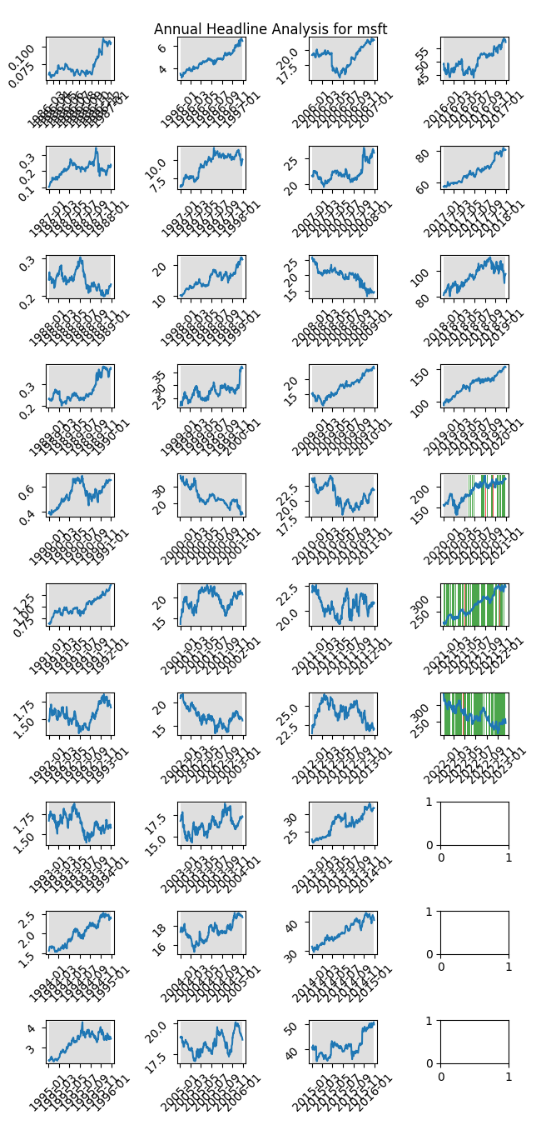

# A Little Bit More Insight Into the Headlines

The best headline was"Microsoft Goes From Strength to Strength, Based on Its Powerful Free Cash Flow" which occured on 2021-05-27 and had a Sentiment Score of 0.91

The worst headline was"TikTok says it has 'no choice' but to sue Trump administration over threatened U.S. ban" which occured on 2020-08-24 and had a Sentiment Score of -0.8885

|  |  |  |  |  |  |  |
| --- | --- | --- | --- | --- | --- | --- |
| Timeframe | -1_min | -1_mean | -1_max | 1_min | 1_mean | 1_max |
| 1-day | -14.06 | -0.05 | 9.76 | -19.29 | 0.11 | 16.76 |
| 3-day | -28.41 | 0.3 | 16.94 | -28.01 | 0.24 | 28.7 |
| 7-day | -27.07 | 1.13 | 23.7 | -36.31 | 0.53 | 31.59 |
| 14-day | -37.37 | 3.26 | 29.17 | -40.37 | 0.82 | 41.37 |
| 21-day | -43.58 | 4.16 | 41.67 | -46.58 | 1.4 | 49.47 |
| 28-day | -48.51 | 6.41 | 44.39 | -54.77 | 1.73 | 53.43 |

# Analyzing the Technical Indicators

## Looking at RSI

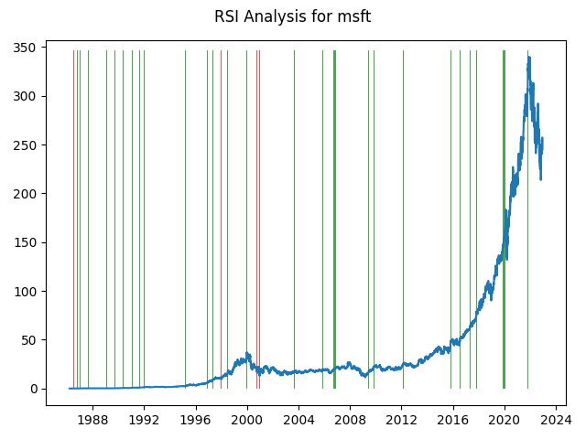

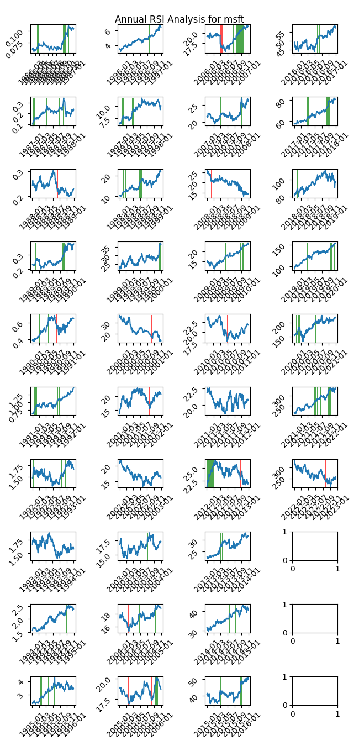

|  |  |  |  |  |  |  |
| --- | --- | --- | --- | --- | --- | --- |
| Timeframe | -1_min | -1_mean | -1_max | 1_min | 1_mean | 1_max |
| 1-day | -3.49 | 0.23 | 8.14 | -14.06 | -0.03 | 7.51 |
| 3-day | -4.52 | 0.41 | 19.59 | -28.41 | -0.0 | 8.99 |
| 7-day | -7.85 | 0.4 | 12.64 | -27.82 | 0.04 | 15.48 |
| 14-day | -15.76 | 0.27 | 10.42 | -35.19 | 0.1 | 21.58 |
| 21-day | -5.95 | 0.81 | 13.17 | -45.15 | 0.1 | 25.87 |
| 28-day | -24.62 | 0.31 | 12.54 | -49.56 | 0.32 | 24.27 |

## Looking at OBV

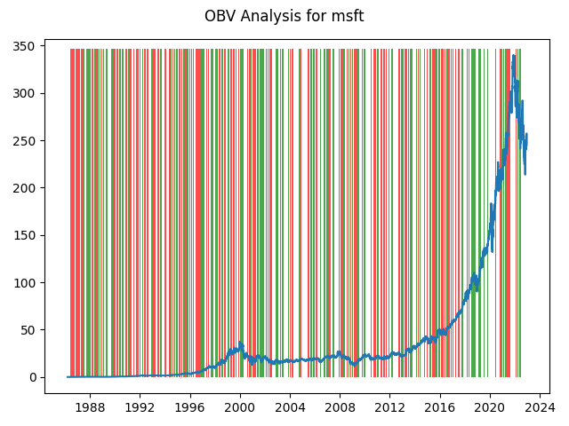

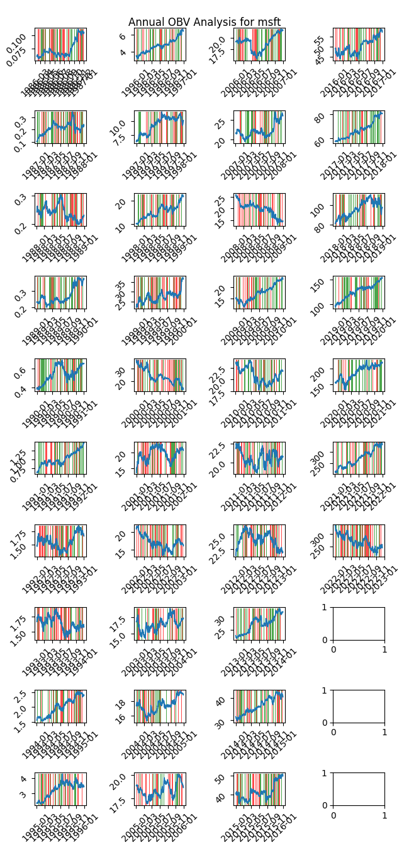

|  |  |  |  |  |  |  |
| --- | --- | --- | --- | --- | --- | --- |
| Timeframe | -1_min | -1_mean | -1_max | 1_min | 1_mean | 1_max |
| 1-day | -14.2 | 0.07 | 19.27 | -22.82 | -0.02 | 12.92 |
| 3-day | -28.01 | 0.15 | 28.7 | -28.41 | 0.01 | 21.27 |
| 7-day | -30.83 | 0.29 | 31.59 | -36.31 | 0.08 | 26.04 |
| 14-day | -40.37 | 0.47 | 41.37 | -38.26 | 0.29 | 36.41 |
| 21-day | -46.59 | 0.66 | 50.33 | -45.77 | 0.48 | 47.15 |
| 28-day | -54.76 | 0.87 | 53.02 | -54.77 | 0.66 | 51.37 |

## Looking at ADX

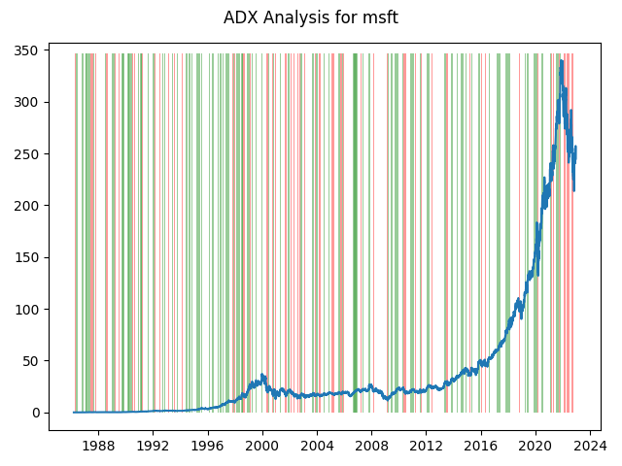

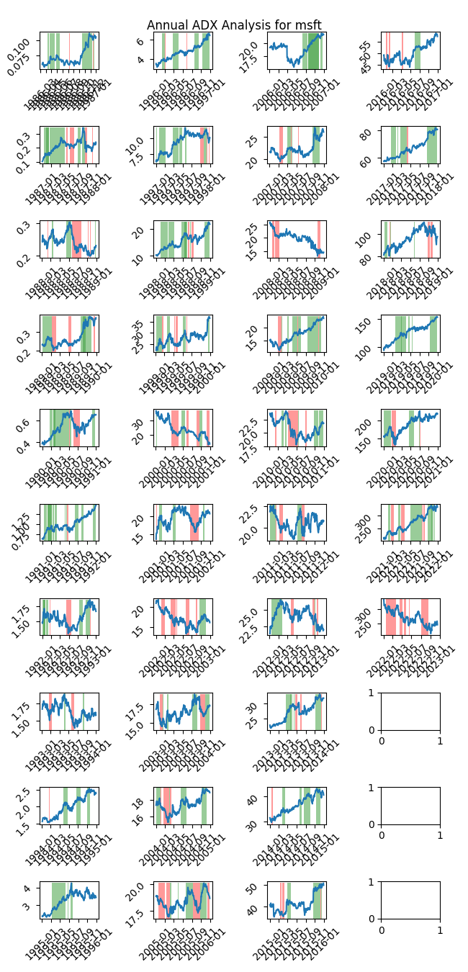

|  |  |  |  |  |  |  |  |  |  |  |  |  |
| --- | --- | --- | --- | --- | --- | --- | --- | --- | --- | --- | --- | --- |
| Timeframe | -2_min | -2_mean | -2_max | -1_min | -1_mean | -1_max | 1_min | 1_mean | 1_max | 2_min | 2_mean | 2_max |
| 1-day | 0.0 | 0.0 | 0.0 | -22.82 | 0.06 | 19.27 | -14.06 | 0.03 | 9.35 | -8.15 | -0.14 | 2.59 |
| 3-day | 0.0 | 0.0 | 0.0 | -25.22 | 0.09 | 19.62 | -28.41 | 0.08 | 13.77 | -10.06 | -0.24 | 0.66 |
| 7-day | 0.01 | 0.01 | 0.01 | -30.07 | 0.1 | 23.82 | -27.82 | 0.16 | 17.76 | -14.53 | -0.52 | 0.82 |
| 14-day | 0.01 | 0.01 | 0.01 | -34.71 | 0.09 | 34.6 | -38.54 | 0.16 | 22.43 | -9.25 | -0.1 | 2.56 |
| 21-day | 0.01 | 0.01 | 0.01 | -41.12 | 0.62 | 49.47 | -46.59 | 0.22 | 25.87 | -15.67 | -0.12 | 4.5 |
| 28-day | 0.01 | 0.01 | 0.01 | -44.6 | 1.3 | 53.43 | -49.56 | 0.37 | 30.24 | -21.33 | 0.06 | 5.55 |

# Analyzing the Analyst Agencies

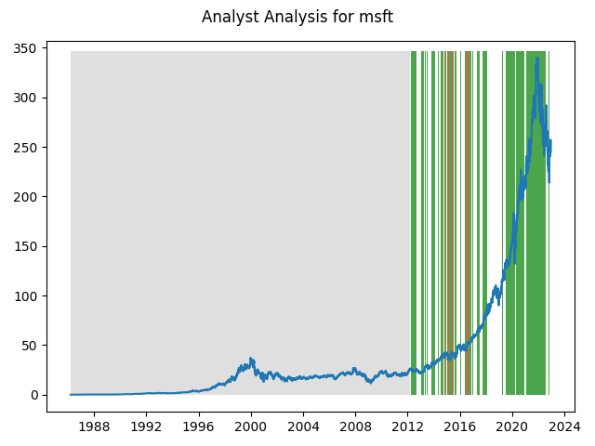

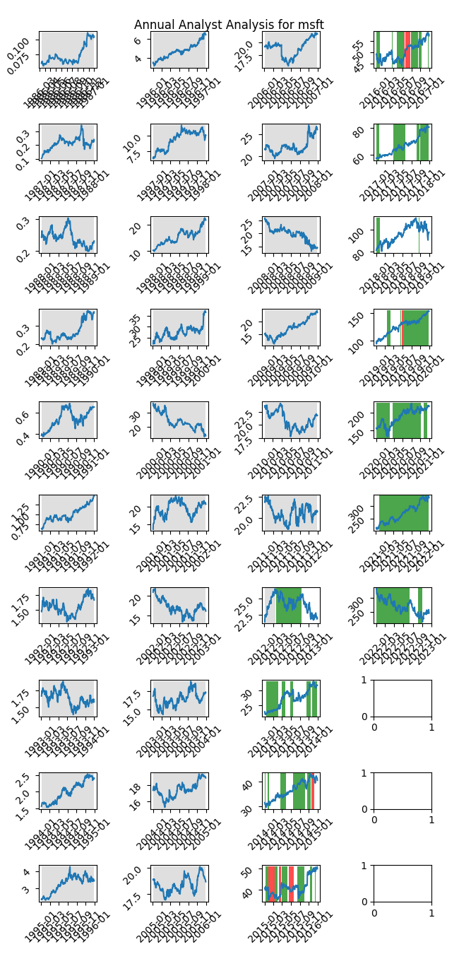

|  |  |  |  |  |  |  |
| --- | --- | --- | --- | --- | --- | --- |
| Timeframe | -1_min | -1_mean | -1_max | 1_min | 1_mean | 1_max |
| 1-day | -1.54 | 0.09 | 3.98 | -22.82 | 0.09 | 19.27 |
| 3-day | -1.75 | 0.32 | 5.12 | -28.41 | 0.26 | 28.7 |
| 7-day | -2.85 | 0.61 | 6.63 | -36.31 | 0.69 | 31.59 |
| 14-day | -2.5 | 0.81 | 4.69 | -40.37 | 1.4 | 41.37 |
| 21-day | -4.68 | 0.73 | 7.16 | -46.59 | 2.08 | 49.47 |
| 28-day | -5.24 | 0.29 | 5.84 | -53.68 | 2.93 | 53.43 |