Automatice Report for nee

# Analyzing the Headline Accuracy

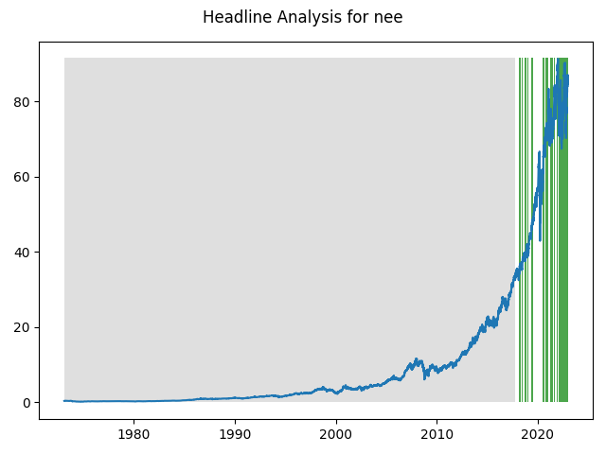

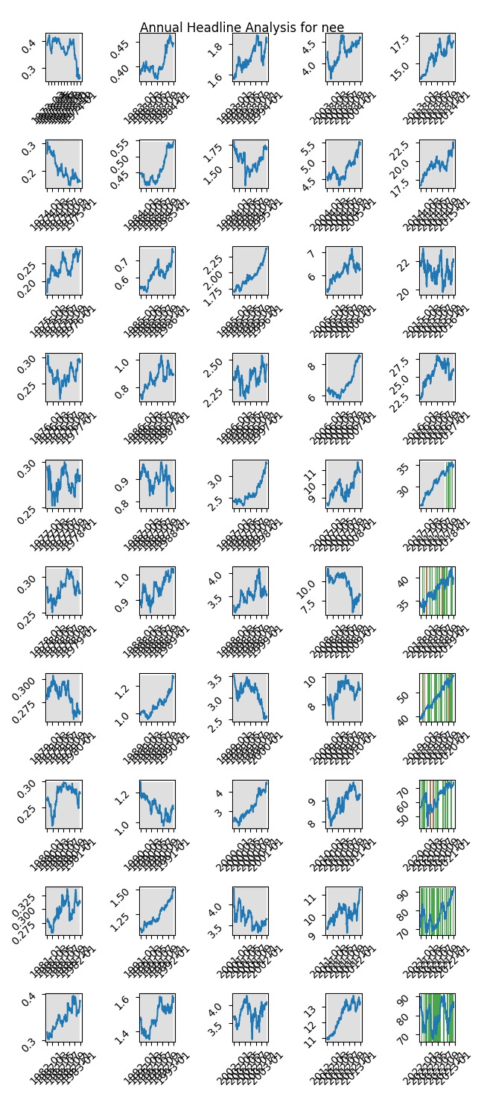

# A Little Bit More Insight Into the Headlines

The best headline was"The Top 5 Best TVs for Your Super Bowl Party" which occured on 2018-01-29 and had a Sentiment Score of 0.9118

The worst headline was"An AI-Powered ETF Failed Miserably at Beating the Market in 2018 -- Here's What You Can Learn From Its Mistakes" which occured on 2019-01-06 and had a Sentiment Score of -0.8979

|  |  |  |  |  |  |  |
| --- | --- | --- | --- | --- | --- | --- |
| Timeframe | -1_min | -1_mean | -1_max | 1_min | 1_mean | 1_max |
| 1-day | -3.63 | -0.03 | 4.82 | -7.65 | 0.04 | 5.88 |
| 3-day | -8.08 | 0.03 | 3.85 | -12.39 | 0.13 | 11.69 |
| 7-day | -17.68 | 0.2 | 9.2 | -14.34 | 0.3 | 11.55 |
| 14-day | -15.9 | 0.48 | 10.3 | -19.74 | 0.56 | 12.9 |
| 21-day | -22.34 | 0.95 | 10.78 | -19.82 | 0.79 | 15.49 |
| 28-day | -20.07 | 0.93 | 12.29 | -21.06 | 1.16 | 14.42 |

# Analyzing the Technical Indicators

## Looking at RSI

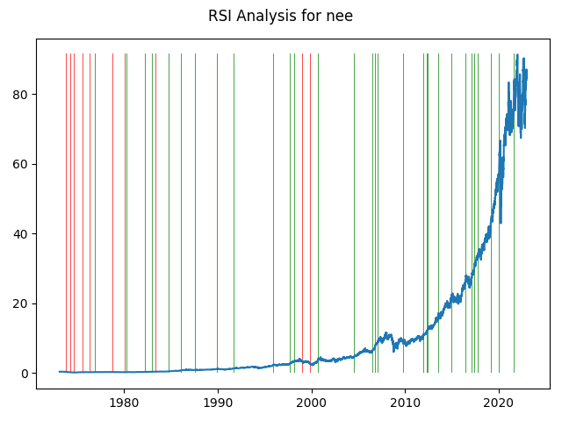

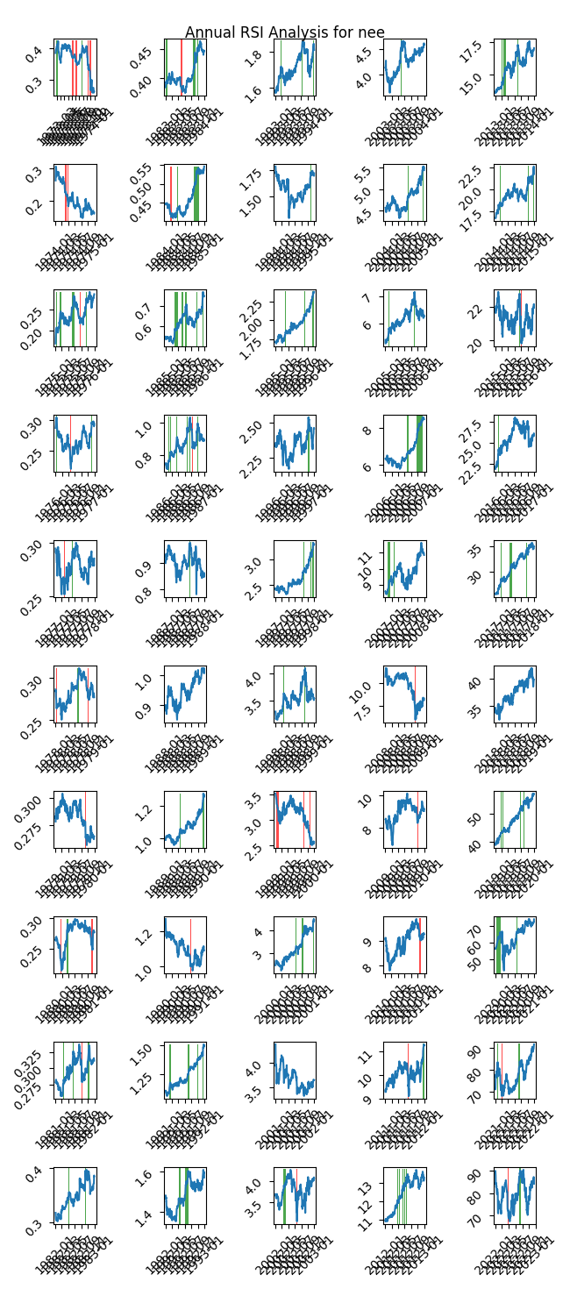

|  |  |  |  |  |  |  |
| --- | --- | --- | --- | --- | --- | --- |
| Timeframe | -1_min | -1_mean | -1_max | 1_min | 1_mean | 1_max |
| 1-day | -2.43 | 0.08 | 5.88 | -1.82 | 0.01 | 2.55 |
| 3-day | -3.35 | 0.14 | 11.69 | -4.23 | 0.02 | 2.83 |
| 7-day | -8.56 | 0.07 | 8.65 | -5.85 | 0.03 | 3.97 |
| 14-day | -5.89 | 0.21 | 12.9 | -13.38 | 0.04 | 4.14 |
| 21-day | -5.89 | 0.44 | 15.49 | -17.18 | -0.04 | 7.0 |
| 28-day | -2.87 | 0.63 | 13.51 | -21.06 | -0.23 | 5.67 |

## Looking at OBV

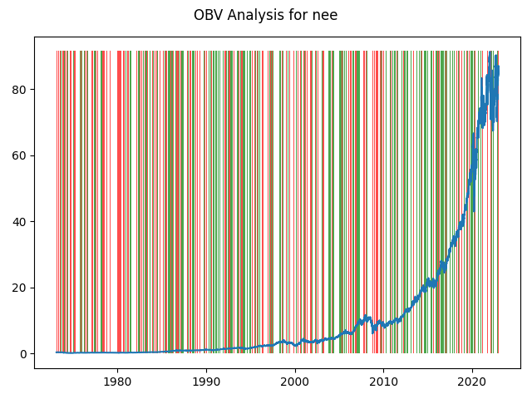

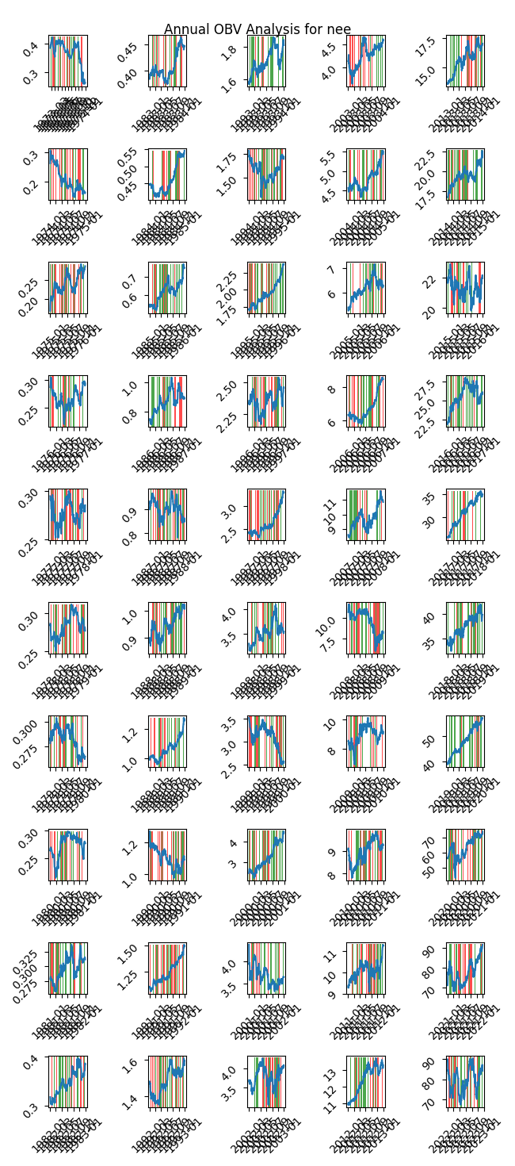

|  |  |  |  |  |  |  |
| --- | --- | --- | --- | --- | --- | --- |
| Timeframe | -1_min | -1_mean | -1_max | 1_min | 1_mean | 1_max |
| 1-day | -7.65 | 0.01 | 5.88 | -4.77 | 0.01 | 4.92 |
| 3-day | -12.39 | 0.02 | 11.69 | -8.23 | 0.02 | 8.45 |
| 7-day | -17.68 | 0.05 | 11.55 | -14.34 | 0.05 | 9.01 |
| 14-day | -19.74 | 0.1 | 12.9 | -18.11 | 0.1 | 11.49 |
| 21-day | -16.03 | 0.16 | 15.49 | -22.34 | 0.15 | 11.89 |
| 28-day | -18.05 | 0.23 | 14.42 | -21.06 | 0.19 | 13.54 |

## Looking at ADX

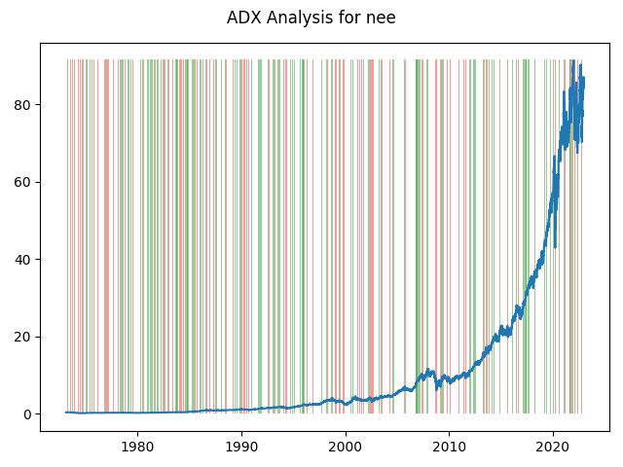

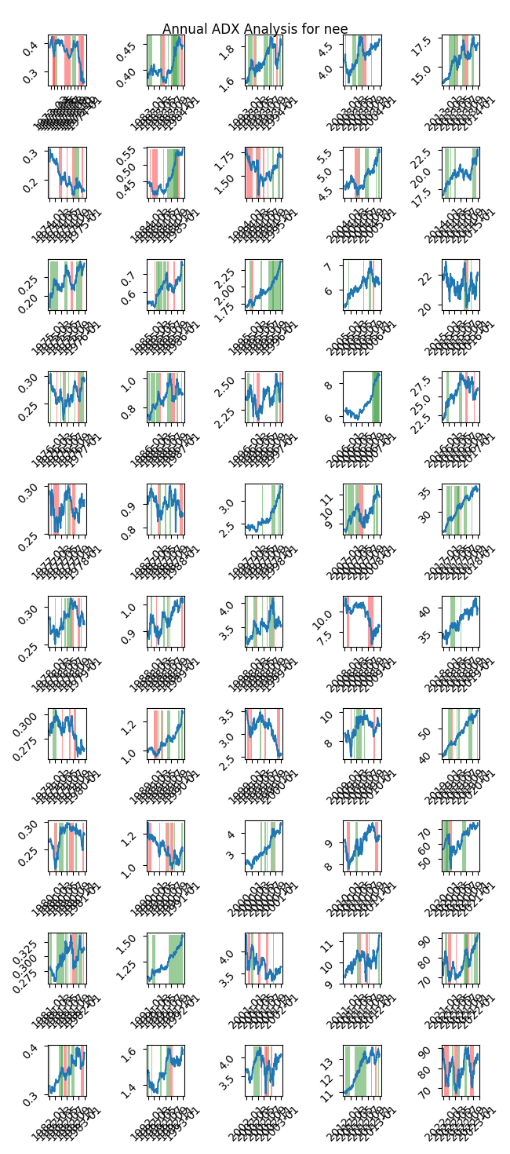

|  |  |  |  |  |  |  |  |  |  |  |  |  |
| --- | --- | --- | --- | --- | --- | --- | --- | --- | --- | --- | --- | --- |
| Timeframe | -2_min | -2_mean | -2_max | -1_min | -1_mean | -1_max | 1_min | 1_mean | 1_max | 2_min | 2_mean | 2_max |
| 1-day | -0.07 | 0.02 | 0.28 | -7.65 | 0.0 | 5.88 | -4.84 | -0.0 | 3.91 | -1.82 | -0.0 | 1.37 |
| 3-day | -0.18 | 0.04 | 0.38 | -12.39 | 0.0 | 11.69 | -6.02 | -0.01 | 3.98 | -2.92 | -0.01 | 2.77 |
| 7-day | -0.14 | 0.04 | 0.62 | -13.3 | 0.04 | 11.55 | -17.68 | -0.03 | 6.0 | -5.85 | -0.06 | 3.22 |
| 14-day | -0.18 | 0.07 | 0.71 | -19.74 | 0.18 | 12.9 | -17.9 | -0.06 | 6.8 | -15.9 | -0.4 | 3.16 |
| 21-day | -0.16 | 0.11 | 0.8 | -11.09 | 0.33 | 15.49 | -19.08 | -0.08 | 8.31 | -22.34 | -1.01 | 3.97 |
| 28-day | -0.35 | 0.07 | 0.75 | -12.5 | 0.46 | 14.42 | -20.07 | -0.13 | 10.26 | -21.06 | -1.17 | 1.09 |

# Analyzing the Analyst Agencies

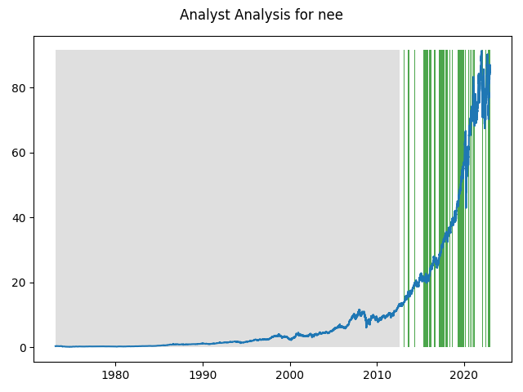

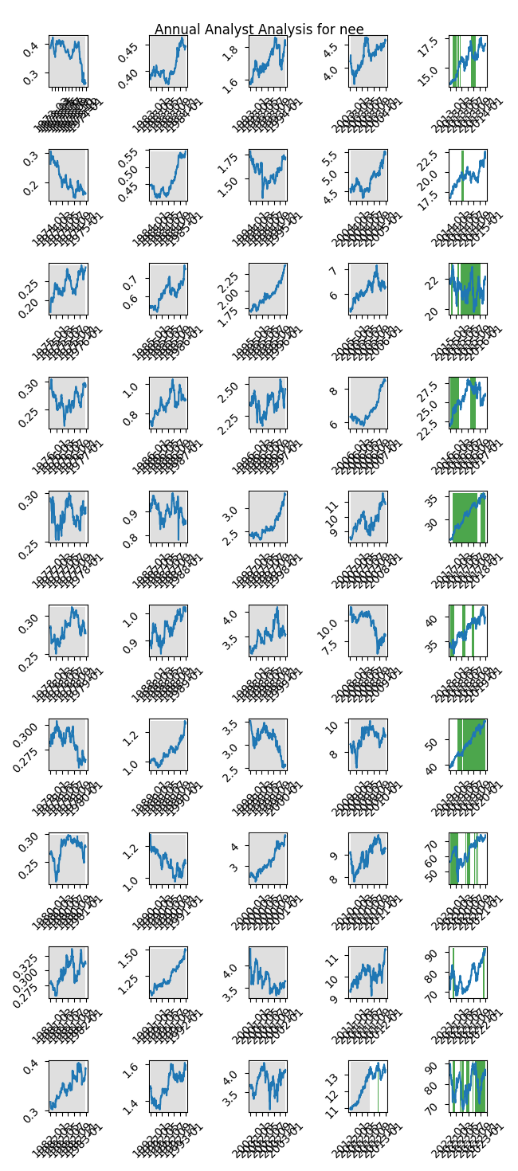

|  |  |  |  |  |  |  |
| --- | --- | --- | --- | --- | --- | --- |
| Timeframe | -1_min | -1_mean | -1_max | 1_min | 1_mean | 1_max |
| 1-day | nan | nan | nan | -7.65 | 0.02 | 5.88 |
| 3-day | nan | nan | nan | -12.39 | 0.04 | 11.69 |
| 7-day | nan | nan | nan | -17.68 | 0.1 | 11.55 |
| 14-day | nan | nan | nan | -19.74 | 0.29 | 12.9 |
| 21-day | nan | nan | nan | -22.34 | 0.61 | 15.49 |
| 28-day | nan | nan | nan | -21.06 | 0.93 | 14.42 |