Automatice Report for noc

# Analyzing the Headline Accuracy

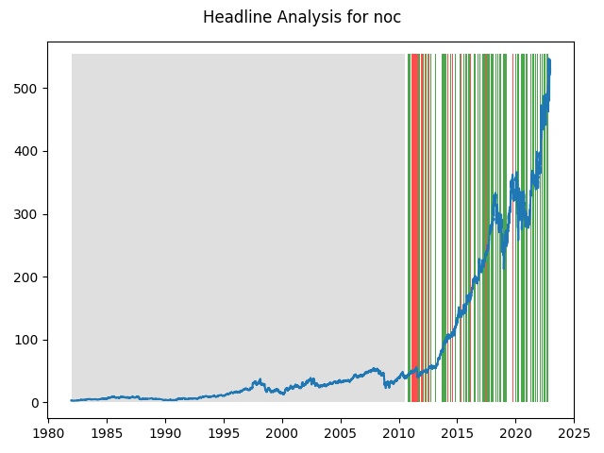

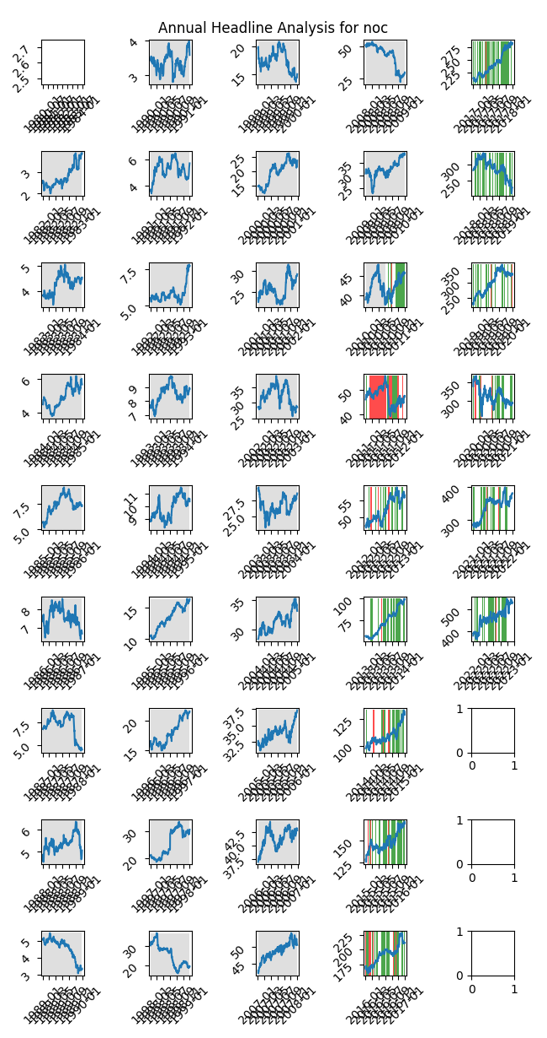

# A Little Bit More Insight Into the Headlines

The best headline was"The Best Ways To Profit From Greater Energy Efficiency" which occured on 2013-05-17 and had a Sentiment Score of 0.9217

The worst headline was"Embraer 4Q Hurt by AMR Bankruptcy - Analyst Blog" which occured on 2012-03-21 and had a Sentiment Score of -0.8494

|  |  |  |  |  |  |  |
| --- | --- | --- | --- | --- | --- | --- |
| Timeframe | -1_min | -1_mean | -1_max | 1_min | 1_mean | 1_max |
| 1-day | -30.5 | 0.08 | 35.11 | -37.13 | 0.29 | 32.13 |
| 3-day | -33.7 | 0.33 | 34.02 | -50.79 | 0.58 | 46.57 |
| 7-day | -52.96 | 0.4 | 33.16 | -52.02 | 1.4 | 63.03 |
| 14-day | -45.04 | 1.01 | 46.53 | -62.78 | 2.53 | 87.97 |
| 21-day | -80.35 | 1.42 | 68.91 | -72.83 | 4.05 | 104.52 |
| 28-day | -74.84 | 1.98 | 76.6 | -92.56 | 5.5 | 77.49 |

# Analyzing the Technical Indicators

## Looking at RSI

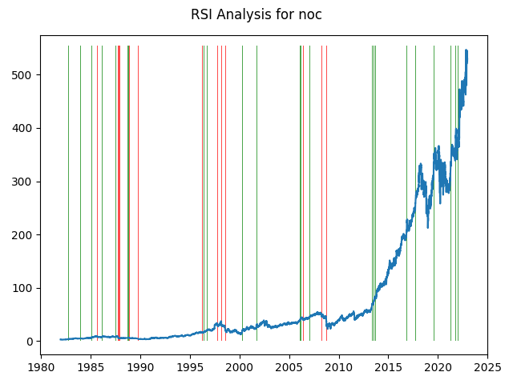

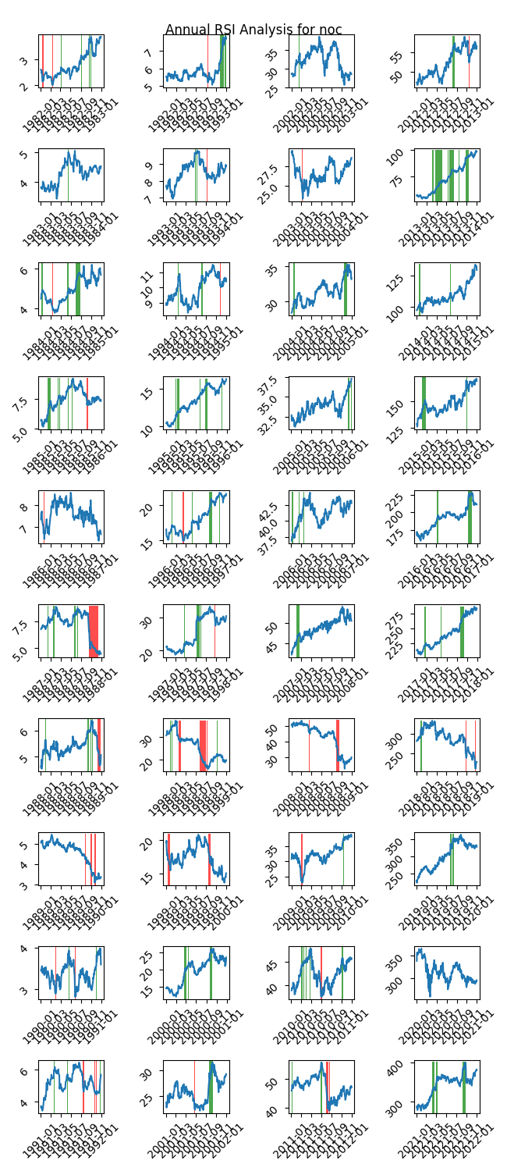

|  |  |  |  |  |  |  |
| --- | --- | --- | --- | --- | --- | --- |
| Timeframe | -1_min | -1_mean | -1_max | 1_min | 1_mean | 1_max |
| 1-day | -14.82 | 0.05 | 16.81 | -28.44 | 0.06 | 18.68 |
| 3-day | -27.58 | 0.21 | 24.89 | -47.08 | -0.04 | 24.3 |
| 7-day | -37.16 | 0.23 | 27.63 | -52.96 | -0.18 | 21.0 |
| 14-day | -56.89 | -0.18 | 30.66 | -46.09 | -0.12 | 27.89 |
| 21-day | -49.33 | -0.03 | 43.69 | -48.71 | -0.06 | 40.7 |
| 28-day | -32.53 | 0.35 | 48.96 | -54.25 | 0.21 | 39.36 |

## Looking at OBV

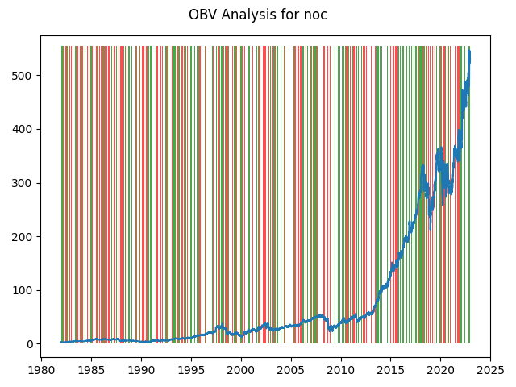

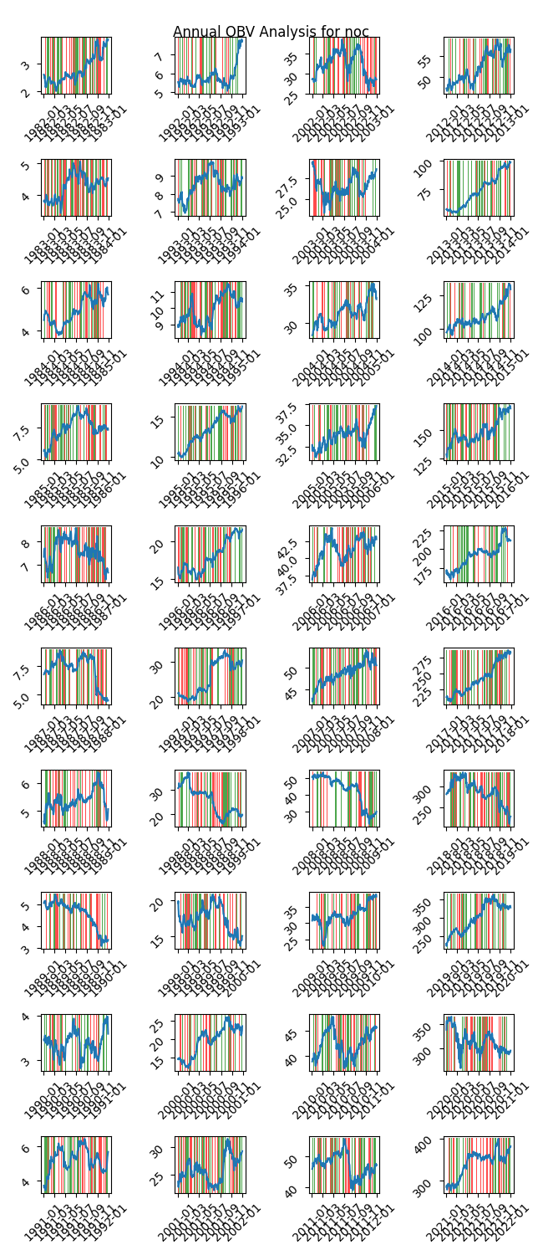

|  |  |  |  |  |  |  |
| --- | --- | --- | --- | --- | --- | --- |
| Timeframe | -1_min | -1_mean | -1_max | 1_min | 1_mean | 1_max |
| 1-day | -28.96 | 0.1 | 35.11 | -37.13 | 0.02 | 32.13 |
| 3-day | -38.61 | 0.26 | 56.99 | -50.79 | 0.07 | 61.53 |
| 7-day | -48.42 | 0.52 | 83.14 | -52.96 | 0.21 | 83.15 |
| 14-day | -56.89 | 0.81 | 87.97 | -71.21 | 0.66 | 77.47 |
| 21-day | -74.65 | 1.19 | 84.07 | -90.94 | 1.03 | 104.52 |
| 28-day | -81.35 | 1.52 | 76.6 | -92.56 | 1.44 | 77.49 |

## Looking at ADX

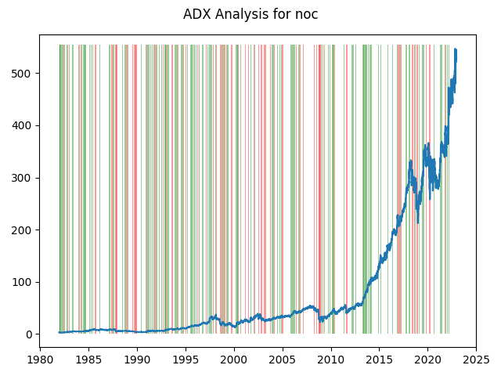

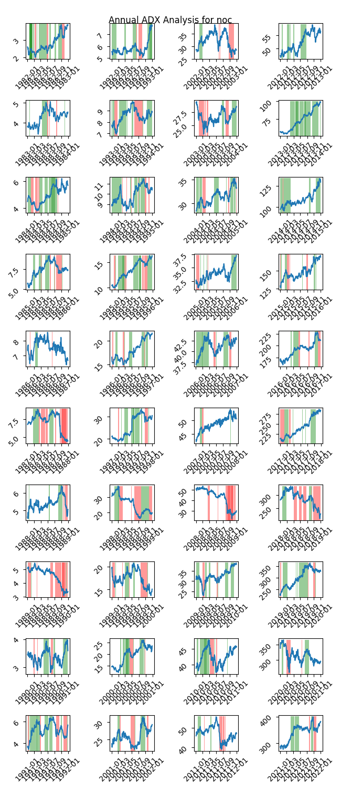

|  |  |  |  |  |  |  |  |  |  |  |  |  |
| --- | --- | --- | --- | --- | --- | --- | --- | --- | --- | --- | --- | --- |
| Timeframe | -2_min | -2_mean | -2_max | -1_min | -1_mean | -1_max | 1_min | 1_mean | 1_max | 2_min | 2_mean | 2_max |
| 1-day | -1.88 | 0.01 | 2.67 | -30.5 | 0.05 | 35.11 | -28.96 | 0.02 | 18.68 | -5.35 | -0.07 | 2.67 |
| 3-day | -3.58 | 0.08 | 3.44 | -50.79 | 0.18 | 49.06 | -47.08 | 0.05 | 29.8 | -3.64 | 0.03 | 3.22 |
| 7-day | -4.15 | 0.12 | 4.5 | -43.19 | 0.4 | 35.49 | -52.96 | 0.12 | 34.24 | -6.44 | 0.01 | 3.56 |
| 14-day | -8.3 | -0.21 | 4.68 | -62.78 | 0.86 | 69.72 | -54.02 | 0.17 | 46.53 | -7.98 | -0.09 | 3.25 |
| 21-day | -7.66 | -0.11 | 6.14 | -38.6 | 1.55 | 104.52 | -56.98 | 0.28 | 45.3 | -9.22 | 0.09 | 5.64 |
| 28-day | -4.79 | 0.38 | 8.42 | -46.91 | 1.56 | 77.49 | -79.05 | 0.5 | 75.57 | -8.48 | 0.1 | 6.4 |

# Analyzing the Analyst Agencies

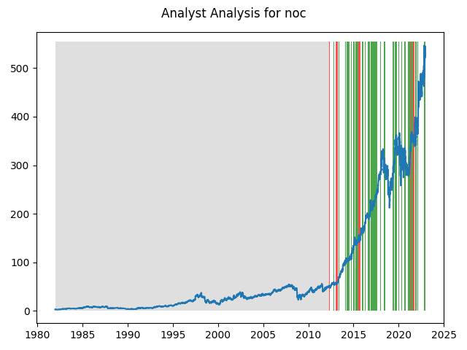

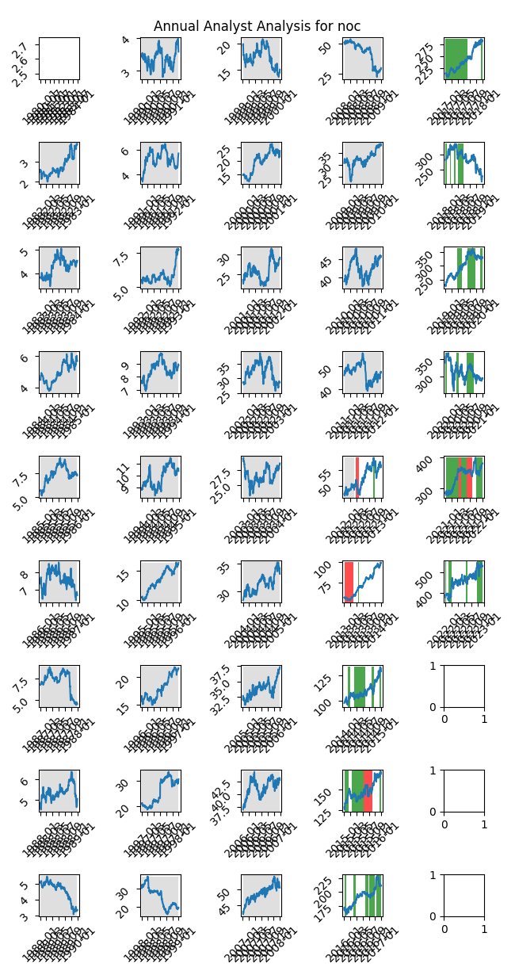

|  |  |  |  |  |  |  |
| --- | --- | --- | --- | --- | --- | --- |
| Timeframe | -1_min | -1_mean | -1_max | 1_min | 1_mean | 1_max |
| 1-day | -7.03 | 0.05 | 10.75 | -37.13 | 0.26 | 32.13 |
| 3-day | -13.83 | 0.1 | 11.62 | -42.98 | 0.78 | 61.53 |
| 7-day | -16.26 | 0.35 | 14.73 | -43.63 | 1.97 | 83.15 |
| 14-day | -22.14 | 1.69 | 47.12 | -36.51 | 4.16 | 87.97 |
| 21-day | -17.07 | 3.52 | 54.7 | -42.76 | 5.55 | 104.52 |
| 28-day | -19.03 | 4.9 | 53.46 | -46.11 | 6.6 | 77.49 |