Automatice Report for ntr

# Analyzing the Headline Accuracy

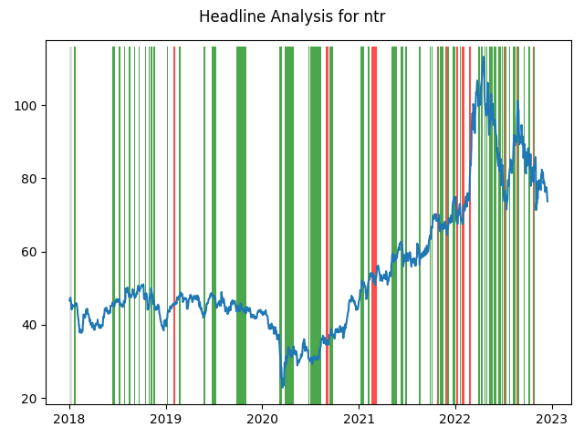

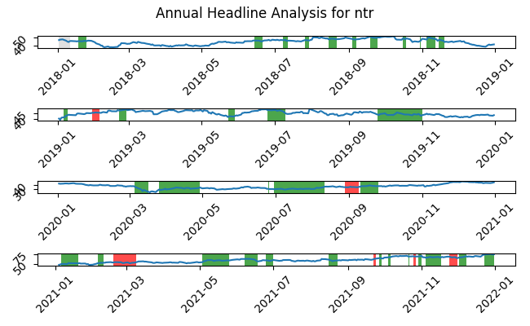

# A Little Bit More Insight Into the Headlines

The best headline was"10 Strong Buy Stocks From the Best Analysts on Wall Street" which occured on 2018-07-26 and had a Sentiment Score of 0.8176

The worst headline was"CANADA STOCKS-TSX futures down on weaker crude prices, Russia-Ukraine tensions" which occured on 2022-02-17 and had a Sentiment Score of -0.8519

|  |  |  |  |  |  |  |
| --- | --- | --- | --- | --- | --- | --- |
| Timeframe | -1_min | -1_mean | -1_max | 1_min | 1_mean | 1_max |
| 1-day | -4.51 | 0.32 | 6.76 | -7.25 | 0.03 | 6.34 |
| 3-day | -14.28 | 1.23 | 10.71 | -9.42 | -0.1 | 11.22 |
| 7-day | -8.27 | 2.25 | 21.56 | -12.91 | -0.21 | 14.38 |
| 14-day | -11.96 | 3.09 | 24.33 | -20.24 | -0.1 | 25.58 |
| 21-day | -18.91 | 4.97 | 31.22 | -22.28 | -0.27 | 29.28 |
| 28-day | -24.5 | 5.11 | 32.79 | -26.09 | -0.2 | 34.48 |

# Analyzing the Technical Indicators

## Looking at RSI

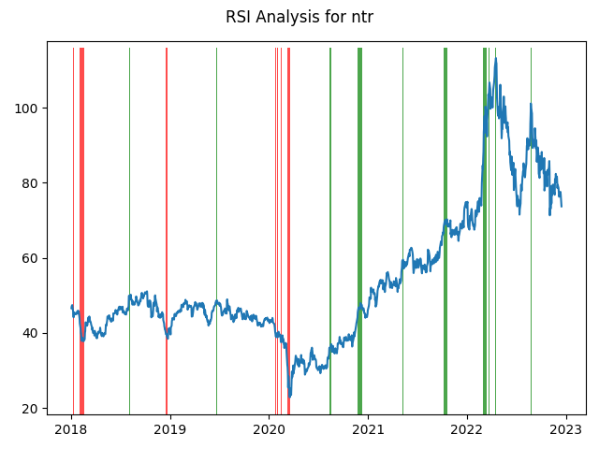

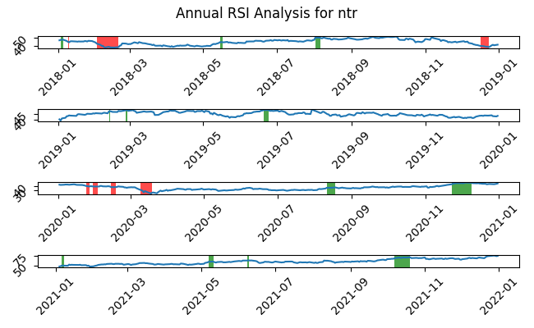

|  |  |  |  |  |  |  |
| --- | --- | --- | --- | --- | --- | --- |
| Timeframe | -1_min | -1_mean | -1_max | 1_min | 1_mean | 1_max |
| 1-day | -3.67 | -0.1 | 3.02 | -5.15 | 0.02 | 6.76 |
| 3-day | -5.99 | 0.01 | 6.25 | -13.39 | -0.42 | 11.21 |
| 7-day | -8.6 | 0.55 | 5.73 | -14.7 | -0.95 | 16.7 |
| 14-day | -13.13 | 2.44 | 9.55 | -20.24 | -0.62 | 19.97 |
| 21-day | -14.73 | 2.07 | 10.22 | -19.83 | -0.51 | 17.33 |
| 28-day | -13.39 | 1.15 | 10.08 | -18.45 | 0.39 | 21.25 |

## Looking at OBV

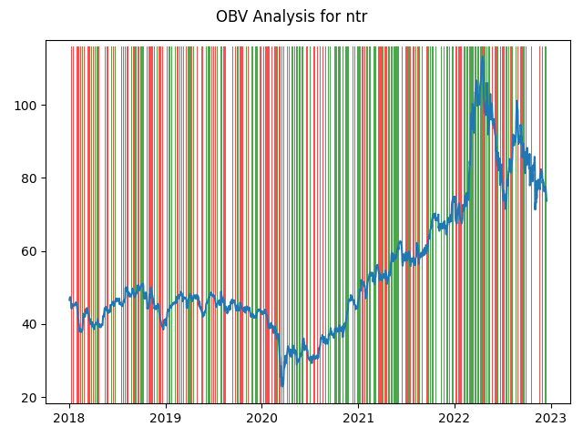

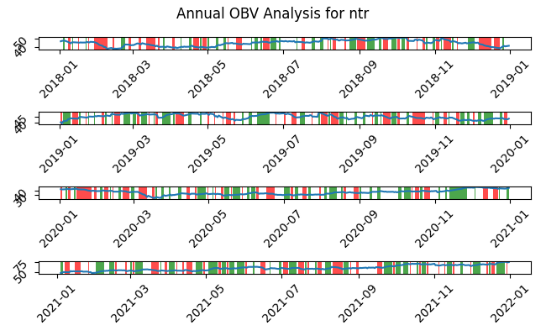

|  |  |  |  |  |  |  |
| --- | --- | --- | --- | --- | --- | --- |
| Timeframe | -1_min | -1_mean | -1_max | 1_min | 1_mean | 1_max |
| 1-day | -11.67 | -0.02 | 4.6 | -10.8 | 0.07 | 6.76 |
| 3-day | -13.39 | 0.08 | 11.22 | -14.28 | 0.07 | 11.21 |
| 7-day | -14.7 | 0.15 | 19.56 | -13.26 | 0.22 | 21.56 |
| 14-day | -20.24 | 0.33 | 25.58 | -17.02 | 0.43 | 24.33 |
| 21-day | -18.91 | 0.63 | 31.22 | -22.28 | 0.53 | 30.45 |
| 28-day | -24.5 | 0.73 | 34.48 | -26.09 | 0.85 | 31.76 |

## Looking at ADX

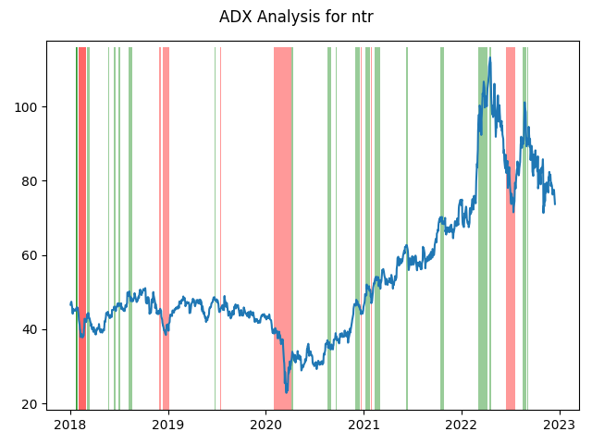

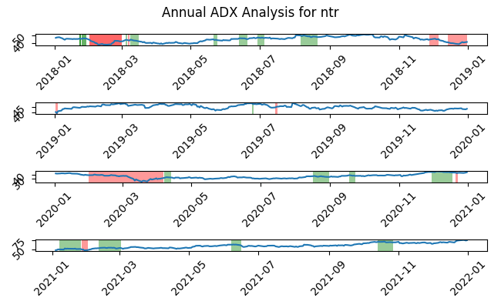

|  |  |  |  |  |  |  |  |  |  |  |  |  |
| --- | --- | --- | --- | --- | --- | --- | --- | --- | --- | --- | --- | --- |
| Timeframe | -2_min | -2_mean | -2_max | -1_min | -1_mean | -1_max | 1_min | 1_mean | 1_max | 2_min | 2_mean | 2_max |
| 1-day | -1.5 | -0.11 | 2.33 | -7.25 | -0.07 | 3.52 | -5.27 | -0.12 | 6.76 | -0.55 | -0.0 | 0.81 |
| 3-day | -3.98 | -0.0 | 4.5 | -7.55 | -0.2 | 6.62 | -13.39 | -0.33 | 11.22 | -1.83 | -1.08 | -0.01 |
| 7-day | -6.8 | 0.66 | 4.78 | -11.81 | -0.26 | 10.12 | -14.7 | -0.63 | 14.38 | -6.07 | -5.33 | -4.05 |
| 14-day | -6.81 | 1.87 | 6.58 | -13.52 | 0.06 | 11.04 | -20.24 | -0.58 | 12.35 | -8.01 | -7.71 | -7.24 |
| 21-day | -3.02 | 1.36 | 5.14 | -15.26 | 0.91 | 20.36 | -19.83 | -0.2 | 18.41 | -3.78 | -3.33 | -2.48 |
| 28-day | -4.08 | 0.02 | 3.01 | -17.34 | 2.13 | 26.63 | -18.45 | -0.71 | 19.91 | -2.92 | -1.98 | -1.31 |

# Analyzing the Analyst Agencies

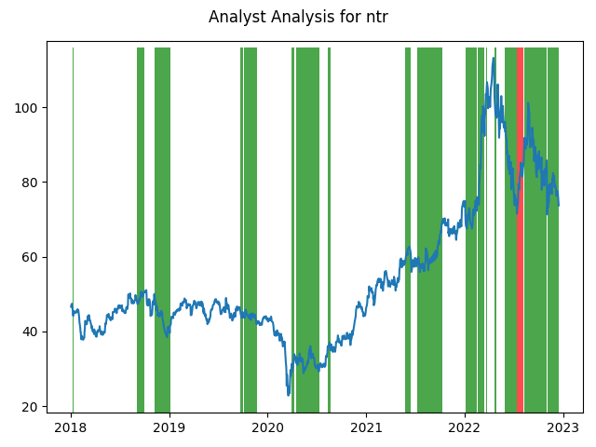

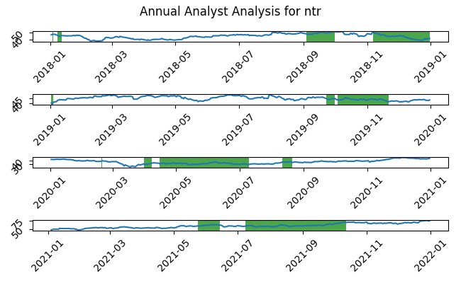

|  |  |  |  |  |  |  |
| --- | --- | --- | --- | --- | --- | --- |
| Timeframe | -1_min | -1_mean | -1_max | 1_min | 1_mean | 1_max |
| 1-day | -1.99 | 0.96 | 3.74 | -8.66 | 0.0 | 6.76 |
| 3-day | -3.75 | 2.91 | 6.62 | -13.19 | 0.01 | 11.22 |
| 7-day | -0.19 | 5.47 | 10.43 | -11.9 | 0.06 | 21.56 |
| 14-day | 6.2 | 10.18 | 17.79 | -16.74 | 0.18 | 25.58 |
| 21-day | 4.72 | 12.44 | 20.36 | -20.55 | 0.56 | 31.22 |
| 28-day | 0.53 | 12.03 | 26.63 | -23.3 | 1.28 | 34.48 |