Automatice Report for pfe

# Analyzing the Headline Accuracy

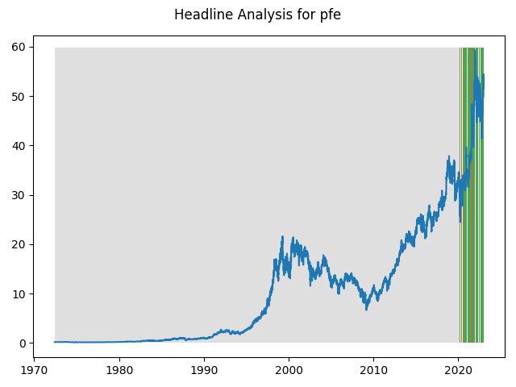

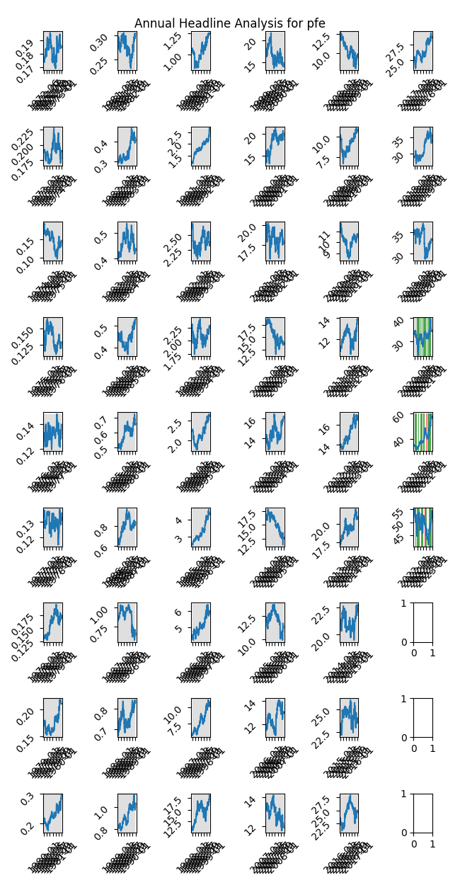

# A Little Bit More Insight Into the Headlines

The best headline was"Are These The Best Health Care Stocks To Buy After Moderna’s Vaccine Success?" which occured on 2020-11-30 and had a Sentiment Score of 0.9022

The worst headline was"COVID SCIENCE-Neurological problems no higher after vaccination; depression, anxiety risk tied to COVID severity" which occured on 2021-09-17 and had a Sentiment Score of -0.886

|  |  |  |  |  |  |  |
| --- | --- | --- | --- | --- | --- | --- |
| Timeframe | -1_min | -1_mean | -1_max | 1_min | 1_mean | 1_max |
| 1-day | -1.67 | -0.0 | 2.23 | -2.7 | 0.02 | 4.61 |
| 3-day | -3.32 | 0.04 | 4.12 | -5.47 | 0.08 | 5.86 |
| 7-day | -3.99 | 0.01 | 9.23 | -6.83 | 0.22 | 8.66 |
| 14-day | -4.56 | 0.11 | 8.24 | -7.26 | 0.44 | 7.81 |
| 21-day | -6.04 | 0.18 | 10.04 | -8.37 | 0.7 | 11.28 |
| 28-day | -6.25 | 0.63 | 9.52 | -9.13 | 0.92 | 14.48 |

# Analyzing the Technical Indicators

## Looking at RSI

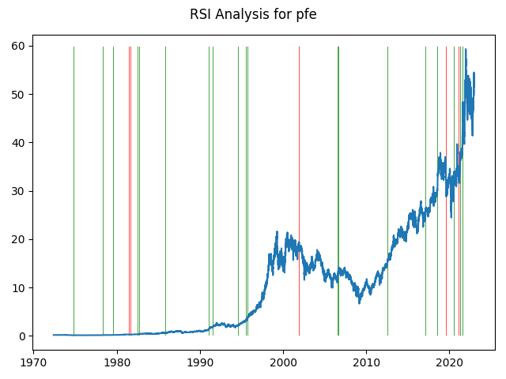

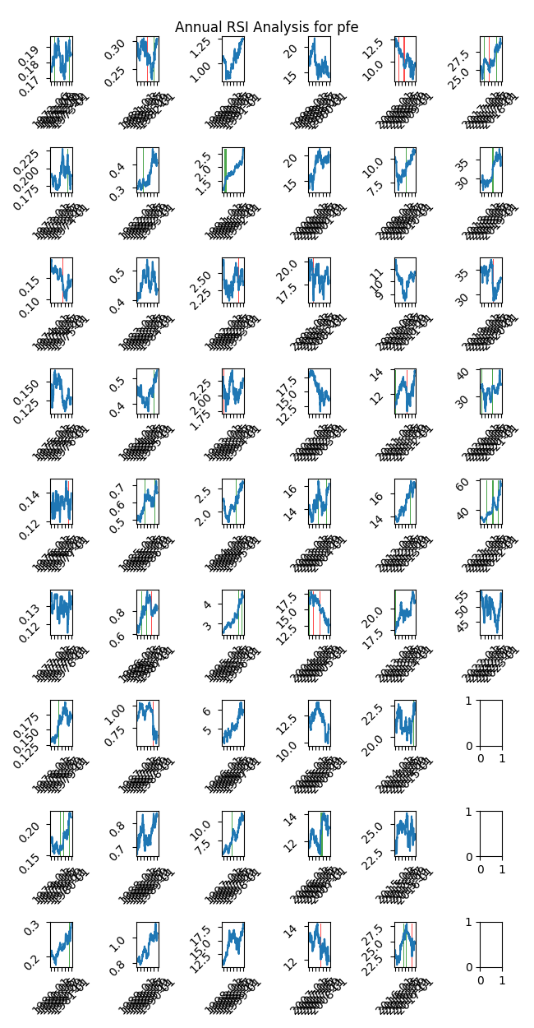

|  |  |  |  |  |  |  |
| --- | --- | --- | --- | --- | --- | --- |
| Timeframe | -1_min | -1_mean | -1_max | 1_min | 1_mean | 1_max |
| 1-day | -0.9 | 0.04 | 2.31 | -2.0 | -0.0 | 2.37 |
| 3-day | -1.78 | 0.09 | 2.83 | -3.1 | 0.01 | 3.05 |
| 7-day | -2.41 | 0.2 | 3.37 | -4.22 | 0.03 | 5.17 |
| 14-day | -4.89 | 0.3 | 8.24 | -6.21 | 0.09 | 7.07 |
| 21-day | -6.21 | 0.38 | 8.83 | -6.92 | 0.16 | 11.28 |
| 28-day | -3.41 | 0.49 | 9.82 | -7.68 | 0.14 | 12.24 |

## Looking at OBV

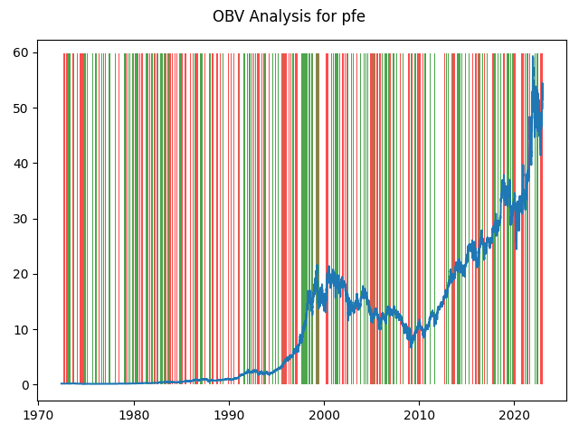

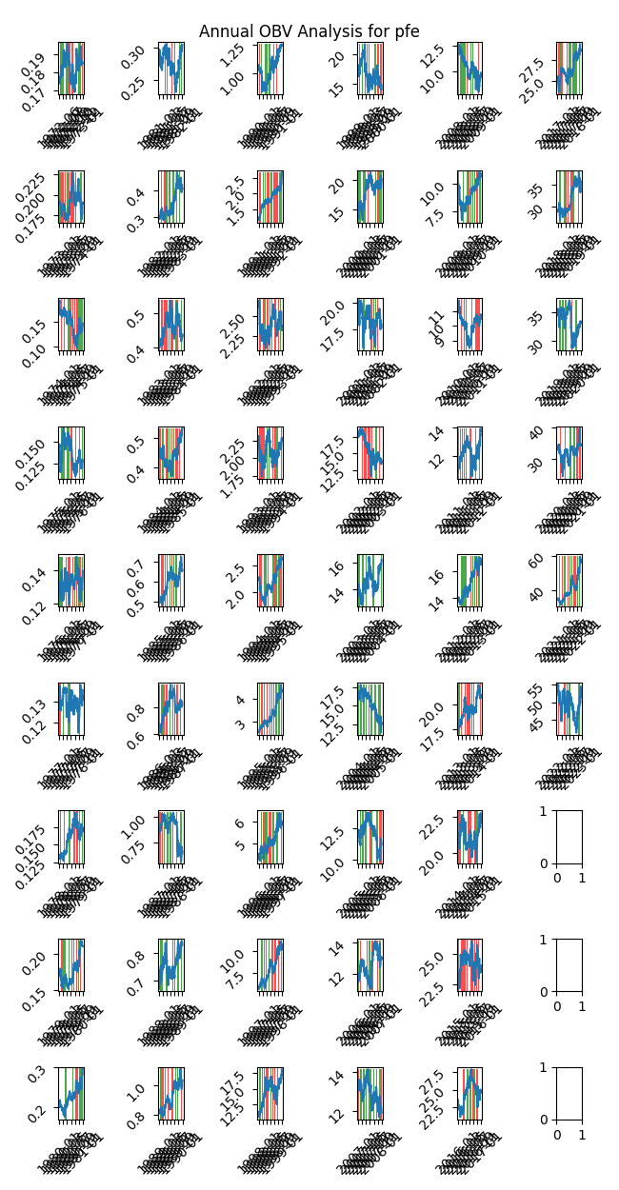

|  |  |  |  |  |  |  |
| --- | --- | --- | --- | --- | --- | --- |
| Timeframe | -1_min | -1_mean | -1_max | 1_min | 1_mean | 1_max |
| 1-day | -2.27 | 0.0 | 4.61 | -2.7 | 0.0 | 3.16 |
| 3-day | -5.47 | 0.02 | 4.12 | -3.93 | 0.01 | 5.86 |
| 7-day | -6.83 | 0.04 | 7.83 | -6.38 | 0.02 | 9.23 |
| 14-day | -7.26 | 0.07 | 8.24 | -6.91 | 0.05 | 7.81 |
| 21-day | -6.68 | 0.1 | 11.28 | -8.37 | 0.07 | 10.04 |
| 28-day | -9.13 | 0.15 | 14.48 | -8.52 | 0.09 | 12.24 |

## Looking at ADX

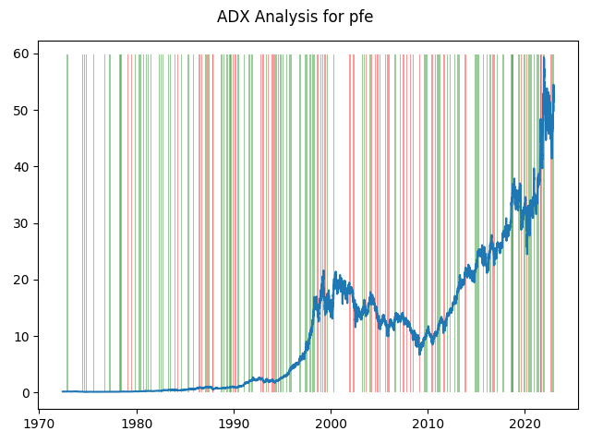

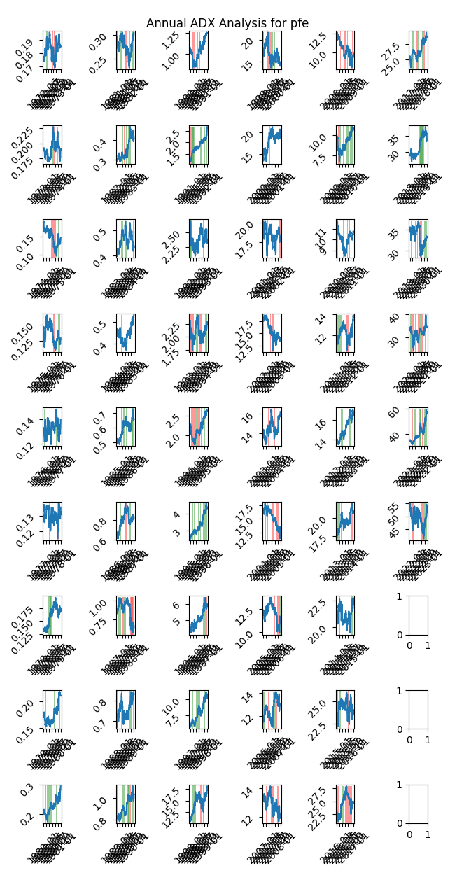

|  |  |  |  |  |  |  |  |  |  |  |  |  |
| --- | --- | --- | --- | --- | --- | --- | --- | --- | --- | --- | --- | --- |
| Timeframe | -2_min | -2_mean | -2_max | -1_min | -1_mean | -1_max | 1_min | 1_mean | 1_max | 2_min | 2_mean | 2_max |
| 1-day | -0.62 | 0.06 | 1.61 | -2.17 | 0.01 | 2.31 | -2.7 | 0.0 | 3.16 | -1.81 | 0.02 | 2.12 |
| 3-day | -0.62 | 0.19 | 2.6 | -3.32 | 0.03 | 3.42 | -3.84 | 0.01 | 5.86 | -2.45 | 0.03 | 3.05 |
| 7-day | -0.15 | 0.31 | 1.92 | -4.53 | 0.07 | 6.64 | -4.22 | 0.03 | 9.23 | -3.73 | -0.04 | 3.2 |
| 14-day | -0.09 | 0.4 | 2.33 | -5.75 | 0.14 | 8.24 | -6.21 | 0.07 | 7.66 | -5.14 | -0.26 | 2.08 |
| 21-day | -0.34 | 0.24 | 1.6 | -6.04 | 0.26 | 8.86 | -7.76 | 0.07 | 11.28 | -5.74 | -0.32 | 2.8 |
| 28-day | -0.32 | 0.25 | 2.32 | -7.11 | 0.34 | 12.63 | -8.52 | 0.07 | 13.29 | -6.72 | -0.46 | 3.23 |

# Analyzing the Analyst Agencies

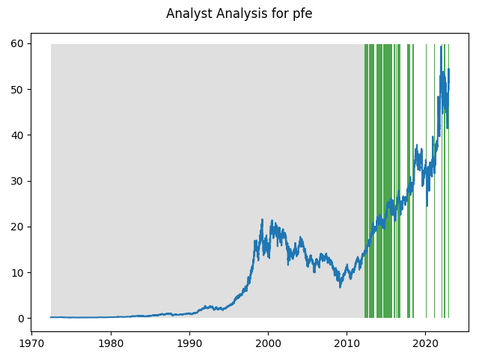

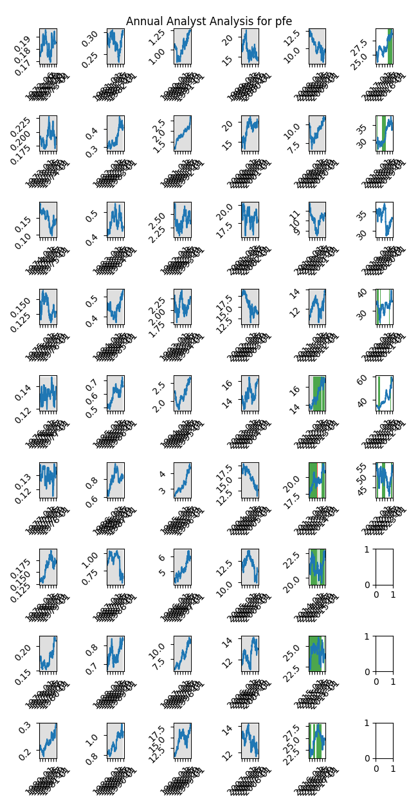

|  |  |  |  |  |  |  |
| --- | --- | --- | --- | --- | --- | --- |
| Timeframe | -1_min | -1_mean | -1_max | 1_min | 1_mean | 1_max |
| 1-day | -0.03 | 0.11 | 0.22 | -2.03 | 0.01 | 3.01 |
| 3-day | -0.06 | 0.29 | 0.47 | -5.47 | 0.03 | 3.5 |
| 7-day | 0.09 | 0.47 | 0.77 | -6.83 | 0.06 | 8.66 |
| 14-day | 0.47 | 0.86 | 1.16 | -7.26 | 0.09 | 7.66 |
| 21-day | 0.46 | 0.89 | 1.32 | -8.37 | 0.12 | 8.09 |
| 28-day | -0.0 | 0.61 | 1.25 | -9.13 | 0.17 | 7.99 |