Automatice Report for pnc

# Analyzing the Headline Accuracy

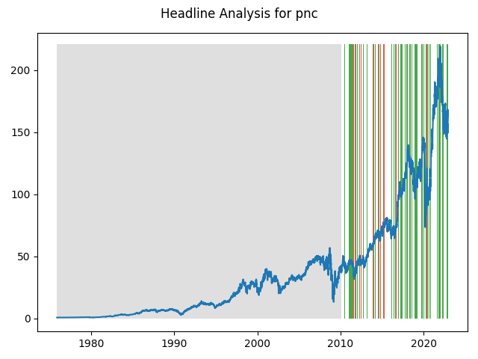

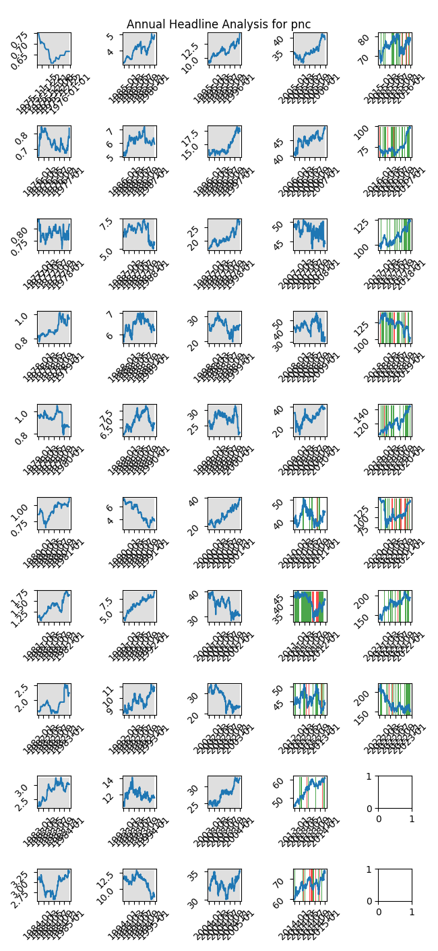

# A Little Bit More Insight Into the Headlines

The best headline was"Bank Stock Roundup: Positive Economic Data Raises Optimism, Wells Fargo & Citi in Focus" which occured on 2013-12-16 and had a Sentiment Score of 0.8442

The worst headline was"Bank Stock Roundup: Trade War Fears, Capital Plan Approvals, JPM & WFC Dominate" which occured on 2018-06-29 and had a Sentiment Score of -0.802

|  |  |  |  |  |  |  |
| --- | --- | --- | --- | --- | --- | --- |
| Timeframe | -1_min | -1_mean | -1_max | 1_min | 1_mean | 1_max |
| 1-day | -6.15 | 0.05 | 6.91 | -15.5 | 0.05 | 12.53 |
| 3-day | -21.78 | -0.06 | 12.14 | -17.73 | 0.18 | 14.25 |
| 7-day | -28.0 | -0.2 | 17.84 | -28.05 | 0.41 | 20.27 |
| 14-day | -27.85 | 0.3 | 28.38 | -40.88 | 0.61 | 26.91 |
| 21-day | -32.36 | 0.88 | 29.64 | -34.76 | 0.69 | 27.96 |
| 28-day | -28.79 | 1.52 | 31.53 | -27.9 | 1.18 | 28.59 |

# Analyzing the Technical Indicators

## Looking at RSI

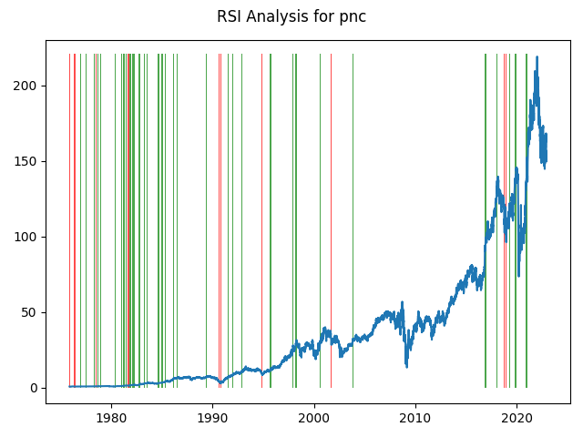

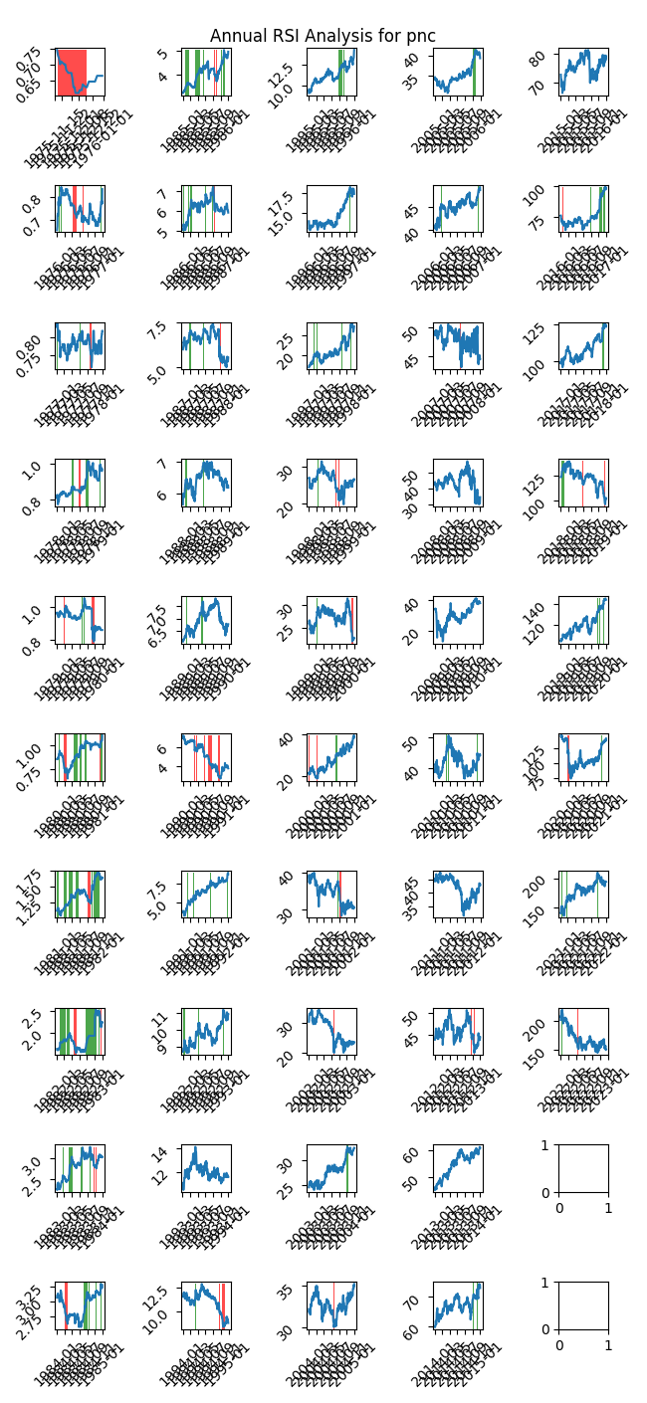

|  |  |  |  |  |  |  |
| --- | --- | --- | --- | --- | --- | --- |
| Timeframe | -1_min | -1_mean | -1_max | 1_min | 1_mean | 1_max |
| 1-day | -14.11 | 0.05 | 11.17 | -6.58 | -0.01 | 4.99 |
| 3-day | -13.62 | 0.02 | 20.31 | -21.78 | -0.06 | 9.28 |
| 7-day | -29.05 | -0.19 | 12.12 | -21.06 | -0.09 | 11.7 |
| 14-day | -46.82 | 0.06 | 18.52 | -27.85 | -0.05 | 13.11 |
| 21-day | -44.93 | 0.21 | 17.7 | -28.58 | 0.06 | 16.72 |
| 28-day | -51.18 | 0.4 | 21.45 | -28.79 | 0.21 | 19.8 |

## Looking at OBV

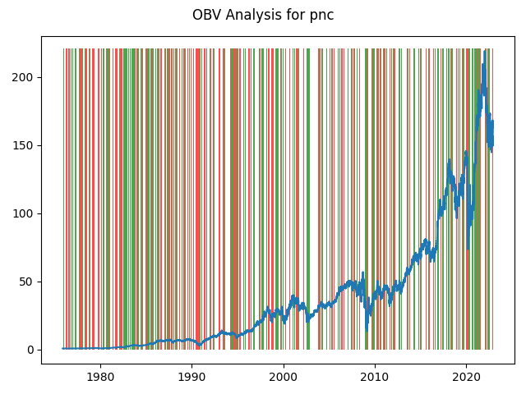

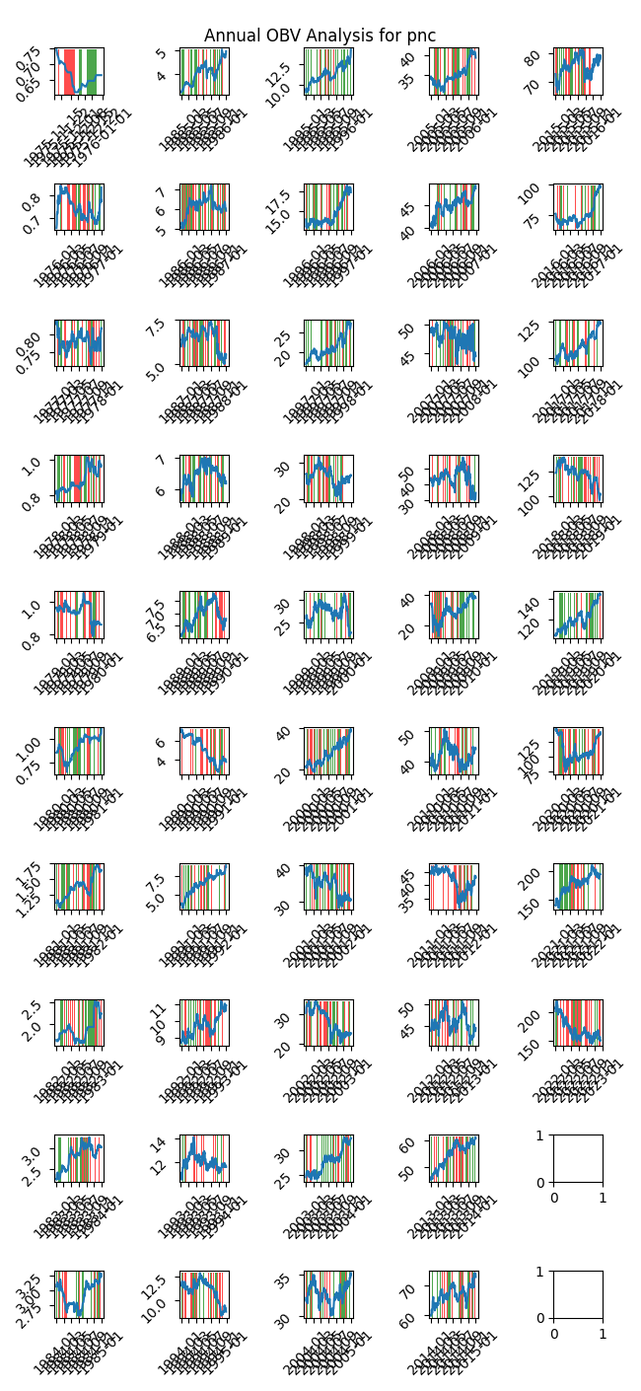

|  |  |  |  |  |  |  |
| --- | --- | --- | --- | --- | --- | --- |
| Timeframe | -1_min | -1_mean | -1_max | 1_min | 1_mean | 1_max |
| 1-day | -14.11 | 0.04 | 12.53 | -15.5 | -0.0 | 9.91 |
| 3-day | -16.58 | 0.07 | 20.31 | -27.94 | 0.03 | 12.14 |
| 7-day | -29.05 | 0.16 | 22.56 | -27.98 | 0.06 | 21.76 |
| 14-day | -53.85 | 0.3 | 28.93 | -47.89 | 0.15 | 27.59 |
| 21-day | -66.68 | 0.38 | 29.64 | -59.56 | 0.28 | 27.52 |
| 28-day | -60.57 | 0.53 | 31.71 | -67.59 | 0.33 | 33.74 |

## Looking at ADX

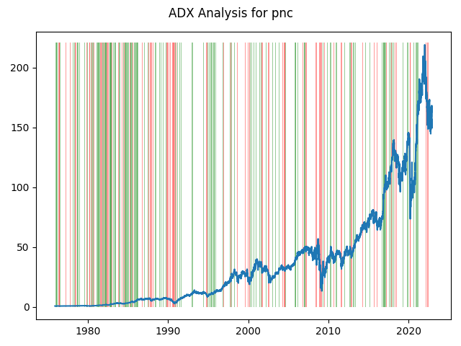

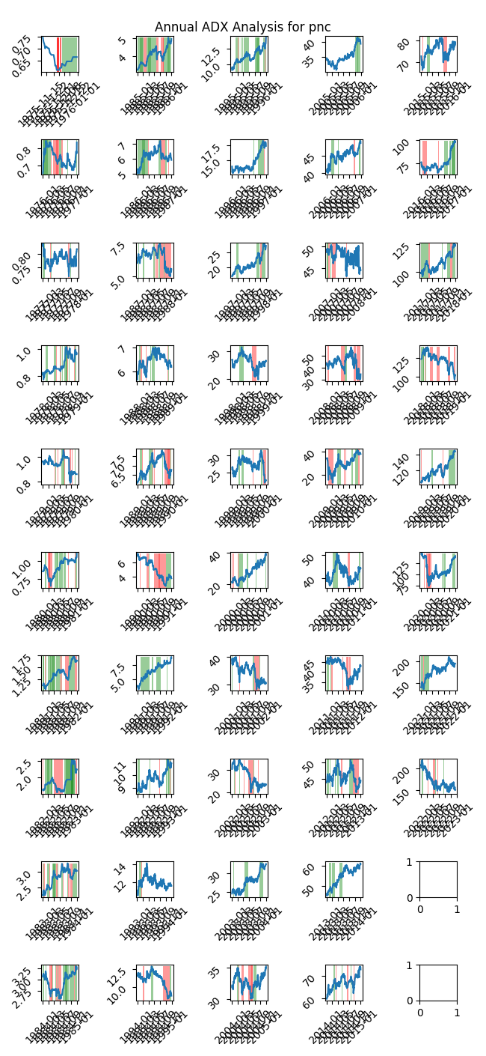

|  |  |  |  |  |  |  |  |  |  |  |  |  |
| --- | --- | --- | --- | --- | --- | --- | --- | --- | --- | --- | --- | --- |
| Timeframe | -2_min | -2_mean | -2_max | -1_min | -1_mean | -1_max | 1_min | 1_mean | 1_max | 2_min | 2_mean | 2_max |
| 1-day | -8.07 | 0.01 | 9.91 | -15.5 | 0.03 | 11.17 | -10.53 | 0.01 | 7.68 | -6.58 | -0.02 | 1.9 |
| 3-day | -11.65 | 0.0 | 20.31 | -27.94 | 0.13 | 13.04 | -21.78 | 0.01 | 9.76 | -6.62 | 0.0 | 2.96 |
| 7-day | -6.94 | 0.78 | 12.41 | -29.05 | 0.26 | 20.27 | -21.06 | 0.04 | 15.38 | -11.66 | -0.02 | 4.66 |
| 14-day | -10.32 | 1.27 | 18.52 | -40.88 | 0.34 | 25.52 | -27.85 | 0.1 | 24.94 | -3.83 | 0.17 | 6.31 |
| 21-day | -4.01 | 1.85 | 17.7 | -54.75 | 0.36 | 28.06 | -28.58 | 0.21 | 26.58 | -1.64 | 0.32 | 9.07 |
| 28-day | -2.98 | 1.89 | 21.45 | -67.59 | 0.28 | 33.74 | -28.79 | 0.43 | 29.19 | -0.91 | 0.5 | 12.25 |

# Analyzing the Analyst Agencies

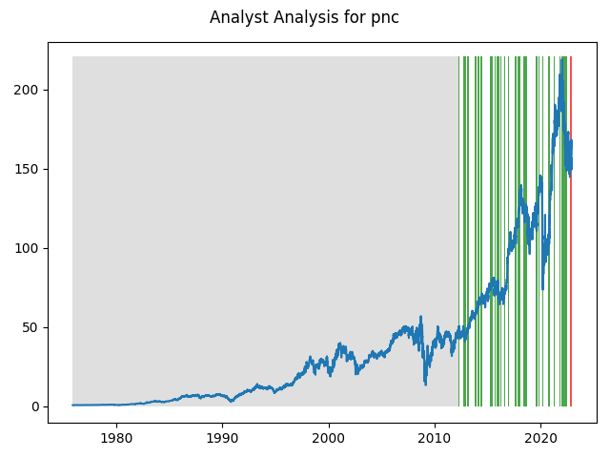

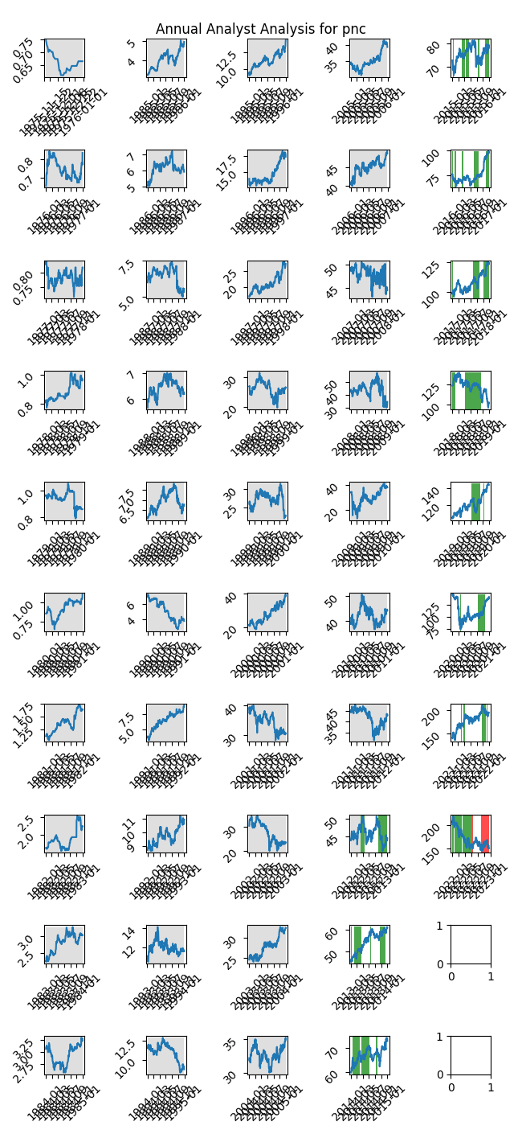

|  |  |  |  |  |  |  |
| --- | --- | --- | --- | --- | --- | --- |
| Timeframe | -1_min | -1_mean | -1_max | 1_min | 1_mean | 1_max |
| 1-day | -6.11 | -0.39 | 8.39 | -11.73 | 0.03 | 12.53 |
| 3-day | -12.57 | -0.32 | 15.24 | -16.23 | 0.1 | 20.31 |
| 7-day | -13.38 | 1.79 | 13.85 | -21.31 | -0.03 | 20.27 |
| 14-day | -17.04 | 3.79 | 17.12 | -25.17 | 0.06 | 25.68 |
| 21-day | -22.63 | 5.48 | 23.44 | -28.52 | 0.46 | 29.64 |
| 28-day | -28.26 | 2.77 | 22.71 | -28.79 | 0.97 | 31.53 |